Problem 5)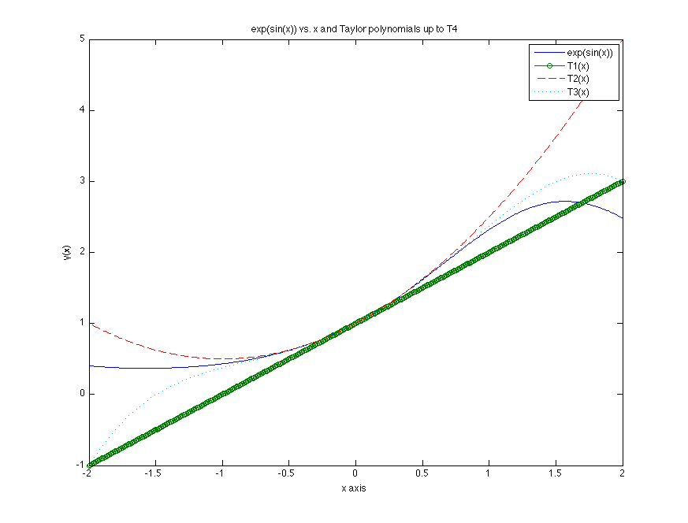

Problem 6)

a) yn will be more accurate than xn for large n because when subtracting numbers that are close in value on a computer, there will be loss of precision. the floating point numbers internal to MATLAB are truncated, and when subtracting numbers that are close in value, the number will be small enough that the truncation will make a large difference.

b)