Definition

Project Overview
DiDi Chuxing is a ride-hailing company with a business model similar to Uber and focused on the Chinese domestic market. The company collects and analyses a large amount of data in order to, among other things, ensure a sufficient supply of cars available for those looking for rides. The DiTech Challenge is an opportunity for machine learning engineers and researchers to help improve the predictive capability of these algorithms using their particular knowledge and skills.
DiDi Chuxing has provided a plethora of data for our consideration. In addition to historical ride order data for much of January 2016, we are provided with traffic and weather data for the same period, as well as points of interest (POI) data which details, in a cryptic manner, the sights and attractions in all 66 districts of the undisclosed city. It is up to those challenged to determine which features out of all provided are key to making predictions about the gap, i.e., the difference between the number of customers requesting a ride in a given district in a given 10-minute interval and the number of cars available to supply rides. As the gap is always a integer greater than or equal to zero, this problem is most naturally treated as one of regression.
I have chosen to pursue a solution to this problem using artificial neural networks (ANNs) primarily because I want to learn more about how artificial neural networks function. When I started this effort I was using Tensorflow, but I was not able to make any progress; the algorithm would not learn from the data. I'll discuss my hypothesis for why this is later on. Nonetheless, once I build my own ANN (in Julia(!)) the scores of my predictions became substantially better. The work in this project will involve porting my Julia code into Python. I do so hope I can achieve the same results.

Problem Statement
The DiTech Challenge is a regression problem, as a single numerical output--the gap--is to be predicted from an understanding of previous supply and demand data, traffic and weather data, and POI data for each district in the city. The time frame is limited to the three previous 10-minute time intervals in the test data provided by DiDi Chuxing. Scoring is done using mean absolute percentage error (MAPE).
The goal of this project is to construct an artificial neural network that yields a model of the training data that results in the lowest possible MAPE. As I cannot judge the performance of the model on the test data by myself (and the competition now being closed, my best efforts far too inferior to have made it through to the final round), I will be forced to split the given training data into a training set and a test set. Thus the test data insofar as this project is concerned is actually a chunk of the training data provided by DiDi Chuxing.
As I discussed above I will build an artificial neural network to do this. This ANN will be a purely feed-forward neural network (i.e., there will be no loops within the network). I will make use of cross validation and grid search to find ideal hyper-parameters.

Metrics
The scoring metric provided by DiDi Chuxing is mean absolute percentage error, or MAPE. MAPE is defined as
(1)
where ŷ_{i} is the predicted value for sample i, y_{i} is the target value for sample i and N is the number of data points, If y_{i}=0 then the MAPE contribution from that data point is automatically considered to be 0 no matter how far out the prediction.
MAPE is less commonly used than the more familiar mean squared error (MSE) cost function. One solid reason for this is that MAPE is not a smooth function. There's a kink whenever ŷ_{i=}y_{i}. It's possible to perform gradient descent on a MAPE scoring function, but it is more challenging than minimizing more well-behaved functions. A well-behaved function such as MSE has a gradient that decreases smoothly toward zero near its minimum. That doesn't happen with MAPE; the curve approaches its minimum with some non-zero steepness. Overshooting during gradient descent becomes a difficult problem to contend with.
Unlike MSE, MAPE punishes errors more when the absolute value of y_{i} is small. Thus if one is attempting to minimize MAPE, one would want to ensure that one gets the predictions for small values right. In fact, if one knew nothing about the factors that gave rise to some set of observations, one would minimize MAPE by predicting some small value at the low end of the distribution [Gneiting]. For example, suppose one was dealing with a discrete exponential distribution. Without knowing the factors that gave rise to the distribution, the best strategy would be to predict 1 every time. Predicting 0 would not work as true zeros do not contribute toward MAPE. Later on I will invoke this 'guess-1' strategy as a benchmark against which to compare the performance of the ANN I will construct.

Analysis

Data Exploration
Substantial effort went into converting the data as provided into a form usable for learning. The code for converting and transforming the raw data is provided here, without much verbosity. The raw training data has not been uploaded to GitHub, but is (hopefully still) available here. The manipulated training data is available, so when the is run, these files will be read relatively quickly (see the `retrieve` function). Do please take notice that for the purposes of this investigation I am focusing on the training data, as I will require data for which known values of gap exist.

Order Data
We are provided with order data from a certain city on the majority of days in January 2016. These data are in the form of individual orders. We are told when they were placed, in which district they were placed, by whom, at what price, and by whom they were fulfilled (if at all). This level of granularity is too detailed for our requirements. I have summarized these data in the following manner
- District_ID: the region of the city as determined by DiDi Chuxing
- UTC: universal time coordinate, an ordered 10-minute-long time interval, referenced to Jan 1st 2016 at 00:00.
- Demand: number of requests for cars in a district in a UTC
- Supply: number of fulfilled requests in a district in a UTC, always less than or equal to demand. (We have no way of knowing if there are other drivers out there who would have responded had not some other driver responded first)
- Med Price: the median proce of a ride in that district in that UTC
- Gap: the arithmetic difference between demand and supply
- Weekday: ordinal value of the day of the week (Jan 1st --> 0 by default)
An example of the summarized order data is given immediately below. It provides data on the first five 10-minute time periods (UTC) for the first day of January in District 1. For example, in UTC 1 in District 1 there were 187 requests for rides, 178 of which were fulfilled. The 9 rides unfulfilled make up the gap.

The median supply, demand and gap values from the training data are summarized below. The median demand is 7, supply 6 and thus the median gap is 1.

POI Data
POI stands for points of interest. These data are intentionally cryptic; they refer to the number of points of interest of various undisclosed type, per district in the city. Points of interest may include things such as restaurants, theaters, historical sites, stadiums etc. There are 64 categories and sub-categories. A number of POI data columns are linear combinations of other columns. Columns have been deleted as necessary in order to achieve linear independence.
It seems that the numbers in most (but not all) columns are multiples of 83. This may be a means of further disguising the true nature of the points of interest. It does not appear to be relevant to the task at hand. NaN values are assumed to correspond to 0 points of interest of that type, as zeros are absent from the database.
An small sample of the summarized POI data is given immediately below. It provides data on five districts, whose order is determined by the order in which they appeared in the raw POI data. POI-1 would appear to be a super-category, with POI-1#1, POI-1#2 apparently being subcategories of POI-1. But the values in the POI-1 column are not simply a sums of the values of its subcategories; the relationship is more complex. You can see that all values appear to be multiples of 83.

Traffic Data
We are provided with information on traffic congestion in each district at numerous instances. The information is slightly criptic, but the gist of it is that we are given the number of roads per district with certain levels of traffic congestion, labeled 1,2,3 and 4 with 1 being the least bad congestion and 4 being the worst. Uncongested roads appear to be unreported.
There is no traffic data available for District 54. A solution to this missing data problem is required. In terms of supply, demand and gap, District 54 is perhaps most similar to Districts 2, 36 and 57 (see the table immediately below). I've taken the mean traffic in these three districts in a given time interval as a proxy for the traffic in District 54 during that same time interval.

In addition to those of District 54 there are other time intervals for which we are provided no traffic data. In cases when traffic data for a district/time interval is missing, I have interpolated a value based upon the nearest two time slots in that district for which data exist. When that is not possible, I have taken the traffic value of the chronologically nearest available measurement in the district in question.
An example of the summarized training traffic data is given immediately below. Traffic data is reported approximately once every 10 minutes for each district (except District 54 as mentioned above). An example is provided below for the first five UTCs on January 1st in District 1.

A summary of the training traffic data is provided immediately below.

Weather Data
We are given three pieces of weather information collected at various intervals for the entire city: temperature (in Kelvin), PM25 (a measure of air pollution, with high values being worse) and weather, which appears to be a categorical value describing the weather at the time.
The training data contains weather category 9, which is not present in the test data. Likewise, the test data contains weather category 6, not present in the test data. We will consider these two categories to be 'weather: other', and lump them together as such.
There are multiple occasions when more than one weather reading is take per time interval, in such cases, I have taken the average temperature and PM25, and the first reported weather category.
In case of missing data, I have interpolated values of temperature and PM25 whenever possible. When that is not possible, I have taken the traffic value of the chronologically nearest available measurement in the district in question. Missing categorical weather data is always filled in by copying the nearest chronological value.
An example of the summarized training weather data is given immediately below. Weather data is reported approximately once every 10 minutes for the entire city. Exemplary data is provided below for the first five time intervals of January 1, just to give yu an idea of whet these data look like.

A summary of the weather data is provided immediately below. The weather category is not reported here as its categorical an a median of a categorical value is meaningless.

Exploratory Visualization
A plot of count vs gap is shown below; count here being defined as the number of data points in the training set that have the corresponding gap is shown on the y-axis with logarithmic scale. The inset shows a close-up of the data up to a gap of 250 to give you a better idea of the shape of what comprises the vast majority of the data. This choice of axes can be explained as follows. One might expect the gap to be distributed exponentially--by definition it cannot be negative and one's intuition expects small values to occur more often than large values. Were the gap distributed exponentially, then a plot of log(count) vs gap would result in an approximately straight line. This is not the case, but it is clear that the probability of observing a particular gap has a strong tendency to decrease as the value of the gap increases.
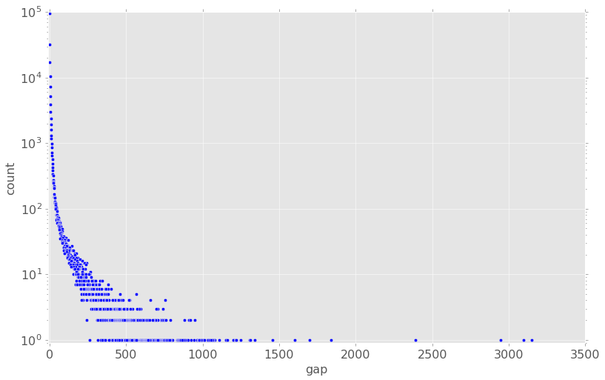
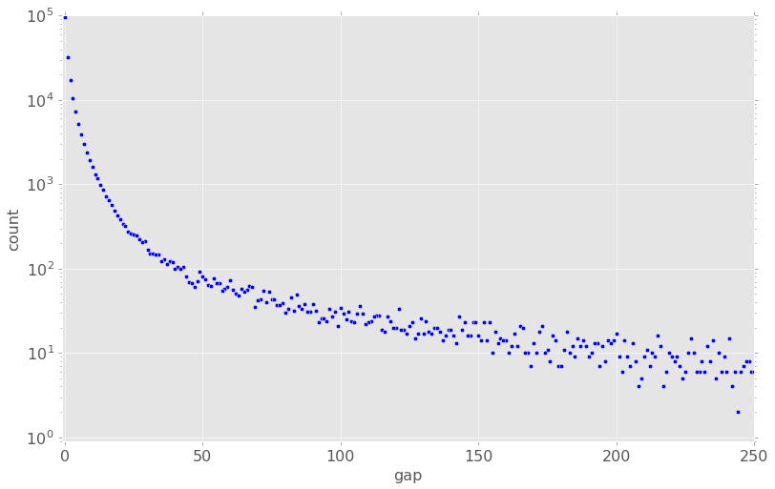

A bar plot of the median gap in each district vs district ID is shown below. The median gap by district extends from a low of 0 for multiple districts to a high of 24 for district 51. Eventually I would like to see the MAPE score on a district level. Will MAPE for district 51 be lower or higher than for district with median gap of 0? It's interesting to speculate: district 51 stands furthest away from the "average" district, thus one would expect predictions for its gaps to be less accurate. But on the other hand MAPE punishes absolute errors less when the true value is large, as is the case for district 51. We shall have to wait and see which of these two factors (or perhaps some other) is the greatest influence on district-level MAPE.
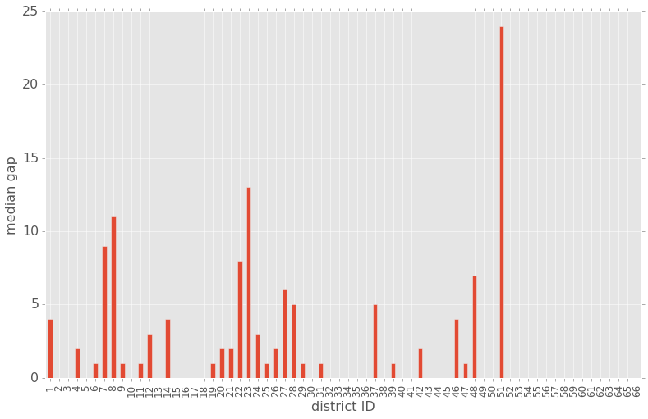

Algorithms and Techniques

Feed-Forward Prediction by Neural Network
Let's consider a two-hidden-layer network with K input nodes, M nodes in the first hidden layer, N nodes in the second hidden layer, and a single output node. The N nodes in the first hidden layer are all of the same non-linear functional type; call that function f₁. Function f₁ could be a sigmoid function, rectifying function, exponential function, etc., as long as it is non-linear. The nodes in hidden layer 2 are also all of the same non-linear functional type; call that function f₂. This rule will be strictly enforced for any neural network considered in this study; all nodes within a given layer will always share the same non-linear function. The key components of this exemplary neural network are compiled in the table below.
Table 1: Key Components of an Exemplary Neural Network
Layer | Num Nodes | Function | Weights (incoming) | Biases | Layer Input | Layer Output
Input | J | NA | NA | NA | NA | X_{ij}
Hidden 1 | K | f₁ | W¹_{jk} | B¹_{k} | X_{ij}
Hidden 2 | M | f₂ | W²_{km} | B²_{m} | a¹_{ik}
Output | 1 | f₃ | W³_{m} | B³ | a²_{im}

We can see from the table above that prediction by neural network is an iterative process. We take the output matrix from the previous layer, multiply it by the weights matrix, add the bias vector in element-wise fashion, and apply the current layer function to the whole thing. This output is called the activation matrix, or the prediction if we're dealing with the output layer. The simple iterative nature of the neural network lends itself nicely to functional encoding. Supposing we know the input matrix X_{ij} and all the weights, biases and functions of the various layers of nodes, we can easily calculate the activation at any layer.

Back Propagation
A moderately complex neural network can easily have many thousands of weights and biases to update. This can be easy if we chose the right updating algorithm, or it can be slow and painful if we don't choose wisely. The wise choice is back propagation, the best known algorithm (to this author) for implementing gradient descent atop a neural network. Let's spend some time to understand from whence back propagation comes and what makes it so desirable.
Back propagation is an algorithm that allows gradient descent to proceed rapidly. The most difficult part of gradient descent is finding all the partial derivatives that are the components of the gradient. The key to back propagation's rapidity lies in finding certain partial derivatives that are simple functions of stuff we already know, and then using those partial derivatives to find the precise partial derivatives we need, i.e., the components of the gradient.
We'll use the exemplary neural network from Table 1 to derive the back propagation algorithm. The conceptual model we'll keep in mind is that of errors propagating backwards through the network. Well, not errors exactly; more like the sensitivity of error to certain small changes. But as a conceptual model, back propagation of error-like quantities works well enough. So in thinking along these lines, we ask ourselves what's the simplest meaningful error-like quantity we can compute. Much of the discussion below is inspired by, if not directly taken from, Neural Networks and Deep Learning, in particular Chapter 2.
We defined the cost in terms of the prediction vector ŷ_{i}, so let's begin by calculating the partial derivative of the cost function with respect to a particular ŷ_{i}
(2)
As stated Eq(2) is the change in the cost function with the change in network output of a given input X_{i}. Once we recognize that the output of the network is nothing but the the activation of the output node, we can envision calculating the change in the cost function with respect to the change in activation at any and all nodes in the network for any given input X_{i}. We do this by propagating bthe error-like quantity ackward through the network That would give us a cost function gradient with respect to activation at all nodes for all input samples. This is not quite what we want, but it is exactly what we need in order to calculate a cost function gradient with respect to all weights and biases of the network.
Let's now propagate the calculation of these error-like quantities farther back into the network, to the second hidden layer.
(3)
From Table 1 we see that we can write the output from the output node as
(4)
We clearly get an idea of how to take the partial derivatives of ŷ_{i} with respect to a²_{im}, Using this knowledge and Eq(3) we obtain
(5)
where ŷ_{i}' is the derivative of the function ŷ_{i} = f₃(z) with respect to z.
Let's take one more back-propagation step to Hidden Layer 1
(6)
From Table 1 we see that we can write the relationship between a²_{im} and a¹_{ik} as
(7)
Taking appropriate partial derivatives of Eq(7), we can rewrite Eq(6) as
(8)
where now (a²_{im})' is the derivative of a²_{im}=f₂(z) with respect to z.
The benefits of choosing a two-hidden-layer network for our example are apparent when we consider Eq(5) and Eq(8) in conjunction. These two equations, considered together, allow us to generalize a back-propagation rule for the error-like quantities.
(9)
Eq(9) states that the error-like quantity at each node in layer L for input X_{i} is calculated from the sum of error-like quantities, activations and connected weights over all nodes from one layer downstream. We have just demonstrated the general rule for propagation of "error" back up through the network. We need only to have an initial, most downstream set of error-like quantities from Eq(2) to feed into Eq(9) to get the procedure started.
Now that we can calculate these error-like quantities at each node in the network for each input X_{i}, we can find the partial derivatives with respect to the weights and biases that are the components of the gradient. Using Eq(4), we see clearly how to take the partial derivatives of ŷ_{i} with respect to W³_{m} and B³. Using this knowledge and Eq(1) we obtain
(10)
Let's do the same for W³_{m}
(11)
Going on to Hidden Layer 2, we see that Eq(7) shows us the way to find the partial derivatives of the cost function with respect to W²_{km} and B²_{m}
(12)
For W²_{km} we have
(13)
Finally, we do the same thing for W¹_{jk} and B¹_{k}. We see from Table 1 that
(14)
So we find for B¹_{k} that
(15)
For W¹_{jk} we find
(16)
The final step is to generalize these rules, which we are now in a position to do.
(17)
(18)
Provided we know the ultimate value of δ_{i} from Eq(1) we can calculate using Eq(9), Eq(17) and Eq(18) all the partial derivatives we need to construct the gradient of the cost function with respect to all the weights and biases of any arbitrarily large feed forward network.

Activation Function Selection
We need to choose activation functions for each of our hidden layers and the output layer. There's a wide variety of hidden layer activation functions to choose from, including perceptrons, sigmoid units, rectifying linear units (ReLU) and exponential units. Perhaps even softmax. Virtually any non-linear function will suffice, but we would like that non-linear function to have a simple derivative. Our options for the output function are more limited, as we need a function whose range is all non-negative real numbers (R₊). That eliminates perceptron, sigmoid and softmax immediately. Now, how do we decide?
We could conceivably include activation function type for each layer individually in grid search, and optimize over the full spectrum of possibilities. Perhaps the globally optimal network has a sigmoid first hidden layer, an exponential second hidden layer, a ReLU third hidden layer and so on. But searching over such an elaborate grid is impractical considering the realities of the computer hardware available for this investigation and all the other parameters (layer widths, learning rates, learning rate decays, number of epochs) we wish to optimize. So we are taking a much simpler course: we choose ReLUs for all hidden layers and the output layer for no other reason that ReLUs are the activation functions of choice in Udacity's Deep Learning course and seem to work.
A rectifying linear unit does as its name implies and rectifies the inputs into it. It passes the input on unchanged if the input is a positive number, and passes 0 on if the input is negative. It can be stated as
(19)
where a is the activation of a particular node for a particular input, W is the weight of the connection between two nodes, B is the bias of the node at which the activation is calculated, the superscripts reference the layer, and the subscripts are referenced by i: the data point, α: the node from the previous layer upstream and β: the node from the layer at which the activation is calculated.
The derivative of Eq(19) is easy to determine:
(20)
where sign(z=0)=0 and sign(z>0)=1.

Benchmark
I will use the 'guess-1' strategy inspired by Gneiting as a benchmark for comparison. The 'guess-1' strategy is the optimal strategy for minimizing MAPE for exponentially-distributed data if one knew nothing about the factors that gave rise to the distribution. While the gap in the DiTech Challenge data is not truly exponentially distributed, it does have some of the key features of an exponential distribution that makes the 'guess-1' strategy the optimal choice, namely that 0 is the most commonly observed gap, and the probability of observing higher gaps 'strictly' decreases with increasing gap.
The 'guess-1' approach works because MAPE punishes errors more severely for examples for which the true gap is small. Thus one can expect to minimize MAPE if one ensures that correct prediction of small gap examples is prioritized over prediction of large-gap examples. Note that a 'guess-0' strategy is sub-optimal, as any observation with true gap of 0 contributes nothing to the MAPE (see Eq(1)). If the data were not exponentially distributed, for instance, it they followed a normal distribution with mean 100 and standard deviation 10, then the 'guess-1' strategy—and quite possibly any 'guess-min' strategy—would be sub-optimal as far as pure guessing strategies go.

Methodology

Data Preprocessing
As mentioned previously, all missing data were filled in by interpolation if possible, and by backfilling if not. The exception to this general rule was the missing traffic data from District 54, which was averaged over the three most similar districts at any given time interval.
No outlier filtering was performed on the data.
All time-dependent data were replicated for the three previous time intervals. In the data I will use for training and prediction, there are three columns of prior-interval traffic data, weather data and supply-demand data.
All original columns X_{j} of numerical data were duplicated and logarithms taken (technically log(X_{j} + 1) to account for zero values in the data). Thus all original numerical feature columns are available in both raw and log form.
One-hot encoding was performed on all categorical data, such as weather and weekday.
All data were normalized to mean 0 and standard deviation 1, including one-hot encoded data. I had a lot of misgivings about this. On one hand, normalizing OHE data seems like an odd thing to suggest. On the other hand, I don't know if normalizing categorical data without normalizing OHE data might lead to some unanticipated glitch in the model (the un-normalized OHE data will have mean greater than 0; would that be a problem? I think it would for the correlation analysis used to order the columns by importance). So it's been done.

Implementation
The training data as provided by DiDi Chuxing was split 80/20 into training and test data for the model. The original test data provided by DiDi Chuxing was not considered as part of this analysis Why? Well, the DiTech challenge is closed as of this writing, and I have no way to assess predictions of the original test data since test labels are proprietary and hidden to me. Thus the need to split a usable test set off the original training data.
The constant ε represents some very small value, such as the machine precision number. Thus it is not too difficult to see that the dMAPE function returns 0 whenever the value of the gap in the target array is 0. This approach is very fast due to vectorization; using something much more closely resembling the MAPE function with conditions for target gap of 0 would be considerably slower.
ANNs are trained using three-fold cross validation. The training data is split into three folds, and three models, each with the same hyperparameters, are trained with three two-fold combinations, with the remaining fold being used as validation data. Test data is fit to each of the three models as well. At the end of the cross validation, the three sets of validation predictions are concatenated vertically, and the MAPE for this full set of validation data is calculated. Simultaneously, the three sets of test predictions are concatenated horizontally and averaged, and this average test prediction is used to determine the test MAPE for the hyperparameter set.
During my participation in the DiTech challenge, I discovered the benefits of a never-ending grid search procedure. Rather than search over a pre-defined hyperspace of hyperparameters, I created an algorithm that performs a randomized grid search around the best known set of hyperparameters, updating the hyperparameters when a new best-known set, as determined by the validation MAPE, are discovered. The grid search algorithm records the hyperparameters and MAPE for both validation and test predictions for each model after 3-fold cross validation. If the validation MAPE is a new record then the full training data is used to train a model with the newly discovered best known hyperparameters, and test predictions are made and fed to the MAPE function to obtain what I expect to be the best model possible with the best known hyperparameters. My thinking here is that a model trained with the complete training data would produce test predictions superior to the average of three similar models trained with three overlapping subsets of training data, such as we encounter with three-fold cross validation. We shall soon see that my thinking is erroneous.
The variable hyperparameters explored by grid search are
- number of feature columns
- number of nodes per each of the four hidden layers (varied independently)
- η, the learning rate
- α, the learning rate decay
- number of epochs, where an epoch consists of one complete round of training data having been fed into the model
The variable number of feature columns requires some explication. Due to hardware limitations, I am unable to feed all 272 feature columns into the model. It simply takes too long to train. So I created a function that orders the feature columns by (the absolute value of) correlation coefficient. Feature columns are selected in order of importance, up to the number determined by the randomized grid search.
By the way, the randomized grid search uses a random normal distribution with mean equivalent to the best known value of a parameter and standard deviation of 10% of that best known value. The randomization for the α parameter works slightly differently due to the fact that it must never exceed 1.
Pseudocode for the MAPE function is shown below

def MAPE(prediction::Nx1 array, target::Nx1 array):
I = [set of all indices for which target > 0]
target = target[I]
prediction = prediction[I]
return sum(abs(prediction – target) / target) / N
While the encoded MAPE function is pretty much as you would expect from Eq(1), the derivative of the MAPE function, which is required for back propagation is rather more complicated. Because we want the change in MAPE with the change in each node for each data point, we cannot 'skip' the calculation when the true gap is zero as one can for the MAPE function. Pseudocode for the derivative MAPE function is shown below
def dMAPE(prediction::Nx1 array, target::Nx1 array):
return (target * sign(prediction – target)) / (N*target**2 + ε)

Refinement
I began the process of identifying the optimal hyperparameters for a three-hidden-layer ANN using grid search. The grid search incorporated four parameters, with values given below
- nodes: 10, 20, 50, 100
- learning rate (η): 0.1, 0.5, 1
- learning rate decay (α): 0.9, 0.99, 0.999
- epochs: 100, 200, 300, 400
In this grid search procedure, the number of nodes per input and hidden layers were not varied independently, i.e., an ANN with 10 input nodes had 10 nodes in each hidden layer as well.
The graph on the next page attempts to show the results of the grid search procedure. I attempted to fit as much information onto this graph as possible, so please allow me to explain. The graph plots the validation MAPE on the vertical axis versus, an measure of the “intensity” of learning by the ANN, on the horizontal axis. The individual points are color coded by the complexity of the model, specifically, —N representing the number of nodes per input or hidden layer—with yellow points indicating 10 nodes and blue indicating 100. The size of the points is proportional to the number of training epochs undertaken. It also shows the benchmark result for the Guess-1 strategy discussed earlier. The graph will be discussed in detail in the next section.
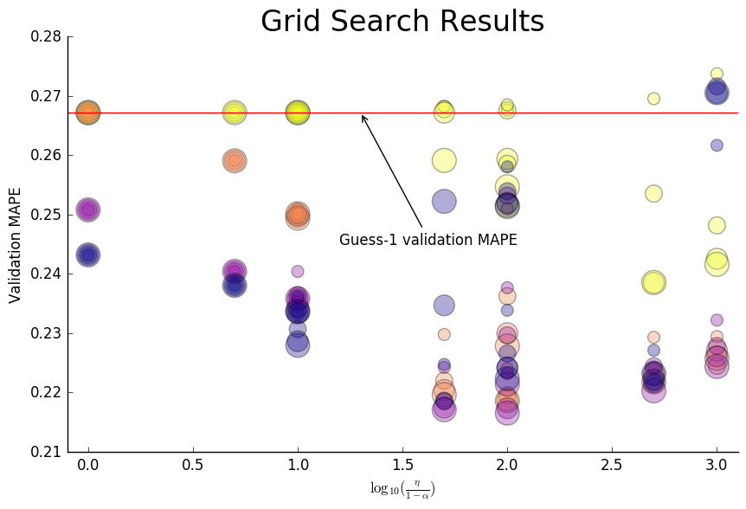
The best model found by grid search had the following parameters and MAPEs:
Nodes | 50
η | 1
α | 0.99
Epochs | 400
Val MAPE | 0.2165
Pseudo Test MAPE | 0.2170
Full Test MAPE | 0.2158

Pesudo test MAPE is the MAPE for the test data based on the average of the three models generated during the three-fold criss validation. The full test MAPE is the MAPE for the test data for a single model with the best known hyperparameters trained on the full complement of the training data.
Now that we have a good starting point, we can perform perpetual search around it. Perpetual search randomizes all hyperparameters independently in the neighborhood of the currently best known hyperparemeters, and then fits the randomized model. It keeps going until you say stop. Here I stopped after 50 iterations. The grid search results graph updated with the results from perpetual search is shown on the next page. I only found one set of hyperparameters that led to validation MAPE superior to the best obtained from grid search. The best known hyperparameters for a three hidden layer ANN and theassociated MAPE values are shown below.

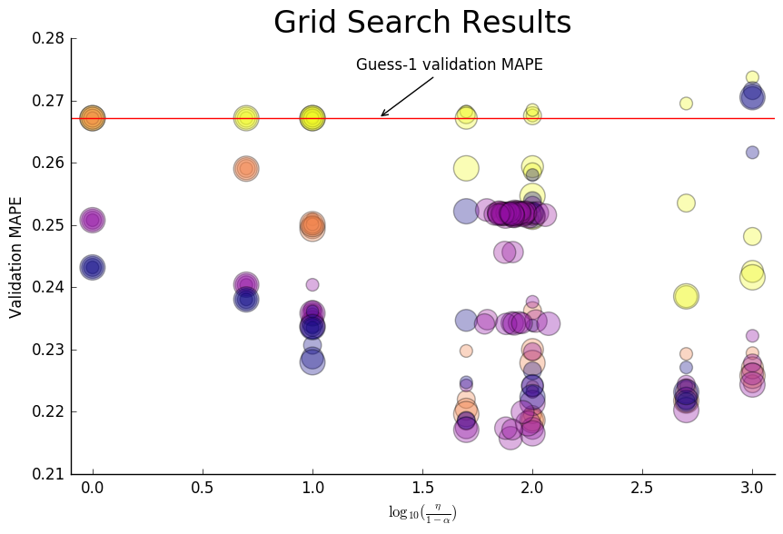

Input Nodes | 64
Hidden Layer 1 Nodes | 40
Hidden Layer 2 Nodes | 62
Hidden Layer 13Nodes | 34
η | 0.898
α | 0.989
Epochs | 337
Val MAPE | 0.2156
Pseudo Test MAPE | 0.2164
Full Test MAPE | 0.2155

Results

Model Evaluation and Validation
It's clear from this graph that most combinations of hyperparemeters lead to better results that the Guess-1 approach. But not always. In fact, a lot of the time the hyperparameters induce the ANN to learn the Guess-1 strategy (and on a few occasions do worse). This is quite interesting, as at first glance it seems that such models have minds of their own and learn the optimal guessing strategy without learning from the data. But recall that the backpropagation algorithm makes use of gradient descent, and that gradient descent will seek out a local minimum in parameter space. If a model is to learn from the data, it must be able to “escape” from the trough surrounding the Guess-1 local minimum. This seems to require a certain minimum amount of complexity. Simple models cannot escape, and thus gradient descent draws them into the guess-1 minimum. The models that underperform the Guess-1 strategy likely haven't reached the minimum, due to too few epochs or too steep of a learning rate decay, or perhaps bounce around the minimum due to too shallow of a learning rate decay.
A graph of pseudo test MAPE versus validation MAPE for all hyperparameter combinations investigated in both grid and perpetual searches is provided in Figure XXX. The curve has some noise to it, but there is a strong correlation between pseudo test MAPE and validation MAPE. This implies that for any of these models validation MAPE is a good predictor of MAPE for an arbitrary test data set. That's good for the DiTech challenge in which you have a limited number of test data prediction submissions per day: you can have confidence that the test MAPE for your submission will be in the ballpark of the known validation MAPE (provided the training and test data are drawn from the same population).
One thing that is not apparent from the graph is any clear explanation of how combinations of parameters will perform. This is especially apparent when you look at the results from perpetual search: models will seemingly very similar hyperparameters result in substantially different MAPE values. That brings us to the question of model stability. The experiment is as follows. Run the best model on 15 different train-test splits (excluding the one form which the optimal model was established as optimal). and determine the validation MAPE. The results are tabulated in Table H.

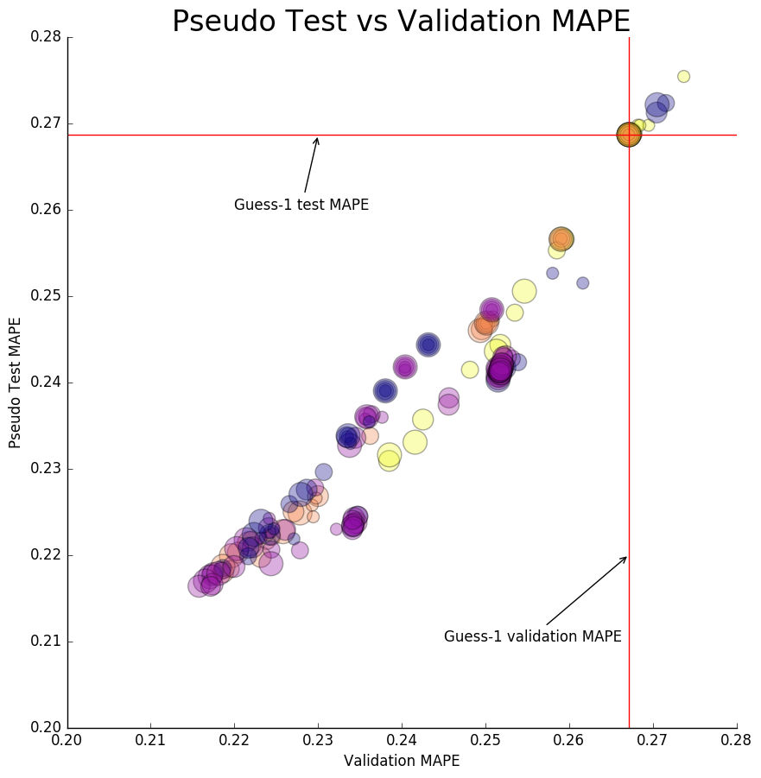

The sensitivity to train-test split is very high. This is evidence of a model that does not generalize well. As to why the model does not generalize, I propose no hypothesis. Its somewhat disappointing to me, simply because I put quite a bit of effort into this project. But as far as the DiTech challenge goes, one does not need the model to generalize well in order to win, only to predict well for the specific train and test sets provided. But having said that, the best MAPE achieved by this model is not competitive with world class MAPE values. I estimate that I would need a full test MAPE of 0.16 or so on these data in order to compete with the best of the best. This model seems to hit the proverbial wall around MAPE 0.21—much too high. One conclusion that could be drawn from this is that you're better off sticking to tools better sited to the task at hand (the Kaggle standard is boosted trees for regression) rather than experimenting with fascinating but complicated artificial neural networks if you want to win a challenge of the DiTech type.
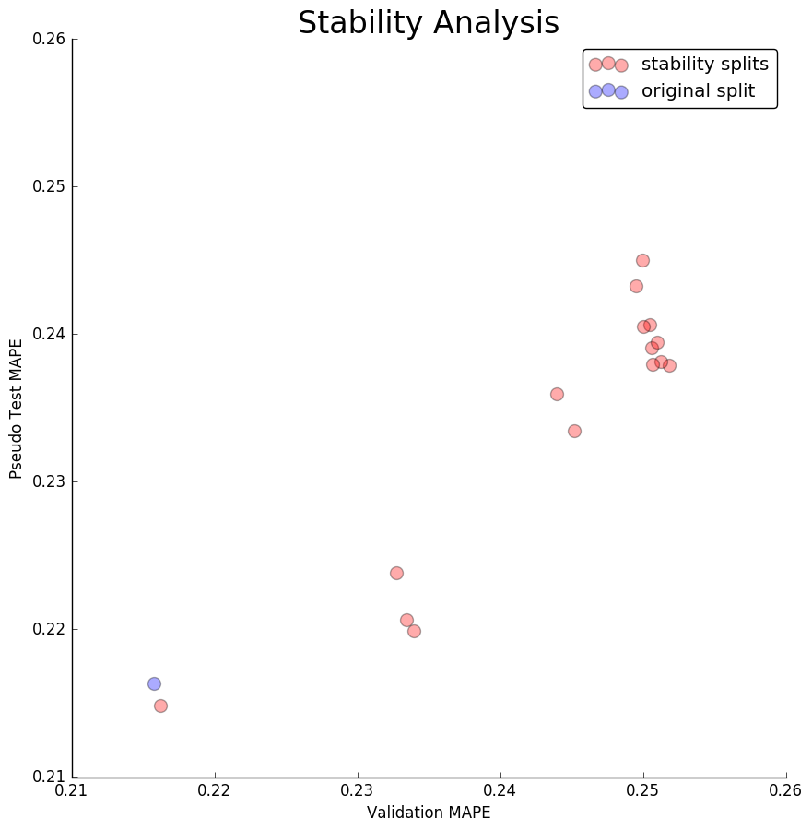

Justification
In this section, your model’s final solution and its results should be compared to the benchmark you established earlier in the project using some type of statistical analysis. You should also justify whether these results and the solution are significant enough to have solved the problem posed in the project. Questions to ask yourself when writing this section:
Are the final results found stronger than the benchmark result reported earlier?
Have you thoroughly analyzed and discussed the final solution?
Is the final solution significant enough to have solved the problem?

Conclusion

Free-Form Visualization
In this section, you will need to provide some form of visualization that emphasizes an important quality about the project. It is much more free-form, but should reasonably support a significant result or characteristic about the problem that you want to discuss. Questions to ask yourself when writing this section:
Have you visualized a relevant or important quality about the problem, dataset, input data, or results?
Is the visualization thoroughly analyzed and discussed?
If a plot is provided, are the axes, title, and datum clearly defined?

Reflection
In this section, you will summarize the entire end-to-end problem solution and discuss one or two particular aspects of the project you found interesting or difficult. You are expected to reflect on the project as a whole to show that you have a firm understanding of the entire process employed in your work. Questions to ask yourself when writing this section:
Have you thoroughly summarized the entire process you used for this project?
Were there any interesting aspects of the project?
Were there any difficult aspects of the project?
Does the final model and solution fit your expectations for the problem, and should it be used in a general setting to solve these types of problems?

Improvement
In this section, you will need to provide discussion as to how one aspect of the implementation you designed could be improved. As an example, consider ways your implementation can be made more general, and what would need to be modified. You do not need to make this improvement, but the potential solutions resulting from these changes are considered and compared/contrasted to your current solution. Questions to ask yourself when writing this section:
Are there further improvements that could be made on the algorithms or techniques you used in this project?
Were there algorithms or techniques you researched that you did not know how to implement, but would consider using if you knew how?
If you used your final solution as the new benchmark, do you think an even better solution exists?
Before submitting your report, ask yourself…
Does the project report you’ve written follow a well-organized structure similar to that of the project template?
Is each section (particularly Analysis and Methodology) written in a clear, concise and specific fashion? Are there any ambiguous terms or phrases that need clarification?
Would the intended audience of your project be able to understand your analysis, methods, and results?
Have you properly proof-read your project report to assure there are minimal grammatical and spelling mistakes?
Are all the resources used for this project correctly cited and referenced?
Is the code that implements your solution easily readable and properly commented?
Does the code execute without error and produce results similar to those reported?

References
- DiTech Challenge
- Deep Learning, Udacity
- Michael A. Nielsen, Neural Networks and Deep Learning, Determination Press, 2015
- Tilmann Gneiting, Making and Evaluating Point Forecasts, 2010

