Assignment 2 Model Architecture Comparison
For HW 1 item 2, the existing architecture sweep compared RNN, GRU, LSTM and Transformer language models on Tiny Shakespeare. Modern GPT 4 x 256 achieved the lowest mean validation bits per byte across two seeds.

Experiment setup
Used nanolm/configs/sweeps/01_char_models.yaml unchanged, with seeds 1337 and 42. Every model received 2,000 updates of 32 sequences x 256 characters: 16,384,000 tokens, about 16.32 passes over the training split. All runs used the RTX 4080 SUPER and automatic bfloat16 mixed precision.
The sweep retains its supplied learning rates and regularization: recurrent models use learning rate 0.002 and zero weight decay; Transformers use 0.001 and weight decay 0.1. Every model uses dropout 0.1 and AdamW with a cosine schedule. Parameter counts and compute therefore differ despite equal token budgets.

Final validation results
Lower bits per byte is better. Mean and sample standard deviation summarize two seeds. Each final score covers the same 111,360 validation characters and bytes.
Model | Parameters | Seed 1337 | Seed 42 | Mean ± SD
RNN 2 x 256 | 280,320 | 2.4463 | 2.4440 | 2.4452 ± 0.0016
GRU 2 x 256 | 806,656 | 2.1563 | 2.1696 | 2.1629 ± 0.0094
LSTM 2 x 256 | 1,069,824 | 2.1424 | 2.1330 | 2.1377 ± 0.0067
LSTM 2 x 512 | 4,236,800 | 2.1687 | 2.1730 | 2.1708 ± 0.0031
Textbook GPT 4 x 256 | 3,438,336 | 2.1773 | 2.1955 | 2.1864 ± 0.0128
Modern GPT 4 x 256 | 3,162,624 | 2.0988 | 2.1022 | 2.1005 ± 0.0024

How the experiments were run
python -m nanolm.sweep --sweep nanolm/configs/sweeps/01_char_models.yaml --gpus 0
python -m nanolm.analyze outputs/nanolm/sweeps/char_models --baseline gpt_textbook --metric val_bpb
Commands run from DeepDataMiningLearning/llm using the project .venv Python. The built-in tools save per-run configs, logs, checkpoints and metrics, plus summary.csv, summary.md, curves.png and bars.png. No model or experiment config was edited.

Sources and verification
Sources: TUTORIAL_nanolm.md sections 0.4 and 1.6.8, HW 1 item 2, and the saved sweep records. All 12 records have the full token budget, finite metrics, complete validation logs and saved checkpoints. Some recurrent processes reported Windows native exit errors after saving completed results; independent CPU rescoring of recurrent checkpoints agreed within 0.001 bpb.

Learning curves
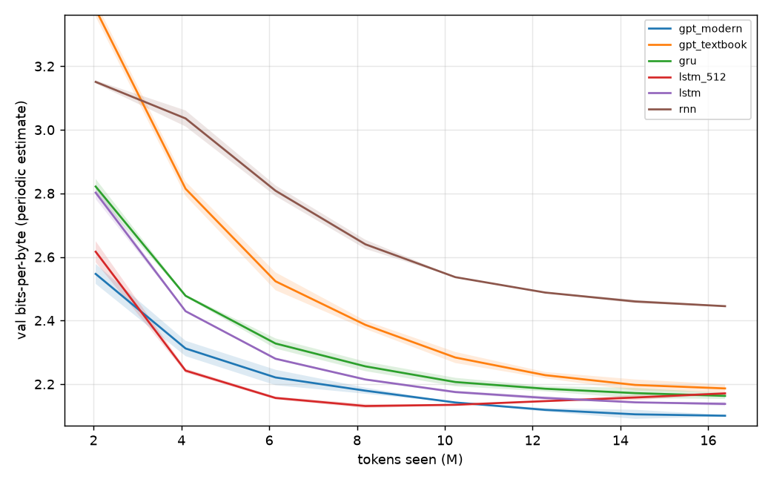
Validation bits per byte versus training tokens. Lines show means and shading shows +/- one sample standard deviation across seeds. The configured periodic evaluation covers the same usable validation split as final scoring.

Interpretation
The modern Transformer scored 2.1005 bpb versus 2.1864 for the textbook Transformer, a difference of -0.0859 bpb. This comparison tests the combined RMSNorm, RoPE and SwiGLU recipe with biases removed; it does not isolate each component.
The vanilla RNN scored 2.4452 bpb. Repeated state transformations without gates can lose long-range information and make gradients harder to preserve. The lower errors of the gated GRU and LSTM are consistent with the tutorial's explanation, although this sweep also changes parameter counts and is not a direct gradient test.
The larger LSTM finished 0.0331 bpb worse than the smaller LSTM. Its mean validation curve was best at 8.19 million tokens (2.1310 bpb). Its final averaged training loss was 1.024 nats/token versus 1.505 on validation.
The validation deterioration after the best point, together with the training-validation loss gap, supports overfitting in the larger LSTM. Increasing model size did not guarantee better held-out performance on this small corpus.
Two seeds provide a descriptive estimate of variability, not a precise confidence interval. Context length was held fixed at 256, so this experiment does not establish which architecture benefits most from longer context.

