Language Models From Scratch
  - HW 1 integrated experimental report
Modern GPT achieved the lowest validation bits per byte under the shared token budget. Gating improved recurrent models, a larger LSTM overfit, and longer context helped both LSTM and Modern GPT. The four experiments below connect these results to metric calculations and measured attention patterns.

Experiment 1 Metrics by hand
The existing 01_char_rnn.yaml configuration actually selects a two layer LSTM, despite its filename. Its trained character checkpoint used seed 1337, 2,000 updates and 16,384,000 training tokens.
Quantity | Calculation | Result
Validation tokens and bytes | From metrics.json | 111,488 each
Total negative log likelihood | Mean loss multiplied by token count | 165,889.713814 nats
Mean loss | Total nats divided by token count | 1.487960263 nats/token
Perplexity | Exponential of mean loss | 4.428054236
Bits per token | Mean loss divided by ln(2) | 2.146672893
Bits per byte | Bits/token multiplied by tokens/bytes | 2.146672893

Recomputed perplexity and bpb match the logged values exactly. Character tokens and bytes are equal for this ASCII validation text. Total loss is reconstructed from the saved mean; it is an arithmetic consistency check, not an independent evaluation of individual token losses.

Untrained tokenizer comparison
Tokenizer | Vocabulary | Measured loss | ln V | Difference
char | 65 | 4.196915 | 4.174387 | +0.022528
byte | 256 | 5.712011 | 5.545177 | +0.166834

Both checks used one step with learning rate and weight decay set to zero, and unchanged weights were verified. Uniform predictions give loss ln V. Random initial predictions are not exactly uniform, explaining the positive gaps. All saved scores were independently checked on CPU to within 0.001 bpb.
Source: outputs/nanolm/question1_char_rnn/metrics_by_hand.json

Experiment 2 Comparing architectures
The existing sweeps/01_char_models.yaml compared six models using seeds 1337 and 42. Every run saw 2,000 x 32 x 256 = 16,384,000 character tokens. Lower validation bpb is better; uncertainty below is sample standard deviation over two seeds.
Model | Parameters | Seed 1337 | Seed 42 | Mean bpb ± SD
RNN 2 x 256 | 280,320 | 2.4463 | 2.4440 | 2.4452 ± 0.0016
GRU 2 x 256 | 806,656 | 2.1563 | 2.1696 | 2.1629 ± 0.0094
LSTM 2 x 256 | 1,069,824 | 2.1424 | 2.1330 | 2.1377 ± 0.0067
LSTM 2 x 512 | 4,236,800 | 2.1687 | 2.1730 | 2.1708 ± 0.0031
Textbook GPT 4 x 256 | 3,438,336 | 2.1773 | 2.1955 | 2.1864 ± 0.0128
Modern GPT 4 x 256 | 3,162,624 | 2.0988 | 2.1022 | 2.1005 ± 0.0024

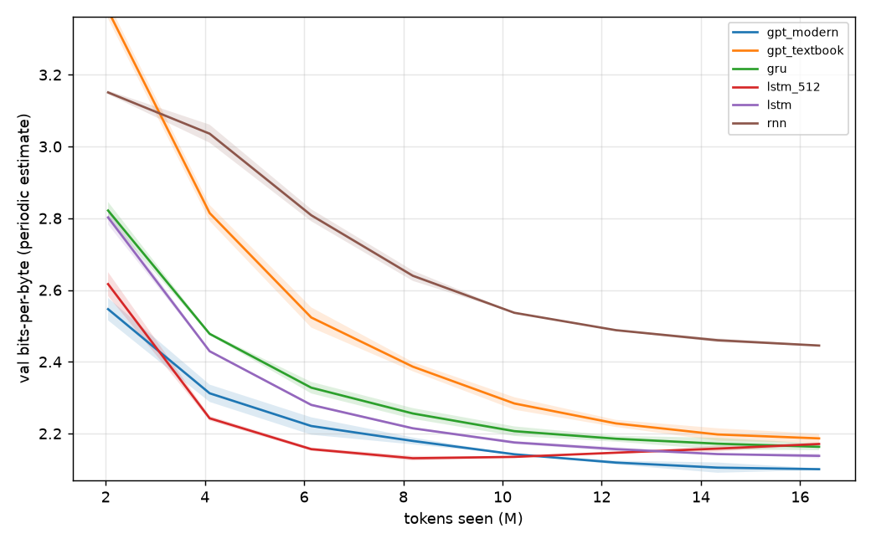
Figure 1 Validation learning curves from the supplied sweep. Bands summarize variation across the two seeds.
Modern GPT finished at 2.1005 bpb, compared with 2.4452 for the vanilla RNN. The larger LSTM improved quickly, reached its lowest mean periodic bpb of 2.1310 at 8.192 million tokens, then worsened to 2.1708.
Control limits: parameters and compute are not matched. The supplied sweep uses learning rate 0.002 and no weight decay for recurrent models, versus 0.001 and weight decay 0.1 for Transformers. This compares the supplied training recipes, rather than isolating architecture alone.

Experiment 3 Context length
The original 01_char_rnn.yaml LSTM and 02b_char_transformer_modern.yaml Modern GPT were trained at contexts 64, 128, 256 and 512. Each setting used two seeds, 2,000 steps and 8,192 tokens per step. Batch sizes were 128, 64, 32 and 16 respectively, keeping the token budget fixed.
Context in characters | LSTM mean bpb ± SD | Modern GPT mean bpb ± SD
64 | 2.1800 ± 0.0017 | 2.1610 ± 0.0030
128 | 2.1491 ± 0.0043 | 2.1180 ± 0.0191
256 | 2.1346 ± 0.0012 | 2.1061 ± 0.0049
512 | 2.1237 ± 0.0067 | 2.0880 ± 0.0098

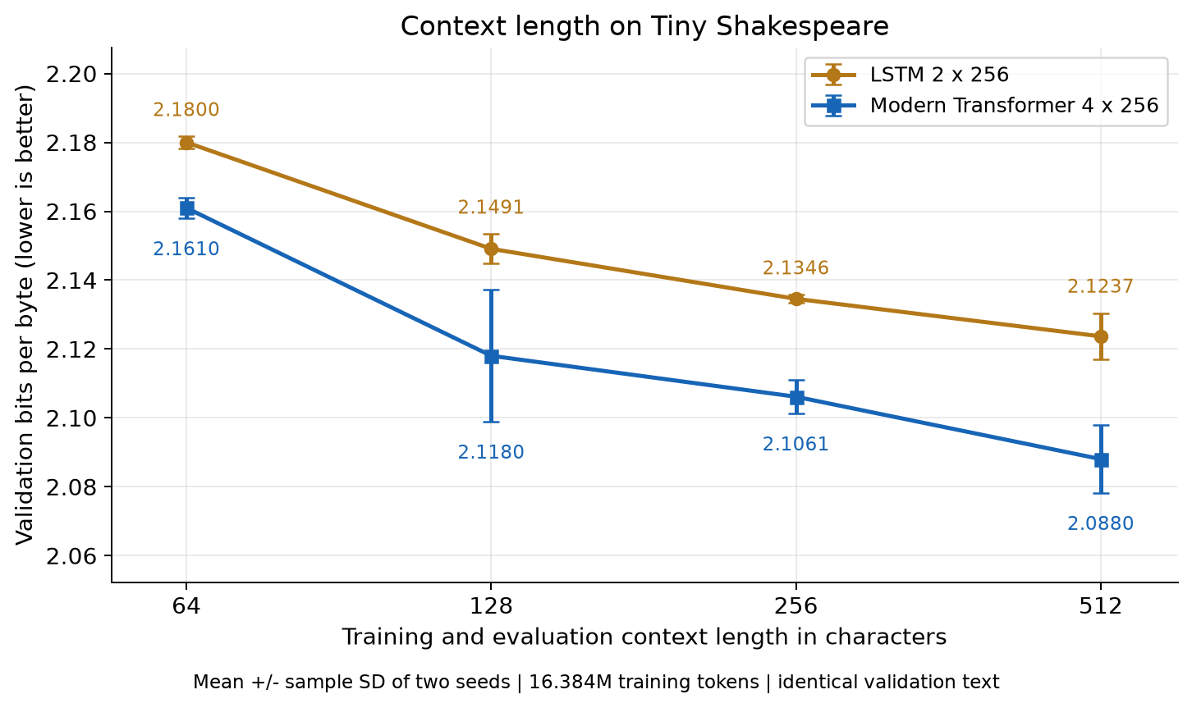
Figure 2 Validation bpb versus context length. Every setting was evaluated on the same 111,104 character validation prefix, with evaluation windows matching its context.
From context 64 to 512, LSTM improved by 0.0563 bpb and Modern GPT by 0.0729 bpb. Between 256 and 512 the reductions were 0.0109 and 0.0181 respectively. Modern GPT therefore showed the larger overall benefit from longer context.
The LSTM shows diminishing gains after 128 characters, but both models still improve in mean at 512. No definite stopping point was found within the tested range. With only two seeds, variation is substantial; Modern GPT at seed 42 slightly worsened from 128 to 256 before improving at 512.
Changing context also changes sequence count per batch and evaluation window boundaries. The experiment measures the combined training and evaluation effect of each context setting.

Experiment 4 Attention analysis
The four layer, four head Modern GPT checkpoint at context 512 and seed 42 was analyzed with the project command nanolm.viz attention. All 16 heads were inspected for each of three texts, giving 48 maps. Complete maps appear in the appendix; layer and head indices start at zero.
Dialogue: ROMEO: / But soft! what light through
Prose: The quiet river runs beneath the old bridge.
Repetition: the silver river and the silver river
Head pattern | Dialogue | Prose | Repetition | Mean
Previous token L0 H3 | 0.532 | 0.568 | 0.571 | 0.557
Word start L2 H3 | 0.425 | 0.249 | 0.285 | 0.319

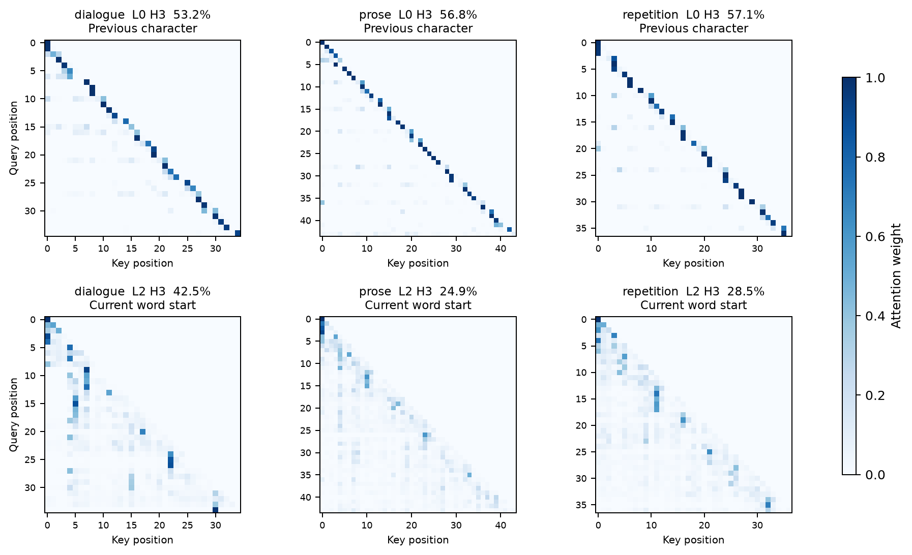
Figure 3 Two measured patterns across three texts. Each displayed score averages attention on the target position over eligible queries.
Previous token: mean weight on position t minus 1 was 0.557, versus 0.087 for a uniform causal baseline. Word start: mean weight on the first letter of the current word was 0.319, versus a uniform baseline of 0.078. Word queries were at least two characters after the start, reducing overlap with previous token behavior.
The word start head exceeded a lag matched nonstart control by 0.218 on average. These measurements support the pattern labels on these examples; three short texts do not establish a universal function for a head.

Answers to the three related questions

Why does the vanilla RNN fall so far behind
Its recurrent state must carry useful information through repeated nonlinear updates. Without gates, earlier information can be overwritten and gradients can shrink or grow across many steps. LSTM and GRU gates help retain relevant information; attention provides direct access to earlier token representations. Consistent with this explanation, RNN finished at 2.4452 bpb, compared with 2.1377 for LSTM and 2.1005 for Modern GPT. The RNN also has fewer parameters, so the performance gap cannot be attributed solely to gating.

Is the larger LSTM better or worse and what do the curves show
It is worse at the final shared budget: 2.1708 versus 2.1377 bpb for the smaller LSTM, a penalty of 0.0331. Its validation curve initially leads, reaches 2.1310 around step 1,000, and then rises. At the end, average logged training loss is 1.0241 nats/token while validation loss is 1.5047. This combination is consistent with overfitting. Early stopping would retain a better large model checkpoint; increasing size alone did not improve the final result.

Which architecture uses longer context more effectively
Modern GPT does in this experiment: its mean gain from 64 to 512 characters is 0.0729 bpb, versus 0.0563 for LSTM, and it has lower bpb at every tested context. Attention can access earlier positions directly, whereas LSTM must summarize them in a recurrent state. This is evidence for the tested configurations and budget, not a parameter matched proof that every Transformer uses context better.

Additional sampling result from section 1 9
Using the same fixed Modern GPT checkpoint at validation bpb 2.0811, five 512 character samples per setting showed increasing diversity with temperature and top p. At top p 1.0, mean distinct character 4 gram fractions were 0.246, 0.734, 0.905 and 0.972 at temperatures 0, 0.5, 1.0 and 1.5. At temperature 1.0, increasing top p from 0.7 to 1.0 raised diversity from 0.818 to 0.905. Higher diversity does not guarantee better language.

Reproducibility and limitations
Training used the existing project configurations and sweep; no custom model was defined. Exact commands are recorded in Analysis_Commands_Questions_1_to_4.txt. Results and plots are under outputs/nanolm/question1_char_rnn, sweeps/char_models, context_length_base_configs and question4_attention. The reported standard deviations describe two seeds and are not confidence intervals. Recurrent run exit errors occurred after results were saved; the metrics and context checkpoints were independently evaluated on CPU.

Complete attention maps for dialogue
ROMEO: / But soft! what light through
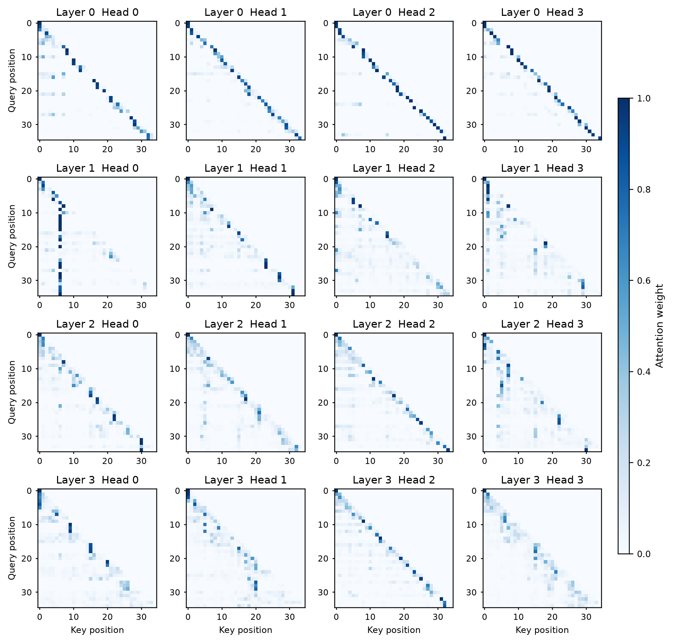
All four layers and four heads are shown. Rows are query positions; columns are attended key positions. Future positions are masked. The common color scale runs from 0 to 1.

Complete attention maps for prose
The quiet river runs beneath the old bridge.
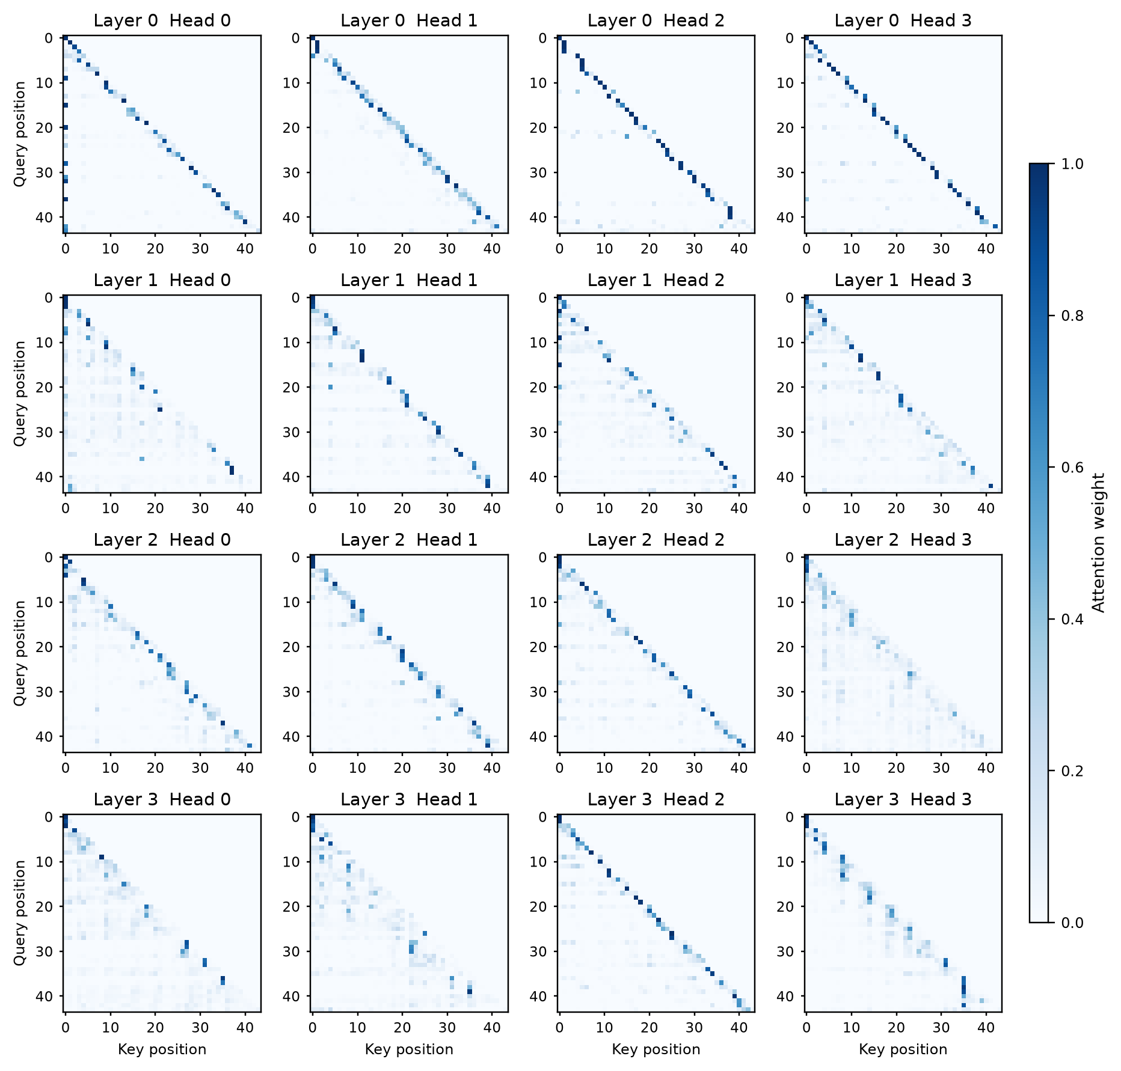
All four layers and four heads are shown. Rows are query positions; columns are attended key positions. Future positions are masked. The common color scale runs from 0 to 1.

Complete attention maps for repetition
the silver river and the silver river
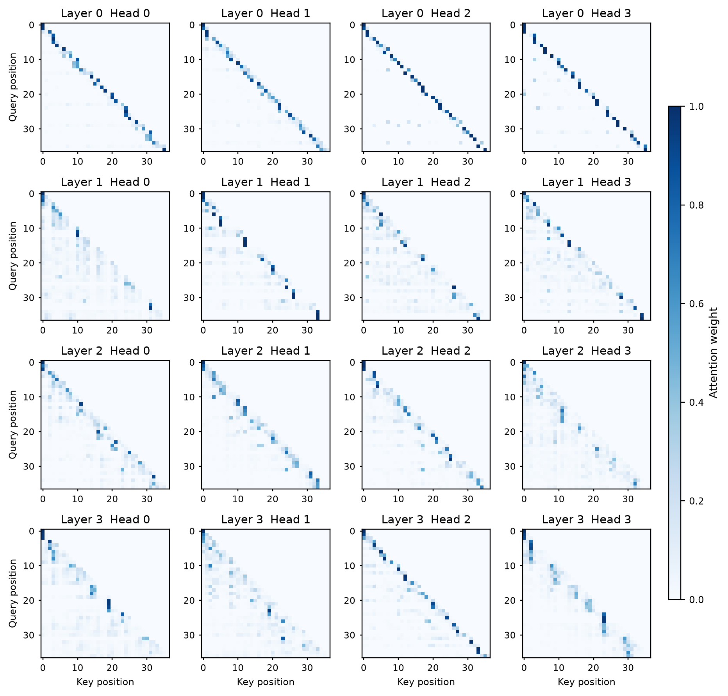
All four layers and four heads are shown. Rows are query positions; columns are attended key positions. Future positions are masked. The common color scale runs from 0 to 1.

