Question 3 Context Length
Ran nanolm.train directly with 01_char_rnn.yaml (default two-layer LSTM) and 02b_char_transformer_modern.yaml (four-layer modern Transformer). Each run used 2,000 steps, seeds 1337 and 42, and 16,384,000 training tokens on Tiny Shakespeare. Batch size was adjusted to keep 8,192 tokens per step; all runs scored the same 111,104 validation target characters at their training context length.
Context | Batch size | LSTM bpb | Transformer bpb
64 | 128 | 2.1800 ± 0.0017 | 2.1610 ± 0.0030
128 | 64 | 2.1491 ± 0.0043 | 2.1180 ± 0.0191
256 | 32 | 2.1346 ± 0.0012 | 2.1061 ± 0.0049
512 | 16 | 2.1237 ± 0.0067 | 2.0880 ± 0.0098
Values are mean ± sample standard deviation of two seeds. Lower bits per byte is better.
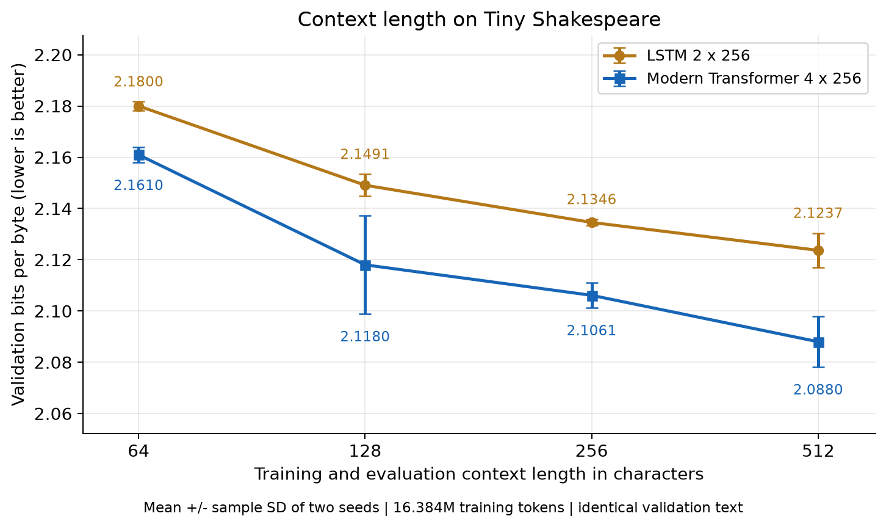

Conclusion
Both models achieved their best mean at 512 characters. The final doubling from 256 to 512 improved LSTM bpb by 0.0109 and Transformer bpb by 0.0181. Neither stopped benefiting within the tested range. A stopping point beyond 512 was not established; two seeds limit confidence in small differences.
Used the named configs unchanged, with command-line context, batch, seed and evaluation overrides; sample generation was disabled. Saved LSTM results affected by Windows shutdown errors were independently checked on CPU within 0.001 bpb. Source: TUTORIAL_nanolm.md, HW 1 item 3; outputs/nanolm/context_length_base_configs.

