Question 4 Attention Analysis
Used the saved 02b_char_transformer_modern.yaml model from Question 3: four layers, four heads per layer, seed 42, context 512 and 2,000 training steps. Ran python -m nanolm.viz attention --run <run> --text <text> on each input. Analysis used the saved weights in CPU float32; no retraining or model edits were needed.
Dialogue: ROMEO:\nBut soft! what light through
Prose: The quiet river runs beneath the old bridge.
Repetition: the silver river and the silver river
In the dialogue input, \n denotes a newline. Layer and head indices below start at zero.
Text | L0 H3 previous | L2 H3 word start | Word start control
Dialogue | 53.2% | 42.5% | 6.8%
Prose | 56.8% | 24.9% | 12.7%
Repetition | 57.1% | 28.5% | 11.1%
Percentages are average attention weights on the specified position, not prediction accuracy.
Previous character (L0 H3): mean A[t,t-1] over t >= 1. Uniform causal attention averages only 7.8-9.3% on those positions. Word start (L2 H3): mean attention on the first letter of the current alphabetic word, including only queries at least two positions beyond that letter. The control uses non-start positions at matched look-back distances, reducing a simple recency explanation.
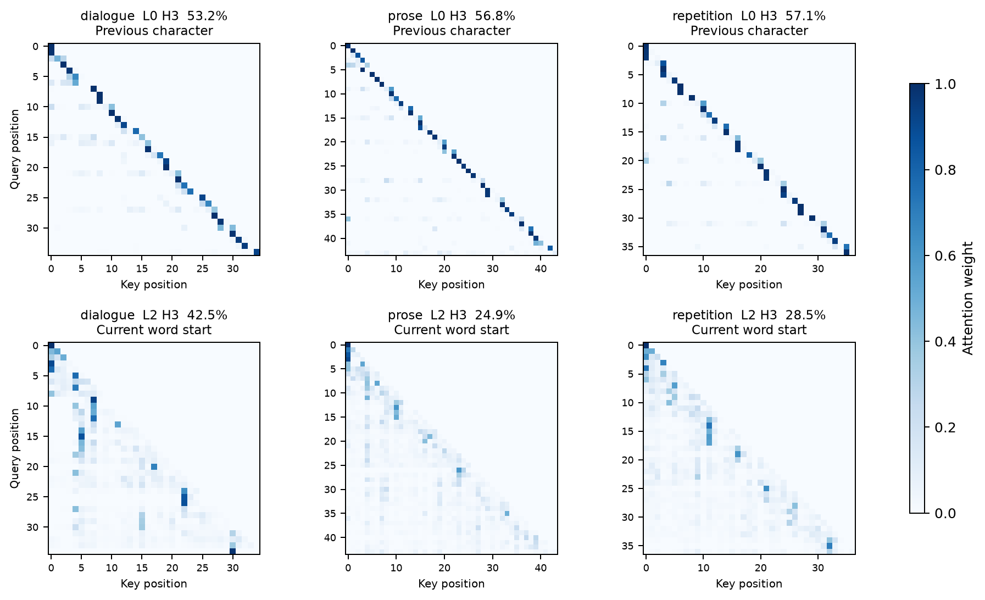

Conclusion
L0 H3 shows a strong previous-character preference; L2 H3 shows word-start preference above the distance-matched control in all three texts. Heads were selected by their mean previous-token weight or word-start excess over the control across these inputs. These are descriptive attention patterns, not proof of causal roles.
Source: TUTORIAL_nanolm.md section 1.6.2 and HW 1 item 4. Checkpoint: outputs/nanolm/context_length_base_configs/ModernGPT_ctx512_s42. Full 16-head figures, command records, raw maps and statistics: outputs/nanolm/question4_attention.

