Question 4 Attention Analysis
Used the saved 02b_char_transformer_modern.yaml model from Question 3: four layers, four heads per layer, seed 42, context 512 and 2,000 training steps. All 16 heads were analyzed for each input, giving 48 maps. This answer includes all four layers and complete grids for all three texts on the following pages.
Ran python -m nanolm.viz attention --run <run> --text <text> on each input. Numerical analysis used the saved weights in CPU float32; no retraining or model edits were needed. Two head patterns are highlighted below, followed by an overview of every layer.
Dialogue: ROMEO:\nBut soft! what light through
Prose: The quiet river runs beneath the old bridge.
Repetition: the silver river and the silver river
In the dialogue input, \n denotes a newline. Layer and head indices below start at zero.
Text | L0 H3 previous | L2 H3 word start | Word start control
Dialogue | 53.2% | 42.5% | 6.8%
Prose | 56.8% | 24.9% | 12.7%
Repetition | 57.1% | 28.5% | 11.1%
Percentages are average attention weights on the specified position, not prediction accuracy.
Previous character (L0 H3): mean A[t,t-1] over t >= 1. Uniform causal attention averages only 7.8-9.3% on those positions. Word start (L2 H3): mean attention on the first letter of the current alphabetic word, including only queries at least two positions beyond that letter. The control uses non-start positions at matched look-back distances, reducing a simple recency explanation.

Overview of all four layers
Layer | Previous character mean | Word start mean
0 | 49.4% | 10.4%
1 | 20.3% | 14.1%
2 | 21.5% | 25.7%
3 | 21.8% | 11.9%
Each layer value equally averages four heads and three text-level means, using the same position definitions above. These averages summarize attention preferences, not layer quality.

Conclusion
L0 H3 shows a strong previous-character preference; L2 H3 shows word-start preference above the distance-matched control in all three texts. Heads were selected by their mean previous-token weight or word-start excess over the control across these inputs. These are descriptive attention patterns, not proof of causal roles.
Source: TUTORIAL_nanolm.md section 1.6.2 and HW 1 item 4. Checkpoint: outputs/nanolm/context_length_base_configs/ModernGPT_ctx512_s42. Full 16-head figures, command records, raw maps and statistics: outputs/nanolm/question4_attention.

Complete Attention Maps Dialogue
Input: ROMEO:\nBut soft! what light through
Panel rows show layers 0-3; panel columns show heads 0-3. Within each heatmap, the vertical axis is the query position and the horizontal axis is the attended key position. All panels share an attention-weight scale of 0 to 1.
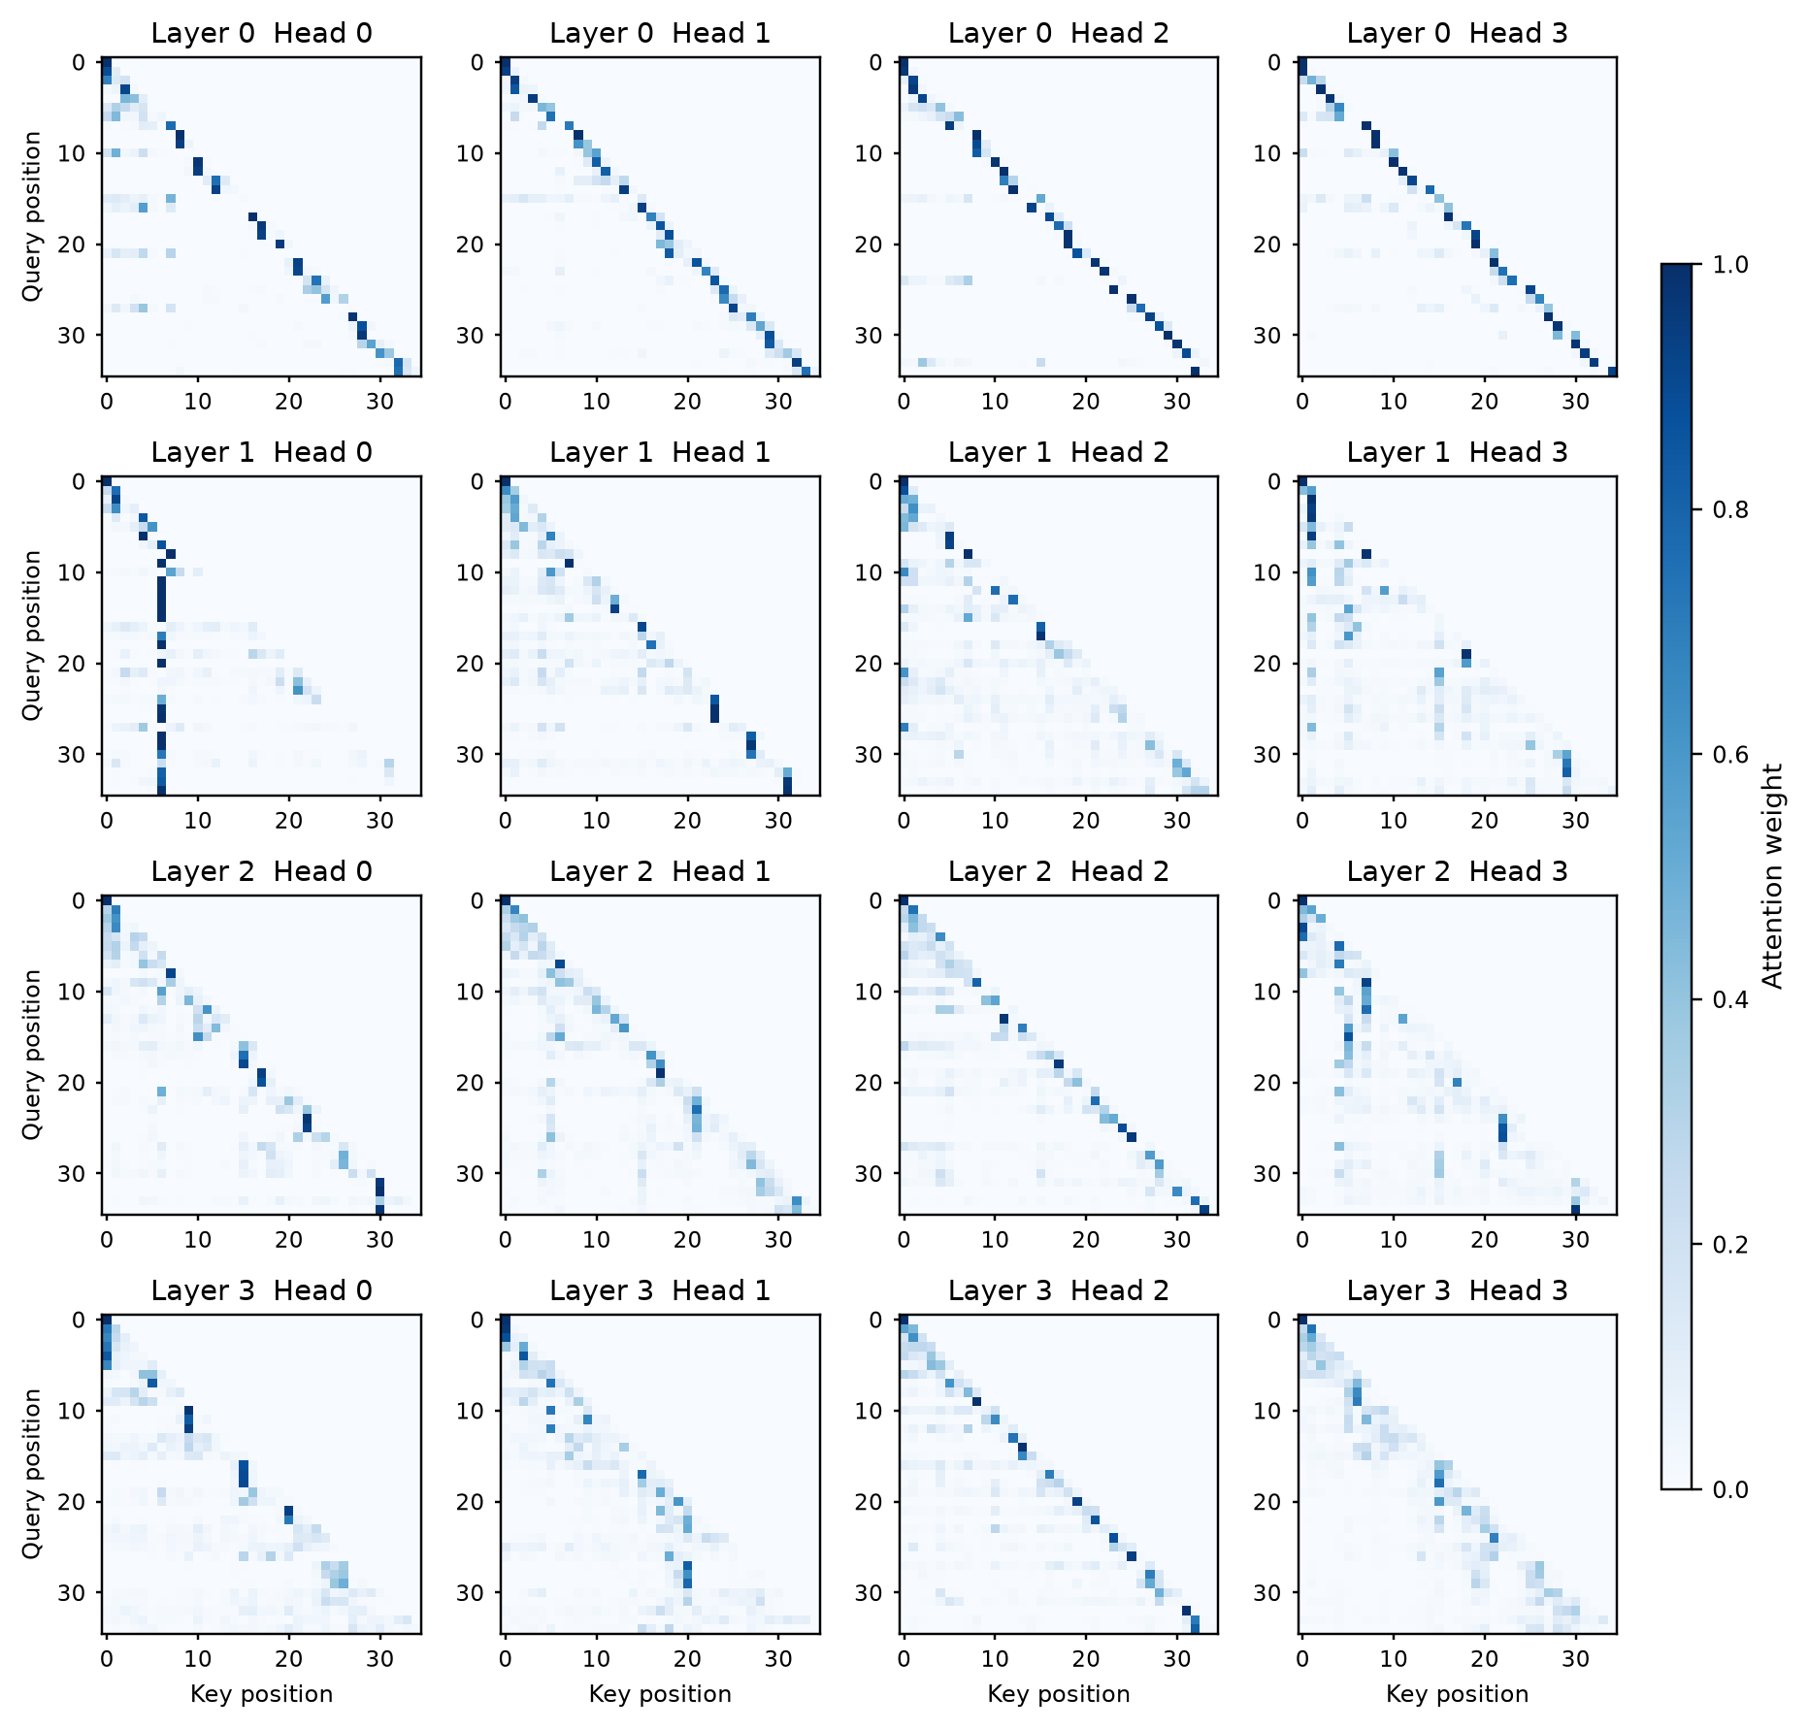
All 16 heads are shown. Character positions are zero-based; the white upper triangle contains future positions excluded by the causal mask. These grids present the complete measured arrays used by the original nanolm.viz figures, with numeric position labels for readability.

Complete Attention Maps Prose
Input: The quiet river runs beneath the old bridge.
Panel rows show layers 0-3; panel columns show heads 0-3. Within each heatmap, the vertical axis is the query position and the horizontal axis is the attended key position. All panels share an attention-weight scale of 0 to 1.
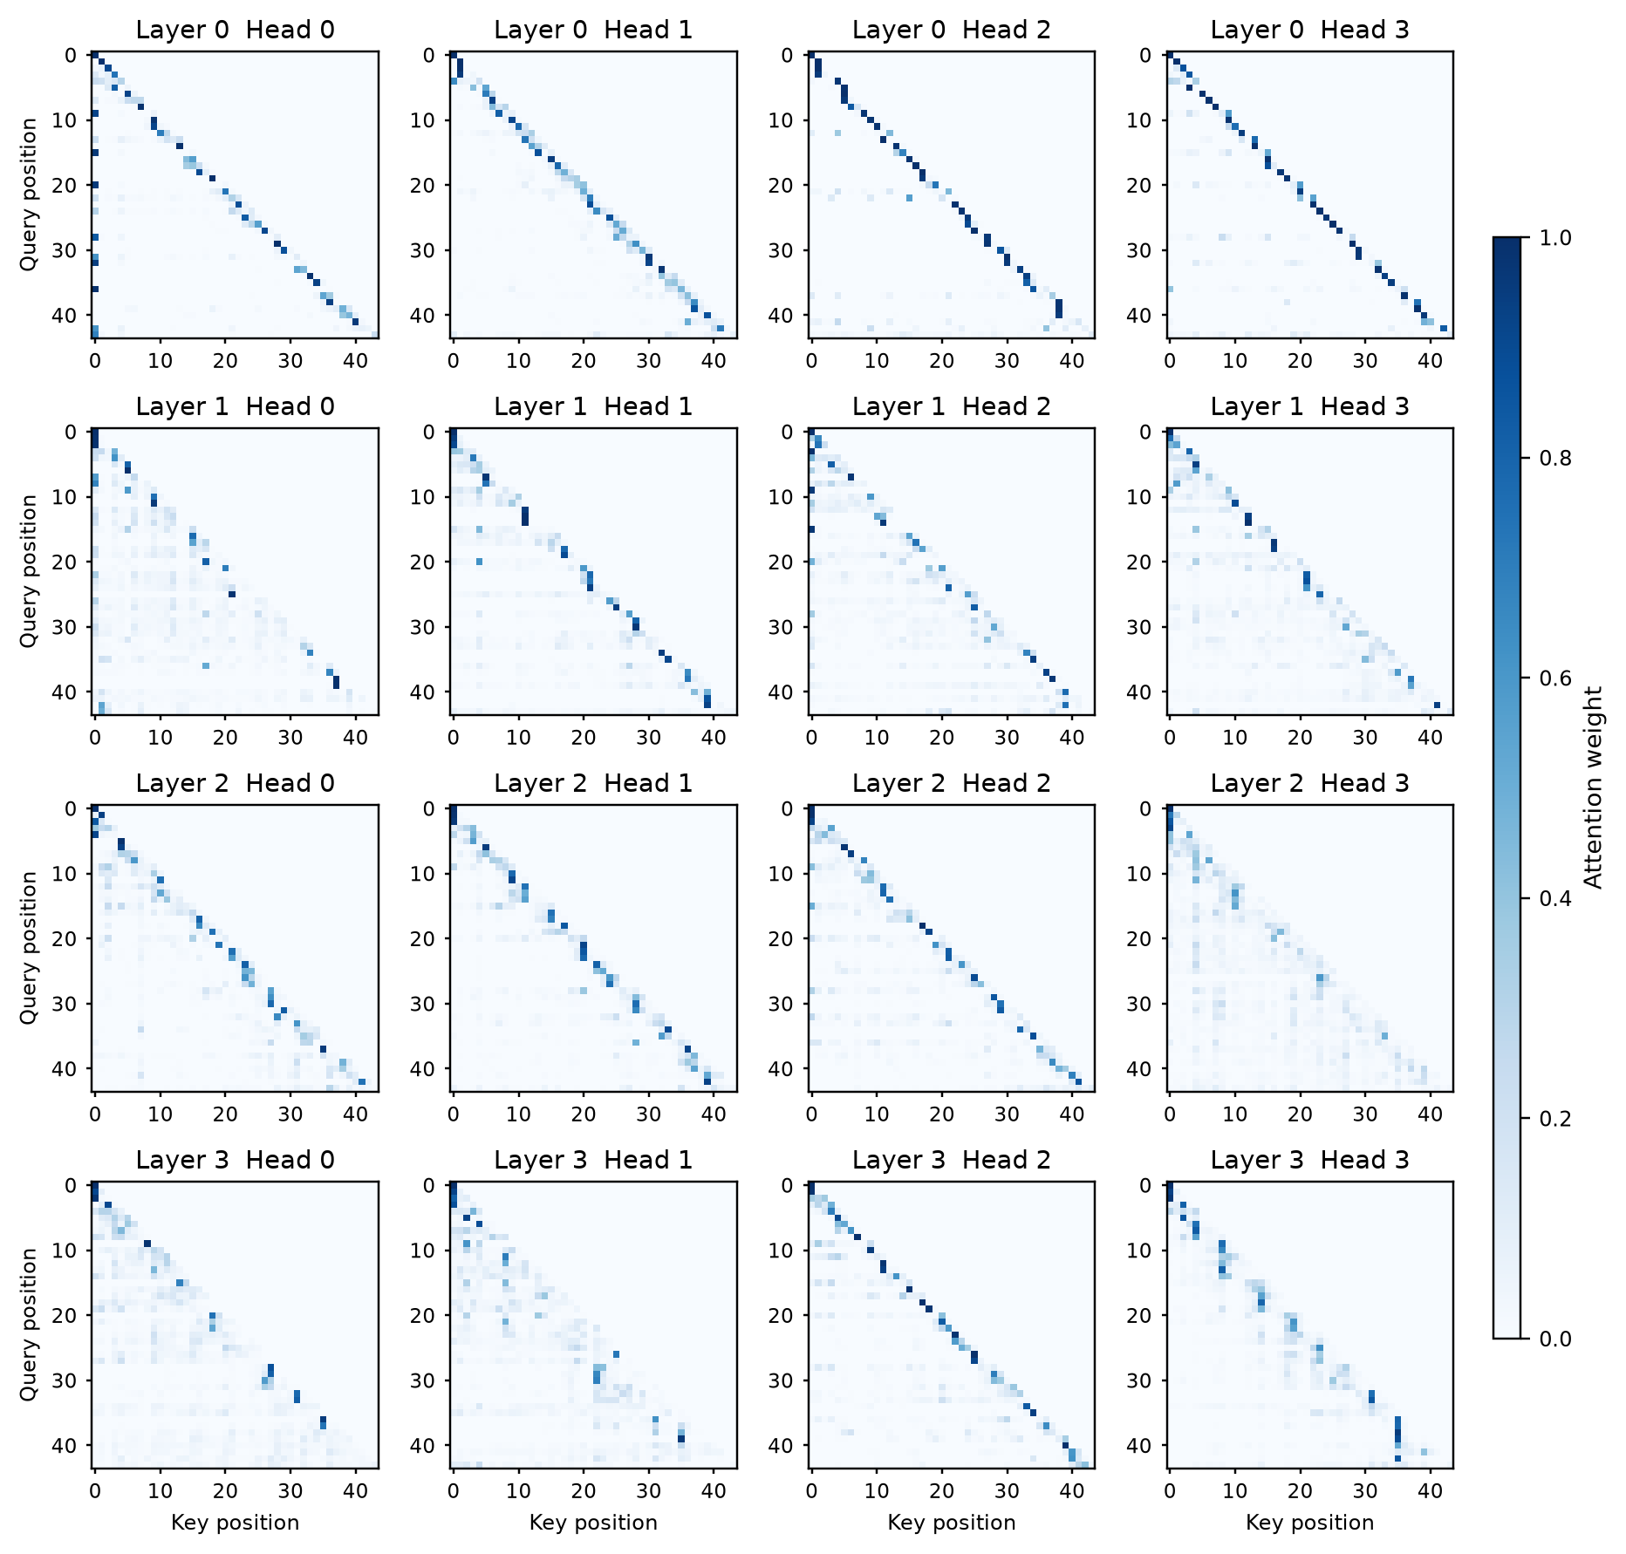
All 16 heads are shown. Character positions are zero-based; the white upper triangle contains future positions excluded by the causal mask. These grids present the complete measured arrays used by the original nanolm.viz figures, with numeric position labels for readability.

Complete Attention Maps Repetition
Input: the silver river and the silver river
Panel rows show layers 0-3; panel columns show heads 0-3. Within each heatmap, the vertical axis is the query position and the horizontal axis is the attended key position. All panels share an attention-weight scale of 0 to 1.
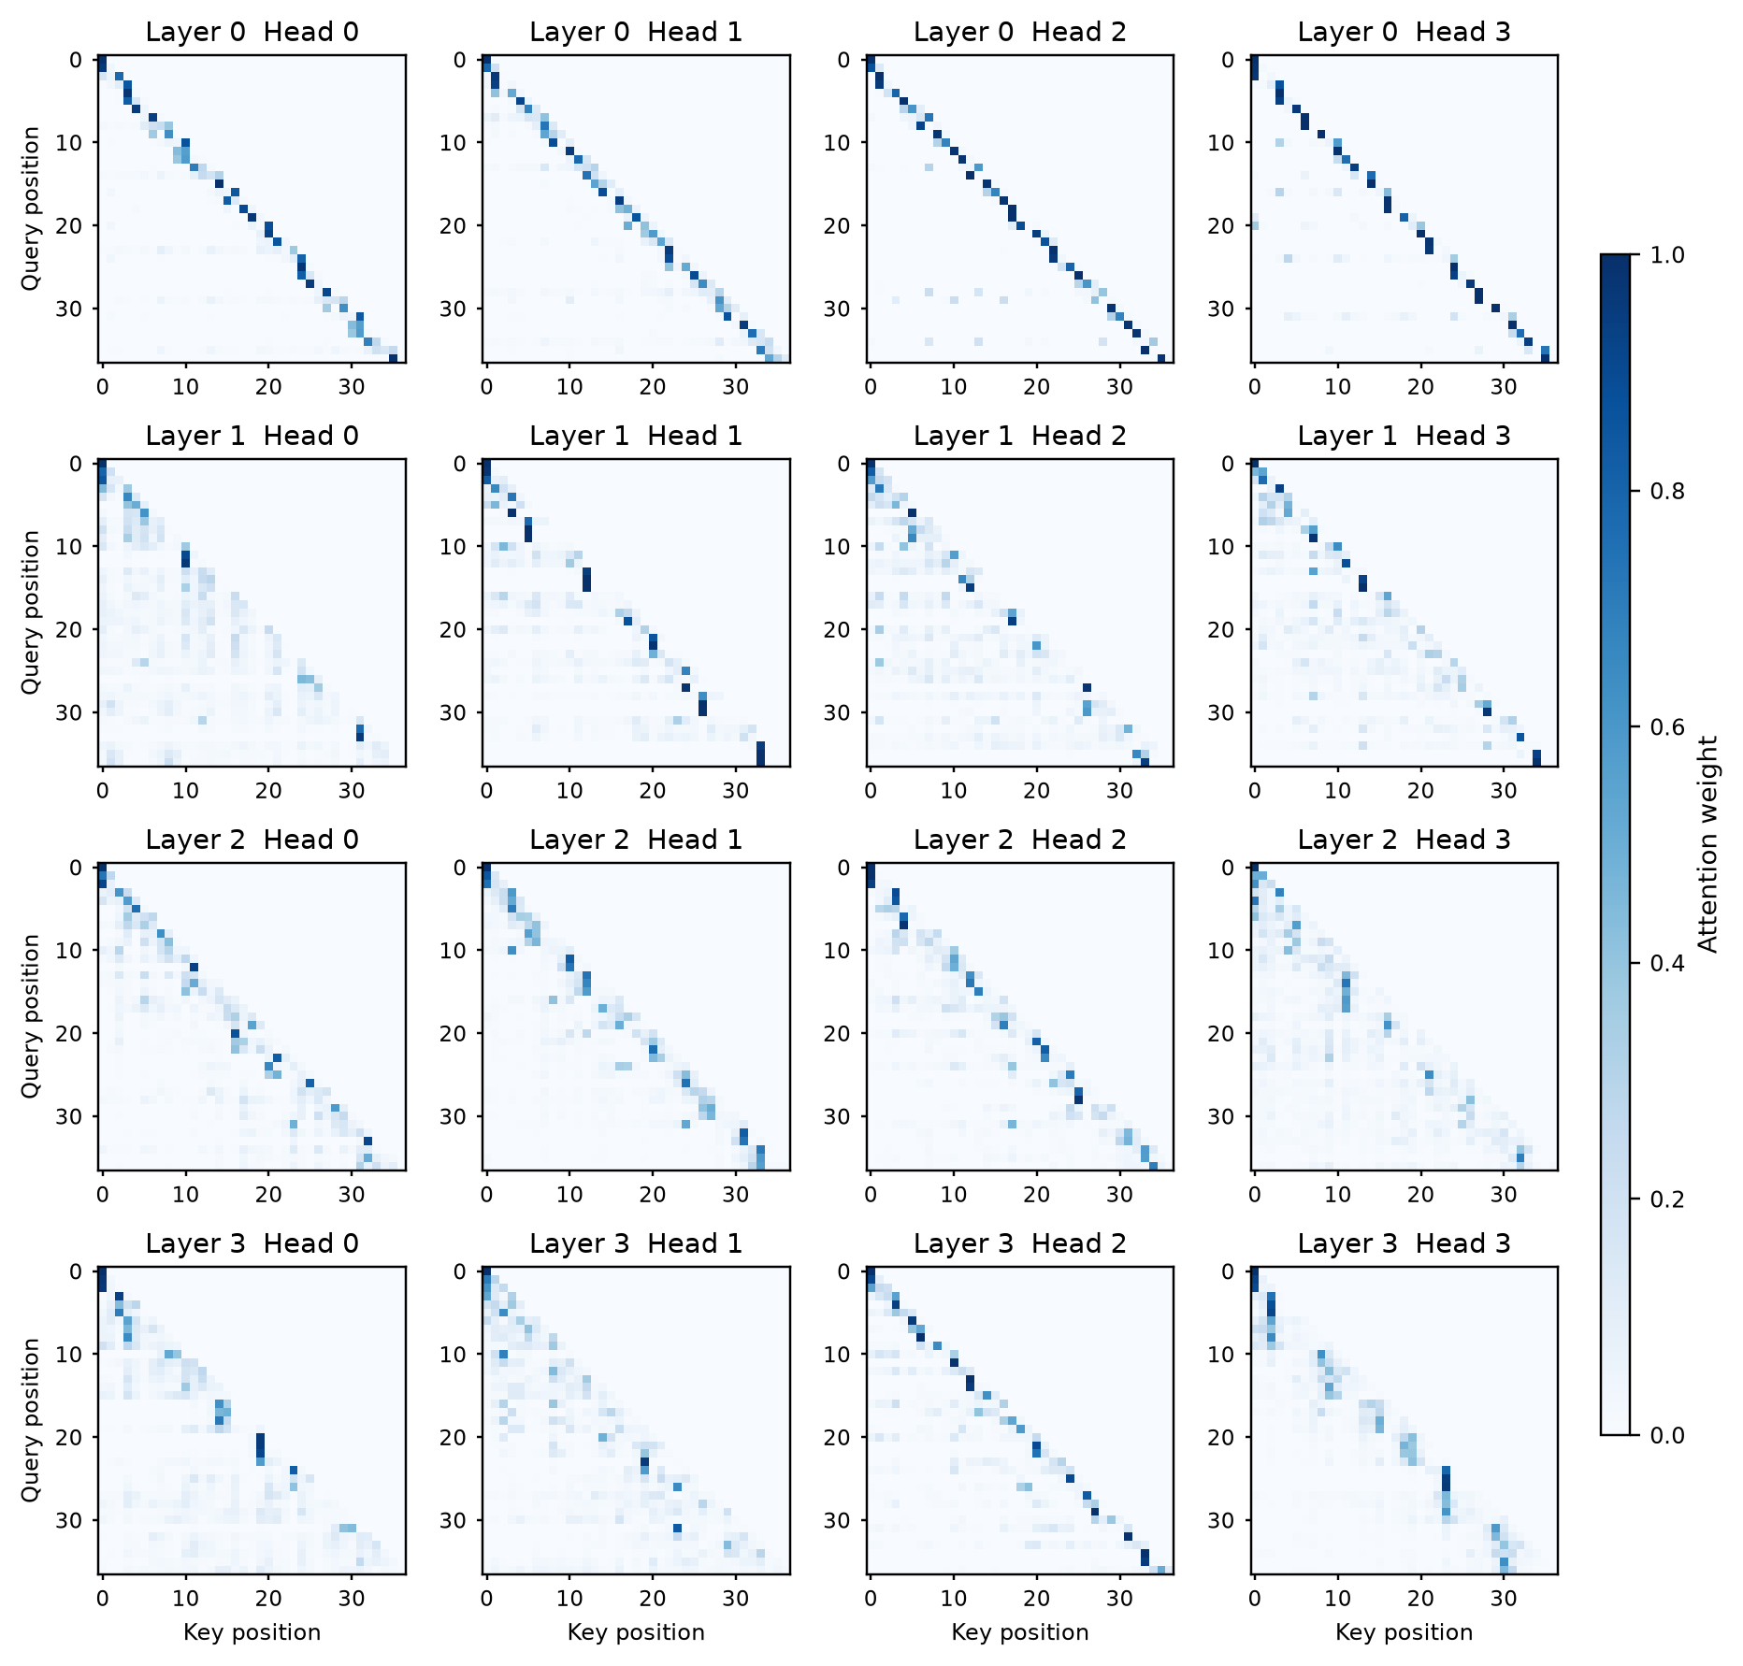
All 16 heads are shown. Character positions are zero-based; the white upper triangle contains future positions excluded by the causal mask. These grids present the complete measured arrays used by the original nanolm.viz figures, with numeric position labels for readability.

