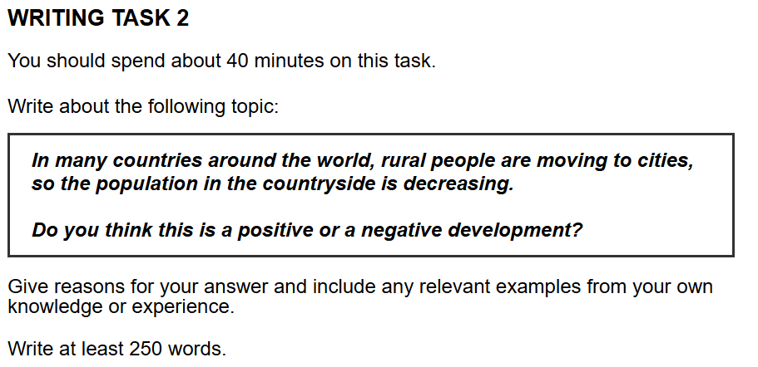
原始作文：
With the rapid development of economics, life condition in the city is improved which leads to the a lot of migrations from countryside to cities. Then, the number of residents in the country is decreasing. As far as environment and social welfare are concerned, I endorse that the mentioned migrations are a negative development.

First, increased population in the city damages the local environment. To be more specific, more people means the more personal devices and more industrial productions for daily consumption. The predicted consequence is that more harmful materials are created and appear in the city. For instance, according to the data of Chinese national statistical website, CO2 emission in the city soared in the decades with increasing city residents, which is bad for climate, and finally evolves to environment problem. Therefore, the population of city should be controlled, instead of continually increasing.

Furthermore, basic function of countryside is not integrate. The basic functions of countryside require people to keep normal running. Under this condition, with decreasing countryside population, there are more and more jobs of basic functions which lacks the people to apply. Then, the quality of countryside residents life cannot be supported. For example, there are so many countrysides in the Africa lacks the doctors. When the local residents get the sicks, they cannot get proper medical treatment. Hence, it is vital to keep the countryside population in a certain level which ensure the basic functions.

In conclusion, I reaffirm the conviction that rural people move to cities is harmful, which leaves the series of potential problems in the area of environment protection and social development. The government should make some policies to promote the more distributed populations in the city and countryside to foster a sustainable development.

修改后的作文：
With the rapid development of the economy, living conditions in cities have improved, which leads to a lot of migration from the countryside to cities. Consequently, the number of residents in the countryside is decreasing. As far as the environment and social welfare are concerned, I would argue that this trend is a negative development.
First, an increased population in cities damages the local environment. To be more specific, more people mean more personal devices and more industrial production for daily consumption. The predictable consequence is that more harmful materials are created and released into the urban environment. For instance, according to data from the Chinese National Statistical Website, CO2 emissions in cities soared over recent decades with the increase in urban residents, which is bad for the climate and finally evolves into environmental problems. Therefore, city populations should be controlled, instead of continuously increasing.
Furthermore, the basic functions of the countryside are disintegrating. The basic functions of the countryside require people to keep them running normally. Under this condition, with a decreasing countryside population, there are more and more jobs related to basic functions that lack people to fill them. As a result, the quality of countryside residents' lives cannot be maintained. For example, there are many rural areas in Africa that lack doctors. When local residents fall ill, they cannot get proper medical treatment. Hence, it is vital to keep the countryside population at a certain level which ensures basic functions can operate.
In conclusion, I reaffirm the conviction that the movement of rural people to cities is harmful, leaving a series of potential problems in the areas of environmental protection and social development. The government should implement policies to promote a more balanced distribution of the population between cities and the countryside to foster sustainable development.

总结：
我们这次的修改主要集中在以下几个方面：
- 冠词 (Articles: a/an, the): 这是最常见的错误类型。
  - the economy, the countryside, the climate: 这些通常被视为特定、独一无二的概念，所以前面要加 the。
  - an increased population, a negative development, a series of problems: 当你首次提到一个可数的单数名词时，前面需要用 a/an。
  - in Africa: 大部分大洲、国家、城市名前面不加 the。
- 主谓一致 (Subject-Verb Agreement):
  - more people mean... (people是复数, 所以动词用原形)
  - ...jobs that lack... (jobs是复数, 所以动词用lack)
  - ...a certain level which ensures... (level是单数, 所以动词用ensures)
- 名词的单复数与所有格 (Nouns: Singular/Plural & Possessive):
  - living conditions, CO2 emissions, environmental problems: 这些概念在文中通常指代多个方面或事物，用复数更准确。
  - countryside residents' lives: “居民的生活”，residents 是复数，其所有格是在 s 后面加 '。
- 词语搭配与词性 (Word Choice & Form):
  - development of the economy: Economics 是“经济学”（一门学科），the economy 是“经济”（一个国家的经济状况）。
  - environmental protection: environmental 是形容词，用来修饰名词 protection。
  - I would argue that...: endorse 的意思是“支持、赞同”，但你的观点是反对，所以用 argue (论证) 或 believe (相信) 更合适。
  - ...are disintegrating: 原句 is not integrate 语法不通。disintegrate (瓦解，崩溃) 能准确表达因为人口减少导致乡村功能失效的意思。
  - implement policies: “实施政策”，比 make policies 更地道、更正式。
- 介词 (Prepositions):
  - data from... (来自...的数据)
  - population at a certain level (在某个水平上)
  - in the areas of... (在...领域)

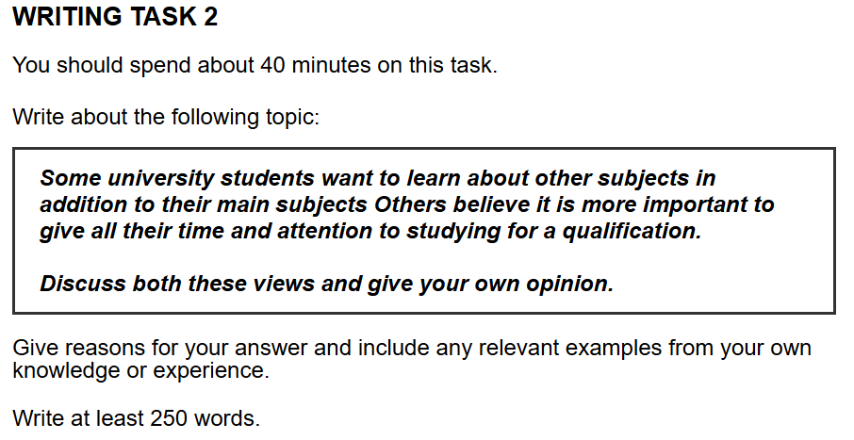
原始作文：
It is hard to deny that due to the diveristy of optional subjects in university, many students tend to learn various optional cources in addition to main subjects due to their interests. Some students choose to allocate their full time to study and obtain a qualification. In this essay, I will firstly show the merit of learning other subject and then analyze the advantage of passing the qulifications, before concluding my own opinion align more closely with the former.
First, gaining a qulification helps students to find a working opportunity. With the rapid development of technology, more and more workers are repalced by automic processes, causing less jobs leaved for humanity. In this condition, requirements of jobs are impoved a lot which compares to the previous. Among the most jobs, the common form of the requirements is a qulification such as software engineering qulificaiton. A vivid illustration is that students major in computer science should pass many programming certifications such some programming languages or computer componets and they pay their full time for the knowledge around the certifications.
However, optional cources is good for students' creativity. To be more specific, main subject is core knowledge in the certain major, which lacks a cruial part such as application areas and then students can not apply their ideas. Various optional cources are able to fit for students perference and also supply the application areas for further creation. For instance, a student learn the music production as majority and also learn about artifical intelligence. Then, a smart music production software can be builded which is a great invention in the area of music. Hence, it is vital for student to learn optional classes and borden the horizon.
In conclusion, while focusing on a qualification offers a more direct path to employment, I firmly believe that the long-term benefits of exploring various subjects are more valuable. The creativity and broader perspective gained from interdisciplinary study are ultimately more crucial for personal and professional development in a rapidly changing world.

修改后的作文：
It is hard to deny that due to the diversity of optional subjects at university, many students tend to learn various optional courses in addition to main subjects due to their interests. Meanwhile, other students choose to allocate their full time to studying for and obtaining a qualification. In this essay, I will first show the merit of learning other subjects and then analyze the advantage of passing qualifications, before concluding that my own opinion aligns more closely with the former.
First, gaining a qualification helps students to find a job opportunity. With the rapid development of technology, more and more workers are replaced by automated processes, causing fewer jobs to be left for people. Under these conditions, job requirements have improved a lot compared to the past. For most jobs, a common requirement is a qualification, such as a software engineering qualification. A vivid illustration is that students majoring in computer science often need to pass many programming certifications, such as for some programming languages or computer components, and they devote their full time to learning the knowledge for these certifications.
However, optional courses are good for students' creativity. To be more specific, studying only a main subject provides core knowledge in a certain major, which often lacks crucial parts such as application areas, making it difficult for students to apply their ideas. Various optional courses are able to fit students' preferences and also supply application areas for further creation. For instance, a student who learns music production as their major and also learns about artificial intelligence could build a smart music production software, which would be a great invention in the area of music. Hence, it is vital for students to learn optional classes and broaden their horizons.
In conclusion, while focusing on a qualification offers a more direct path to employment, I firmly believe that the long-term benefits of exploring various subjects are more valuable. The creativity and broader perspective gained from interdisciplinary study are ultimately more crucial for personal and professional development in a rapidly changing world.

总结：
你这次的论证逻辑非常清晰，特别是两个主体段的论点都很有说服力。结论段写得尤其好，简洁、有力地总结了你的立场。我们这次的修改主要解决了以下几类问题：
- 拼写错误 (Spelling Errors): 这是这次最主要的问题，但好消息是，这也是最容易通过仔细检查来改正的。
  - diveristy -> diversity
  - cources -> courses
  - qulification -> qualification
  - repalced -> replaced
  - automic -> automated / automatic
  - impoved -> improved
  - componets -> components
  - cruial -> crucial
  - perference -> preference
  - artifical -> artificial
  - borden -> broaden
- 主谓一致 (Subject-Verb Agreement):
  - optional courses are... (主语 courses 是复数, 动词用 are)
  - a student who learns... (主语 a student 是单数, 动词用 learns)
  - my own opinion aligns... (主语 opinion 是单数, 动词用 aligns)
- 名词单复数和词性 (Noun Plurals & Word Forms):
  - other subjects (other后面跟复数名词)
  - fewer jobs (job是可数名词，所以用fewer而不是less)
  - broaden their horizons (这是一个固定搭配，意思是“开阔眼界”，horizons用复数)
  - 动词形态错误：leaved -> left (过去分词)；builded -> built (不规则动词的过去式/分词)
- 语句结构与地道表达 (Sentence Structure & Natural Phrasing):
  - find a job opportunity 比 a working opportunity 更常见。
  - job requirements have improved 比 requirements of jobs are improved 更简洁。
  - compared to the past 是一个清晰的比较状语。
  - for most jobs, a common requirement is... 这样的表达比原文更清晰、直接。

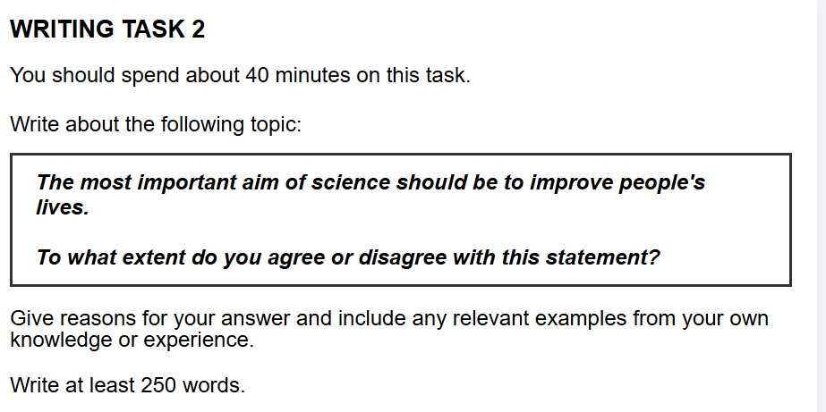
原始作文：
With rapid development of scientific research, frontier science brings many advantages in the area of health and social development. Consequently, Consequently, the question of whether the primary aim of science should be to improve human lives has arisen. From my perspective, as far as health care and technology are concerned, I wholeheartedly endorse this argument.

Firstly, it is vital for human to do further scientific research about health. In history, people got sick and were hard to take the health care due to lacking correspond medicine. That caused high death rate and explained the reason of low population. New types of medicine for various illnesses should be produced after a long process with successful medical experiment. For example, Youyou Tu explored the Qinghaosu and won the Nobel Prize for her contribution in the area of health. Her research saved a lot of people's lives. Hence, effect of science cannot be ignored in the health of human.

Secondly, science brings many techniques which is convenient for daily life. In many situations, tools are necessary such as an oven for making cookies. Developing science can help tools implement more functions and provide more convenience. For instance, artificial intelligence is most important research fruit in the past decade and make daily devices smarter. Automatic sweeping robots now appear in more houses and save the time of owners, causing that people cannot leave for the robots. Therefore, technical research plays an important role in live today.

In conclusion, I reaffirm my conviction that it is most important to help people improve lives. Government should make a series of policy to encourage scientific research to foster better future.

修改后的作文：
With the rapid development of scientific research, frontier science brings many advantages in the areas of health and social development. Consequently, the question of whether the primary aim of science should be to improve human lives has arisen. From my perspective, as far as healthcare and technology are concerned, I wholeheartedly endorse this argument.
Firstly, it is vital for humans to do further scientific research into health. In the past, people who got sick had difficulty receiving healthcare due to a lack of appropriate medicine. That caused a high death rate and explains the low population at the time. New types of medicine for various illnesses are produced after a long process of successful medical experiments. For example, Youyou Tu discovered Artemisinin (Qinghaosu) and won the Nobel Prize for her contribution in the area of health. Her research saved many people's lives. Hence, the effect of science on human health cannot be ignored.
Secondly, science brings many techniques which are convenient for daily life. In many situations, tools are necessary, such as an oven for making cookies. Scientific developments can help tools implement more functions and provide more convenience. For instance, artificial intelligence is the most important research breakthrough in the past decade and makes daily devices smarter. Automatic sweeping robots now appear in more houses and save the time of owners, making them indispensable in many households. Therefore, technical research plays an important role in life today.
In conclusion, I reaffirm my conviction that helping people improve their lives is of the utmost importance. The government should implement a series of policies to encourage scientific research to foster a better future.

总结：
• 词语搭配与地道表达 (Collocation & Phrasing): 这是这次修改的重点。有些表达受到了中文思维的影响，我们把它们调整得更符合英文习惯。
- research fruit -> research breakthrough: “研究成果”在英文里没有直译的 fruit，更地道的说法是 breakthrough (突破), outcome (成果), 或 finding (发现)。
- were hard to take the health care -> had difficulty receiving healthcare: 这是更自然的表达“看病难”的方式。
- people cannot leave for the robots -> making them indispensable: 原句的字面意思不通，修改后的句子能准确表达“人们离不开它们”这个意思。
- health of human -> human health: 这是更简洁、更常见的说法。
• 冠词 (Articles: a/an, the): 老朋友了，但依然是提分的关键。
- the rapid development, a high death rate, the most important..., a better future。定冠词 the 和不定冠词 a 的使用需要持续关注。
• 主谓一致 (Subject-Verb Agreement):
- techniques which are... (主语 techniques 是复数)
- AI ... makes... (主语 Artificial intelligence 是单数)
• 名词单复数 (Noun Plurals):
- for humans (指代“人类”这个群体)
- medical experiments (通常指多次、多种实验)
- a series of policies (policy 的复数是 policies)

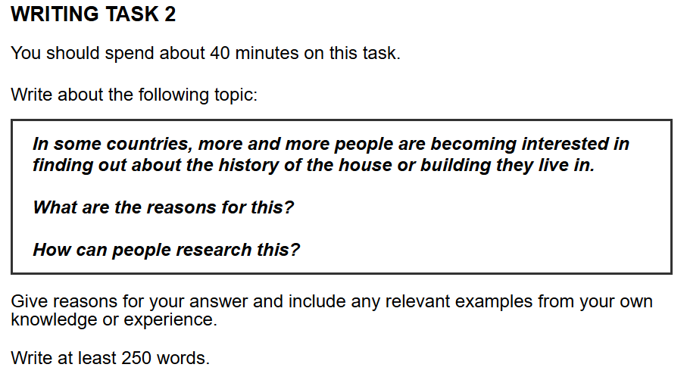
原始的作文：
In recent years, there has been a noticeable increase in learning about history of lived house. This phenomenon is caused by a variety of factors, including safety and culture requirements, and there are substantial methods for people to collect relative information about the house.
First and foremost, history plays a vital role in safety of house, as reflecting the building process of the house. To be more specific, different construction methods can effect the house quality and people can learn the specific method from house's history; In addition, whether the house experience some natural catastrophe is also an important aspect, verifying the reliability.
Furthermore, the fact that history is crucial for traditional culture indicates that old houses of celebrities are regarded as scenic spot. Take the case of House of Lao She, which recorded his life and provided a vivid image of Lao She. As a result, more and more people are attacted by history of house, which has contributed to focus on their own house. Hence, history of house becomes a way to improve person knowledge especially in the traditional or local culture.
People can obtain historicial details of house through several effective avenues. Firstly, libarary can be an available way, as holding many historcial books. Secondly, old neighbors yield insightful information. Lastly, people can use Internet to search relative information such Wikipedia.
In conclusion, as far as satety and culture are concerned, people have diverse reasons for interests of house history. They can collect historical details through Internet conveniently.

修改后的作文：
In recent years, there has been a noticeable increase in people learning about the history of the house they live in. This phenomenon is caused by a variety of factors, including safety and cultural requirements, and there are substantial methods for people to collect relevant information about their house.
First and foremost, history plays a vital role in the safety of a house, as it reflects the building process of the house. To be more specific, different construction methods can affect the house's quality, and people can learn the specific method from the house's history. In addition, whether the house has experienced any natural catastrophes is also an important aspect, verifying its reliability.
Furthermore, the fact that history is crucial for traditional culture indicates that old houses of celebrities are regarded as scenic spots. Take the case of the House of Lao She, which records his life and provides a vivid image of Lao She. As a result, more and more people are attracted by the history of houses, which has contributed to a focus on their own homes. Hence, the history of a house becomes a way to improve a person's knowledge, especially of traditional or local culture.
People can obtain historical details of a house through several effective avenues. Firstly, libraries can be a useful resource, as they hold many historical books. Secondly, long-time neighbors can yield insightful information. Lastly, people can use the Internet to search for relevant information on websites such as Wikipedia.
In conclusion, as far as safety and culture are concerned, people have diverse reasons for their interest in house history. They can collect historical details conveniently through the Internet.

总结：
• 拼写错误 (Spelling Errors): 这是最需要注意的地方，一些小错误会影响文章的整体印象。
- attacted -> attracted
- historicial -> historical
- libarary -> libraries
- satety -> safety
- 特别注意: effect vs affect。Affect 是动词（影响），Effect 通常是名词（效果，影响）。在你的句子中，需要的是动词，所以用 affect。
• 冠词 (Articles: a/an, the): 这是我们一直在练习的重点，这次依然有一些地方可以提升。
- the safety of a house: “一栋房子的安全”，泛指。
- the Internet: “互联网”是专有名词，前面要加 the。
- the House of Lao She: 特定的建筑或地点前通常加 the。
• 用词准确性与地道表达 (Word Choice & Phrasing):
- history of lived house -> history of the house they live in / history of their homes。lived house 是一个中式英语的表达，英文中没有这种说法。
- relative information -> relevant information。Relative 是“相对的”，Relevant 是“相关的”，这里需要的是后者。
- scenic spot -> scenic spots。“景点”是可数名词，这里指代的是一类地方，所以用复数。
- improve person knowledge -> improve a person's knowledge。名词所有格，表示“一个人的知识”。
• 句子结构 (Sentence Structure):
- ...as reflecting... -> ...as it reflects...。加上主语 it，句子结构更完整。
- ...as holding... -> ...as they hold...。同理，补上主语 they。
- search relative information -> search for relevant information。search for 是一个固定搭配，表示“搜寻”。
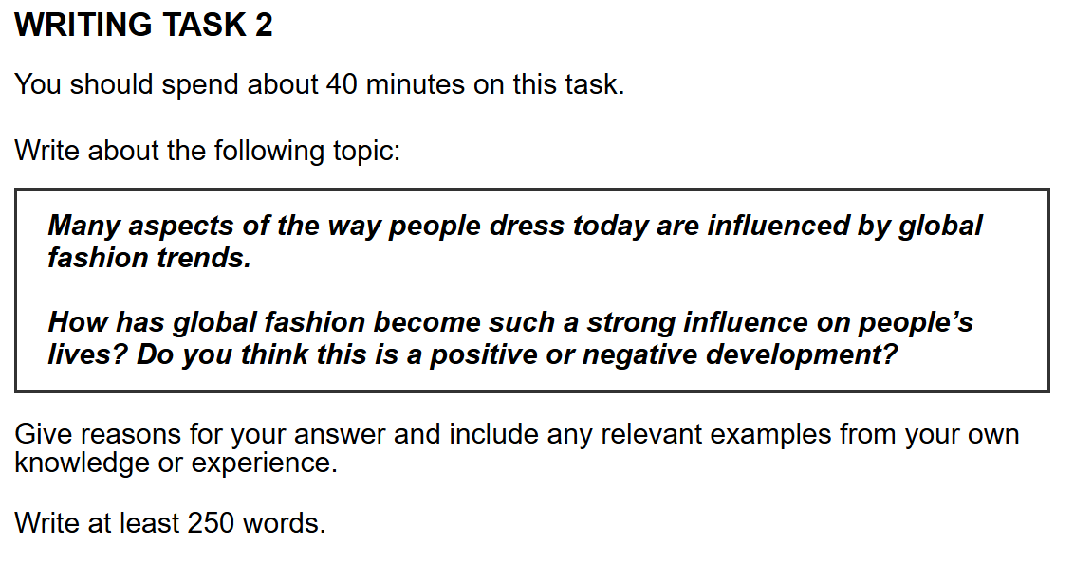
我的提纲：
不同的文化和地域带来了不同的服装设计，在信息化的时代，越来越多人欣赏国际的服装而不单关注于本国的设计，走向了国际潮流话。我认为科技推动了时尚潮流化，此外这是一个积极的发展，因为能推动国际的交流和发展。

段落1：
观点1：科技推动了这个现象。
互联网是科技的一个体现->信息不会像以前一样闭塞->有网络就能看到全球最新的设计。

段落2：
看法1: 积极的。
原因：穿衣全球潮流化推动了文化和经济的进步。
文化->着装是文化的一个体现，推动了文化交流。
经济->时尚全球化，会有人想买进口服装->推动全球贸易。

总结：
科技推动了时尚全球化，进而推动了经济和文化的发展。各国政府应该鼓励文化交流和贸易往来，实现更加自由，和平的未来。

范文：
It is true that in the modern era, clothing styles are increasingly shaped by global fashion trends rather than just local customs. In my opinion, this phenomenon is primarily driven by technological advancements, and I believe it is a positive development as it promotes both cultural and economic progress.
First, the development of technology, especially the internet, is the main reason why global fashion has become so influential. In the past, information travelled slowly, and people's knowledge of fashion was often limited to their own country's designs seen in local shops or magazines. However, the internet and social media have completely changed this situation. Now, anyone with a smartphone can instantly see the latest designs from fashion shows in Paris, Milan, or New York. This immediate access to information breaks down geographical barriers and allows trends to spread across the world in a very short time.
Furthermore, I am convinced that this trend is a positive development for two key reasons. Firstly, it fosters cultural exchange. Clothing is a significant part of a culture's identity, and when people from different backgrounds start appreciating and wearing international styles, it shows a form of mutual respect and curiosity. This sharing of fashion can lead to a deeper understanding and appreciation of different cultures. Secondly, the globalization of fashion stimulates the world's economy. When a style becomes popular globally, it creates a huge demand for certain products. This encourages international trade, as consumers may want to purchase clothes or accessories from foreign brands, which in turn supports businesses and creates jobs worldwide.
In conclusion, I would reaffirm my view that technology has been the key driver behind the rise of global fashion. This is a largely positive trend that brings the world closer through cultural communication and economic cooperation. Governments should continue to encourage this kind of global exchange to build a more prosperous and interconnected future.

优秀表达：
我们可以把它们分成几类来学习：
1. 表达“影响与驱动” (Influence & Driving Forces)
- be shaped by...: 意为“被...塑造”。
  - 为什么好用？ 比 be influenced by (被...影响) 更加生动、形象，有一种“捏造成型”的感觉。
  - 例句: Clothing styles are increasingly shaped by global fashion trends. (服装风格日益被全球时尚潮流所塑造。)
- be driven by...: 意为“被...驱动/推动”。
  - 为什么好用？ 这是表达“原因是...”的高分说法，强调了背后强大的驱动力。比 the reason is... 更正式。
  - 例句: This phenomenon is primarily driven by technological advancements. (这个现象主要是由科技进步所驱动的。)
- the key driver behind...: 意为“...背后的关键驱动力”。
  - 为什么好用？ driver 在这里不是指司机，而是指“驱动因素”，是一个非常地道的名词用法。
  - 例句: I would reaffirm my view that technology has been the key driver behind the rise of global fashion. (我重申我的观点，科技一直是全球时尚兴起背后的关键驱动力。)
2. 表达“促进与发展” (Promotion & Development)
- promote: 意为“促进，提倡”。
  - 为什么好用？ 这是一个非常万能且正式的动词，可以用在经济、文化、健康等多个话题中。
  - 例句: It is a positive development as it promotes both cultural and economic progress. (这是一个积极的发展，因为它促进了文化和经济的进步。)
- foster: 意为“培养，促进”。
  - 为什么好用？ 和 promote 意思相近，但 foster 更侧重于在一个持续的过程中，慢慢地、有意识地去培养和支持某事物的成长。用词更高级。
  - 例句: Firstly, it fosters cultural exchange. (首先，它促进了文化交流。)
- stimulate: 意为“刺激，激励”。
  - 为什么好用？ 在经济学和商业话题中非常常用，表示“让...变得更活跃、更发达”。
  - 例句: The globalisation of fashion stimulates the world's economy. (时尚的全球化刺激了世界经济。)
3. 高分名词和名词词组 (Advanced Nouns & Noun Phrases)
- technological advancements: 意为“科技进步”。
  - 为什么好用？ 比 development of technology 更简洁、更书面化。
- geographical barriers: 意为“地理障碍”。
  - 为什么好用？ barrier 是一个很形象的词，这个词组生动地表达了“地域限制”被打破。
- cultural exchange: 意为“文化交流”。
  - 为什么好用？ 固定搭配，在文化类话题中必不可少。
- mutual respect and curiosity: 意为“相互的尊重和好奇心”。
  - 为什么好用？ 这两个词用得很具体，解释了文化交流的内涵，让论证更有深度。
- economic cooperation: 意为“经济合作”。
  - 为什么好用？ 在全球化话题中非常核心的词组。
4. 逻辑连接与观点表达 (Linking & Expressing Opinions)
- primarily: 意为“主要地，根本上”。
  - 为什么好用？ mainly 的高级替代词，用于强调最主要的因素。
- I am convinced that...: 意为“我确信...”。
  - 为什么好用？ 比 I think 或 I believe 的语气更强烈、更肯定，显示出你对自己的观点很有信心。
- reaffirm my view that...: 意为“我重申我的观点...”。
  - 为什么好用？ 用在结论段的开头非常有力，完美地引出对全文观点的总结。

