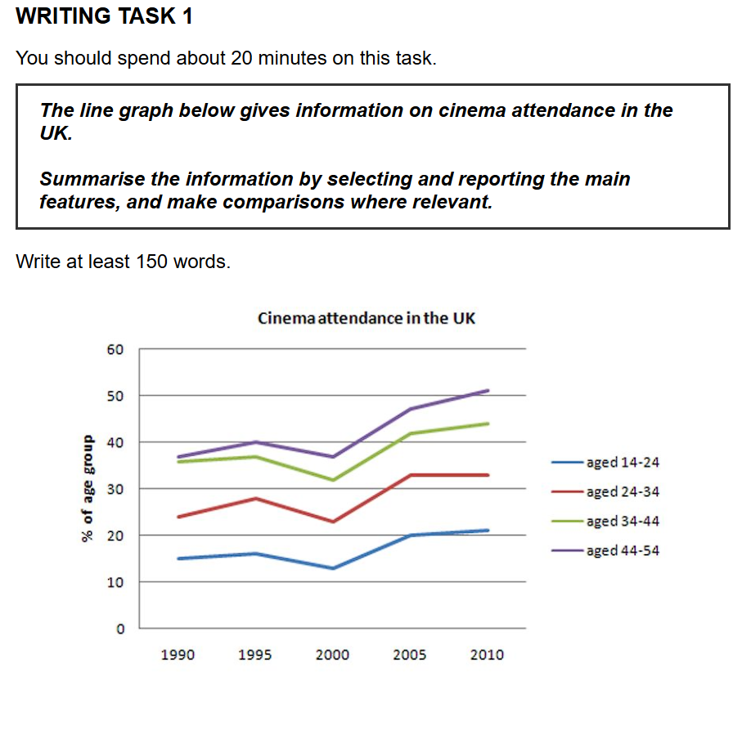
The line graph illustrates the percentage of people in four different age groups who attended the cinema in the UK over a 20-year period from 1990 to 2010.

Overall, what stands out from the graph is that cinema attendance was most popular among the older age groups, while the youngest group consistently had the lowest participation rate. Another significant feature is that all four groups followed a remarkably similar trend, experiencing a dip around the year 2000 before rising in the following decade.

Looking at the details, the 44-54 age group started with the highest proportion, at just under 40% in 1990. After a slight dip, this figure rose steadily to finish at a peak of just over 50% in 2010. Similarly, the 34-44 age group began at approximately 35, then saw a drop to around 32% in 2000, climbed to about 44% by the end of the period.

In contrast, the younger demographics showed lower attendance figures. The percentage of people aged 24-34 fluctuated in the first decade, starting at 24% before rising and then falling to a low of 23% in 2000. It then saw a steady increase to roughly 33% in 2010. The 14-24 age group, representing the least frequent cinema-goers, started at 15% and, following the same pattern, ended at a higher point of approximately 21%.
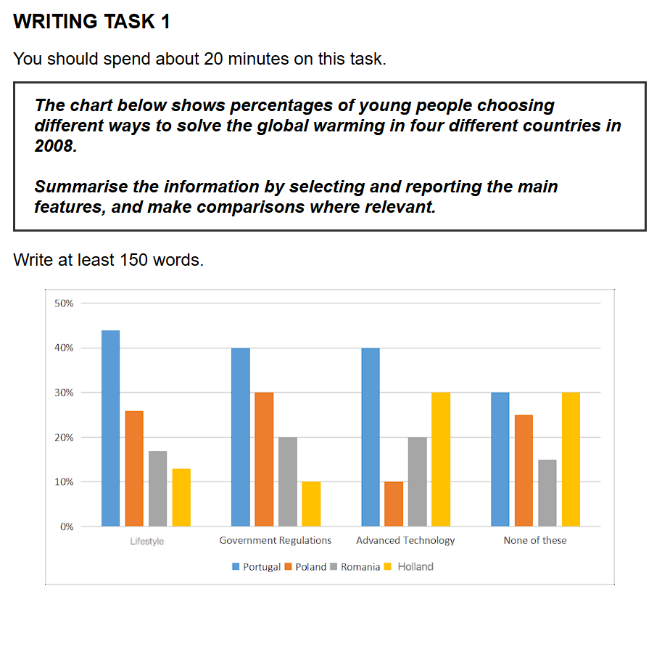
The provided bar chart illustrates proportions of young people choosing different ways to solve the global warming in four different countries in 2008.

Overall, it is clear that altering lifestyles and implementing government regulations were the two most favoured strategies in the majority of the countries surveyed. In stark contrast, Holland stands out, as the most common response among its youth was that none of these solutions were suitable.

Focusing on the two most popular methods, over 40% of young people in Portugal chose changing their lifestyle, the highest figure in the chart. Similarly, government regulations were also a very popular choice in Portugal, selected by 40% of its youth. In Poland, these two options were also the top choices, though at lower proportions of approximately 26% and 30% respectively.

Conversely, advanced technology was generally the least popular solution, with only around 10% of young people in Poland and Holland choosing this method. The "None of these" category reveals an interesting trend. This was the most selected option in Holland, at 30%, and was also very high in Poland, at 25%. The figures for these two categories were generally lower in Portugal and Romania.
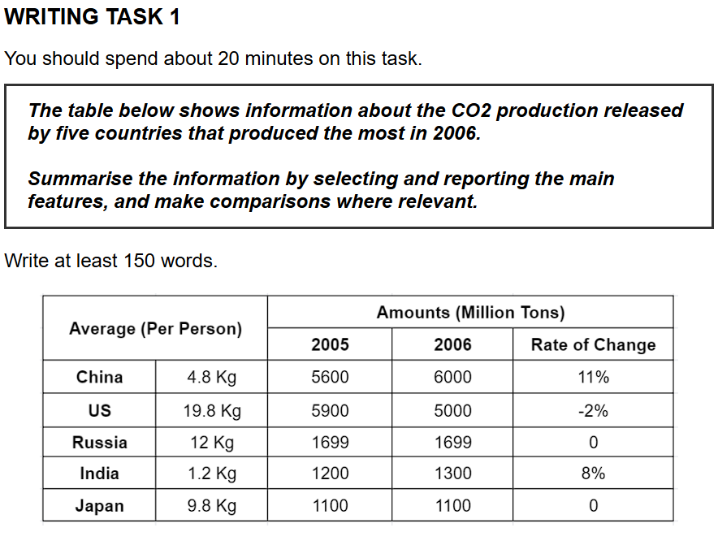
The table illustrates the CO2 emissions of the five highest-producing countries in 2005 and 2006, along with per capita figures for 2006.

Overall, it is clear that China and the US released significantly more CO2 than Russia, India, and Japan in terms of total volume. However, the pattern was different for per capita emissions, where the figures for China, India, and Japan were considerably smaller than those of the other two nations.

Regarding the countries with the largest emissions, the US produced 5900 million tonnes of CO2 in 2005. This figure then decreased by 2% to 5000 million tonnes in 2006, despite the nation having the highest per capita output at 19.8 kg. In contrast, China's average personal production was relatively small at 4.8 kg, whereas its total emissions grew from 5600 to 6000 million tonnes in the following year, a significant increase of 11%.

Turning to the remaining countries, Russia's output remained stable at 1699 million tonnes, with a per capita figure of 12 kg. Similarly, Japan's production was also unchanged at 1100 million tonnes, and its individual output was 9.8 kg. Lastly, India had the lowest per capita production at just 1.2 kg, yet its total emissions saw a substantial 8% rise to 1300 million tonnes.
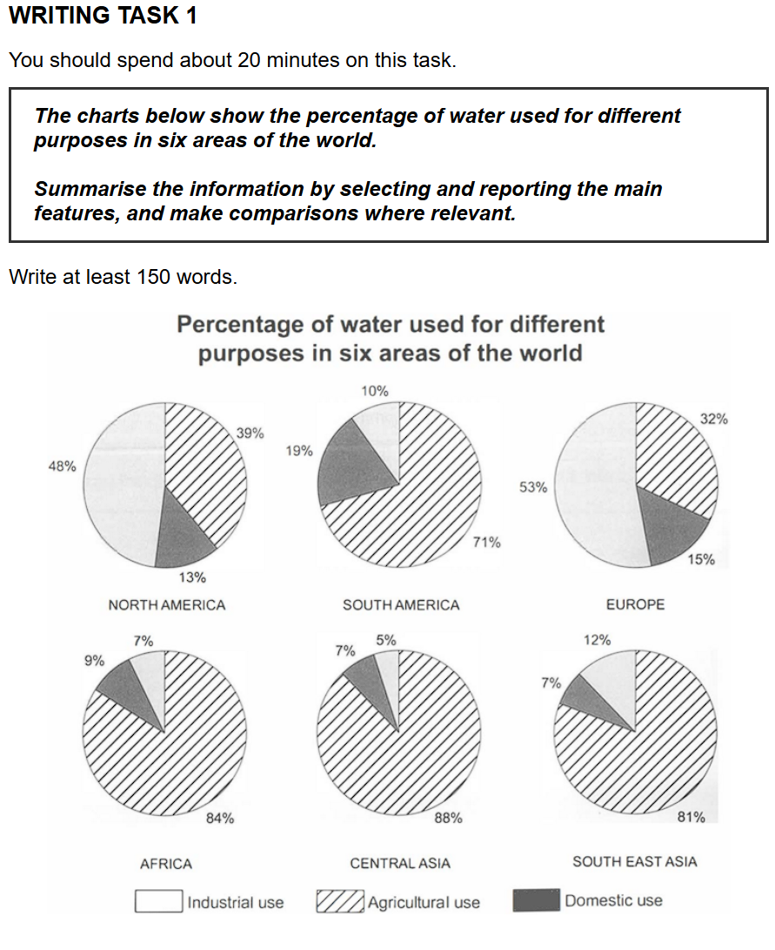
The provided pie charts illustrate how water is used for three different purposes—industrial, agricultural, and domestic—across six regions of the world.

Overall, it is clear that agriculture is the primary category of water consumption in South America, Africa, Central Asia, and Southeast Asia. In contrast, industrial use is the dominant factor in the water consumption of North America and Europe.

Regarding the four agriculturally dominated regions, this sector accounts for over 80% of water usage in Africa (84%), Central Asia (88%), and Southeast Asia (81%). The proportion is slightly smaller in South America, at 71%. In these four regions, domestic use consistently represents a small fraction, though it is notably higher in South America (19%) compared to the others (7-9%).

Turning to the remaining two regions, the pattern is reversed. Industrial water consumption is the largest category in both North America and Europe, at 48% and 53% respectively. Agricultural use, while significant, accounts for a smaller share (39% in North America and 32% in Europe). Finally, domestic water use in these two developed regions stands at 13% and 15%.
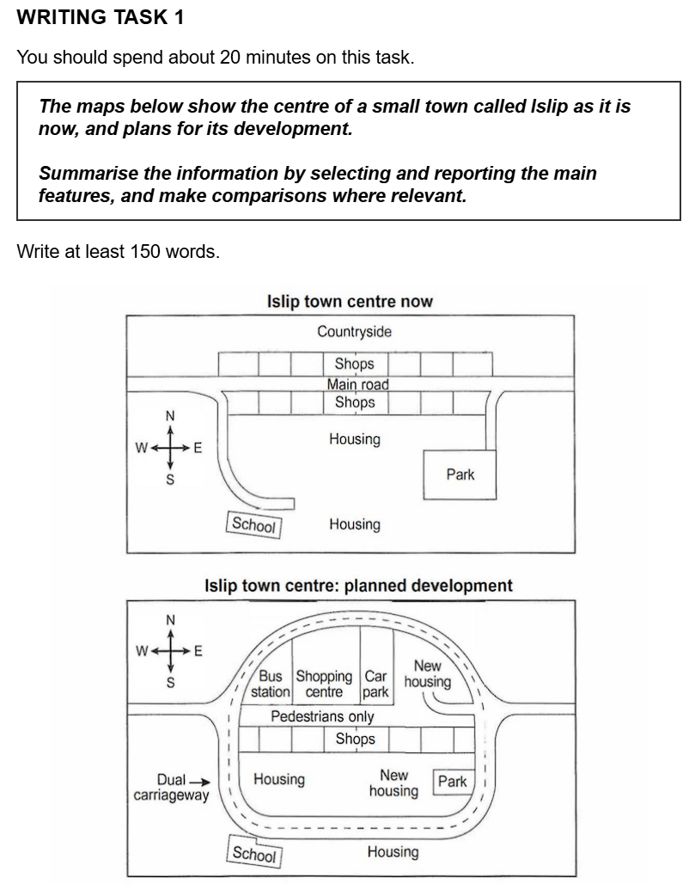
The maps demonstrate the present and planned future layout of the town center of Islip. Supported by new infrastructure and facilities, the area covered and the capacity for both shoppers and residents will increase.

One prominent planned change is on the roads – the main road going through town center from west to east will be replaced by a dual carriageway that surrounds the whole town center, covering a larger area. In addition, the section of main road inside the dual carriageway will be converted into a pedestrian street. Shops currently stand on the northern side of main road will all be demolished (those on the south side unchanged), and the larger new enclosed space in the north between the pedestrian street and carriageway is intended for a new bus station, larger shopping center, car park, and housing area with a pathway out.

The original housing area in the south also will experience changes: it will be divided into two sections by the new dual carriageway with new housing development in the upper enclosed area; the park originally in the southeastern corner of town center will also be enclosed and shrink in size.

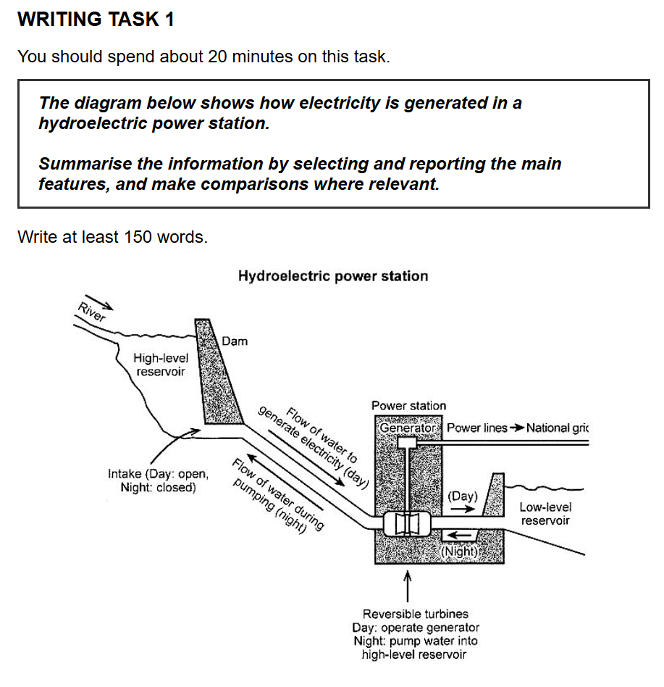
The given diagram illustrates the step-by-step process of how electricity is generated in a hydroelectric power station.

Overall, it is clear that this is a cyclical process, which involves two main stages: generating electricity during the day and pumping water back at night.

To begin with, water from a river is stored in a high-level reservoir, held back by a large dam. During the day, an intake opens, allowing this water to flow downwards through a large pipe towards the power station. Inside the station, the force of the flowing water turns reversible turbines. These turbines, in turn, drive a generator, which produces electricity. This electricity is then sent via power lines to the national grid. After passing through the turbines, the water is released into a low-level reservoir.

Conversely, at night, the process reverses. The intake from the high-level reservoir is closed. Water is pumped from the low-level reservoir back up into the high-level reservoir. This pumping action is also carried out by the reversible turbines, which now function as pumps. Once the water returns to the high-level reservoir, the entire process can begin again the next day.
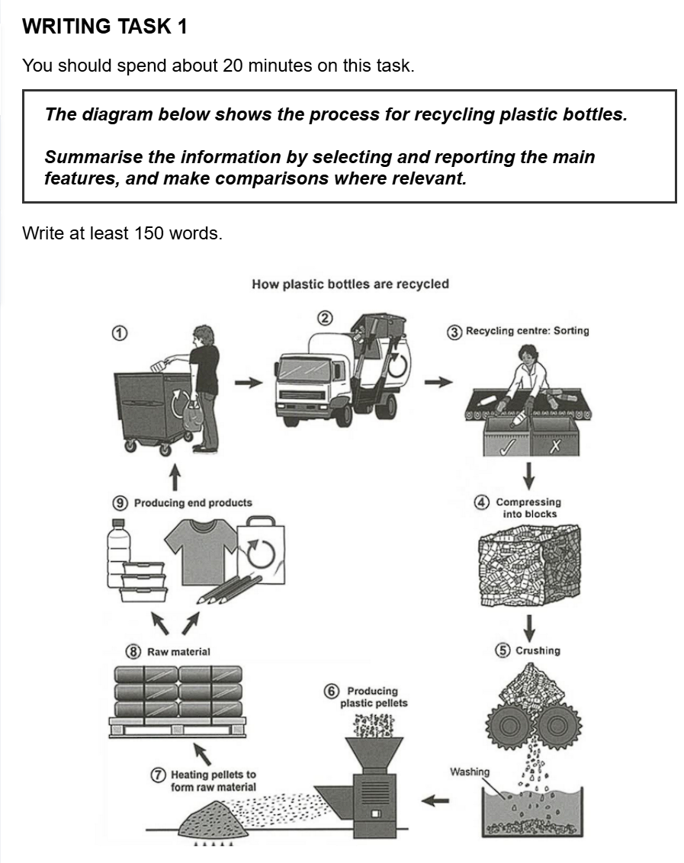
The diagram illustrates the step-by-step process by which plastic bottles are recycled.
Overall, it is clear that the recycling of plastic bottles is a cyclical process that encompasses nine distinct stages, starting from public waste disposal and ending with the manufacturing of new goods.
The process begins when members of the public discard their used plastic bottles into designated recycling bins. Following this, the bottles are collected by a specialized truck and transported to a recycling centre. At the centre, workers sort the bottles by hand to separate those suitable for recycling.
In the next stage of the process, the sorted bottles are compressed into large blocks. These blocks are then fed into a crushing machine, which breaks them down into small pieces. After being crushed, these pieces are thoroughly washed in a tank to remove any impurities.
The final stage involves manufacturing. The clean plastic pieces are processed in a machine to produce pellets. Subsequently, these pellets are heated to create a raw material, which is then used to manufacture a variety of new end products, such as bottles, T-shirts, and bags. Once used and discarded, these items can re-enter the process, thus completing the cycle.
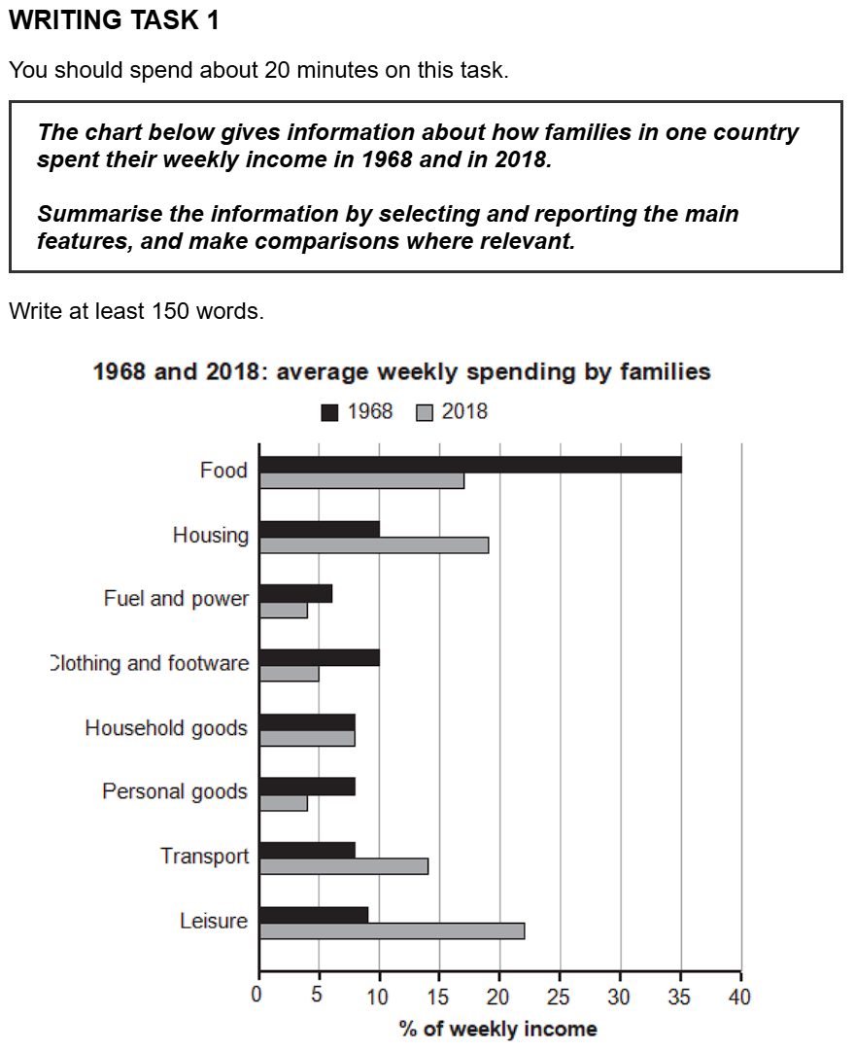
原始作文：
The bar chart illustrates weekly spending by families in one country in 1968 and in 2018.
Overall, it is clear that food costed the most percentage of weekly income in 1968, whereas leisure was primary category in 2018. In addtion, four categories food, housing, transport and leisure saw a significant variation, while the other four categories approximately levelled off.
Regarding the significantly varied categories, food accounted for main percentage at 35% in 1968, before the sharp decreasing to over over 15% in 2018. However, upward trend showed in the housing, transpor and leisure spending from 1968 to 2018. Families average cost on housing made up 10% and then soared to about 18%. Similarly, transport and leisure started at approximate 7%-8% in 1968 and climbed dramatically to nearly 15% and over 20%, which leisure consumed most of famiy income in 2018.
Turning to remained outcome types, they were not more than 10% in 1968 and 2018. Household goods stayed unchange, whereas fuel and power, clothing and footware, personal goods experienced a downward trend.

修改后的论文：
The bar chart illustrates weekly spending by families in one country in 1968 and in 2018.
Overall, it is clear that food accounted for the highest percentage of weekly income in 1968, whereas leisure was the primary category in 2018. In addition, four categories—food, housing, transport and leisure—saw a significant variation, while the other four categories remained relatively stable.
Regarding the significantly varied categories, food accounted for the highest percentage at 35% in 1968, before decreasing sharply to just over 15% in 2018. However, an upward trend was seen in housing, transport and leisure spending from 1968 to 2018. Average family spending on housing made up 10% and then soared to about 18%. Similarly, transport and leisure started at approximately 7%-8% in 1968 and climbed dramatically to nearly 15% and over 20% respectively, with leisure consuming the most family income in 2018.
Turning to the remaining spending types, they were not more than 10% in 1968 and 2018. Household goods stayed unchanged, whereas fuel and power, clothing and footwear, and personal goods experienced a downward trend.

总结：
• 拼写错误 (Spelling Errors):
- In addtion -> In addition
- transpor -> transport
- famiy -> family
- footware -> footwear 这些是可以通过仔细检查来避免的小失误。
• 词性与词形错误 (Word Form):
- costed -> accounted for。Cost的过去式是cost，但在这里用account for（占据）是描述图表数据更地道的动词。
- unchange -> unchanged。动词stay后面需要形容词，所以用过去分词unchanged。
- approximate -> approximately。修饰数字时，我们用副词approximately（大约）。
- remained outcome types -> the remaining spending types。remaining是形容词“剩下的”，spending比outcome在这里更贴切。
• 冠词 (Articles: a/an, the):
- primary category -> the primary category。最高级或表示唯一事物时，前面要加the。
- upward trend -> an upward trend。第一次提到一个可数名词时，前面要加a/an。
• 句子结构与连接 (Sentence Structure):
- before the sharp decreasing -> before decreasing sharply。用verb+adv.（动词+副词）的结构来描述变化，比用the+adj.+noun的结构更简洁、更常用。
- ...which leisure consumed... -> ...with leisure consuming...。原句的which从句使用不当，它不能独立地修饰前面整个句子。用with + 名词 + doing的独立主格结构来补充说明情况，是Task 1写作中的一个高级且常用的句式。

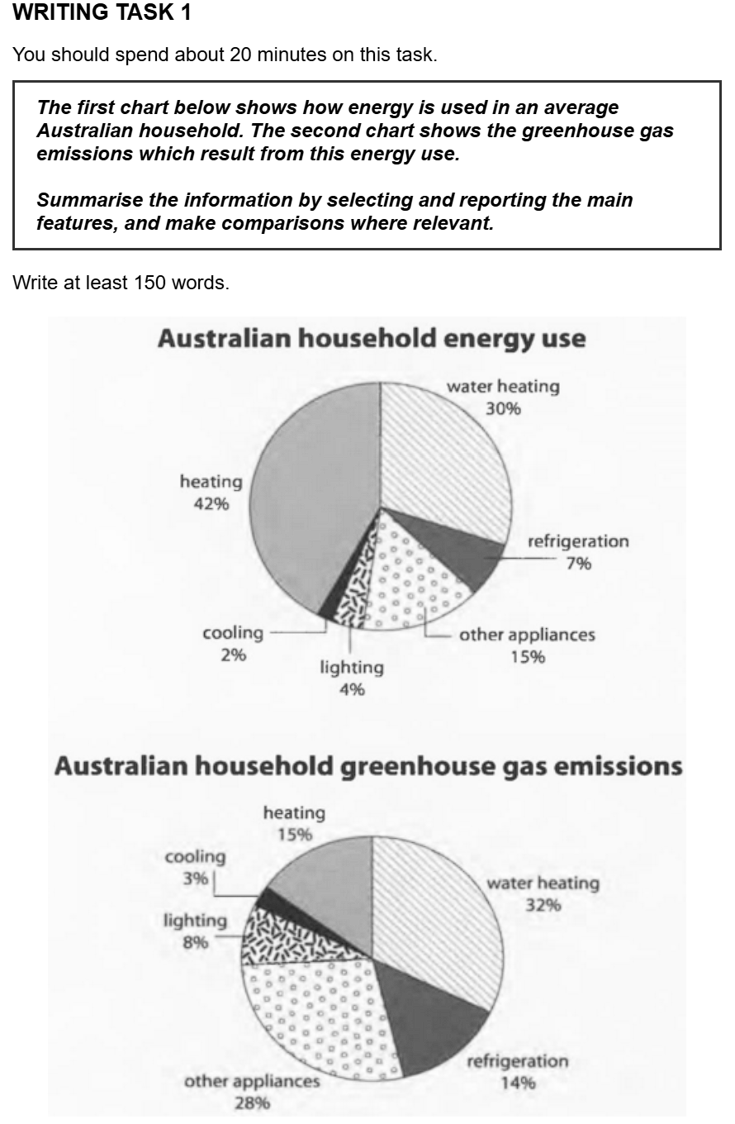
原始作文：
The first pie chart illustrates the information of energy use in an average Australian household. In addition, the second chart reflects the greenhouse gas emissions.
Overall, it is clear that heating was primary category of Australian household energy use, and water heating accounted for the second highest proportion. Similarly, the proportion of water heating was highest among all categories in gas emissions.
Regarding the first pie chart, heating and water heating were the main contributors of energy use, at 42% and 30%. However, the percentage of refrigeration, lighting and cooling were relatively distributed and low, at 7%, 4% and 2%. Other appliances totally made up 15% of energy use.
Turning to second chart, the percentages of water heating (32%) and heating (15%) in greenhouse emissions showed reversed pattern of energy use. By contrast, the emissions of refrigeration accounted for 14% which were double percentage of energy use. The sectors of lighting and cooling were still small, at the low proportions 8% and 3%. Finally, other appliances totally made up a relatively high percentage 28% of emissions.

修改后的作文：
The first pie chart illustrates information on energy use in an average Australian household. In addition, the second chart reflects the resulting greenhouse gas emissions.
Overall, it is clear that heating was the primary category of Australian household energy use, and water heating accounted for the second highest proportion. Similarly, the proportion of water heating was the highest among all categories in greenhouse gas emissions.
Regarding the first pie chart, heating and water heating were the main contributors to energy use, at 42% and 30% respectively. However, the percentages of refrigeration, lighting and cooling were relatively low, at 7%, 4% and 2% respectively. Other appliances made up a total of 15% of energy use.
Turning to the second chart, the percentages of water heating (32%) and heating (15%) in greenhouse gas emissions showed a reversed pattern to that of energy use. By contrast, the emissions from refrigeration accounted for 14%, which was double the percentage for energy use. The figures for lighting and cooling were still small, at 8% and 3% respectively. Finally, other appliances made up a relatively high percentage of 28% of emissions.

总结：
- information of -> information on
  - 原因: 这是介词搭配错误。“information”后面通常跟介词“on”或“about”来表示“关于...的信息”，而不是“of”。
- primary category -> the primary category / was highest -> was the highest
  - 原因: 冠词使用错误。当使用最高级（如 primary, main, highest, biggest）来指代群体中独一无二的那个事物时，前面必须加定冠词“the”。
- contributors of -> contributors to
  - 原因: 介词搭配错误。“Contribute”这个词（动词）和它的名词形式“contributor”后面都应该跟介词“to”，表示“对...做出贡献”。
- the percentage ... were -> the percentages ... were
  - 原因: 主谓一致错误。因为你后面列举了“refrigeration, lighting and cooling”三个项目的多个百分比，所以主语应该是复数“percentages”，谓语动词也相应地使用复数“were”。（另一种改法是保持 the percentage 不变，但把 were 改成 was，但这样逻辑上不如前者通顺，因为你指代的是多个数值）。
- 在句末添加 respectively
  - 原因: 用词准确性。当你列出两个或多个项目以及它们对应的数据时，在句末加上 respectively（分别地），会让句子逻辑更清晰、表达更严谨。这是学术写作中非常常见的用法。
- Turning to second chart -> Turning to the second chart
  - 原因: 冠词使用错误。在序数词（如 first, second, third）前，需要加定冠词“the”。
- showed reversed pattern of -> showed a reversed pattern to that of
  - 原因: 这句话有几个小问题。首先，“pattern”是可数名词，这里是第一次提到，所以需要一个不定冠词“a”。其次，在表示“与...的模式相反”时，用介词 to 比 of 更地道。最后，用 that of 来指代前面出现过的 the pattern of energy use，可以避免重复，使句子结构更简洁、更高级。
- emissions of refrigeration -> emissions from refrigeration
  - 原因: 介词使用错误。为了表达“来自...的排放”，介词 from 是最准确的。
- which were double percentage of -> which was double the percentage for
  - 原因: 这也是一个复合错误。
    - which 指代的是前面 14% 这个单一的数字，所以谓语动词应该是单数 was。
    - “是...的两倍”的正确表达是 be double the + 名词，所以 percentage 前需要加 the。
    - 这里的介词用 for (用于能源使用的百分比) 比 of 更清晰。
- percentage 28% -> percentage of 28%
  - 原因: 介词缺失。在“a percentage” 和具体的数值之间，需要用介词 of 来连接，即 a percentage of 28%。

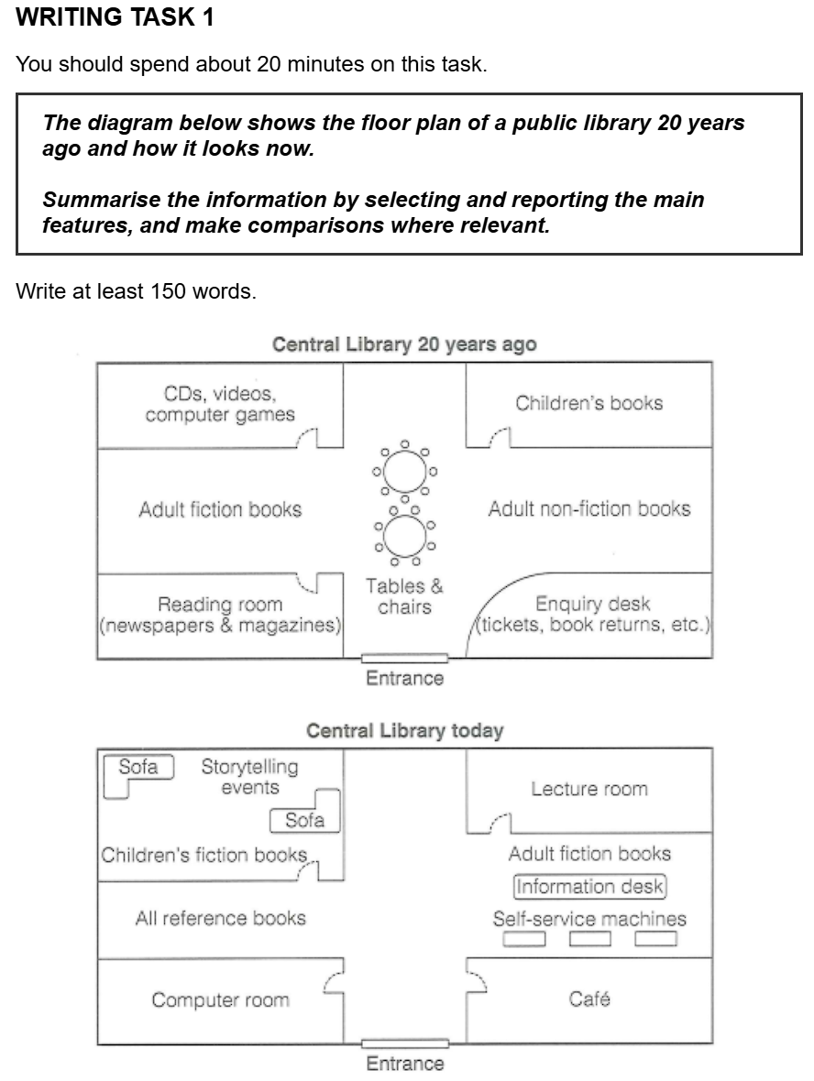
第一步：审题和找变化
我们有两个图：一张是“20年前的中央图书馆”，另一张是“今天的中央图书馆”。我们的任务就是找出这两张图的不同之处。
我们一起来“找不同”吧：
- 入口 (Entrance): 看看入口的位置，有变化吗？（看起来没有，还是在底部中间）
- 中间区域: 20年前，图书馆中央是“桌椅 (Tables & chairs)”。现在呢？（现在这个区域被移走了）
- 右边区域:
  - 20年前的右上角是“儿童读物 (Children's books)”，右下角是“咨询台 (Enquiry desk)”。
  - 现在这两个区域变成了一个大的“演讲室 (Lecture room)”和一个“咖啡厅 (Café)”。咨询台的功能似乎被更小的“信息台 (Information desk)”和“自助服务机 (Self-service machines)”取代了。
- 左边区域:
  - 20年前，左边从上到下分别是“CD、影像和电脑游戏区”、“成人小说区 (Adult fiction books)”和“阅览室 (Reading room)”。
  - 现在，这个区域变化很大。最上面变成了“讲故事活动区 (Storytelling events)”和沙发，下面是“儿童小说区 (Children's fiction books)”、“所有参考书区 (All reference books)”和一个独立的“电脑室 (Computer room)”。
第二步：构思文章结构
一篇好的Task 1作文，通常有三个部分：
- 引言 (Introduction)：用一句话改写题目，告诉读者这两张图是关于什么的。
- 主体段落 (Body Paragraphs)：分段描述我们找到的主要变化。我们可以把变化分类来写，比如：
  - 段落一: 描述一些主要区域的变化，比如中间区域和右边区域的变化。
  - 段落二: 描述左边区域的变化，以及一些新增的设施。
- 结尾 (Conclusion/Overall)：用一句话总结整个变化的最大趋势。比如，这个图书馆变得更现代化、更注重多功能了。
第三步：学习简单实用的词汇和句型
在描述变化时，我们可以用一些非常简单的词汇：
- 表示增加/替换: A was replaced by B (A被B取代了), A new B was added (增加了一个新的B), B was built in the place of A (B建在了原来A的位置)。
- 表示位置: in the top-right corner (在右上角), on the left side (在左边), in the center of... (在...的中央)。
- 表示变化: The library has changed a lot. (图书馆变化很大), The biggest change is... (最大的变化是...)。

现在，基于上面的分析和词汇，我为你准备了一篇用词非常简单的范文。你可以仔细读一读，看看我是如何把刚才我们讨论的那些变化点写进文章里的。
范文示例 (Simple Version)
The two pictures show the layout of a public library 20 years ago and how it looks now.
Overall, the library has seen significant changes, becoming a more modern and multi-functional space. The central area and the services offered to visitors have been completely updated.
Twenty years ago, the center of the library was filled with tables and chairs. On the right, there was an enquiry desk near the entrance and a children's book section in the corner. Today, these features are gone. The tables and chairs have been removed. A new lecture room now occupies the top-right corner, and a café has been built on the right side of the entrance.
On the left side of the library, the changes are also clear. The old reading room and the adult fiction section have been replaced. Now, this area has a computer room, a section for all reference books, and a dedicated children's fiction area with sofas and a space for storytelling events. The adult fiction books have been moved to the right side, next to the new lecture room. Finally, self-service machines have been installed near the entrance.

