学长作文全部更新完成(大、小作文）

不卖笔记啦，大家加油哦！！

大作文

一.大作文分类：
教育；科技和媒体；全球化；地方文化习俗；政府经济；犯罪；动物及环境保护；社会生活；

二.问题指令：
好坏型；观点型；讨论型；比较型；报告型；混搭型；

1．好坏型
Do you think this is a positive or negative development?
认为话题中的社会现象是一个好的发展趋势还是坏的发展趋势？

2．观点型
To what extent do you agree or disagree?
你在多大程度上同意、不同意话题中的观点？

3．讨论型
Some people think.. other people think
Discuss both view and give your own opinion.
讨论话题中的两个观点，并给出自己的观点

4．比较型
Do you think the advantages of this trend outweigh the disadvantages?
你认为话题中的社会现象的优点是否超过或大于他的缺点？

5．报告型原因、结果、解决方案、优点、缺点
Why has this happened?
What can be done to deal with this?
针对这种社会现象，他的原因\结果是什么？他的解决方案又是什么?
What are the reasons and consequences of this trend?
这种社会现象的原因和影响分别是什么？

6．混搭型

三.文体类型：
Argument类：前四种 主观+客观 议论
Report类：报告型

四.评分标准

（一）coherence&cohesion
连贯 内容层面
衔接 逻辑衔接词 8个类别 至少15个连接词 1-2+4-6+1-2
- 递进关系连接词
first/second/third; in addition; moreover; futhermore
- 因果关系连接词
because; since; due to; as a result; consequently; therefore; thus
- 指代关系连接词
this/that/these/those; such; 【which; that(引导定语从句）】
- 转折关系连接词
矛盾，互斥，不相连
while; whereas; on the other hand; by contrast; on the contrary; but; however
- 让步关系连接词
虽然有差异，但是能共存
although; even though; despite; in spite of; but; however
- 类比关系连接词
由此及彼
similarly; likewise;
- 条件关系连接词
if; on the condition that; suppose that
- 总结关系连接词
in sum; to conclude; in conclusion; overall

（二) lexical resource 词汇运用
地道性；灵活性；1-2个高级词；
词汇灵活性的三种方式
- 同义替换，
词义改写：
例子：consumers; customers; buyers; users; people who buy or purchase things;
词性改写：
world：worldwide; international; multinational; among the countries
- 不同程度改写：
futility 小型失败 徒劳
failure 中型失败 失败
catastrophe 大型失败 灾难
fail 考试的失败
defeat 比赛的失败
loss 投资的失败
founder 计划的失败
- 增加深度 思维

（三) Grammatical Range and Accuracy 语法灵活度和准确度
- 句型灵活性 句式多样
- 正确性
- 标点使用
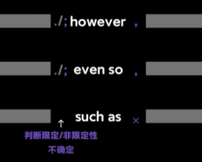

五. Arguement类型大作文的分类

一边倒的形式：
完全同意；完全不同意

（二）中立观点形式：

让步型：
承认AB两面，虽然有A面，但是B面更重要；倾向性选择

对立型：
MN场景，不存在交集
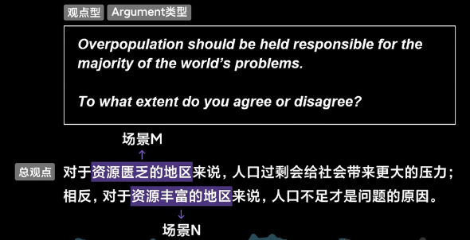

共存型：
①两个观点都有道理，必须同时存在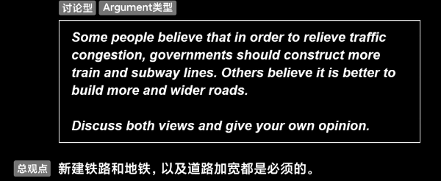
②在场景M下 观点一正确；在场景N下 观点二正确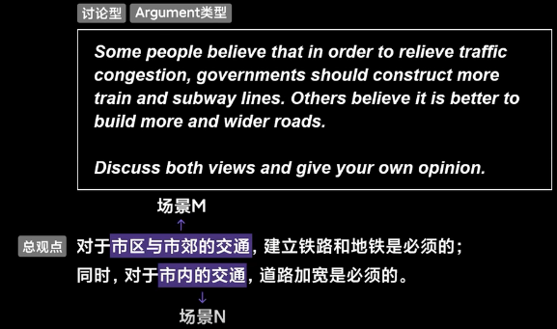

六. 1+2+1, 1+3+1
- 1+2+1:
1+2(2+2)+1 两个展开段 有两个分论点（论证模块）每段100字
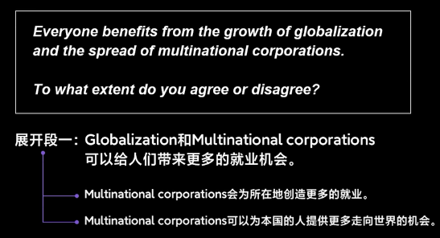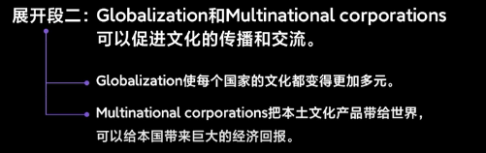
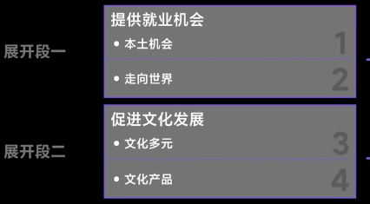
- 1+3+1 每段60-80字
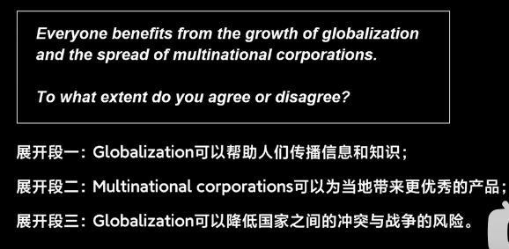

七. 分论点构建方式

观点型/好坏型构建
1.3C分解法（characterization特点； classification分类；consequence结果）
分解出主题关键词和客体关键词
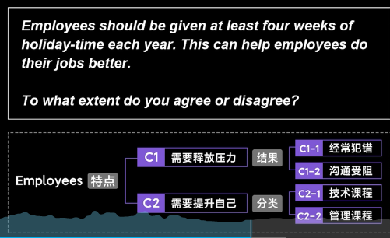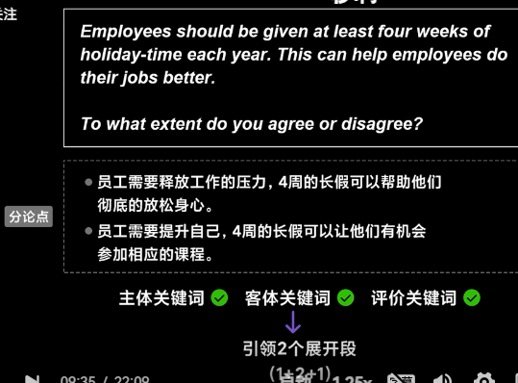
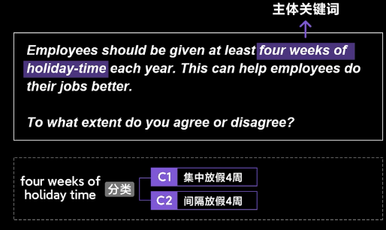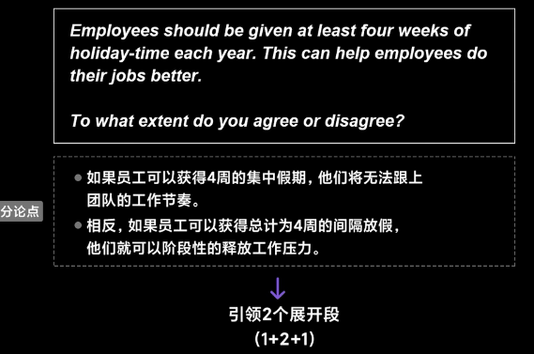
注意总观点和分论点都是一边倒/中立的，要有一致性

补充视角：（观点型）to what extent do you agree or diagree? do you 就是主观第一视角，你的想法。
第一视角补充词汇：
i think/ in my opinion/ base on my knowledge or experience
第三视角补充词汇：
some people believe/ other people argue/ proponents支持者 think/ opponents反对者 claim
因为是第一视角，所以在总观点句不可少的就是第一视角词汇的运用，在分论点也可以使用，但是为了不重复，在分论点句可以做省略。
第一视角和第三视角不能混 要统一

（二）中立态度构建分论点的补充：（让步/对立/共存）
- 让步态度：
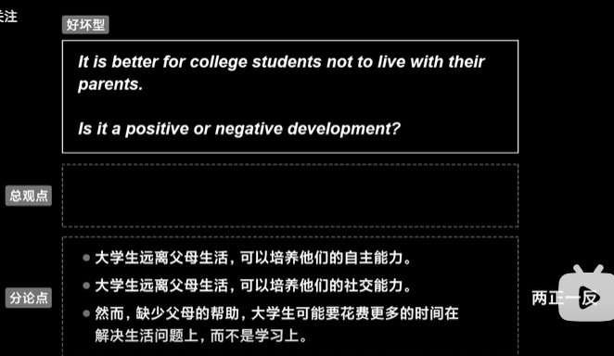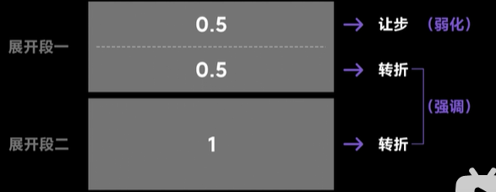
逻辑连接词：
让步段落admittedly/ certainly/ indeed/ i cannot denny that... 诚然 虽然 必须承认
转折后段落 but/ however 然而 但是
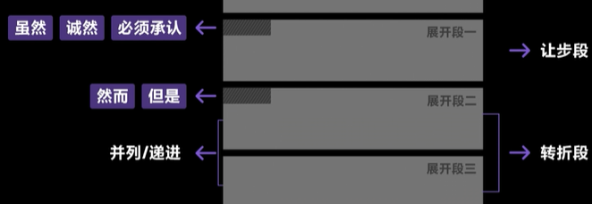
- 对立态度 MN场景
两个论点篇幅相当 两场景完全对立
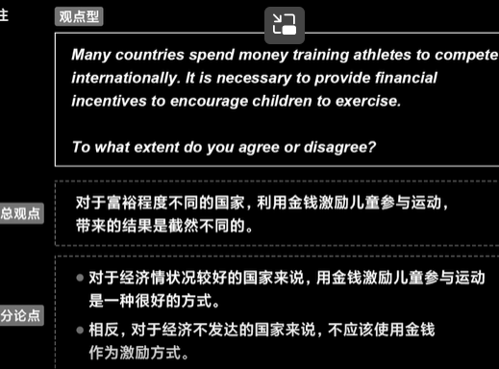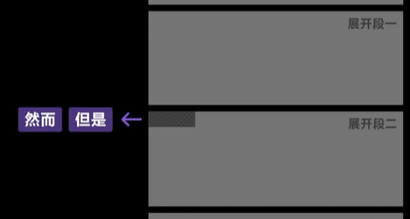
- 共存态度 两个观点互相比较，同样重要 即出现共存
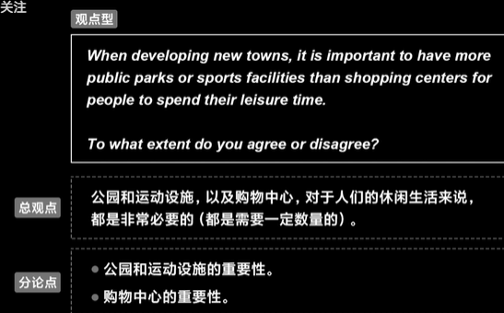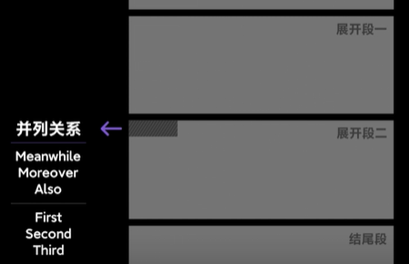

特殊关键词题目的破题方式（出现逻辑关键词和程度关键词）

含有并列/比较/对比题目的破题
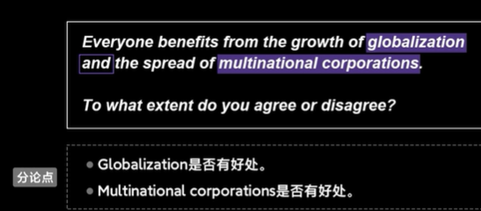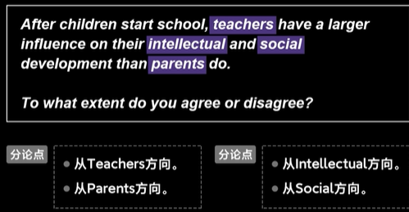

含有因果关系题目的破解
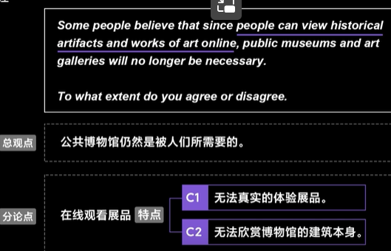

程度关键词的破题
极端词反对更好写
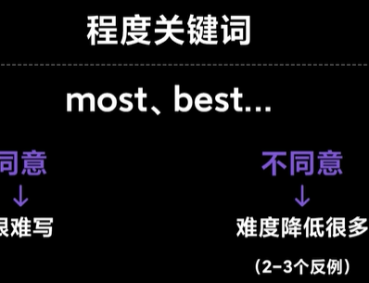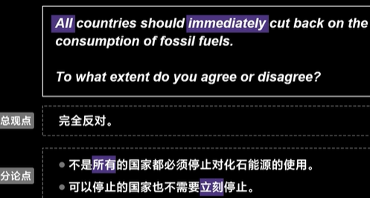

讨论型分论点构建
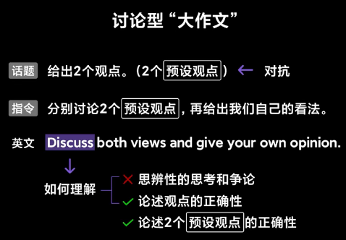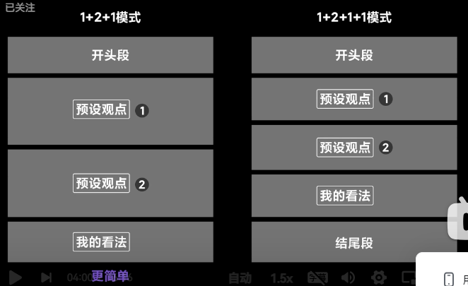
论述两个预设观点的正确性；在own opinion才可以自己说；
不需要在开头表述2个看法，只需要重复2个预设观点；

两个预设观点
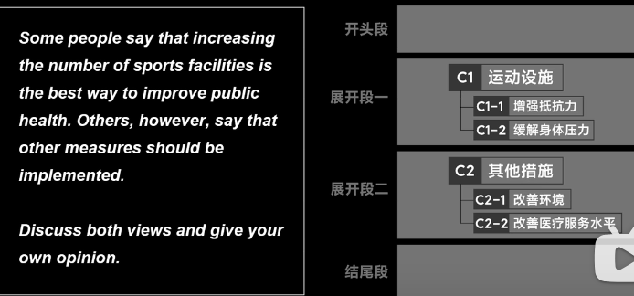

我的看法
①结论式 中立态度-让步型/共存型，不可以是对立型（都是支持两个预设观点）
②另起一段展开段论述
给支持的一方支持的形式
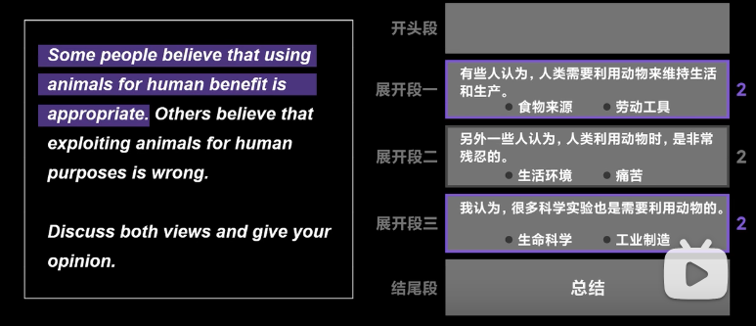
解决矛盾的方法
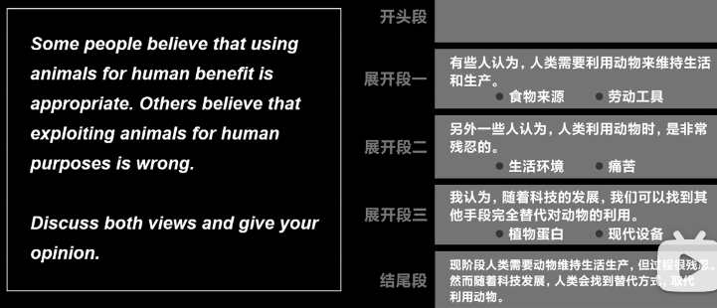

视角及模板
两预设观点：第三视角
some people think.../ other people think...
我的观点：第一视角
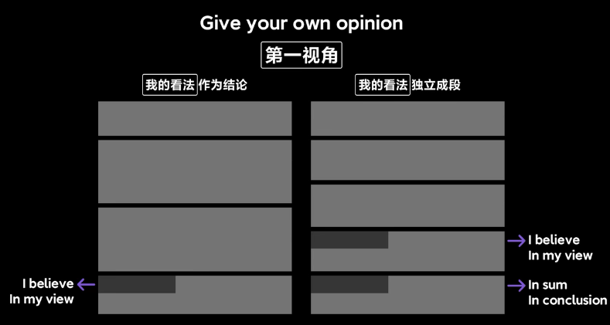

比较型分论点构建
给出社会现象描述，问你这个社会现象好处是否大于坏处？
需要两方面讨论，不能只偏向一方，和讨论型相似（比较型的结论都是偏向于哪方面的，尽管他有好处，但是坏处大于好处|尽管他有坏处但是他的好处大于坏处，两个观点不是平均的）
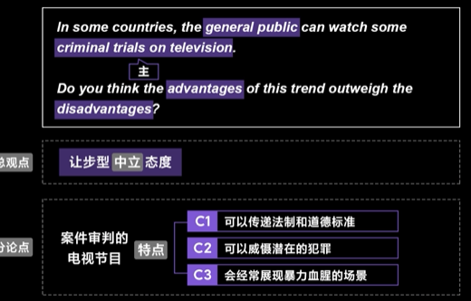
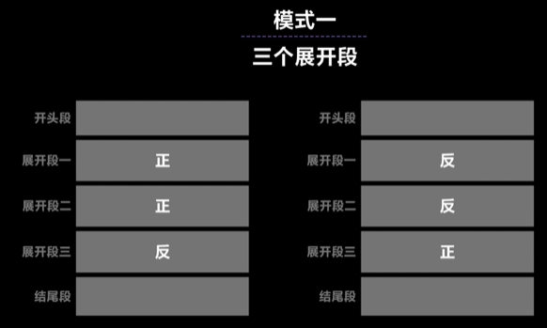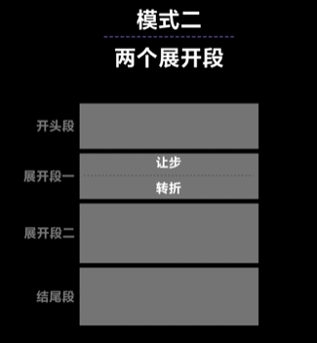

报告型及混搭型分论点构建
- 报告型：
社会现象描绘，给出他的原因、结果、解决方案等（最简单）
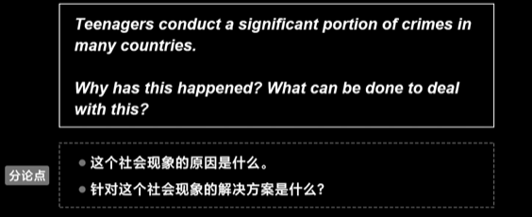
省略视角（i think 、other people think 模糊视角即可）
报告型不存在总观点、不用对社会现象进行描述或者给出态度
- 混搭型：
社会现象描述，给出原因、有好处或者是有坏处？
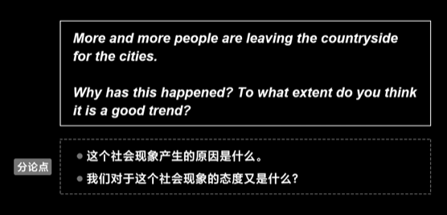
第二点问题，要给出我们的看法，与观点型作文类似，最后形成一边倒、中立的总观点
视角：第一视角使用对分论点进行引导

八. 落笔写作

（一）argument 类型开头段
两个元素：
①对话题的复述——写作的主题方向
②总观点——亮明我们的立场
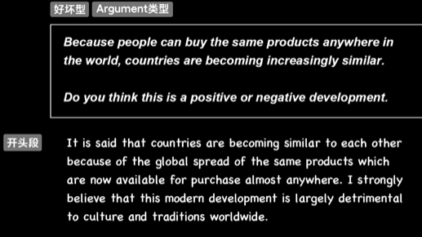

（二）report类型开头段
①对话题的复述——写作的主题方向
②预告——两个问题点（给一个或者两个都给，因为两个观点互相联系，只需要用预告引出下文就可）
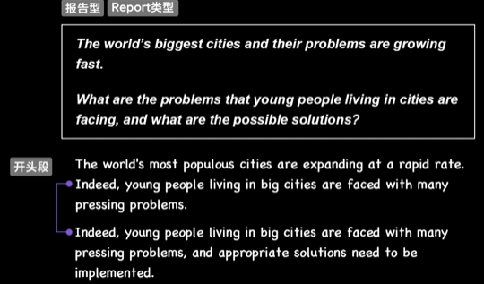

（三）大作文结尾段注意事项
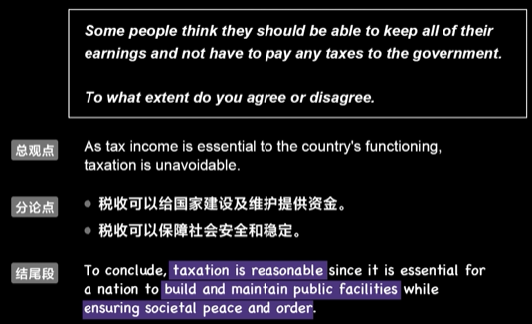

（四）展开段写作元素（主客观均可）
元素：论述；例子；细节

论述（功能、语法）
有逻辑连接词和逻辑关系
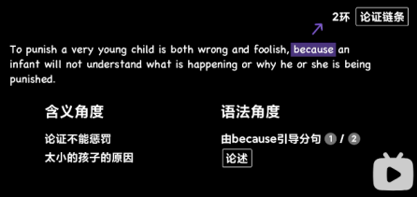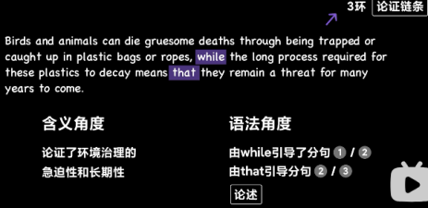

例子（事件或场景）


细节（细化或量化）
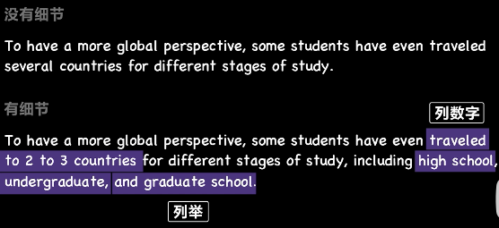

内容组成
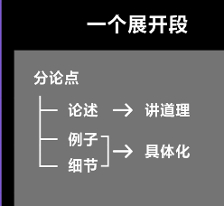
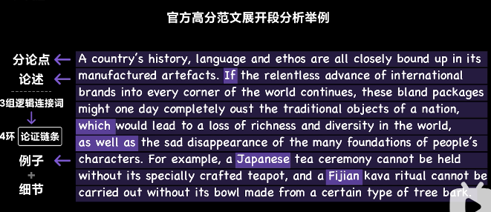

例子与细节的写作要领

语气方面 （主客观均可）
主观
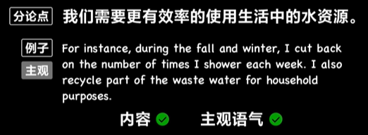一直在用 I...
客观：
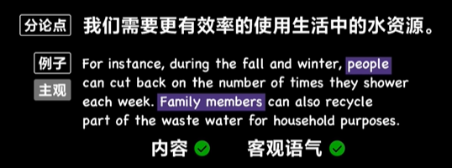

信息精准性
不用非得是具体的数字，可以做模糊化处理
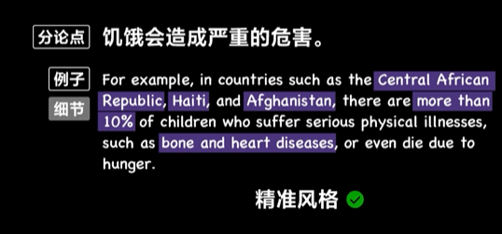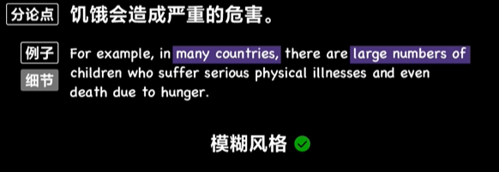

例子的写作手法
①描述型
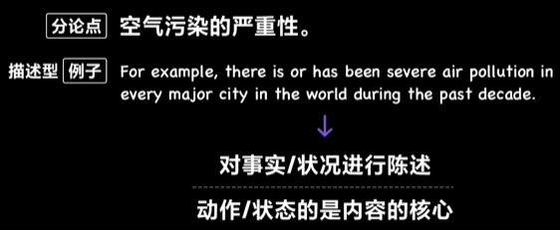
②论述型
有逻辑连接词
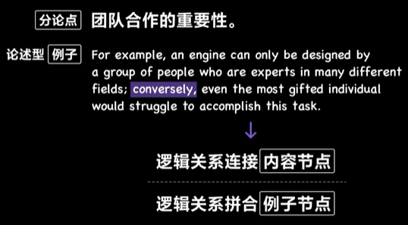
③叙事型
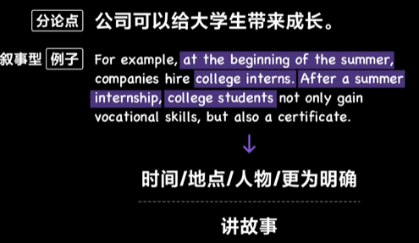

例子和细节与论证链条的位置关系
模板一：
模板二：

九. 举例写作
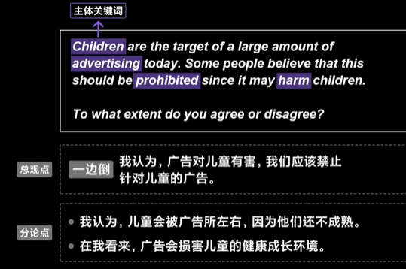
- 抓住主体关键词，利用3C分解法，拆分出来儿童的两个特点，不成熟、健康的成长环境，形成一边倒的态度方向，有害要禁止，agree的态度
- 开头段构建，复述话题+总观点
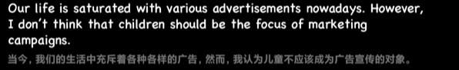
- 分论点继续展开
C1：不成熟——特点C1-1没有判断力-冲动消费（例子）
C1-2 没有自制力-产生犯罪（细节，做什么事情）
C2：健康的成长环境——分类 C2-1 游戏-沉迷、暴力
C2-2 垃圾食品（特点细节）-肥胖、犯罪

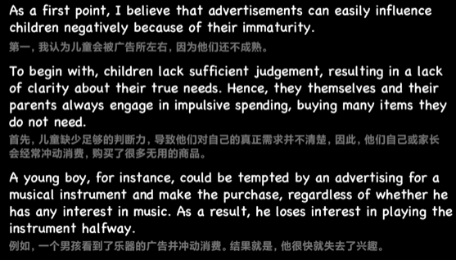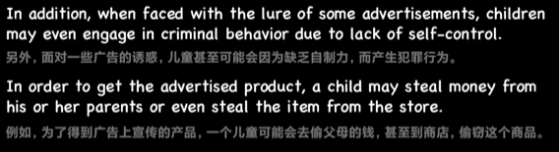
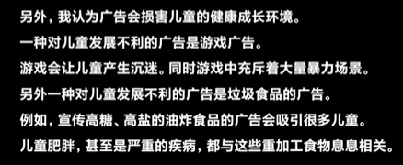
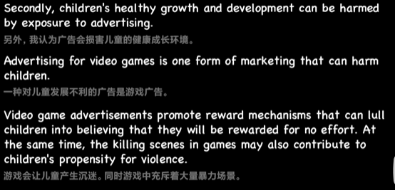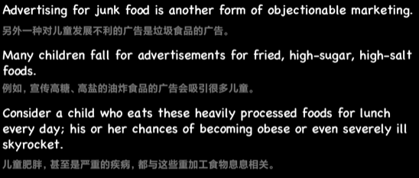
- 结尾段
总结分论点+再次点明总观点
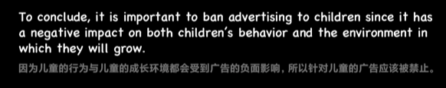

十. 论证链条的构建
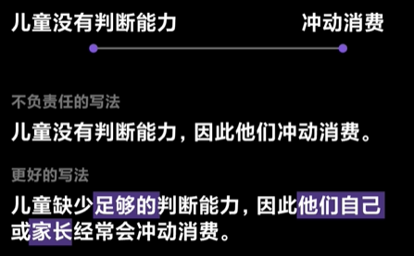
因果联系-并补充因果关系
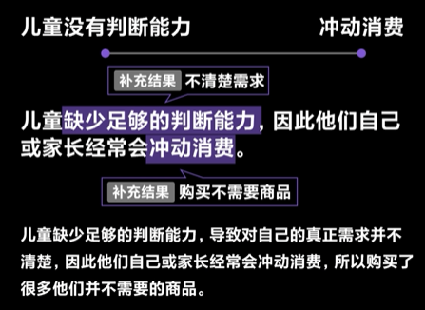
条件、对比、让步关系举例
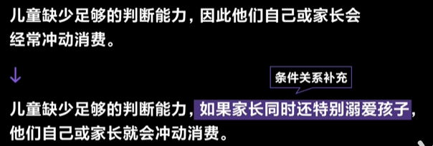
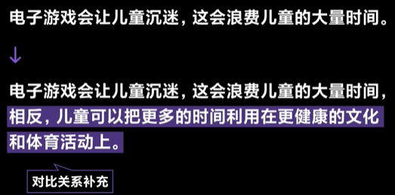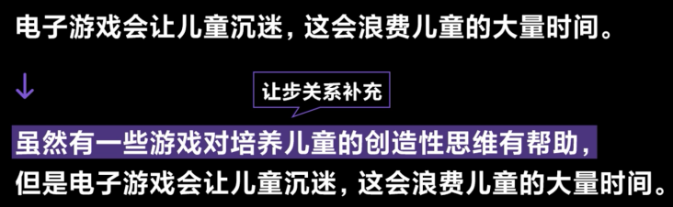

十一. 两小时公开课

展开段第一句构建（好坏题）
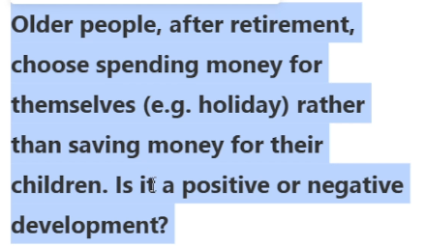
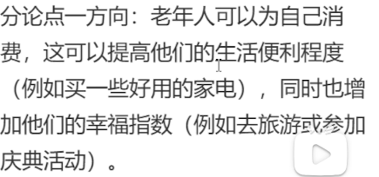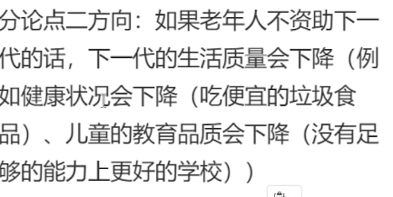

连接词 锚点 10%
第一：firstly /first /first of all
1.1: to begin with ; one concern（负向）；specifically/ primarily (首先我们需要关注的是...）; in the first place ; for one ;
1.2: additionally/ in addition ; moreover / futhermore / what's more ; anthor concern ; also ; foe another ;
第二：second /secondly ; moreover/ futhermore（另外）
第三：third /thirdly ; lastly / at last（最后）

句子构成 80%
准确回应题目指令：这个现象是优点还是劣势？
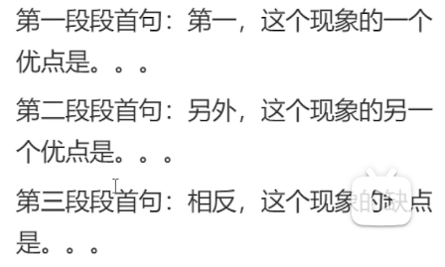
1+2+1
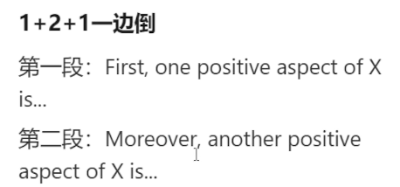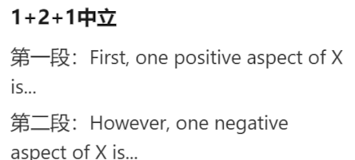
替换：
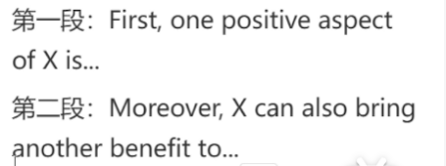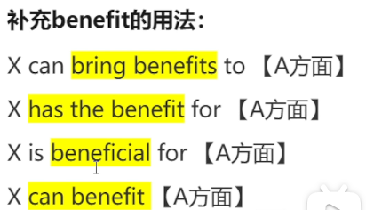
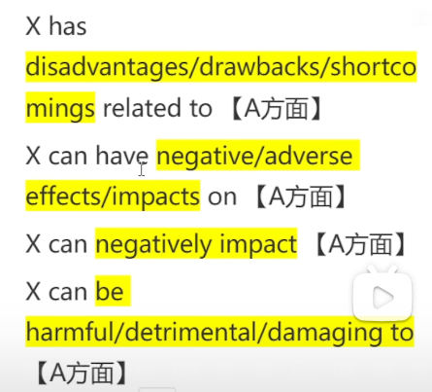2
补充：
however, it is important to note/acknowledge the negative aspect of X.（逻辑转折的空洞的橘子）
1+3+1 一边倒:
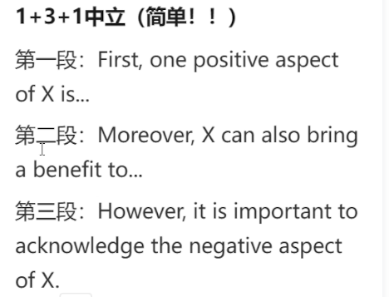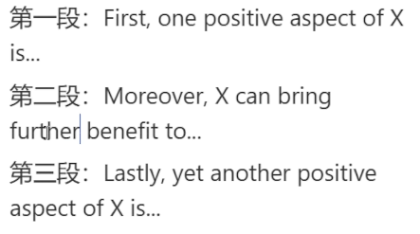
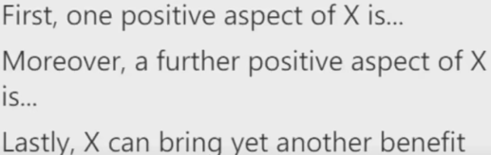

段首句展开：
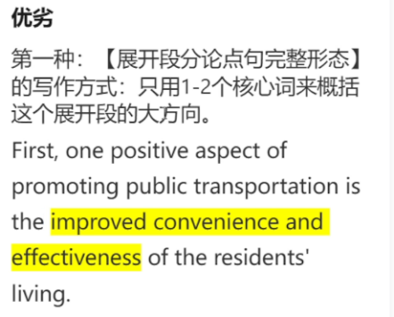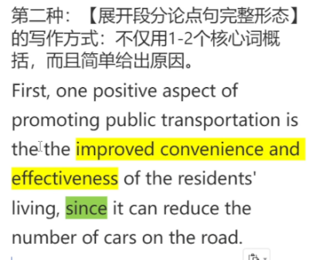第一种更好，适合下文展开说
第一种的improved可以换词，见词库；
更简便：
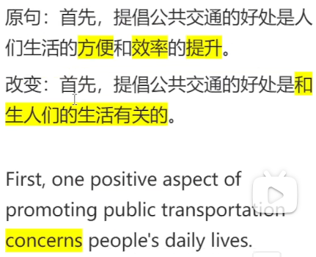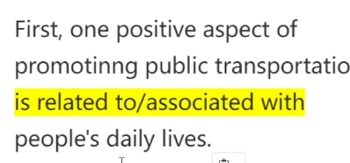
拆成两句话：
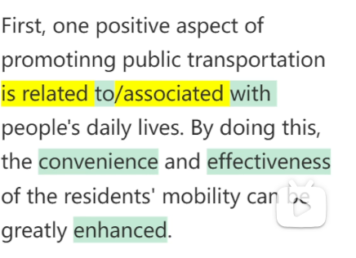

因果关系：
because：强调原因
since、as：强调结果
lead：a lead to b
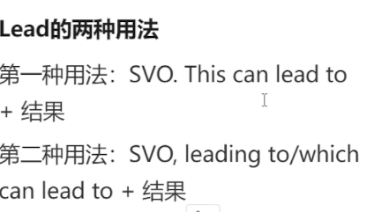SVO：一个完整的句子
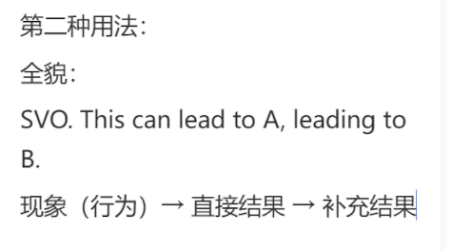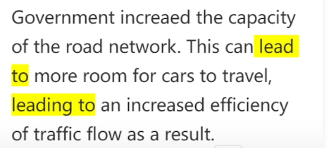
改善重复：
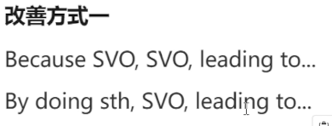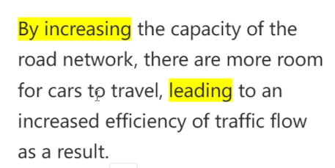

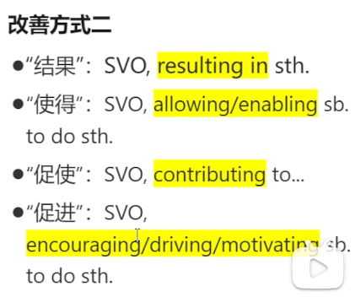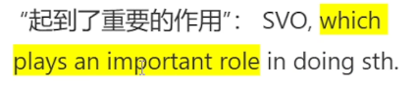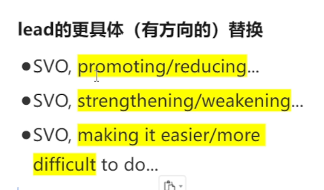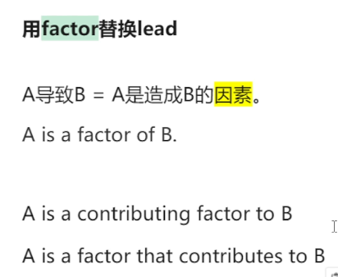
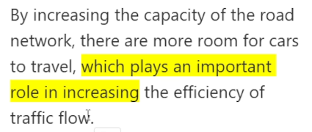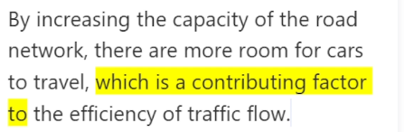

therefore/ as a result/ consequently
在总结句使用
thus / in turn/ thereby 因此
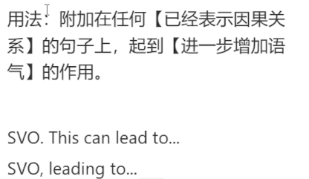
which means:
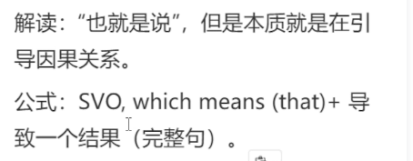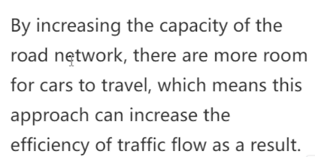

构建一个分论点：
（范文）
（GPT写的中立开头）The decision of elderly individuals to spend money on themselves rather than saving for their children after retirement has sparked widespread debate. This choice has both positive aspects and potential negative implications, and this essay will explore these facets in a neutral manner.

first, one positive aspect of elderly people saving for themselves is related to their lifestyles. to begin with, it is clear that an increasing number of elderly people choose to spend money on some advanced household appliances（家用电器）. these devices can greatly enhance the convience and comfort of their daily routine, resulting in an improved quality of life. For example, a rice cooker and a microwave oven can reduce the physical effort required on preparing the meals for the elderly people. in addition, seniors can also spend money on meaningful experiences such as holiday or travel. by engaging in such activities and events, older individuals have the chance to break routine and monotony of everyday lives, thus reducing stress and promoting their overall mental and emotional well-being.

after a long working period, older people who are retired choose spending money on themselves is beneficial for their health, and make them have an pleased later life.
otherwise, facing the problem that in our society, young people are struggled about making money, it is reasonable for older people to saving for their children.

十二. 补充：
- 小一小二：
①第一：
To begin with
one concern
Specifically/ Primarily 首当其冲的是。。。
In the first place
For one（和For another 对应）
②第二：
Additionally/ In addition
Moreover/ Furthermore/ What's more
Another concern
Also
For another
- 段首句怎么写
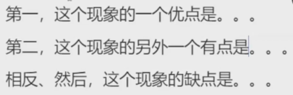
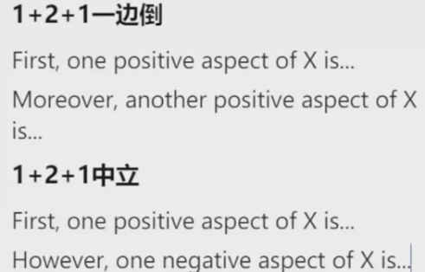

小作文

一. 小作文类型及要求

图表
折线图linechart
柱状图 bar chart
饼图 pie chart
表格 table

流程图

地图

要点
不可以有主观或者个人的观点，要客观准确全面

动态图和静态图
动态图：有时间维度，趋势，连续性，可以插入中间值
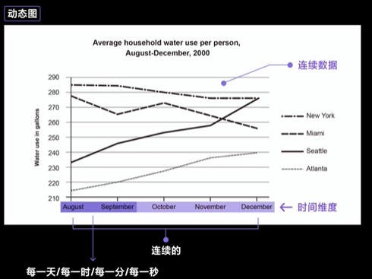
时间具有连续性—数据具有连续性—体现变化趋势
静态图：无时间维度，独立的，不具有连续性
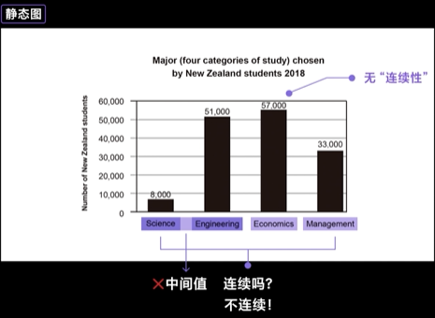
不连续，无变化趋势，是数据之间的比较—difference
问题：summarize the information by selecting and reporting the main features, and make comparisons where relevant.
①选择并报告图形的所有主要特征
②做比较

features
即图表中所有我们可以唯一看到的内容
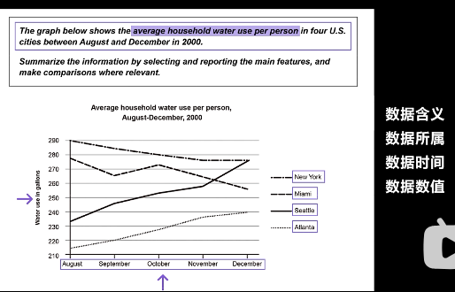

make comparisons
数据：最大值 最小值 等值 差值 倍数 大于 小于
趋势：上升 下降 波动 稳定 ——形成趋势（只存在于动态图）
描述趋势变化程度：剧烈 平缓

二. 小作文每段怎么写
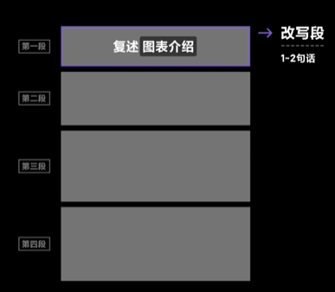
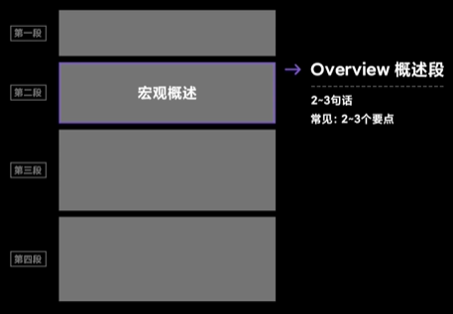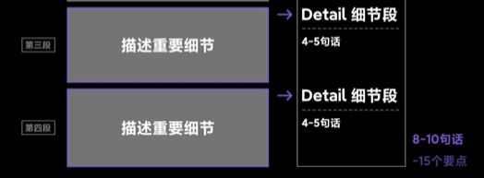
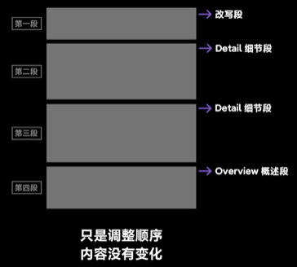

（一）首段
改写：换词 换位置 概括
换词：

proportion—— percentage
information—— data
number—— figure
types—— categories
trends—— changes
换位置：

概括：

eg:
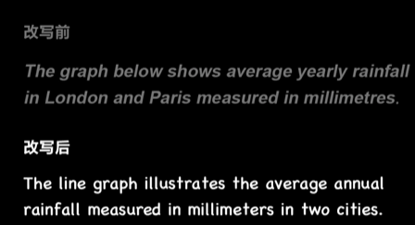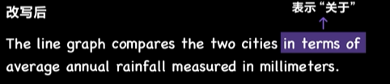

（二）概述段和细节段

概述 整体形状
动态图：提取变化趋势方面的宏观特征
静态图：提取差异方面的宏观特征
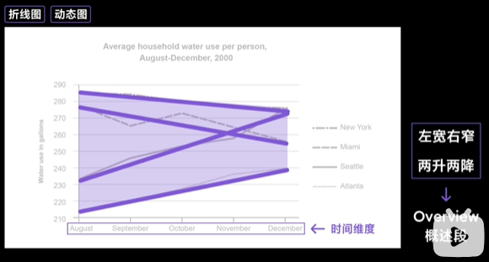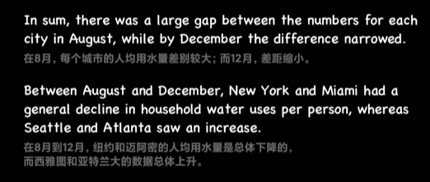
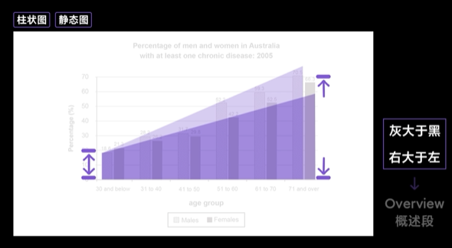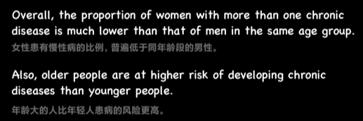
注意静态图：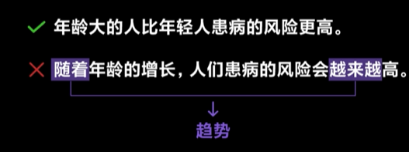
饼图：
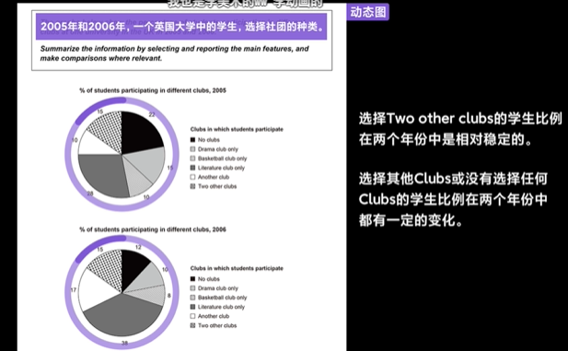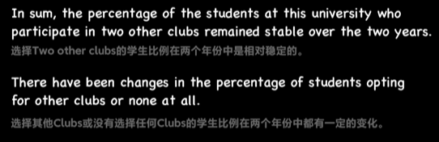
表格图：
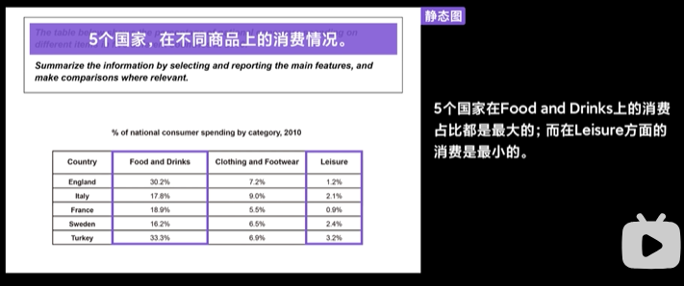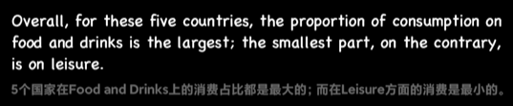

细节性内容的组织方式
分组方式：时间、排名、自身特点
①时间
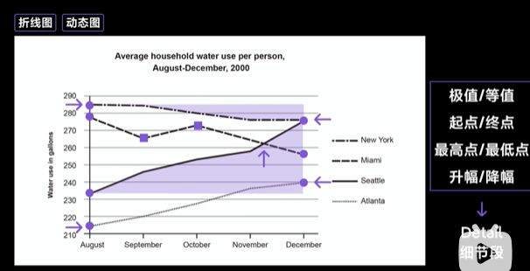
②排名

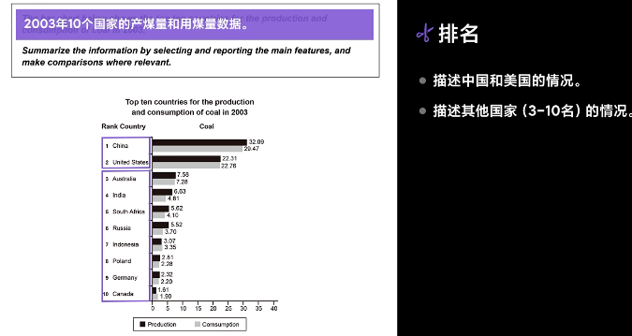
③自身特点
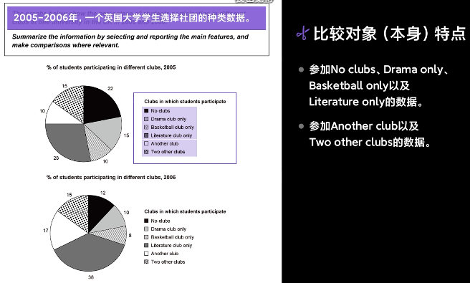
④比较维度
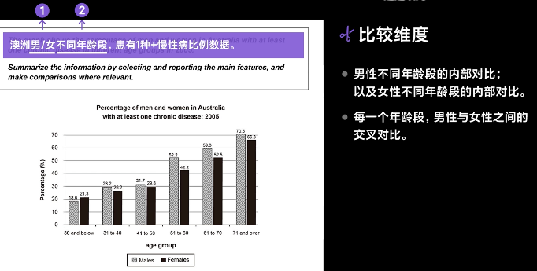
⑤图表数量
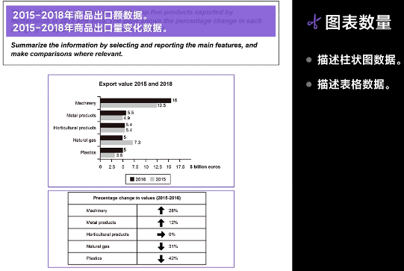

引导词：逻辑连接词
①X和Y是不同的数据
as for X ; concerning Y
②相似、相反
similarly ; likewise ; by comparison ; by contrast ; on the other hand ;
③不同的图表
as shown in the first chart ; as shown in the second chart ;

注意事项
①时态：
过去完成进行时：have been doing
到某个时间（过去的时间）为止，一个数据的状态一直是怎样的
现在完成进行时：
到某个时间（现在的时间）为止，一个数据的状态一直是怎样的

将来完成进行时：will have been doing
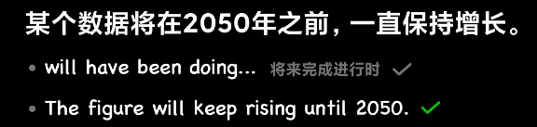
②逻辑连接词
递进 类比 转折/对比：客观的建立数据之间的相似或者差异关系


高分表达
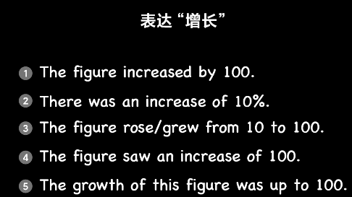
主句+辅句
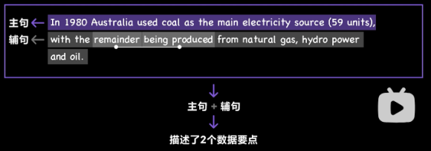
①前后结合
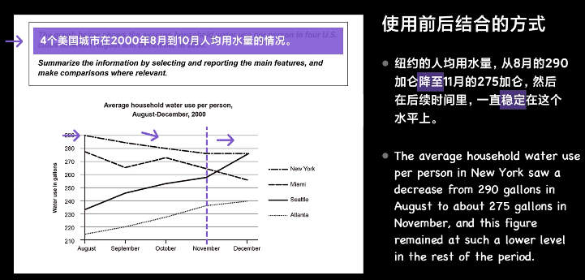
②文理结合
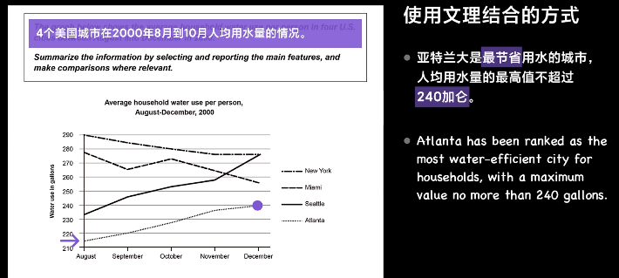
③动静结合
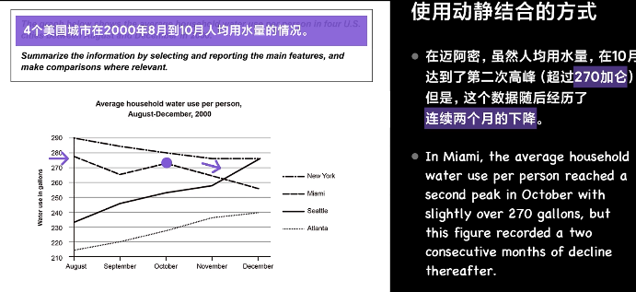
④宏微结合
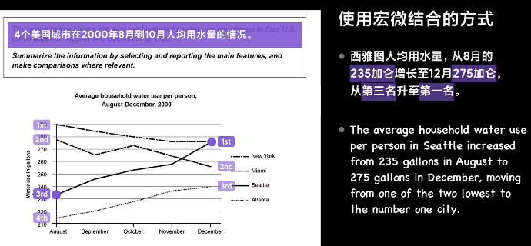

三. 动静结合图、饼表结合图范文举例

（一）动静结合图
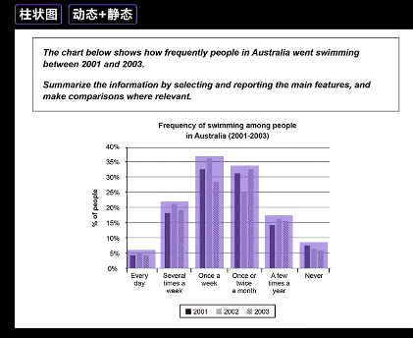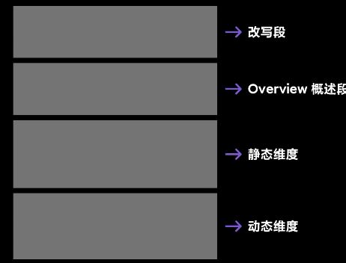
开头改写：the bar chart illustrates the frequency with which people swam in Australia between 2001 and 2003.

概括段：in sum, the proportion of people who swam irregularly weekly and monthly was the highest. As for those who swam with different frequencies, the trend varied from 2001 to 2003.

对数据的细节段描写（静态）：
of these, the largest group was those who swam at least once a week, with an average percentage of over 25% and a peak over 35%.
the percentage of people who swam one to two times a month was also high, with the lowest measurement being only 25%.
at the same time, 15% to 20% of the population swam serval times a week or several times a year, while only about 5% of people swam everyday or never swam at all.
对数据的细节段描写（动态）：更关注一组数据中的变化趋势
in 2002， there was a large increase (about 5%) in thepercentage of people who swam once a week and a considerable decline (more than 5%) in the percentage of people who swam once or twice a month.
During these three years, there was relatively little variation in the percentage of people who swam daily or several times a year, fluctuating only by 1 to 2%.
of the trends monitored, only the percentage of those who never swam showed a continuous downward trend throughout the cource the three years.

（二）饼表结合图
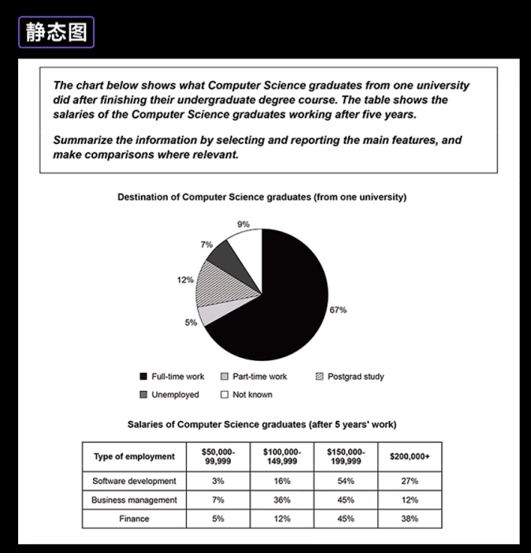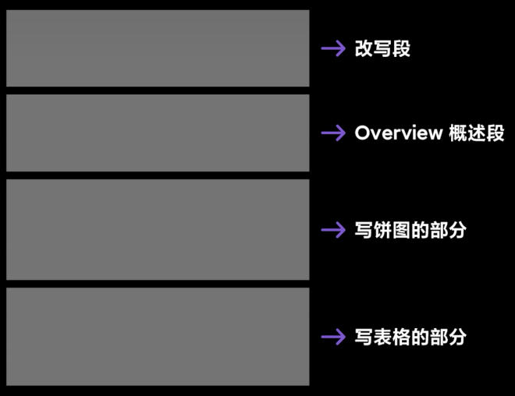

开头改写：

概括段：
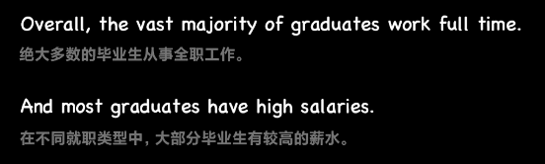
细节段（饼图）：对数
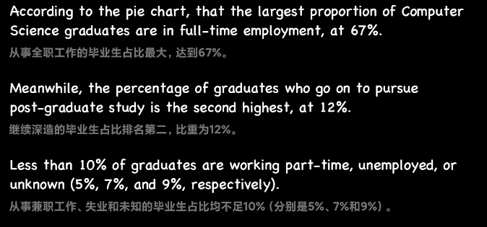
细节段（表格）：
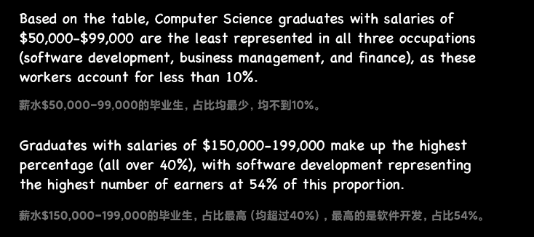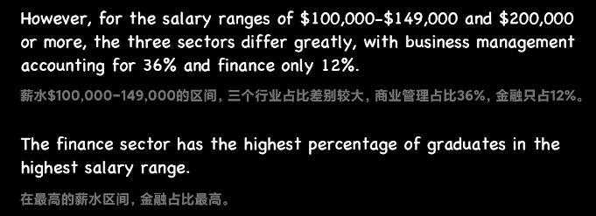

四. 流程图小作文

介绍
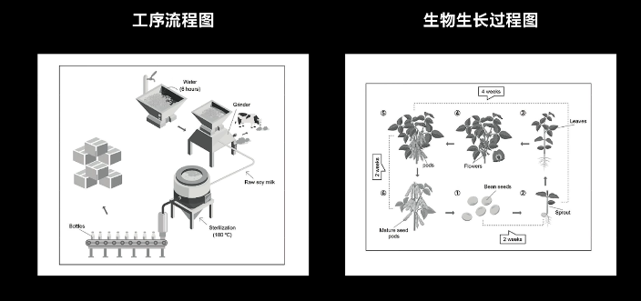
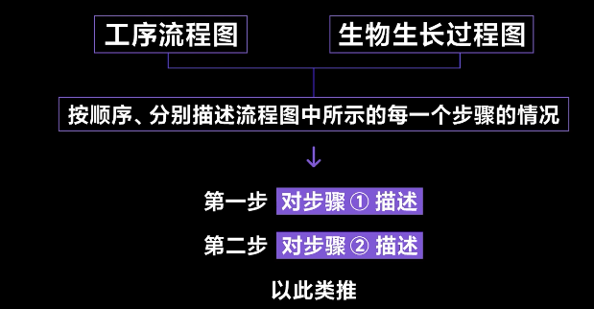
工序流程：被动语态；一般现在时；
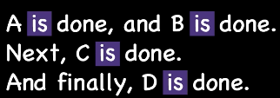
生物生长：主动语态；一般现在时；

段落组成
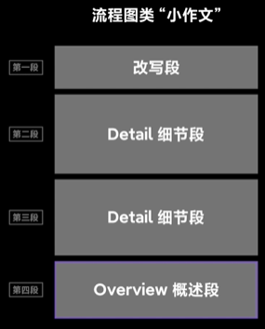

高分特点
图形整体的描述；文字、数字解释性内容；完整性
表达方式：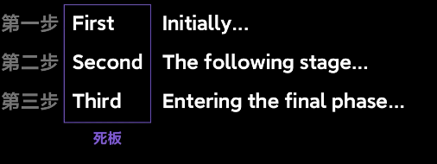
主辅结合： 

范文实例
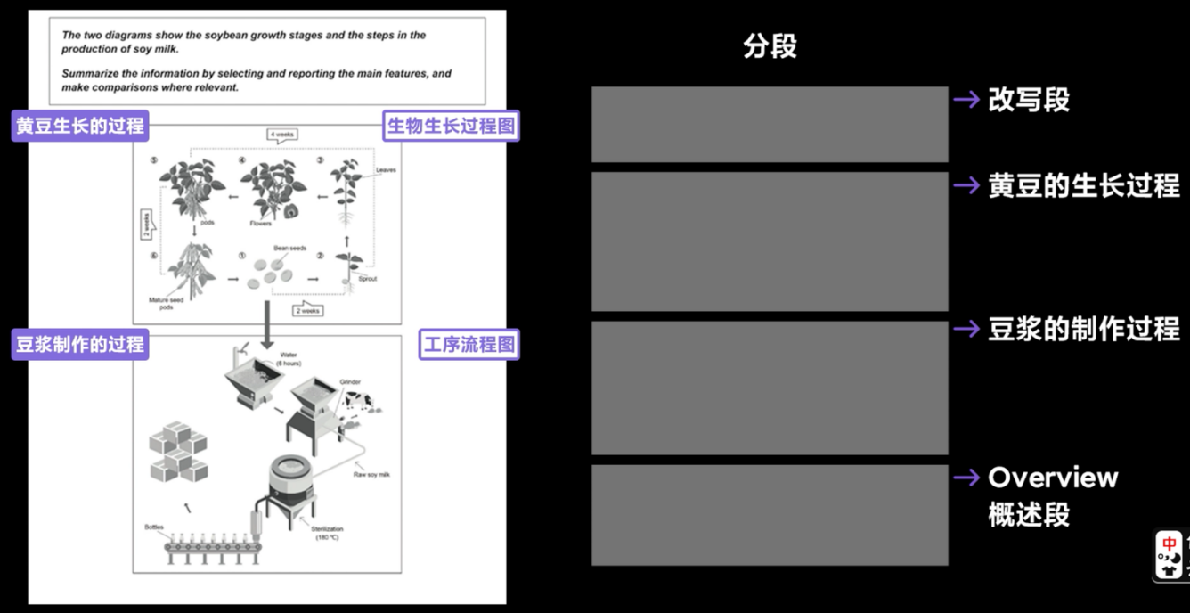
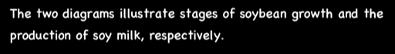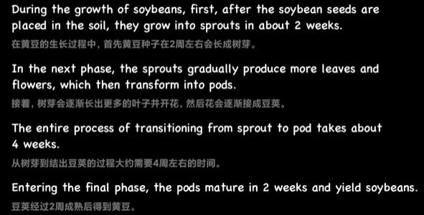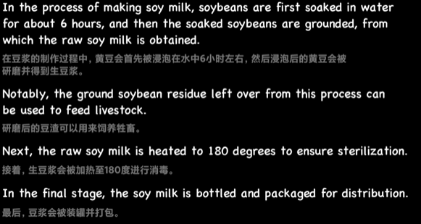

五. 流程图小作文

类型
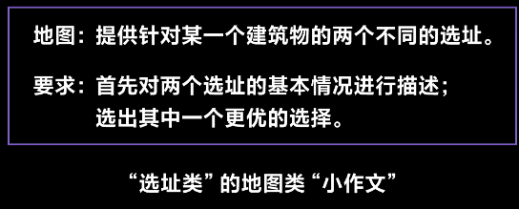
变化类更重要

段落组成
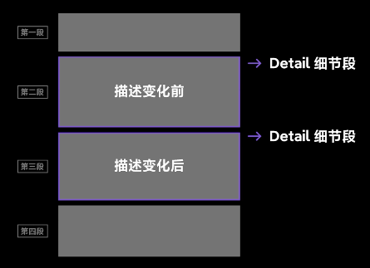

范文实例
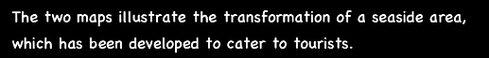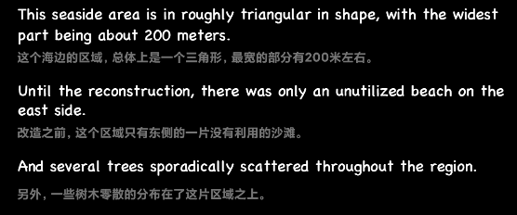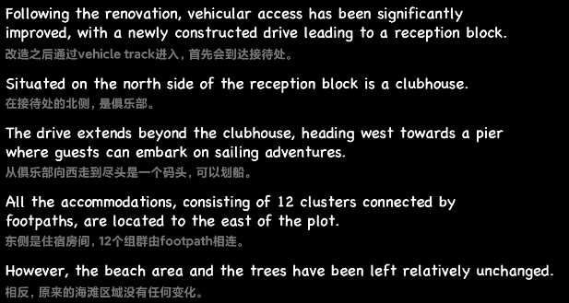

六. 补充小作文 词用法
- 小写
three categories of items – food, drinks and tobacco, clothing and footwear,
and leisure and education- in five countries - Ireland, Italy, Spain, Sweden and
Turkey - in 2002.
The bar chart shows the number of minutes of three kinds of telephone calls -
local fixed line calls, national and international fixed line calls, and mobile calls -
that were made in the UK in the seven year period between 1995 and 2002.

- number of = countable
amount of – quantity of – volume of = uncountable

①The line graph shows the amount of water that was used globally by agriculture,
industry and in homes, in the 100 year period between 1900 and 2000.
②The line graph shows the amount of water that was used globally divided into
three categories - agriculture, industry and homes - between 1900 and 2000.
①The second bar chart shows the percentage of American adults who were
married, divorced, never married, or widowed in 1970 and 2000.
②The second bar chart shows American adults divided into four groups by marital
status - married, divorced, never married, and widowed – in 1970 and 2000.
①The bar chart shows the percentage of Australian men and women who
regularly exercised in 2010, divided into 6 groups by age .

- 预测
a forecast / a prediction (of future consumption - production - use) until / for
2030.
...together with a forecast [of future consumption] until 2030.

- together with用法
the graph shows X AND Y – X together with Y – this requires X and Y to have the SAME subject – for example, the same graph

①The first bar chart shows the number of American adults who got married and divorced in the 30 years from 1970 to 2000, and the second chart shows the percentage who were married, widowed, divorced or never married in 1970 and 2000.
②The line graph shows the amount of energy that was produced from six different
kinds of fuel in the USA in the 28 year period from 1980 to 2008, together with a
forecast until 2030.

封神：The top line graph shows the amount of water that was used globally by
agriculture, industry and in homes between 1900 and 2000. The table below
shows the quantity of water (that was) used per person in Brazil and the Congo in
2000, together with the amount of irrigated land and the population of the two
countries.

