Partner: An AI That Does Research While You Sleep
LLM generates text. Agent executes tasks. Partner does research — on its own.

The Problem
As a researcher, I have more ideas than time. Papers to read, experiments to run, code to review, and connections to find between projects. No matter how fast I work, the backlog grows.
What if I had a research companion that worked independently — reading papers, exploring my codebase, building a knowledge base, and proposing new ideas — while I focused on the hard problems?

The Three Layers of AI
We've seen two layers of AI tools:
LLM: You ask → It answers → Done
Agent: You command → It executes → Waits
LLMs are passive — they need a prompt. Agents are reactive — they need a command.
I wanted something proactive: an AI that starts working when you turn it on, accumulates knowledge over time, and reports back when you ask.
Partner: It works on its own → You ask "what have you been doing?" → It reports

Introducing Partner 🤝
Partner is an autonomous research entity. It sits on top of existing agent frameworks (like how agents sit on top of LLMs) and conducts research independently.
The core interaction is beautifully simple:
"Hey Partner, what have you been doing?"
And it tells you everything it discovered while you were away.

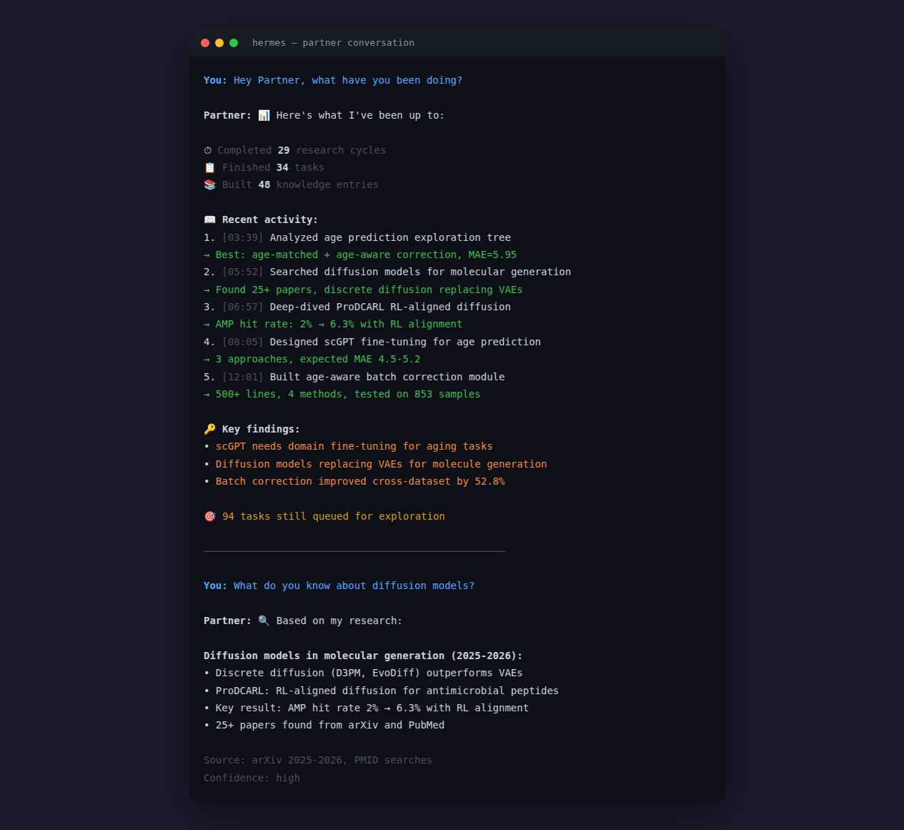
Figure 1: Partner conversation — asking what it has been doing

How It Works
Partner runs in the background, executing a research cycle every 30 minutes (configurable). Each cycle:
- Picks a task from its queue (self-generated or user-injected)
- Executes it via the agent backend (web search, code analysis, etc.)
- Records findings in its knowledge base
- Generates new tasks based on what it learned
- Repeats — forever

┌──────────────────────────────────────────┐
│ 🤝 Partner │
│ ┌──────────┐ ┌──────────┐ ┌──────────┐ │
│ │ Task │ │Knowledge │ │ Journal │ │
│ │ Queue │ │ Base │ │ System │ │
│ └──────────┘ └──────────┘ └──────────┘ │
└──────────────────┬───────────────────────┘
↕
Agent Backend (Hermes, OpenClaw, Codex, ...)

Events: The Heart of Partner
An Event is one complete research cycle — like how Agents have Skills, Partner has Events.
Each Event follows a structured flow:
📖 Literature → Search and read papers
🔬 Project Scan → Analyze your codebase
💡 Idea Generate → Propose improvements
🧭 Exploration → Try new directions
📝 Knowledge → Record findings
🌱 Spawn → Create new Events

Events grow on their own — one Event's findings automatically spawn new Events. The research never stops.

Real Results
I ran Partner overnight on my bioinformatics research projects. By morning:
- 29 research cycles completed autonomously
- 34 tasks finished
- 48 knowledge entries accumulated
- 94 tasks queued for future exploration

Key discoveries Partner made on its own:
Finding | Impact
scGPT needs domain fine-tuning for aging tasks | Avoided a dead-end approach
Diffusion models replacing VAEs for molecule generation | Found 25+ new papers
Batch correction improved cross-dataset generalization by 52.8% | Quantified the improvement
ProDCARL RL alignment boosted AMP hit rate from 2% to 6.3% | New method for antimicrobial design

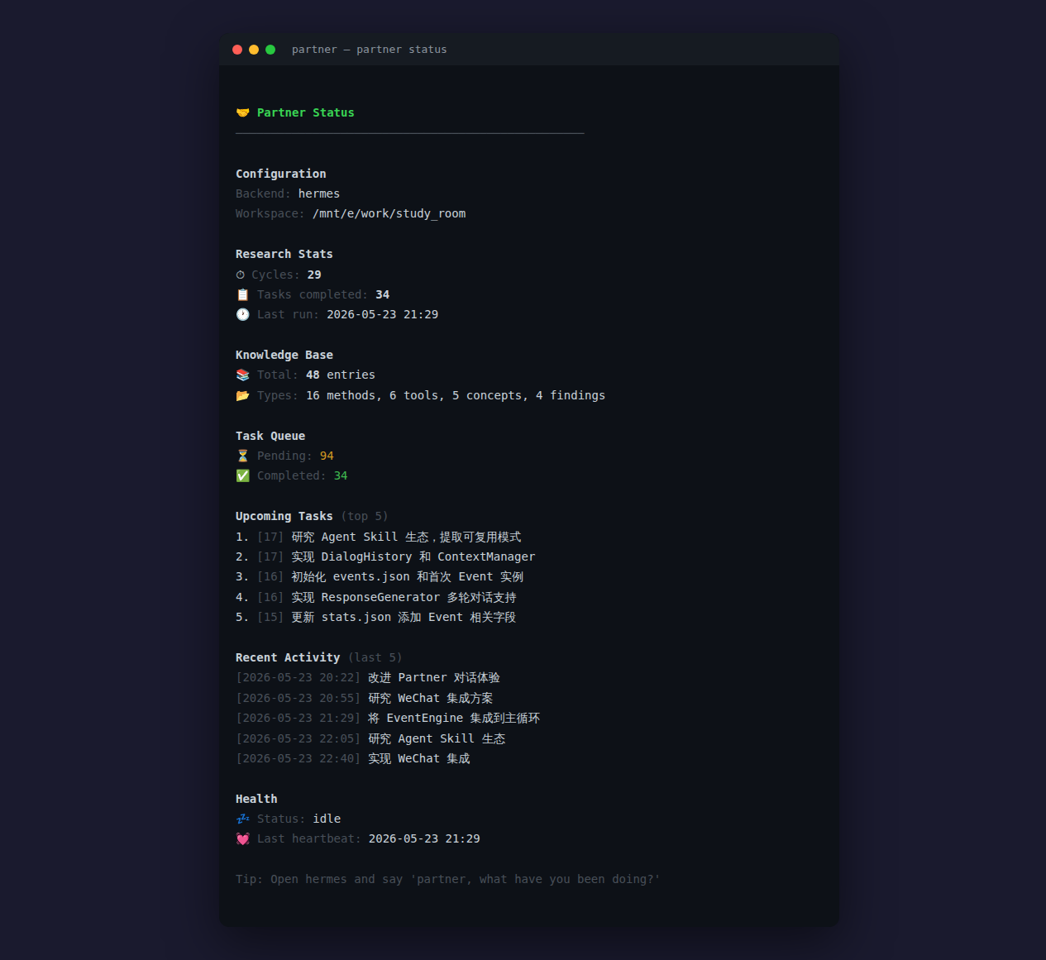
Figure 2: Partner status dashboard — overnight research results

Multi-Agent Support
Partner works on top of existing agent frameworks — it doesn't reinvent the wheel.
Agent | Status
🔮 Hermes Agent | ✅ Full support
🦞 OpenClaw (小龙虾) | ✅ Supported
⚡ OpenAI Codex | ✅ Supported
👥 CrewAI | ✅ Supported
💻 gptme | ✅ Supported
🤖 AutoGPT | 🔜 Coming
👐 OpenHands | 🔜 Coming
🧠 Claude Code | 🔜 Coming

Run partner setup to auto-detect installed agents.
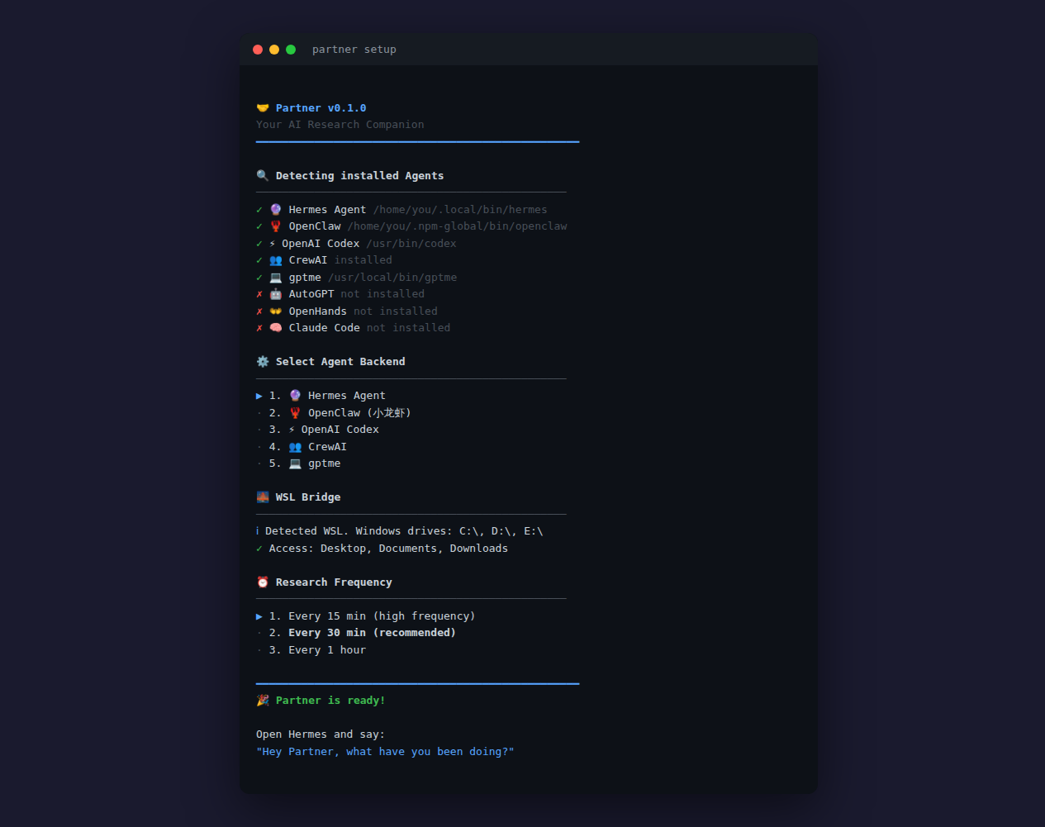
Figure 3: Partner setup — auto-detecting installed agent backends

Cross-Platform
Partner runs on Linux, macOS, Windows, and WSL. On WSL, it can automatically access your Windows files through the WSL Bridge.

Getting Started
git clone https://github.com/zty522/partner.git
cd partner
pip install -e .
partner setup
Then open your agent (Hermes, OpenClaw, etc.) and say:
"Hey Partner, what have you been doing?"

What's Next
- WeChat/QQ integration — ask Partner via voice message
- Community Events — share and install Event templates
- Multi-Partner collaboration — multiple Partners working together
- More agent backends — Claude Code, Cursor, and more

──────────────────────────────────────────────────
Partner: because research shouldn't wait for you.
GitHub: github.com/zty522/partner

