SQL Database Project
Online electronics retail database (SQLite) | Data Science | Individual report

1. Overview
The database represents an electronics retailer's data, which is carried out online. It has 1,500 customers, 120 products, 5,000 orders, 9,626 order lines, and five related tables from January 2023 to September 2026. The largest tables easily surpass the 1000-row requirement and all four measurement scales - nominal, ordinal, interval and ratio - are represented. The SQLite file is the file electronics_shop.db.

2. How the data was generated
The data was all created by a single Python script (see Section 6) with only the standard library (random, sqlite3, datetime). No external datasets were downloaded. A fixed random seed (42) makes the database exactly reproducible. Each table has been created in dependency order meaning that all foreign keys will point to a row that is already in the table:
Categories and products (8 and 120). Product names are a mixture of fictional brands and model specific names for the category. The distribution of prices is skewed and it ends in .99 in a realistic range within each category of price (cheap items are the most common). Weight and stock level is based on category appropriate ranges.
Customers (1,500). The names are taken from a small pool of names for the first and last names, and the emails are unique with the reserved domain email@example.com. City, Tier (50/28/15/7% Bronze to Platinum) and Marketing Consent are weighted draws. Sign up dates are even between 2022 and 2026, and birth years are triangularly distributed such that all customers are adults.
Orders (5,000). Weights are assigned to customers – Platinum gets ordered more often than Bronze (8 times). Order dates happen after the customer's registration date, and reach their highest point in July and November-December. Status indicates the date, and the orders placed in the last 10 days are only Processing or Shipped. The delivery time is slightly less with Gold and Platinum, and ratings are reduced by deliveries of 6 days or more. There is no rating for cancelled orders and only 60% of orders delivered have a rating.
Order items (9,626). There are 1-5 different products in each order, selected using a popularity weight. The quantity is dependent on the price; the sale price is up to 5% off the list price and discounts are based on tier plus a seasonal promotion in November and December.
Validation. > PRAGMA foreign_key_check returned no violations > PRAGMA integrity_check returned ok > No order is dated before its customer's signup date.
Sample of the data produced. Here are the first rows of each table, stored in electronics_shop.db and as they were created, the number of rows reported by the database viewer.
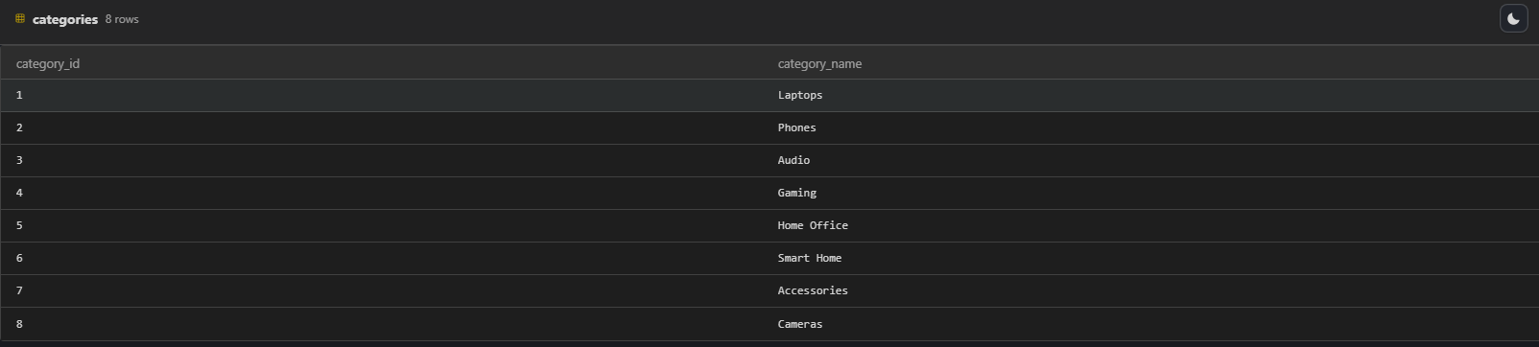
Figure 1:categories table (8 rows): lookup of product categories.
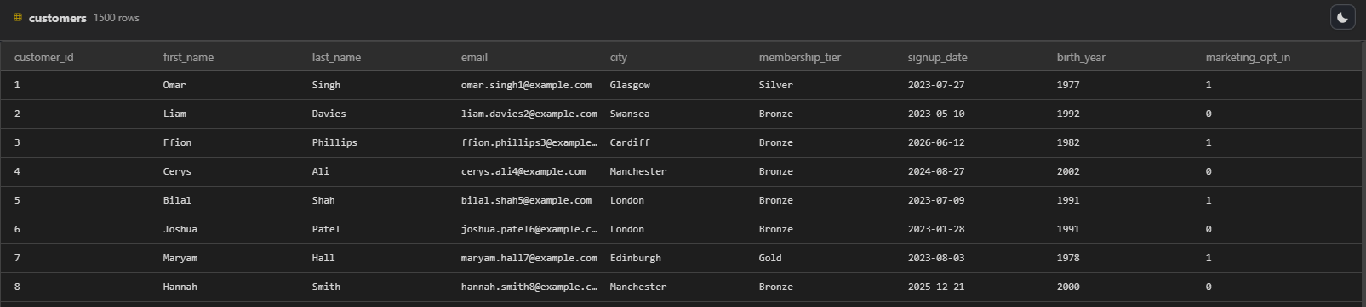
Figure 2: customers table (1,500 rows): synthetic names, example.com emails, tier and consent flag.
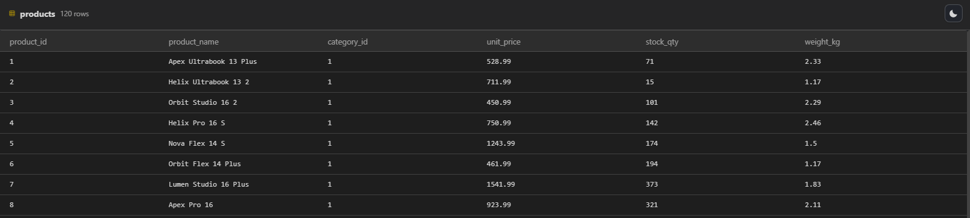
Figure 3: products table (120 rows): fictional brands, category foreign key, price, stock and weight.
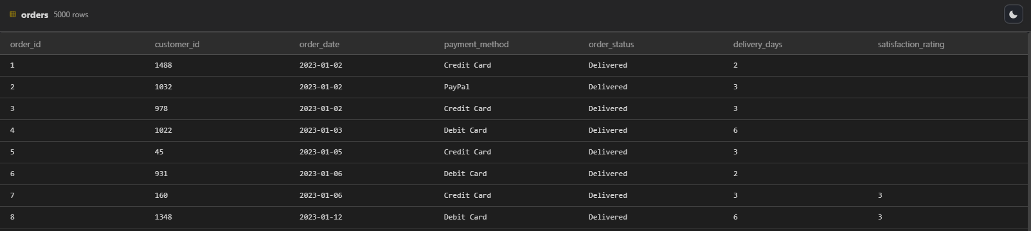
Figure 4: orders table (5,000 rows): customer foreign key, status, delivery days and nullable rating.
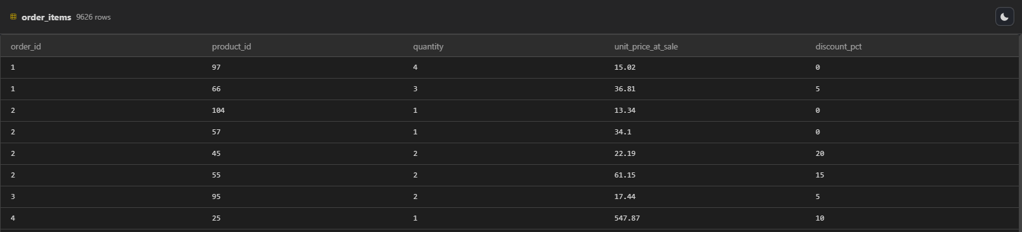
Figure 5: order_items table (9,626 rows): compound key (order_id, product_id) with price at sale and discount.

3. Database schema
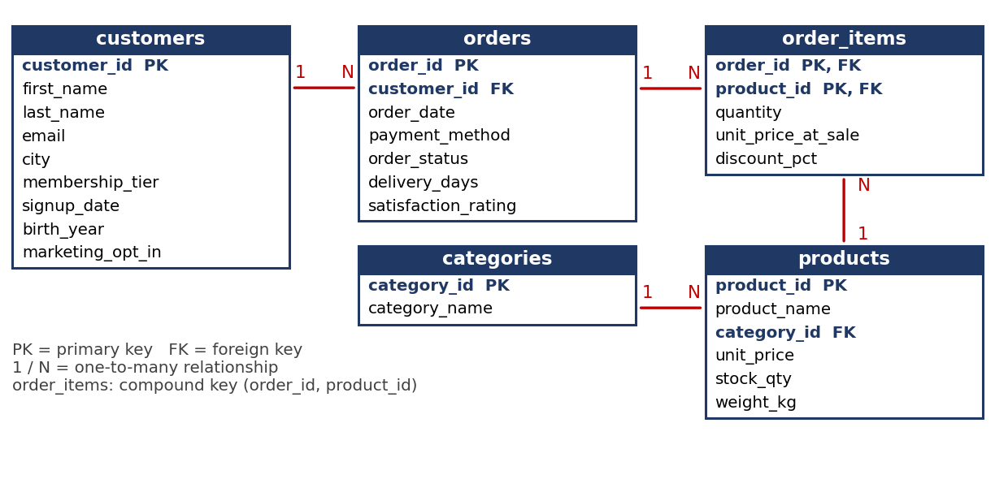
Figure 6: Entity relationship diagram of the five tables.
Scale | Columns
Nominal | city, payment_method, order_status, category_name, product_name, email, first_name, last_name
Ordinal | membership_tier (Bronze < Silver < Gold < Platinum), satisfaction_rating (1 to 5)
Interval | signup_date, order_date, birth_year (differences are meaningful, zero is arbitrary)
Ratio | unit_price, unit_price_at_sale, quantity, discount_pct, stock_qty, weight_kg, delivery_days (true zero)

4. Justification for separate tables and constraints
Table | Rows | Reason for a separate table
customers | 1,500 | Customer details are stored once instead of being repeated on every order (third normal form).
orders | 5,000 | One row per purchase; holds order-level facts (date, payment, status, delivery, rating).
order_items | 9,626 | Resolves the many-to-many link between orders and products. The compound primary key (order_id, product_id) stops the same product appearing twice on one order. unit_price_at_sale keeps the historical price when list prices change.
products | 120 | Product facts are stored once; referenced by order_items.
categories | 8 | A lookup table avoids inconsistent category spellings and allows categories to be renamed in one place.
Constraints. Each of the tables has its own primary key, and all of the relationships are constrained by foreign key (PRAGMA foreign_keys = ON). All fields required are NOT NULL, and email, product_name and category_name are UNIQUE. CHECK constraints restrict values to valid values: tier lists, status lists, rating 1-5, price > 0, stock >= 0, quantity > 0, discount 0-50, opt-in 0 or 1, delivery_days 0-30 and an adult birth-year range.
The following details (delivery_days and satisfaction_rating) are intentionally left as nullable, since they are actually unknown where an order has been cancelled, is new, or not reviewed. This provides realism of the missing data to deal with in the subsequent data preparation process. It improves performance for time-based queries and joins by creating indexes on foreign key columns and order_date. Dates are stored as text in ISO-8601 format, sortable in SQLite.

5. Ethical and data privacy discussion
Synthetic data. There is no real person to represent, thus there is no consent or problem arising for re-identification. Names are generated from a generic pool, thus, the possibility exists that it may be the same as someone's name, but it isn't. Example.com is a domain reserved for documentation, and no real mailbox was ever available for receiving e-mail.
Artificial in appearance. The schema is based on the principles of UK GDPR and Data Protection Act 2018. It does so via data minimisation, which means that birth year, not a full date of birth, is recorded; city, not a street address; and no phone numbers, card numbers or passwords, only the payment type (bank, credit card, or cash). It lets you do purpose limitation with an explicit marketing_opt_in consent flag. In a live system, customer rows would be anonymised, access limited, etc., and new requests for the erasure of customer rows would be processed by anonymising a customer row, ensuring that order history was still valid.
Re-identification and fairness. Quasi-identifiers like city, birth year and tier are possible in a small population and would require aggregation or generalisation before becoming suitable identifiers for sharing. In actual business, discounts and delivery speed may need to be tiered, but this should be reviewed to ensure that the lowest tier customers are not disproportionately disadvantaged by the analytics that are created on their discounts.
Limits of realism. The distributions (city mix, names, ratings) are my assumptions of behaviour and not necessarily true. All analysis and models derived from this information are technique only and shouldn't be shown as evidence of actual customers.

6. Code
The full generator, generate_db.py, is commented throughout to justify each design choice. It is available as a GitHub repository: https://github.com/zu25aam/SQL-db. Running it recreates electronics_shop.db identically.

