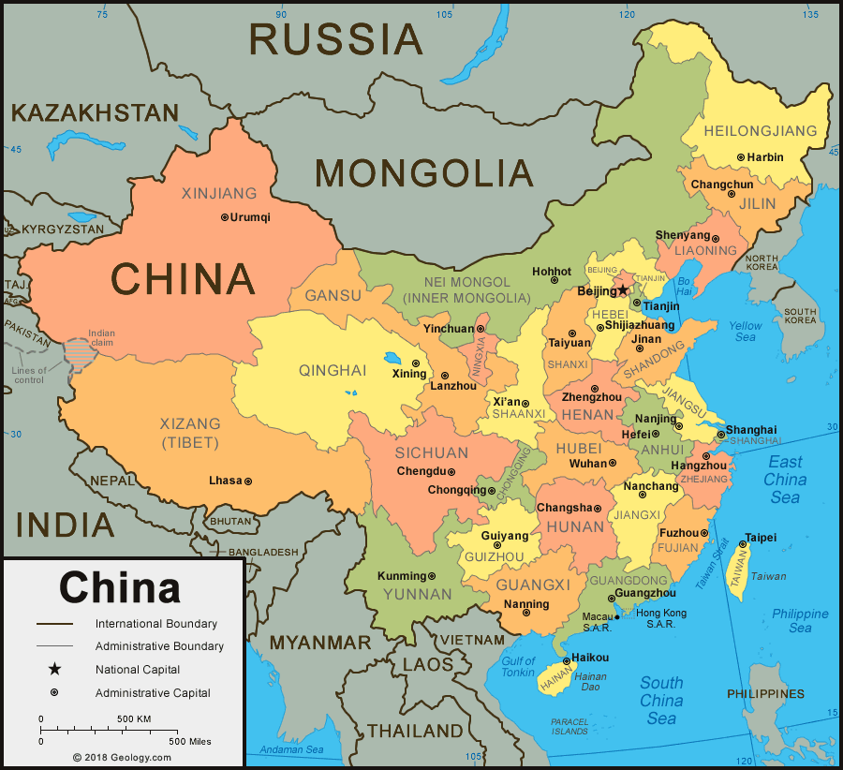[China Notes](file:///C:\Users\aaron\Creating\Writing\Pieces\China\China_Notes.docx)

[Western Peace](file:///C:\Users\aaron\Creating\Writing\Pieces\China\Western%20Peace.docx)

[Northern Capital](file:///C:\Users\aaron\Creating\Writing\Pieces\China\Northern%20Capital.docx)

[Four Seas](file:///C:\Users\aaron\Creating\Writing\Pieces\China\Four%20Seas.docx)

[Engrish](file:///C:\Users\aaron\Creating\Writing\Pieces\China\Engrish.docx)

[Cross Cultural](file:///C:\Users\aaron\Creating\Writing\Pieces\China\Cross%20Cultural.docx)

[Chinese Zodiac](file:///C:\Users\aaron\Creating\Writing\Pieces\China\Chinese_Zodiac.docx)