David Schutter // [Rhona Hoffman Gallery](https://www.rhoffmangallery.com/artists/david-schutter?view=slider#6)

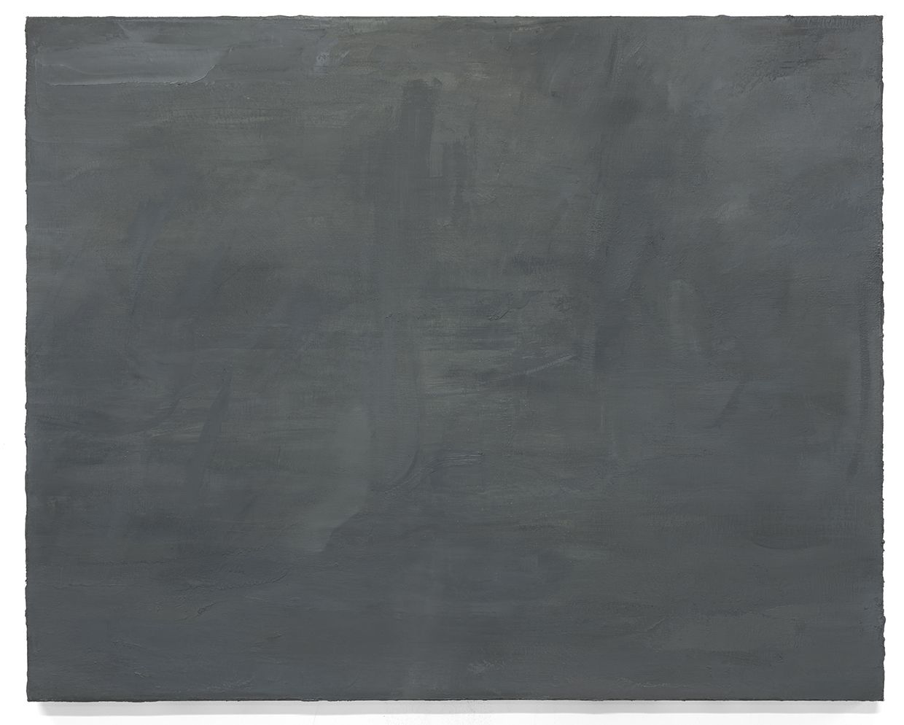

In his approach to his subjects, Schutter locates his practice within the traditions of philosophical inquiry by beginning with the surfaces of things. His questions elicit responses to how we re-stratify our knowledge of the past while developing representations of the present, how we can uncover circumscribed categories and make new knowledge from the experience, and how repeated questions come to be ultimately forms of description in a world where the past is often a difficult and arguable anteriority.