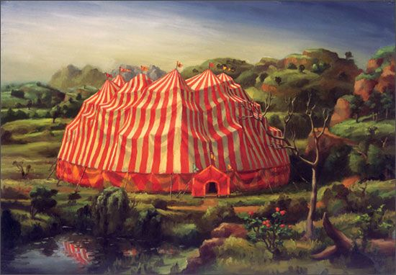

**Wudgie, Mudgie, and Pudgie**

Sources--

Chip and Dale’s Rescue Rangers

Duck Tales

The Lost City of Gold

Belle and Sebastian

Voltran

The Scarlet Pimpernel

Jack London

Herman Melville

Ambrose Bierce

John Muir

Humbolt

Walt Witman

Henry David Thoreau

Ralph Waldo Emerson

George Washington

Benjamin Franklin

Alternative names

* Flying Swedish Meatballs
* The Flying Swedish Squirrels

Characters

* Wudgie, Mudgie, and Pudgie
* Mr. White- rat, man, giant.
  + He wants to dominate the city for control, for a free hand to set the rules the way he wants them to be. He has really high taxes set on people bringing things into the city, so he makes all of the money. The engineers help people smuggle things in via tunnels and from the lake and the air. The smuggling aspect could have something of the Scarlet Pimpernel about it.
* “STRIDER”
* The Roma
* Gem and Eye: the TWINs— henchmen of Mr. White
* The RAVENS
* Wild horses?’

Scenes

* Dam bursting mind battle between Wudgie(?) and Mr. White

“You’re a rat Lehaver”

“No! I’m a giant!”

* Big top scene showing off their incredible acrobatic skills.
* Description of the Gypsy incampment
* Railcar fire
* Going into the town
* Something to depict the strength but also the vulnerability of Wudgie, Mudgie, and Pudgie.
* The Poe Locks at Ste. St. Marie.
* Out of the way Pony express depot

They pose as performers and inhabit a gypsy camp because it can protect them from the hunters.

I think I could lift heavily from the highlander wit this. There doesn’t have to be a lot of killing, just the threat, the menace, the possibility. Tension to move the story along.

Idea Depository/ mise-en-scene

* Handcar- “Kalamazoo”
* Union suit
* Steam engines
* Tracks
* Mines
* Circus tent
* Smoke
* Fire
* Industrial revolution
* Supernatural
* Cool Scadanavian Style
* Never ending story
* Dumbo
* The Hobbit
* Totoro
* Miyasaki in general
* HIlda
* Rats of Nimh
* J.R.R. Tolkien
* Redwall (Brian Jaques)
* Cat Warriors?
* Joseph Campbell.
* Olive-green-liveried steam train
* Hothouses
* Hock and Bordeaux
* Indestructible tweeds

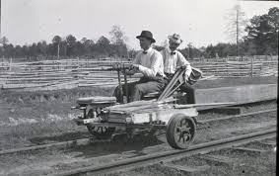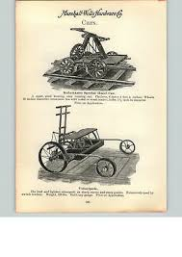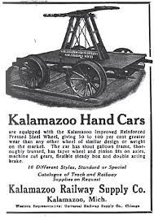

Are they animals? Are they aliens. What are the other people in this world. Its kind of a hard scrambled existence. But The three are siblings that are hiding on this planet because they were royalty on their home planet. Their uncle betrayed their father and they were only able to escape with the help of STRIDER. Mr. White is another alien who initially just wants to control the show. He takes it over after running the three out of town. They replace the best acts with trickery. THE TWINS. Based on the G.I> Joe twins characters (you hit the one and it hurts the other) and those circus twins that performed in Marquette when I was a little kid and we helped them clean up afterwards and they gave me $5?

I went to bed early again. Passed out with Helena beside me in our bed. I remember her squirmed and kicking me in the side a few times, then I wake up and its almost midnight and betsy is coming to bed. I pick Helena up and slide her into her low crib that is now more like a bed with the 4th wall removed.

Esme jumping through the 4th wall in the character of LeBron James. It’s LeBron James and he will now jump out of the Television. And how LeBron James became Mudgie over time—

A TV character on an imaginary show in which I the curious viewer tune in and then am sucked into the show when I press the IN button on my remote control.

Then I join in as Mudgie, joining Wudige and Pudgie, in battling our arch nemesis Mr. White. We are acrobats in a gypsy circus that Mr. White had wanted to take an ownership stake in. We refused to allow him into the business because he seemed untrustworthy. He proved to be untrustworthy and he tries to burn our circus down.

The circus is actually our cover because we are three extraterrestrial creatures who are in exile on this planet. Mr. White is also an extraterrestrial, a serial criminal who has arrived at this far-flung corner of the galaxy to live comfortably and exploit and control and neutralize the people around him.

He is actually a rat, but can make himself appear as a plump little business man in the habit of dressing in white suits, as well as a giant. I had one vision of a scene where Wudgie and Mr. White have a battle of the minds with water rushing down upon them and Mr. White getting swept away in the rush and roar of the water, but that does not necessarily have to be the end of Mr. White. It could also have something to do with another character or even be back story.

Something that was really traumatic for Wudgie. But he saved the day and he survived, even though he realized he had gotten very close to not coming out on top.

This image of Mr. White operating a hand cart and cruising through the Sceney stretch towards Sault Ste. Marie and the Locks and trying to get his boat through the locks and on our along the St. Lawrence Seaway. He needs lots of money because he has a lot of people on pay roll. Whole towns depend on his largesse. The shipbuilders. The miners. He takes control of the mine.

His luxury ship, something inspired by the Day After tomorrow. Mr. White is kind of an Ass, but he has really nice things and is much more connected to the people and the community than the three adventures. He wants to control it though. He wants to be the boss of it. His generosity is on his terms and he is very generous. His birthday is the biggest even in the town. He gives generously to the church and the mayor (or he is the mayor), and the sheriff and the newspaper. He uses the law and public opinion to get back at the Siblings. Older, middle, youngest. Genderless. Compassionate. Daring. Longing for return. Not nostalgically, but preparing, anticipating when it will be their time.

The old ways— they sing a beautiful three part harmony.

They practice a stretching and tumbling martial artistry: Tai qi, yoga, aikido, karate, acrobatics, dancing, they tell stories with their dancing and their tumbling, and they can actually kind of fly, but they obfuscate this a bit with their act.

Staying near the Roma protects them from being sensed on this planet. They are in hiding from their evil Uncle who attempted to grasp control when their grandfather had attempted to hand the power over to the people. Their father had died in the struggle with their Uncle, who vowed that the traditions of the family were more important than the fate and well -being of the country. The three siblings then had to go into hiding. The rebels know where they are and will come for them when the time is right to launch the revolution against their corrupt and greedy uncle.

They could start in New York and then have to leave the New York show scene because there are people looking for them

They are alien orphans from another planet. Stashed on this far-off planet, the bounty hunters are lazy and generally stick to the dense cities where its easy to get information on people because of the ubiquitous surveillance. Information can be expensive, but there is a certain economy between information and bounties. Some cities will go on a purge and sell the information on its non-citizens cheaply, incentizing the bounty hunters to harvest another round of undesireables. If the markets are not right though-- the bounties too low, or the information required to capture them efficiently is too low then most of the Bounty Hunters just lounge around and prepare (or not) for the next hunt. Though there are some of the true believers who never pay for information and simply stalk signs of people who do not belong. They will single people out and then run face recognition software on them. They refuse to pay for information, but they have plenty of technology and honed sky and obsessive patience and hacking abilities that allow them to stay fed in every season, but they tend to mix working and living together much more than the non-believers. They tend to bring back more kills even though that outcome brings a smaller purse.

Mr. White and the Carnival Train.

Barge trip-- carnival on the barge, heading out to the island for a show.

Have to get back from the island, the weather is super inclimate, they shouldn’t try to cross, but they have to get back my morning to make their next schedule engagement. The man who hosted the birthday party on the island turns out to be Mr. White’s nephew. He is very good and kind, but often duped and manipulated by Mr. White.

Is there a battle in the bay, with the waves rocking and rolling and nearly capsizing the whole lot.

Pudgie hears a strange, troubling frequency, but then he harmonizes with it and slowly harmonizes it into calm, the water settles in the bay and Mr. White behind and tree in his white suit has his ear drums blown out.

The Ringmaster is losing his cool-- haven drank too much with Mr. White’s happy-go-lucky son. Michael Razny. Just innocent enough to be likeable sometimes, but then flashes of very obviously what he is and what he will just stew deeper into. Which I suppose is his truth-- beautiful. How can I bring the vitality of a living person to a character in a story?

The Huntsman, a bounty hunter that comes looking for Mudgie, Wudgie, and Pudgie-- but he turns out to be their cousin, who was just trying to make sure that they were okay. He shows up and threatens them, but it turns out he was testing their defenses.

