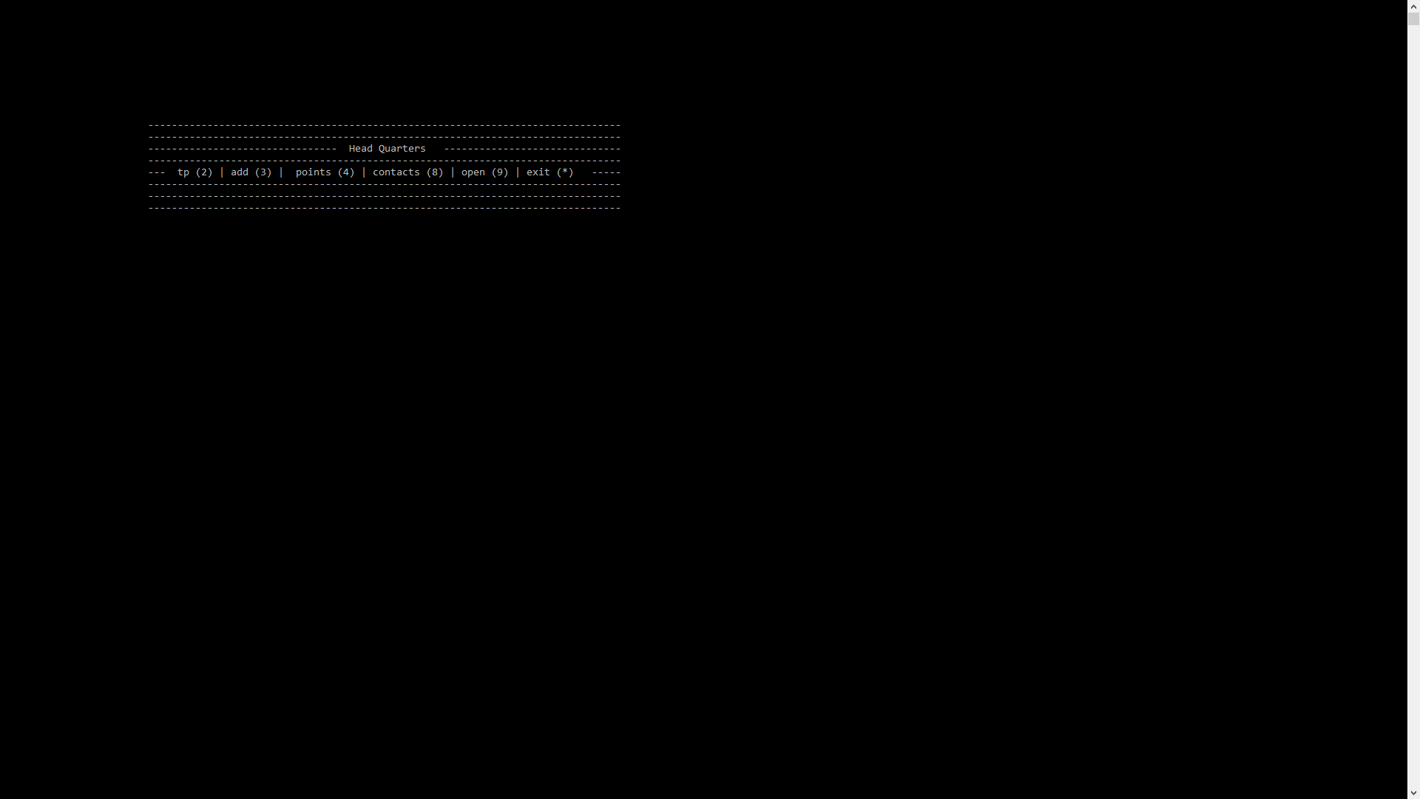

Head Quarters Main Menu Options

* tp -- search an index of all notes
* add -- an entry(person) or a project/topic
* points -- lists all notes and displays menu for displaying them
* contacts -- displays all entry’s (people and projects)
* open -- open a specific entry or project
* exit -- exit the program

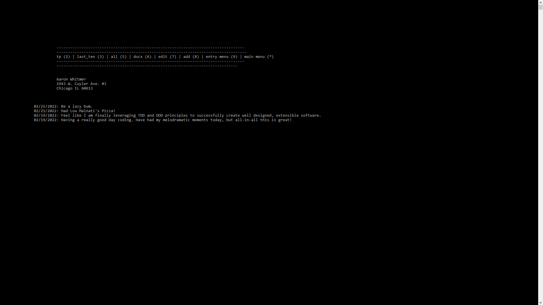

Entry / Project Menu

* tp -- search index of individual notes
* last_ten -- list last ten notes in descending order
* all -- list all notes
* docx -- open entry / project associate Word document
* edit -- edit that entry or project info
* add -- add a note to the entry / project
* entry menu -- return to entry menu view
* main menu -- return to the main menu