CHARACTER ART
& GAME-READY 3D
CHARACTER MODELING / STYLIZED WORLDS / GAME CREATURES
Selected character projects
A compact portfolio copy kit covering realistic sports characters, anime-style modeling and VRM rigging, stylized character recreation for animation, and game-ready creature design.
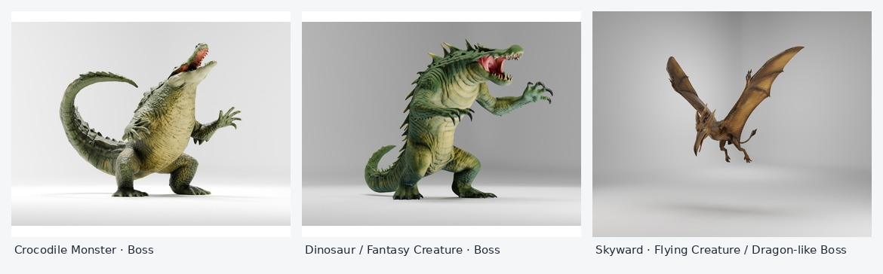
Selected creature designs from the game-character roster
PROJECTS IN THIS DOCUMENT
01 Football Player Characters for Unreal Engine
02 Anime-Style Fox Girl — Modeling & VRM Rigging
03 Michella — Stylized Family Characters for Animation
04 Game Creatures & Monsters — Bosses and Mobs

PROJECT 01 / FOOTBALL CHARACTERS

Football Player Characters for Unreal Engine
Realistic player models, consistent proportions, and a cohesive in-game character look.
3D Character Modeling / Unreal Engine / Sports Character Art / Clothing Integration
PORTFOLIO CARD
Football Player Characters for Unreal Engine
A roster of realistic football player characters developed for a UE game, with focus on body proportions, deformation, hair variation, skin and material quality, and clothing integration.
VIEW PROJECT →
PROJECT TYPE | Character development for an Unreal Engine football game
PIPELINE FOCUS | Unreal Engine / MetaHuman-oriented character workflow
KEY DETAILS | Body variation, realistic skin and materials, hair options, deformation, and uniform integration
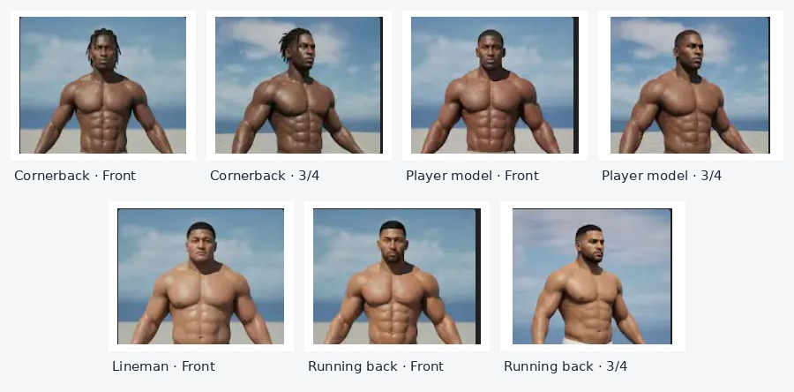  Player model variations and viewing angles | 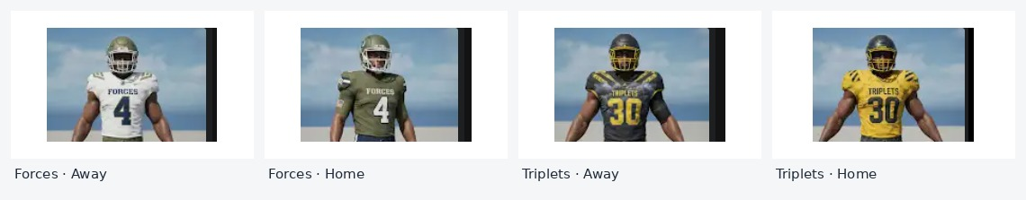  Uniform and team color variations

01 Player types and proportions
The project included varied player builds and roles, including cornerback, running back, and lineman body types. The work required proportional consistency across the roster while preserving the individual silhouette of each player.

02 Realism in skin, hair, and materials
Skin shading, surface quality, and hair variation were important to the final look, helping the characters feel cohesive and believable within a realistic sports-game presentation.

03 Deformation and clothing integration
Careful attention to body deformation and clothing fit helped support the characters’ intended use in an Unreal Engine game. Uniform presentation and material quality were treated as part of the character rather than as an afterthought.
CLOSING LINE A consistent player roster built around believable forms and game-ready presentation.

PROJECT 02 / STYLIZED CHARACTER

Anime-Style Fox Girl — Modeling & VRM Rigging
A stylized character created within a strict 50K polygon budget.
Stylized Character Modeling / VRM Rigging / Polygon Budget Optimization
PORTFOLIO CARD
Anime-Style Fox Girl — Modeling & VRM Rigging
An anime-inspired character modeled and rigged for VRM use, balancing character detail and silhouette with a strict 50,000-polygon limit.
VIEW PROJECT →
PROJECT TYPE | Anime-style 3D character
DELIVERABLES | Character model and VRM rigging
TECHNICAL CONSTRAINT | Maximum 50,000 polygons
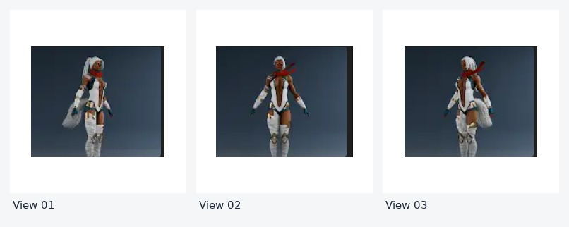
Fox Girl character preview from multiple angles

01 Stylized character modeling
The character was developed around an anime-inspired silhouette, layered costume elements, and a clear visual read from multiple angles. The model balances visual detail with the polygon limit required for the project.

02 VRM rigging and use
Rigging for VRM use was part of the deliverable, with the character prepared for a workflow that depends on a suitable model structure and controllable pose or movement.

03 Working within 50K polygons
The 50,000-polygon budget made efficient use of geometry a core constraint. Detail had to be focused on the areas that contributed most to the character’s silhouette, costume, and overall presentation.
CLOSING LINE A distinctive stylized character, prepared for a constrained VRM workflow.

PROJECT 03 / CHARACTER RECREATION

Michella — Stylized Family Characters for Animation
Turning family photo references into a cohesive, cartoon-inspired character cast.
Stylized 3D Character Modeling / Photo-Based Character Recreation / Animation Character Art
PORTFOLIO CARD
Michella — Stylized Family Characters for Animation
A set of stylized 3D characters created from family photos, translating recognizable family members into a cartoon-inspired visual style for an animation project.
VIEW PROJECT →
CLIENT / PROJECT | Michella character project
REFERENCE | Family photographs supplied for the character recreation
PURPOSE | A stylized family cast designed for animation
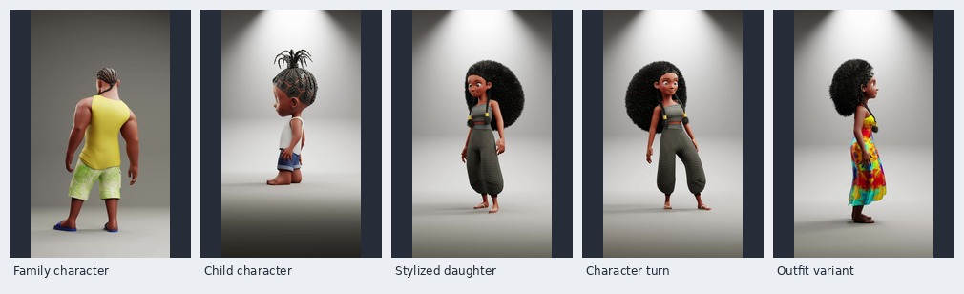
Selected character views from the supplied animation clip

01 From family photos to stylized characters
The character designs were based on family photographs, with the goal of preserving recognizable traits while translating each person into an appealing, cartoon-inspired form.

02 Consistency across the cast
Distinct hairstyles, outfits, silhouettes, and proportions help individual characters remain recognizable while feeling as though they belong in the same animated world.

03 Designed for an animation project
The character work supports a personal, story-driven animation concept: recreating a family as stylized 3D characters rather than presenting generic models. The visual treatment balances likeness, warmth, and a consistent art direction.
CLOSING LINE Personal references, translated into a stylized animated cast.

PROJECT 04 / GAME CREATURES

Game Creatures & Monsters — Bosses and Mobs
A varied character roster designed for encounters in a game world.
Game Character Modeling / Creature Design / Boss Characters / Mob Characters
PORTFOLIO CARD
Game Creatures & Monsters — Bosses and Mobs
A collection of game-ready creature characters, including large boss encounters such as a crocodile monster, a dinosaur-inspired fantasy creature, and a flying dragon-like creature, alongside a supporting roster of enemy mobs.
VIEW PROJECT →
PROJECT TYPE | Game-ready creature and monster characters
BOSS CREATURES | Crocodile Monster, Dinosaur / Fantasy Creature, Flying Creature / Dragon-like Creature
SUPPORTING ROSTER | Witch, Realm Knight, The Chaplain, Xanthrikrok, Alian, and Monkey
Boss-character lineup: crocodile monster, dinosaur / fantasy creature, and flying dragon-like creature

01 Boss creatures
The larger creatures were conceived as boss characters for the game. Their scale, silhouettes, and distinct physical features help them read as major encounters rather than standard enemies.

02 Distinct creature identities
The crocodile monster, dinosaur-inspired fantasy creature, and flying dragon-like creature each provide a different visual profile, helping the game’s creature roster feel varied.

03 Game-ready character focus
The creature models were created for game use, with the aim of presenting recognizable forms that can occupy a clear role within the game world. Technical requirements beyond the supplied brief can be added once the target engine and asset specifications are confirmed.
CLOSING LINE A creature roster built around recognizable silhouettes and encounter variety.

PROJECT 04 / SUPPORTING MOB ROSTER

Supporting Mobs & Enemy Characters
Additional character designs created for the game as part of its regular enemy roster.
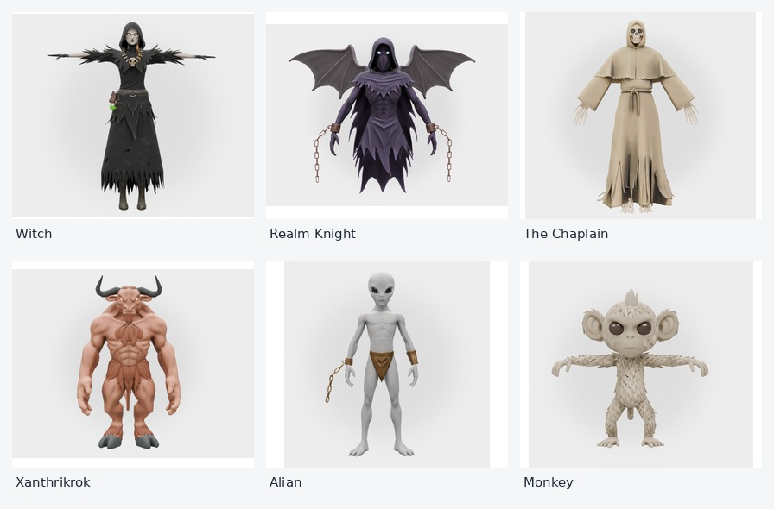
Witch · Realm Knight · The Chaplain · Xanthrikrok · Alian · Monkey

A supporting cast with different silhouettes
Alongside the larger boss creatures, this roster includes Witch, Realm Knight, The Chaplain, Xanthrikrok, Alian, and Monkey. The designs use varied shapes, costume language, and creature proportions to give the game a broader range of character types.

How the roster works together
Bosses establish the larger, high-impact encounters, while mob characters help populate the game with additional enemy types. Presenting the characters as a single roster makes the range of styles and roles easier to review at a glance.
CLOSING LINE Distinct characters for a world with more than one kind of encounter.

