***Project 2***

***Web Application Development***

***Student Name: Zubair Ali***

***Student ID: 104823405***

***Project Name: ShopOnline***

1. **List of files in the system:**

* **PHP Files:** register.php, login.php, bid.php, createListing.php, fetch_auction_items.php, generateReport.php, logout.php, maintenance.php, updateBidPrice.php, updateBidPriceAndStatus.php. These files are located at Project2 folder of mercury.
* **XML Files:** auction.xml, customer.xml. These files will be located at data directory of mercury.
* **CSS Files:** bid.css, createListing.css, logic.css, register.css. These files are located at Project2 folder of mercury.

1. **How to Use the ShopOnline System:**

**ShopOnline User Guide:**

Welcome to ShopOnline, your go-to platform for buying and selling items using the exciting English Auction strategy! Below, we'll guide you through the various components of ShopOnline and explain how to use each feature effectively.

**1. Login/Registration:**

**Existing Customers (Login):**

* Enter your registered email address and password.
* Click "Login" to access your account.
* If successful, you'll be redirected to the bidding page.
* You can also reset the form by click on “Reset” button

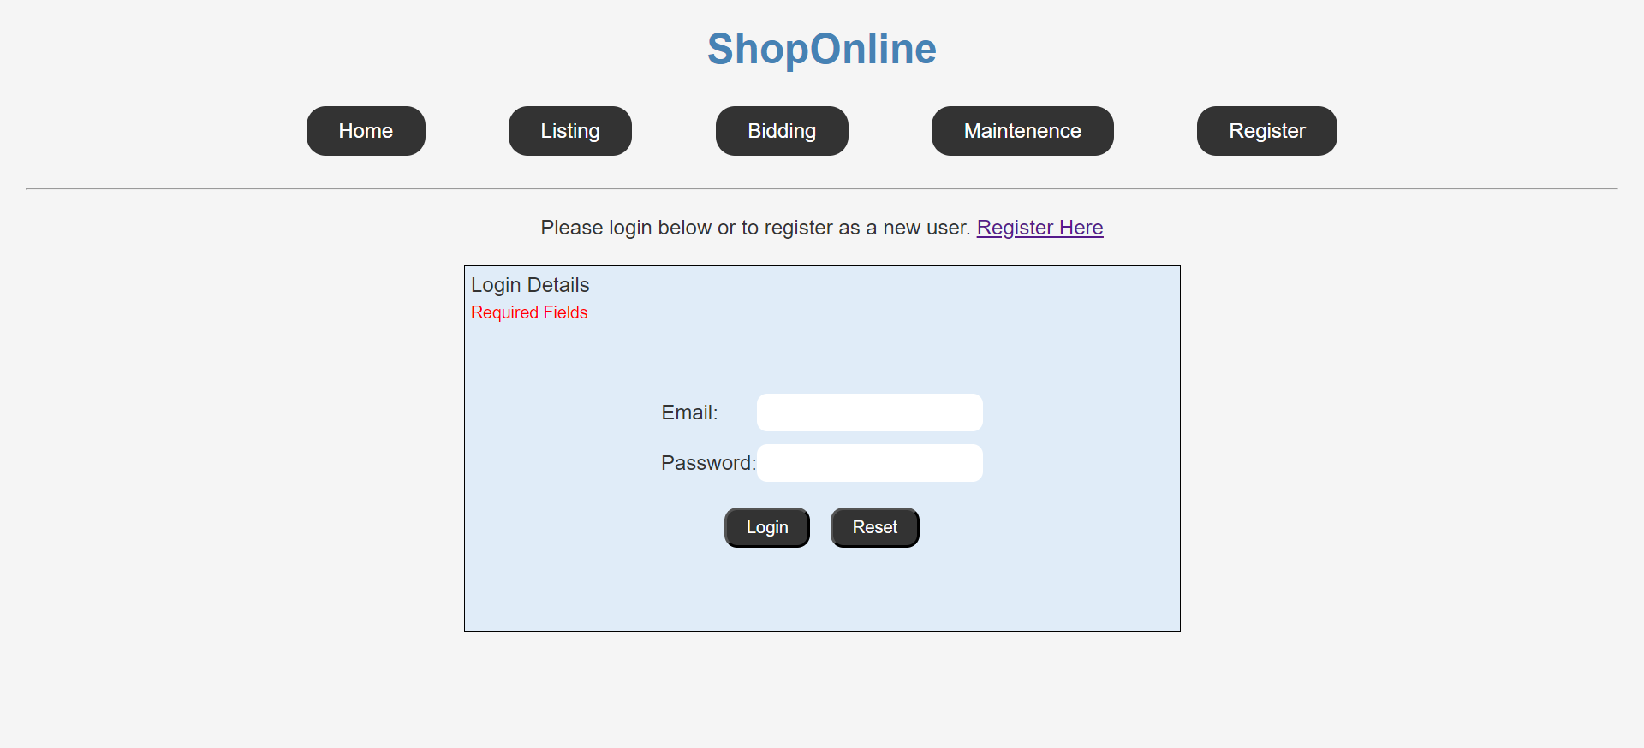

**New Customers (Registration):**

* Fill in your first name, surname, unique email address, password, and re-type the password.
* Click "Register" after ensuring all fields are correctly filled.
* Upon successful registration, you'll receive a confirmation email with your customer ID and password. Please check your spam.
* Use these credentials to log in.
* You can also reset the form by click on “Reset” button

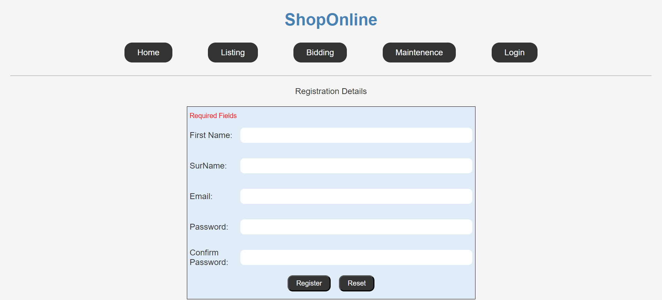

**2. Listing an Item for Selling:**

* Click on the "List Item" tab.
* Provide item details including name, category, description, reserve price, buy-it-now price, start price, and duration.
* Click "List Item" after validation.
* Your item will be listed, and bidding will start immediately.
* You can also reset the form by click on “Reset” button

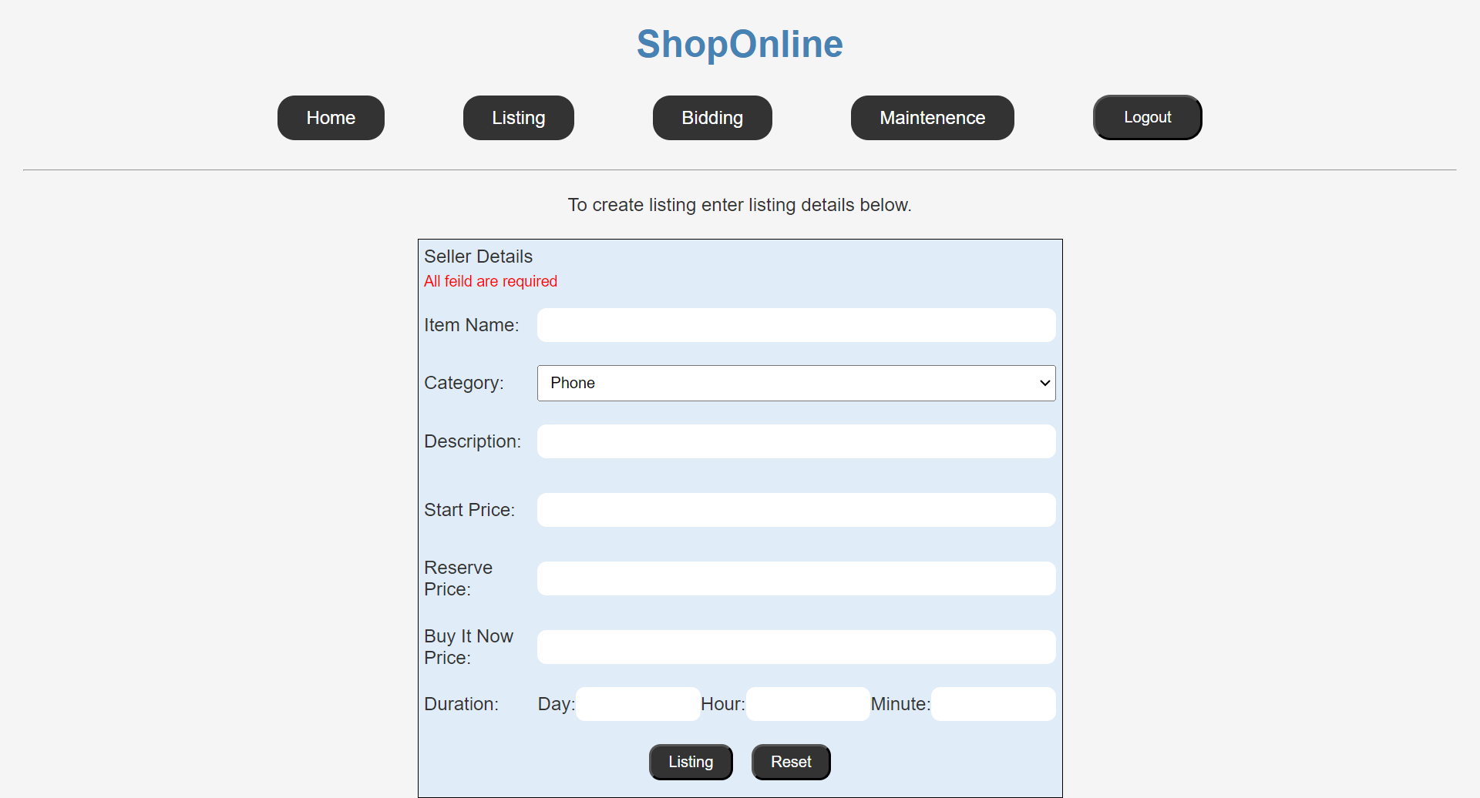

**3. Bidding on Items:**

* Click on the "Bid Now" tab to view all available items.
* Items will display their number, name, category, description (shortened), buy-it-now price, current bid price, and time left.
* If an item is active (not sold or expired), you can either "Place Bid" or "Buy It Now."

**Placing a Bid:**

* Click "Place Bid" to enter your bid price.
* If your bid is valid (higher than the current bid price), it will be recorded.
* If your bid wins, you'll receive a confirmation message.

**Buying It Now:**

* Click "Buy It Now" to purchase the item immediately at the specified price.
* Upon purchase, you'll receive a confirmation message.

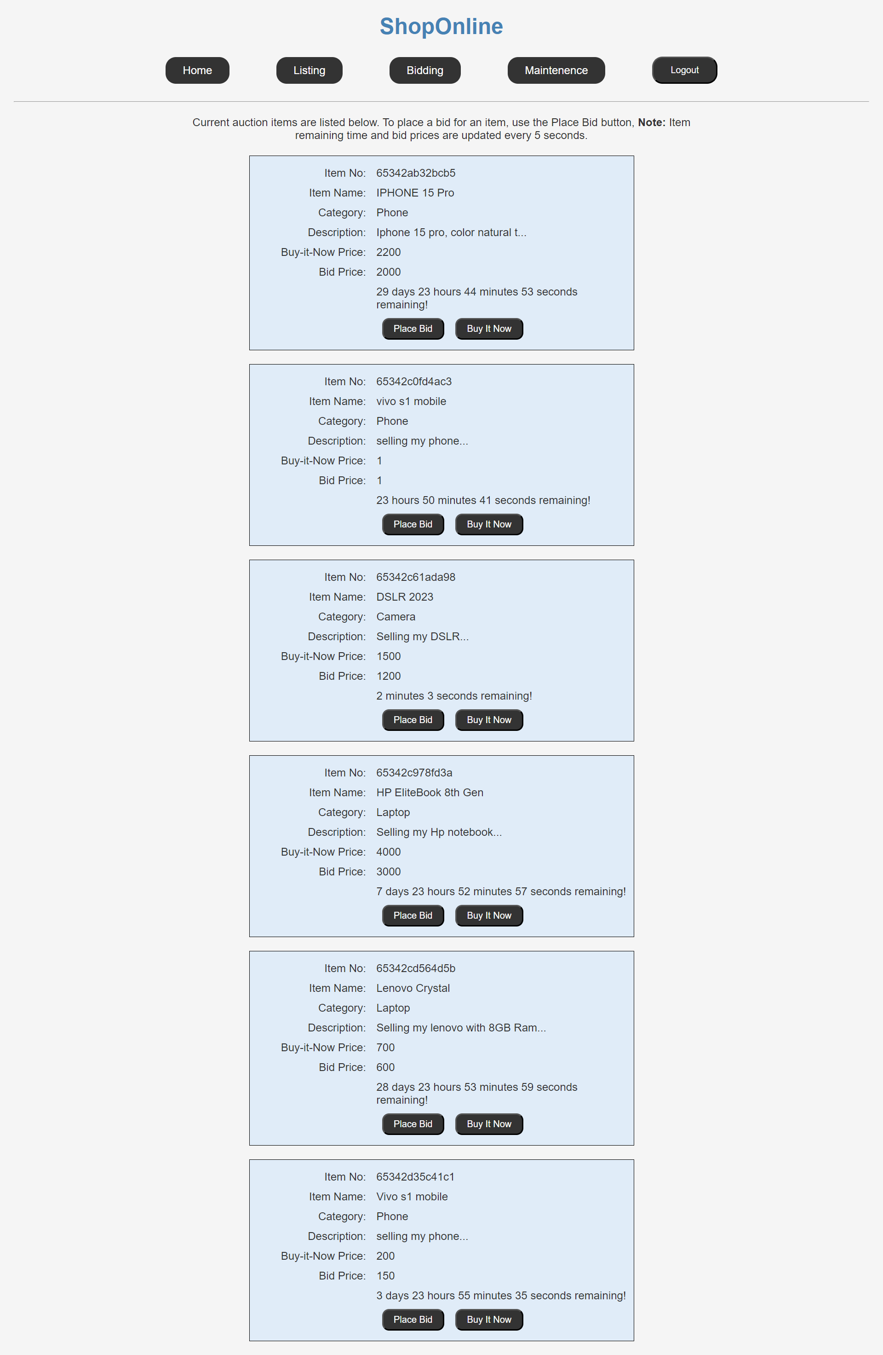

**4. Maintenance:**

**Processing Auction Items:**

* Click "Process Auction Items" to update the status of items that have expired.
* Items are marked as "sold" or "failed" based on bids and reserve prices.

**Generating Reports:**

* Click "Generate Report" to view a table of sold/failed items and total revenue.
* Items are removed from the system after generating the report.

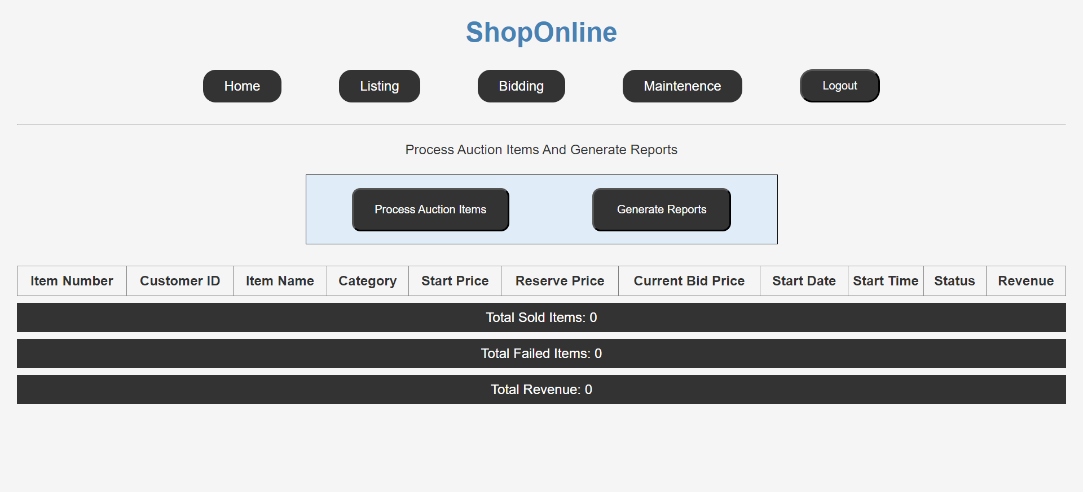

**Note:**

* ShopOnline charges 3% of the sold price for each sold item and 1% of the reserved price for each failed item.
* Ensure all actions comply with the rules and regulations specified on the platform.
* Thank you for choosing ShopOnline! Happy buying and selling!