GIT COMMANDS:

git init:
The git init command creates a new Git repository. It can be used to convert an existing, unversioned project to a Git repository or initialize a new, empty repository.

Git config - -global user.name or user.email
The git config command is a convenience function that is used to set Git configuration values on a global or local project level.

git remote. The "remote" command helps you to manage connections to remote repositories.
Git remote add origin <git repository link>
ex: git remote add origin https://github.com/zubairAhmed777/git_practice.git
to check all remote links
git remote -v
o/p: origin https://github.com/zubairAhmed777/git_practice.git (fetch)
origin https://github.com/zubairAhmed777/git_practice.git (push)

.gitignore file contains the file names which need to be ignored by git.

Git add :
to add files to stagged region
Ex:git add . (This will add all files in directoary)

git reset
when you commit changes that are not complete, this sets your index to the latest commit that you want to work on with.
Syntax: git reset <:mode:> <:COMMIT:>
Ex:git reset (will reset all stagged files)
Anoteher method to remove stagged file(s).
git rm --cached test.c

git clone
To copy a git repository from remote source, also sets the remote to original source so that you can pull again.
Syntax: git clone <:clone git url:>
git commit:
To commit changes ito your repositoary.
Ex:git commit -m "Practice git"

git log:
git log lists the commits made in that repository.

Git revert:
used to undo/revert the last commit, using the commit hash which you get from the git log command.

Ex:git revert <commit-id>

git pull:
The git pull command is used to fetch and download content from a remote repository and immediately update the local repository to match that content.

Ex: git pull origin master

git push:
The git push command is used to upload local repository content to a remote repository.
Ex:git push origin master

git show:
For commits it shows the log message and textual diff.

Git diff:
git-diff - Show changes between commits, commit and working tree, etc

git branch :
to create a new branch
syntax:git branch <branch name>
ex: dit branch test
git branch -d <branch name> to delete branch.
Ex: git branch -d test (-D flag to delete forcefully)

git checkout:
to move from branches
syntax:dit branch <branch name>
ex:git checkout test (move to test branch from master branch).

Note:commit changes in local branch and move(checkout) to another branch

git stash:
used to save changes in the stack , git stash is mostly used when you want to switch between branches but dont want to merge files between branches and dont want to loose your changes.

Git merge :
to merge the changes in one branch to another branch.
Syntax: git merge <branch name>
ex: git merge test (suppose you are in master the changes in test will be merged into master)

getting new branch from remote repo:
git checkout -b <branch name> origin/<branch name>
ex: git checkout -b test origin/test

syntax: git stash
to check stash list --> git stash list
to take changes back --> git stash apply

to drop stash contents --> git stash drop stash@{number}

git pull & git fetch:

When you use pull, Git tries to automatically do your work for you. It is context sensitive, so Git will merge any pulled commits into the branch you are currently working in. pull automatically merges the commits without letting you review them first. If you don’t closely manage your branches, you may run into frequent conflicts.
- When you fetch, Git gathers any commits from the target branch that do not exist in your current branch and stores them in your local repository. However, it does not merge them with your current branch. This is particularly useful if you need to keep your repository up to date, but are working on something that might break if you update your files. To integrate the commits into your master branch, you use merge.

Git pull will make local repo upto date (all commits pulled and make chages to files)
git pull=git fetch + git merg
git fetch will make local repo upto date (all commits are pulled and doesnt make any changes to files in local repo).
Git cherry-pick:
to get particular commit changes from one branch to another branch we use git cherry-pick

syntax: git cherry-pick <commit-id>
ex: If we create one file (1.txt) in test branch and commited.Again we created another text file(2.txt) and commited.Now in master branch we want only 2.txt so, we can use cherry-pick.
Git cherry-pick <commit-id of 2.txt commit> in master branch.

Git rebase:
In Git, the rebase command integrates changes from one branch into another. It is an alternative to the better known "merge" command. Most visibly, rebase differs from merge by rewriting the commit history in order to produce a straight, linear succession of commits.

Merge:

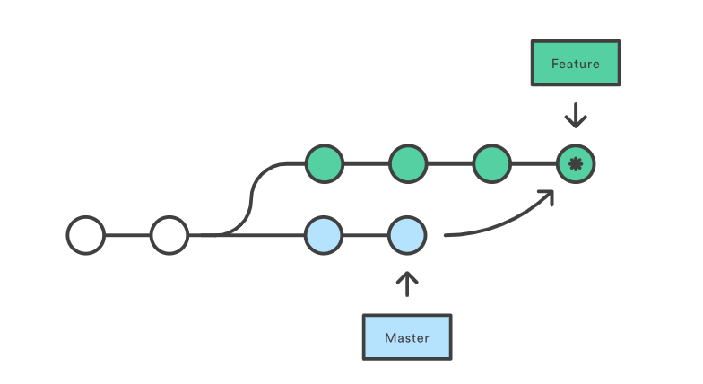

commit 1e9679a9f9f94fcde2b64d7557138208f3199005
Merge: bd47186 bad766b
Author: ****
Date: Fri Feb 7 23:59:35 2020 +0530

Merge branch 'master' of https://github.com/****/git_practice

merge will create a new commit id at merge point.
Rebase:

Rebase will put all commit ids in linear order as shown in figure.
