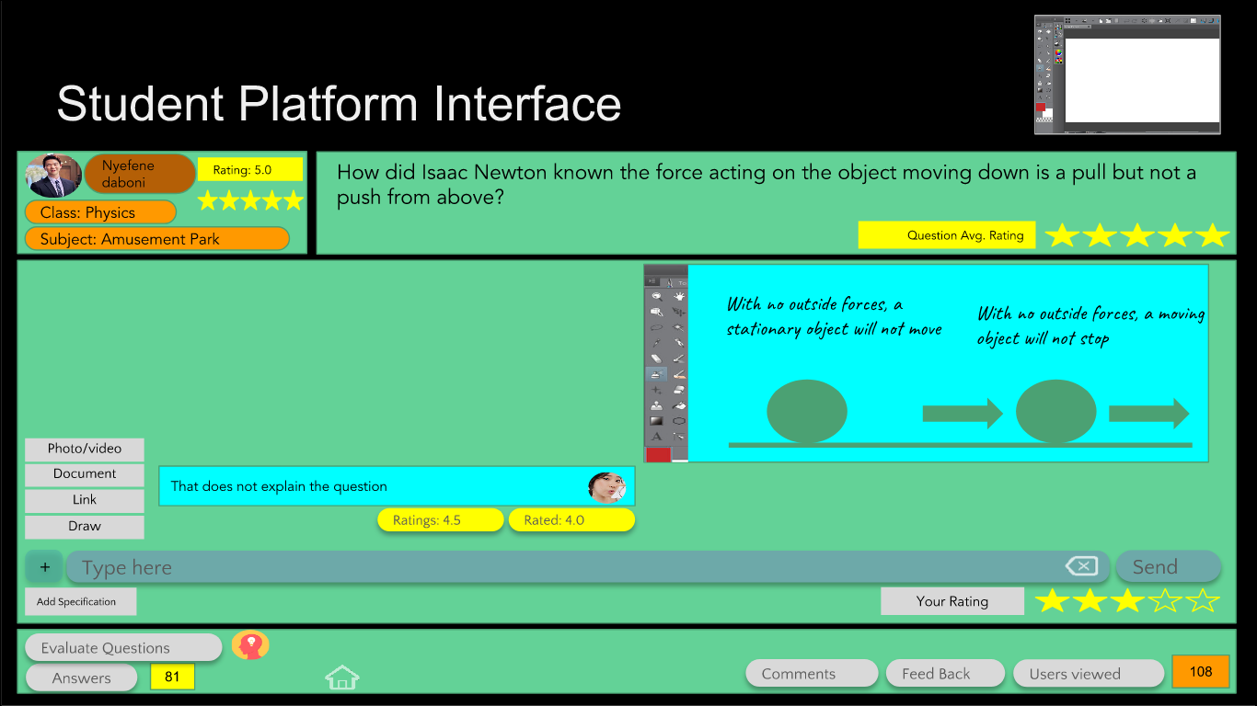
Project Synopsis/Project Concept Document
(Due: 20th August)

Project number | 8
Project Title | SMILE platform
Document | SSAD Project Concept Document
Creation date | 2018-08-20
Created By | Zubair Abid. Aaron Augustine, Visvesh Subramanian, Sireesha Vakada
Client | Priyanka Gujjula, NexRea

Description
Local/Global Platform to promote brainstorming and collaborative thinking at a primary level.
The SMILE Platform is Stanford run question-answering forum to encourage collaborative thought among primary schoolchildren at a global level. The aim of this project is to rewrite the platform, at a local scale at least, to extend its functionality – make it more suitable to brainstorm-centered group discussions.

Profile of Users
There are two primary end-users: (groups of) students, and a teacher role. The students use the platform to ask questions, answer questions, rate questions and answers, and message each other over questions asked, as a form of discussion/brainstorming. Features present for the student users include: “Game Level”s, Badges, a Critical thinking progress graph, questions answered and asked, average rating given and gotten. Teacher roles are more restricted: they don’t interact with the students the way they do with each other, but take on a more supervisory role.

Usage Model and Diagrams (if any)

