BLOG POST (Cluster 2, article 7) | Category: Social Media | URL: /youtube-tags/ | Title Tag: YouTube Tags in 2026: What They Do and What Still Matters | Meta Description: Do YouTube tags still matter? What YouTube says, how to add tags on computer and mobile, how many to use, tag generators and where keywords work better. | Focus Keyword: youtube tags | Secondary: how to add tags to youtube video, how many tags should i use on youtube, what are youtube tags, youtube tags vs hashtags, youtube tag generator, do youtube tags matter | Schema: Article, HowTo, FAQ

YouTube Tags in 2026: What They Do and What Still Matters
Quick Answer: YouTube tags are optional keywords added in YouTube Studio. YouTube says they play a "minimal role" in discovery and help mainly when your topic is often misspelled. Add a few accurate tags in a couple of minutes, then spend your keyword effort on the title, description and thumbnail.
[Image: 01-youtube-tags-featured.webp] Alt: YouTube tags in 2026: what they do and what still matters
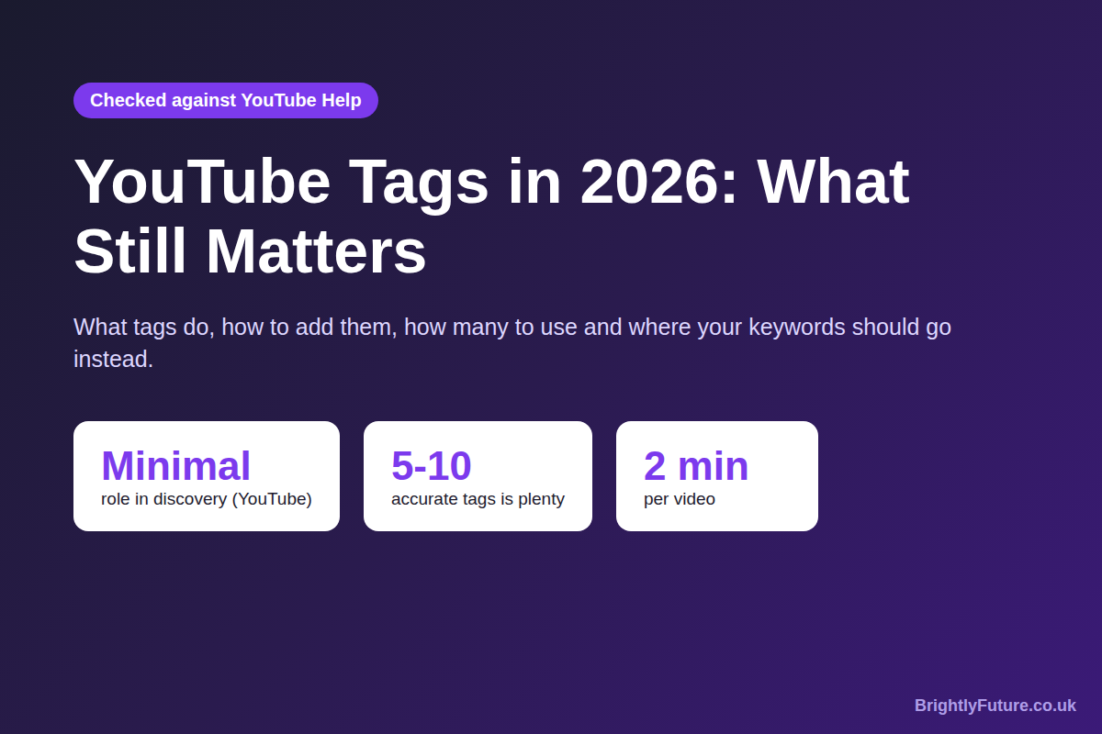
Search for YouTube tag advice and you'll find two camps. One says tags are a ranking factor and you should fill every character. The other says tags are a myth. Both leave you staring at the Tags box in YouTube Studio wondering what to type.
YouTube has answered the question itself, in its own help pages. This guide starts there, then covers how to add tags on a computer, on mobile and on Shorts, how many to use, whether tag generators and extractors are worth it, and where your keywords should go instead. It's part of our social media marketing guide.

What are YouTube tags, and do they still matter in 2026?
YouTube tags are descriptive keywords you add to a video in YouTube Studio to help viewers find it. They still exist, but they matter far less than most guides claim. YouTube's own help page on tags puts it plainly:
"Your video's title, thumbnail, and description are more important pieces of metadata for your video's discovery. Tags can be useful if the content of your video is commonly misspelled. Otherwise, tags play a minimal role in your video's discovery."
YouTube Help: Add tags to your YouTube videos
YouTube's upload help describes the Tags field the same way: "descriptive keywords to help correct search mistakes" (YouTube Help).
Creators who have tested this report the same thing. Social Video Plaza uploaded videos with and without tags and found that a video without tags didn't "fall flat on its face"; it was one small channel's test, but it matches what YouTube says.
So tags aren't dead, and they aren't a ranking lever. They're a backup that catches searches your title and description miss. That's worth two minutes per video, not twenty.

How do you add tags to a YouTube video?
Add tags in the Tags box on your video's details page in YouTube Studio, either while uploading or afterwards. You can also edit them on mobile.
[Image: 02-youtube-tags-how-to-add.webp] Alt: How to add tags to a YouTube video in YouTube Studio
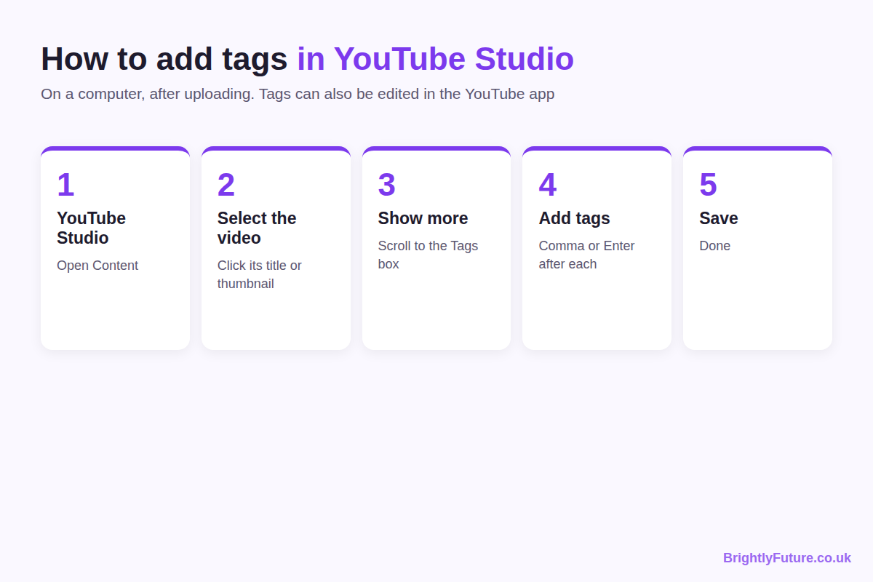
On a computer, while uploading:
1. Upload your video in YouTube Studio.
2. On the Details step, click Show more.
3. Type each tag in the Tags box, pressing Enter or typing a comma after each one.
4. Finish the upload as normal.
On a computer, after uploading:
1. Open YouTube Studio and go to Content.
2. Click the video's title or thumbnail to open its details.
3. Click Show more, add or edit tags in the Tags box, then click Save.
[SCREENSHOT PLACEHOLDER: YouTube Studio video details page with "Show more" expanded and the Tags box visible. Add manually.]
On mobile: YouTube's help page confirms you can edit tags in the YouTube app. Open the video's edit screen from your channel and look for the Tags field in the video's details.
On Shorts: Shorts are uploaded as YouTube videos, so you add tags the same way, in YouTube Studio on a computer or in the edit screen on mobile. Hashtags in a Short's title or description are a separate thing, covered below.

When are YouTube tags actually useful, and what should you use?
Tags are useful when people search for your topic in a way your title doesn't cover: misspellings, other names for the same thing, and different spellings between countries. Those are the tags worth typing.
Use a tag for | Example video | Tags that help
Common misspellings | A tutorial on "Self Assessment" tax returns | self asessment, self assesment
Brand or product names people get wrong | A review of a "Dyson" vacuum | dison, dyson v15 detect
Abbreviations and full names | A guide to "VAT returns" | value added tax return
UK and US spellings | "How to colour-grade video" | color grading
Other names for the same thing | A "sourdough starter" recipe | levain, wild yeast starter

Then add your main topic phrase, the same words that are already in your title.
Don't add tags that describe other people's videos, unrelated trending topics or your competitors' channel names. They don't describe your video, so they don't help the right viewers find it.

How many tags should you use on YouTube?
Use as many as you need to cover your topic phrase, its misspellings and its other names; for most videos that's around five to ten. There's no benefit in filling the box.
Two limits apply:
- Excessive tags break YouTube's rules. YouTube's help page says adding excessive tags to your video description is against its policies on spam, deceptive practices and scams.
- The Tags box has a character limit. It's widely reported as 500 characters in total, though YouTube doesn't state the figure on its help pages. If you see a "tags are too long" message, you've gone over; remove the weakest tags rather than shortening the useful ones.

Can you see other videos' tags, and are tag generators worth using?
Tags aren't shown on the video page, but they're in the page's code, which is how tag extractors and browser extensions such as vidIQ and TubeBuddy display them. You can see them, but copying them won't help much, for three reasons:
- Tags carry little weight, by YouTube's own account, so a competitor's tags aren't the reason their video ranks. Their title, thumbnail, viewer response and channel history are.
- Their tags describe their video. If yours covers something different, their tags don't fit.
- Tag generators suggest tags from a topic. They're quick for spotting a misspelling or alternative name you hadn't thought of, but delete anything that doesn't describe your video.
An extractor is more useful for a different job: seeing which words successful videos in your niche use, so you can check your title and description use the words viewers search for.

What's the difference between tags, hashtags and keywords?
Tags are hidden keywords that help YouTube match searches; hashtags are visible, clickable links to a page of other videos; keywords are the search words you want to be found for, and they belong mainly in your title and description.
[Image: 03-youtube-tags-vs-hashtags-keywords.webp] Alt: YouTube tags vs hashtags vs keywords
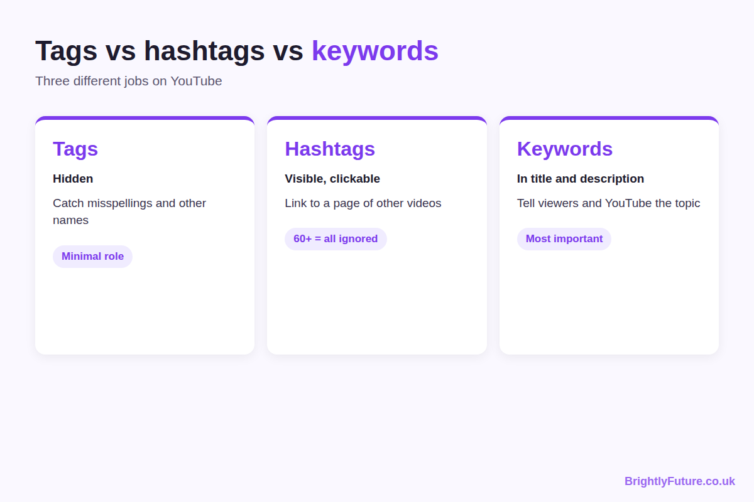
 | Tags | Hashtags | Keywords
Where you add them | Tags box in YouTube Studio | Title or description, with # | Title, description, spoken words
Visible to viewers? | No | Yes, as clickable links | Yes, as normal text
What they do | Help catch misspelled or alternative searches | Link to a page of videos using the same hashtag | Tell viewers and YouTube what the video covers
YouTube's guidance | Small role, mainly for misspellings | Over 60 hashtags and YouTube ignores them all | Use 1–2 main words in title and description

According to YouTube's hashtag help page, up to three hashtags from your description can appear next to your title, and a hashtag in your title links viewers away to other videos with the same hashtag. Tags don't need a # symbol and never appear on the page.

Where should your keywords go instead of tags?
Put your main keywords in the title, the first lines of the description and the words you say in the video. YouTube's description tips recommend identifying one or two main words that describe your video and featuring them in both the title and the description.
In order of impact:
1. Title. Put the phrase viewers search for near the start. Our guide to writing YouTube titles covers how, with data from 60 ranking titles.
2. Description, first two lines. These show before "more". Repeat the main words naturally and say what the viewer will learn.
3. What you say. Say the topic out loud early in the video. Accurate captions, which you can check and correct in YouTube Studio, put those words into text.
4. Chapters. Timestamps in the description with clear chapter names describe each part of a longer video.
5. Thumbnail. It doesn't carry keywords for search, but it decides whether the viewer clicks once your video appears.

Which YouTube tag tips are myths?
Most tag tips that promise views aren't supported by anything YouTube has said. The common claims, checked against YouTube's own help pages:
Claim | What YouTube says | Verdict
"Tags are a major ranking factor" | Tags play a "minimal role" in discovery | Myth
"Your first tag carries the most weight" | Nothing on tag order in YouTube's help | Unsupported
"Use all 500 characters" | Excessive tags break the spam policy | Myth, and risky
"Copy a viral video's tags" | Tags must describe your video | Doesn't help
"Trending or viral tag lists get views" | No list of tags brings views on its own | Myth
"Tags help you appear in Suggested videos" | YouTube doesn't say this | Unsupported
"Tags help with misspellings" | Yes: "useful if the content of your video is commonly misspelled" | True

The gaming, music and "copy and paste" tag lists that rank in Google fall into the same trap. They're written for every video, so they describe none of them.

Frequently Asked Questions

Do tags help YouTube Shorts?
As little as they help long videos. YouTube's guidance on tags doesn't treat Shorts differently. Add a couple of accurate tags if your topic is often misspelled, then focus on the Short itself.

Should you change the tags on old videos?
Only if they're wrong, for example if a product name changed or you spot a common misspelling you missed. Changing tags alone is unlikely to revive an old video; a clearer title or a better thumbnail has far more effect.

Should you add tags in other languages?
Only if the video serves viewers in that language. A better option for reaching other languages is YouTube's translation feature for titles and descriptions, which can show your video in search for speakers of those languages.

Should every video on your channel use the same tags?
No. Reusing one block of tags on every upload makes them describe your channel, not the video. Keep one or two tags for your brand or series name if people search for it, and write the rest for each video.

How long do new tags take to work?
YouTube doesn't publish a timeframe, and because tags count for so little, you're unlikely to see a measurable change from tags alone. If you want to test a change, adjust the title or description and compare views from YouTube search in Analytics over the next few weeks.

Your 2-minute tag routine
For each upload, add your main topic phrase, any common misspellings, other names for the topic and UK or US spelling variants, then stop. Put the rest of your keyword effort into the title, the first two lines of the description and what you say in the first minute of the video.

