BLOG POST (Cluster 2, article 5) | Category: Social Media | URL: /social-media-character-limits/ | Title Tag: Social Media Character Limits 2026: Every Platform in One Table | Meta Description: Character limits for X, Instagram, TikTok, LinkedIn, YouTube, Facebook, Threads and more, checked against each platform's own help pages in October 2026. | Focus Keyword: social media character limits | Secondary: x character limit, instagram caption character limit, tiktok caption limit, linkedin post character limit, youtube title character limit, threads character limit | Schema: Article, FAQ

Social Media Character Limits 2026: Every Platform in One Table
Quick Answer: X allows 280 characters per post (25,000 with Premium), Instagram captions 2,200, LinkedIn posts 3,000, TikTok captions up to 4,000 in the app, YouTube titles 100 and descriptions 5,000, and Threads 500. Most platforms cut posts off long before the limit, so the first line matters more than the maximum.
[Image: 01-character-limits-featured.webp] Alt: Social media character limits 2026: every platform in one table
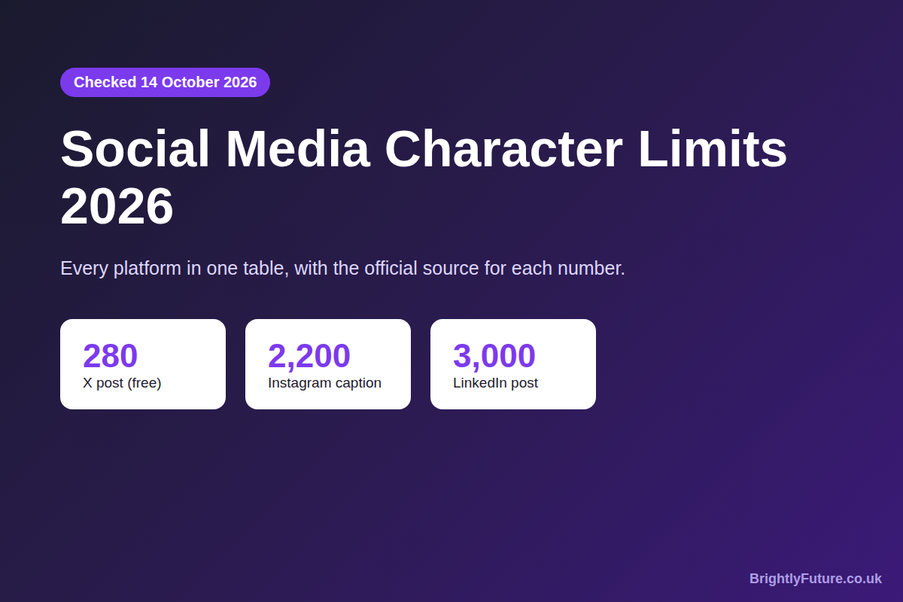
Character limits change more often than most guides are updated. In the last two years TikTok raised its caption limit, X made long posts a paid feature and Threads added 10,000-character text attachments.
This page lists the current limit for each field a business uses, with a link to the platform's own help page wherever one exists. Where a number comes only from third-party sources, we say so. Limits checked on 14 October 2026. For the strategy behind your posts, see our social media marketing guide.

What are the character limits for each social media platform?
These are the limits for the main fields on each platform. Spaces and line breaks count towards every one of them.
Platform | Post or caption | Other limits | Source
X (Twitter) | 280 (25,000 with Premium) | Links count as 23; emojis count as 2 | X developer docs
Instagram | 2,200 | Bio 150; up to 5 hashtags per post | Instagram, reports below
TikTok | Up to 4,000 in the app; 2,200 via scheduling tools | – | TikTok developer docs (2,200); app figure unofficial
LinkedIn | 3,000 | Longer text: publish an article | LinkedIn Help
YouTube | – | Title 100; description 5,000 | YouTube Help
Facebook | 63,206 | – | Widely reported; not in Meta's Help Centre
Threads | 500 | Text attachment up to 10,000 | Meta, via TechCrunch
Pinterest | Description 500 | Title 100 | Third-party sources
Bluesky | 300 | – | Third-party sources

[Image: 02-character-limits-table.webp] Alt: Social media character limits by platform in 2026
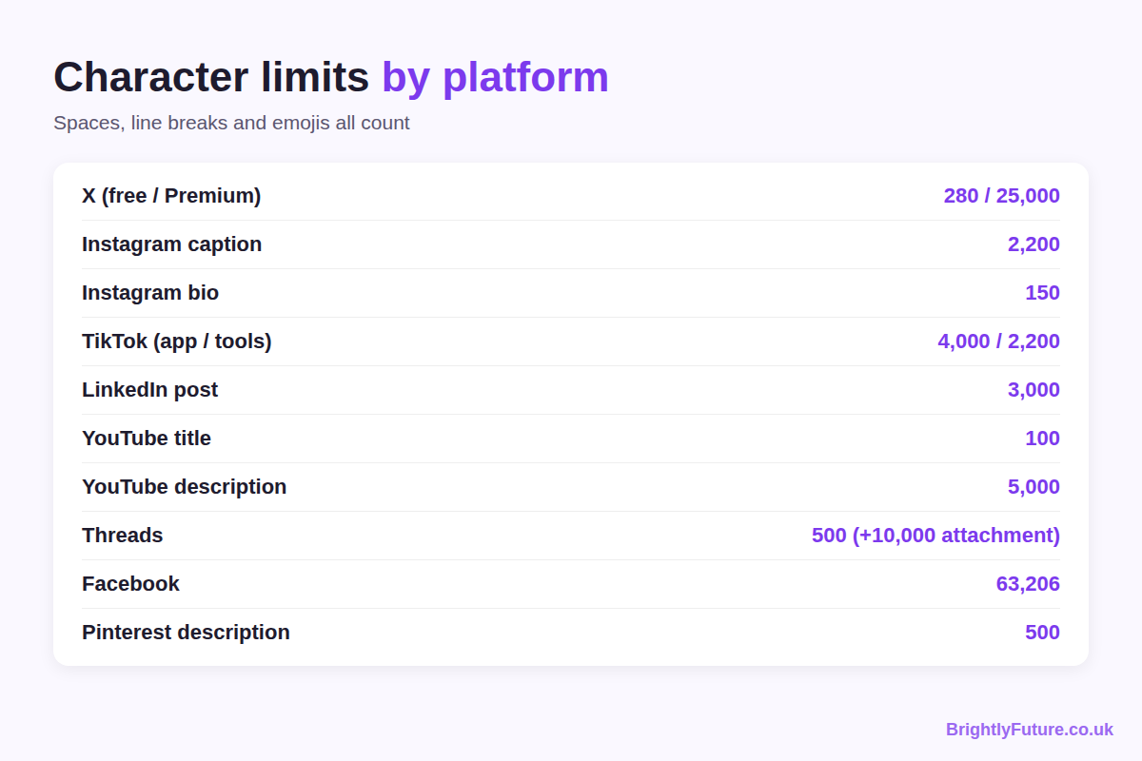

What is the X (Twitter) character limit?
A post on X can be 280 characters on a free account. Subscribers to X Premium can write longer posts of up to 25,000 characters, but the timeline shows only the start, with "Show more" for the rest.
X doesn't count every character the same way. According to X's developer documentation:
- Most letters, numbers and punctuation count as 1.
- Emojis count as 2, so a post of only emojis fits 140.
- Every link counts as 23, however long the address is, because X shortens it.
- Chinese, Japanese and Korean characters count as 2.

What is the Instagram character limit?
An Instagram caption can be up to 2,200 characters, and a bio up to 150. Since December 2025 a post or Reel can also carry no more than five hashtags, and the hashtags count towards the 2,200.
Each of these has its own guide on BrightlyFuture:
- Captions: how to use the space, from the first line to the call to action, in our guide to writing Instagram captions for business.
- Bio: what to fit into 150 characters, with 18 examples, in Instagram bio ideas for business.
- Hashtags: how to choose the five, in our Instagram hashtag strategy.

What is the TikTok caption limit?
TikTok's app accepts captions of up to 4,000 characters, according to most 2026 sources, though TikTok hasn't published that number on a help page we could find. If you post through a scheduling tool, the limit is 2,200: that's the maximum in TikTok's Content Posting API, which those tools use.
So if you schedule TikTok posts, write to 2,200. If you post in the app, you have more room, but only the first line or two shows over the video.

What is the LinkedIn character limit?
A LinkedIn post can be up to 3,000 characters. For anything longer, LinkedIn's Help Centre suggests publishing an article instead.
LinkedIn shows the first few lines of a post in the feed and hides the rest behind "see more", so put the point of the post in the opening.

What are the YouTube title and description limits?
A YouTube video title can be up to 100 characters and a description up to 5,000, as YouTube Help confirms. Neither can include invalid characters.
Titles are cut short in search results and on phones well before 100 characters, so the words that matter go first. Only the first couple of lines of the description show before "more".

What are the Facebook, Threads, Pinterest and Bluesky limits?
- Facebook: posts can be up to 63,206 characters. The figure is repeated by nearly every guide, but Meta doesn't list it in its Help Centre, so treat it as unofficial. In practice no one reaches it; the feed cuts posts off after a few lines.
- Threads: a post can be 500 characters. Since September 2025 you can also attach up to 10,000 characters of extra text, which readers open by tapping, as TechCrunch reported.
- Pinterest: a Pin title can be 100 characters and a description 500, according to third-party guides. Pinterest shows only the start of each in the feed.
- Bluesky: a post can be 300 characters, according to third-party guides.

How many characters show before "more"?
Far fewer than the limit, and no platform publishes an exact number. The cut-off depends on the device, the screen size and line breaks, so a post that looks complete on a laptop can stop mid-sentence on a phone.
Rough figures quoted by social media tools (not official):
Platform | Roughly visible before "more"
Instagram caption | About 125 characters
LinkedIn post | About 210 on mobile, more on desktop
Facebook post | A few lines
TikTok caption | The first line or two
YouTube description | The first couple of lines

The safest test is to preview the post on a phone before publishing. Whatever is visible there should make sense on its own.
[Image: 03-character-limits-limit-vs-visible.webp] Alt: Hard character limit vs what people see before "more"
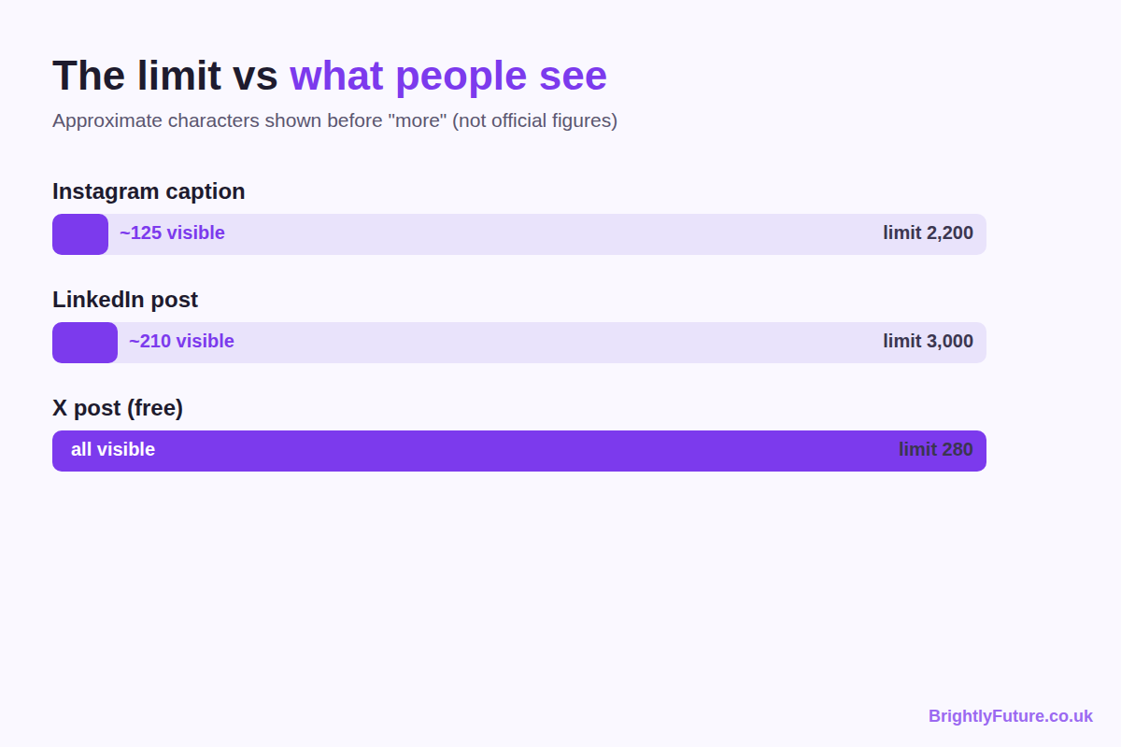

Do emojis, spaces and links count as characters?
Yes, all three count, but not always as one character each.
- Spaces and line breaks count as one character each on every platform.
- Emojis often count as two, and some, such as flags or skin-tone variants, as more. X counts every emoji as 2.
- Links count at their full length on most platforms. X is the exception, counting any link as 23. On Instagram, links in captions aren't clickable, so they cost characters without bringing clicks.
If your text is close to a limit, paste it into the platform's own post box: its counter is the one that decides.

What happens if your post goes over the limit?
Usually the platform stops you before you post. X, LinkedIn and Instagram won't publish text that's too long; you have to shorten it first. Scheduling tools typically warn you or fail to publish, which is why TikTok posts sent through them must fit 2,200.
If you need more space, each platform has a way round it:
- X: split it into a thread, or subscribe to Premium for longer posts.
- LinkedIn: publish an article and share it as a post.
- Threads: use a text attachment.
- Instagram: use carousel slides for the detail and keep the caption for context.

Frequently Asked Questions

How often do social media character limits change?
Often enough that any list goes out of date. Recent examples include TikTok's caption increase, X Premium's long posts and Threads' text attachments. Check the platform's help page before planning content around an exact number.

Do paid ads have the same character limits?
No. Ads have their own fields, such as headline and primary text, with separate limits and recommended lengths set in each platform's ad manager. Check the ad specs in Meta Ads Manager, LinkedIn Campaign Manager or TikTok Ads Manager when you build the ad.

Do hashtags and @mentions count towards the limit?
Yes. Hashtags and @mentions are part of the text, so every character in them counts, including the # and @ symbols.

Can you post the same text on every platform?
You can, as long as you write to the shortest limit you're posting to. A post written for X's 280 characters fits everywhere; a 2,000-character Instagram caption won't fit X or Threads without cutting it.

