PILLAR PAGE: AI Content Writing: The Complete Guide for 2026 | BrightlyFuture.co.uk | URL: /blog/ai-content-writing-guide/ | Meta Description: The complete guide to AI content writing in 2026: what AI does well, the tools, a 7-stage workflow, SEO and Google rules, risks and 10 in-depth guides. | Primary Keyword: ai content writing complete guide

AI Content Writing: The Complete Guide for 2026
Quick Answer: AI content writing means using tools like Claude, ChatGPT or Jasper to research, outline and draft content that a person then edits, fact-checks and publishes. Done well, it ranks: Google judges usefulness, not authorship. Done badly, it produces generic, error-prone pages that neither readers nor Google reward.
[Image: 01-ai-writing-featured.webp] Alt: AI content writing – the complete guide for 2026
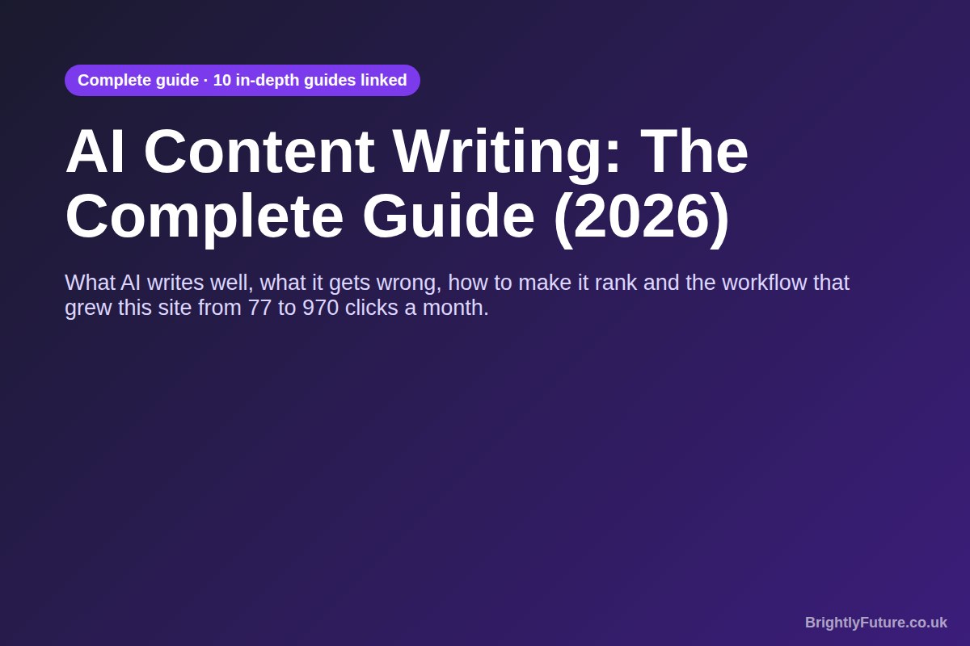
Every article on this site starts as an AI draft. I use Claude, give it detailed instructions about the business, and then spend most of my time on the parts it can't do: testing, checking sources and adding what I've seen first-hand. That process took our Search Console clicks from 77 in the first month to 164 in the second and 970 in the third.
This guide is the map of that process. It explains what AI content writing is, what it does well and badly, which tools matter, how the workflow fits together and what Google actually rewards. Each section gives you the essentials, then points to a dedicated guide when you want the full detail.
In this guide:
- What is AI content writing?
- What can AI write, and what should it not write?
- Is AI content as good as human writing?
- Which AI writing tools should you use?
- What does an AI content workflow look like?
- How do you measure whether AI content is working?
- Is AI writing good for SEO?
- Can Google detect AI content, and is it against Google's policies?
- What are the risks of AI content writing?
- AI content writing glossary
- Free tools for AI content writers
[Image: 02-ai-writing-hub-map.webp] Alt: Map of the AI content writing guides: the complete guide and ten in-depth articles
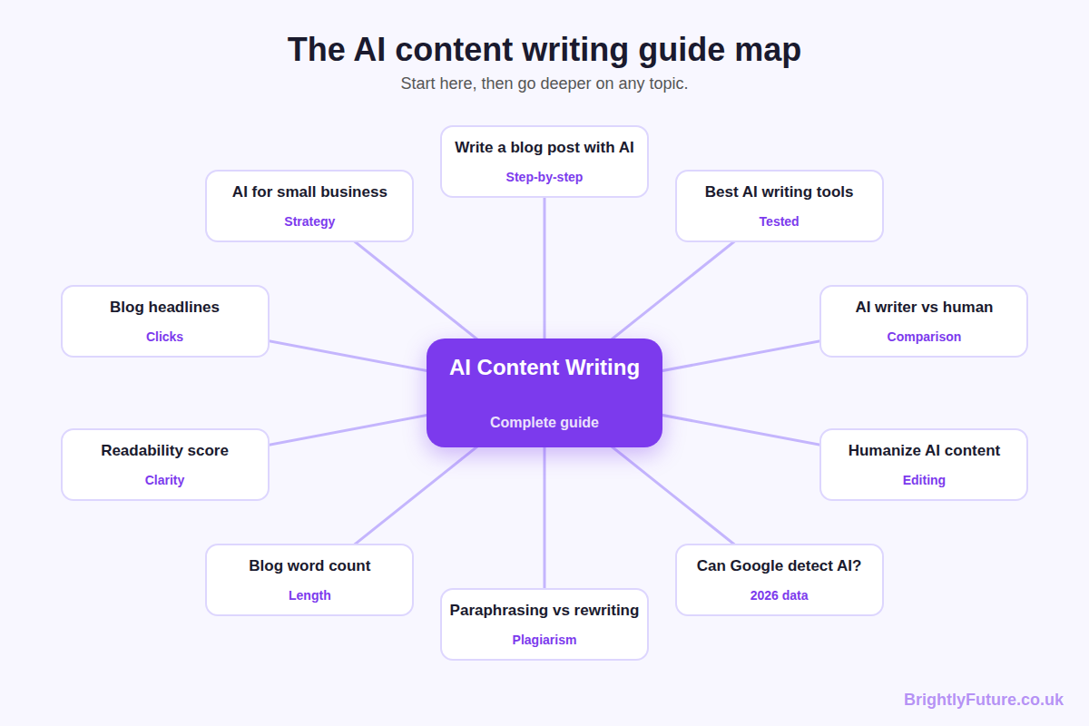

What is AI content writing?
AI content writing is the use of large language models to help create written content: blog posts, emails, product descriptions, social posts and web pages. The AI produces text; a person decides what to say, checks that it's true and makes it worth reading.
A large language model (LLM) works by predicting the most likely next word, one word at a time, based on patterns in the enormous amount of text it was trained on. That explains both its strengths and its weaknesses:
- Why it's fast and fluent: it has seen millions of examples of well-formed sentences, headings and explanations, so it produces clean prose almost instantly.
- Why it sounds generic: "most likely" means average. Left alone, it writes the version of an article that already exists many times over.
- Why it invents things: it predicts plausible text, not verified facts. A made-up statistic can look exactly like a real one.
Most people now use AI content writing in one of three ways. Some use it as an assistant for ideas, outlines and editing. Others use it as a co-writer that drafts while they add expertise and check facts. A few use it as an autopilot that publishes with little review. The first two can produce excellent content. The third is where most of the problems described in this guide come from.

What can AI write, and what should it not write?
AI can draft almost any routine content well, including blog posts, newsletters, social captions, product descriptions, FAQs and ad variations. It should not have the final word on anything that makes a factual, legal, medical or financial claim, or anything that depends on experience it doesn't have.
[Image: 05-ai-writing-ai-vs-you.webp] Alt: What AI writes well, and what it gets wrong
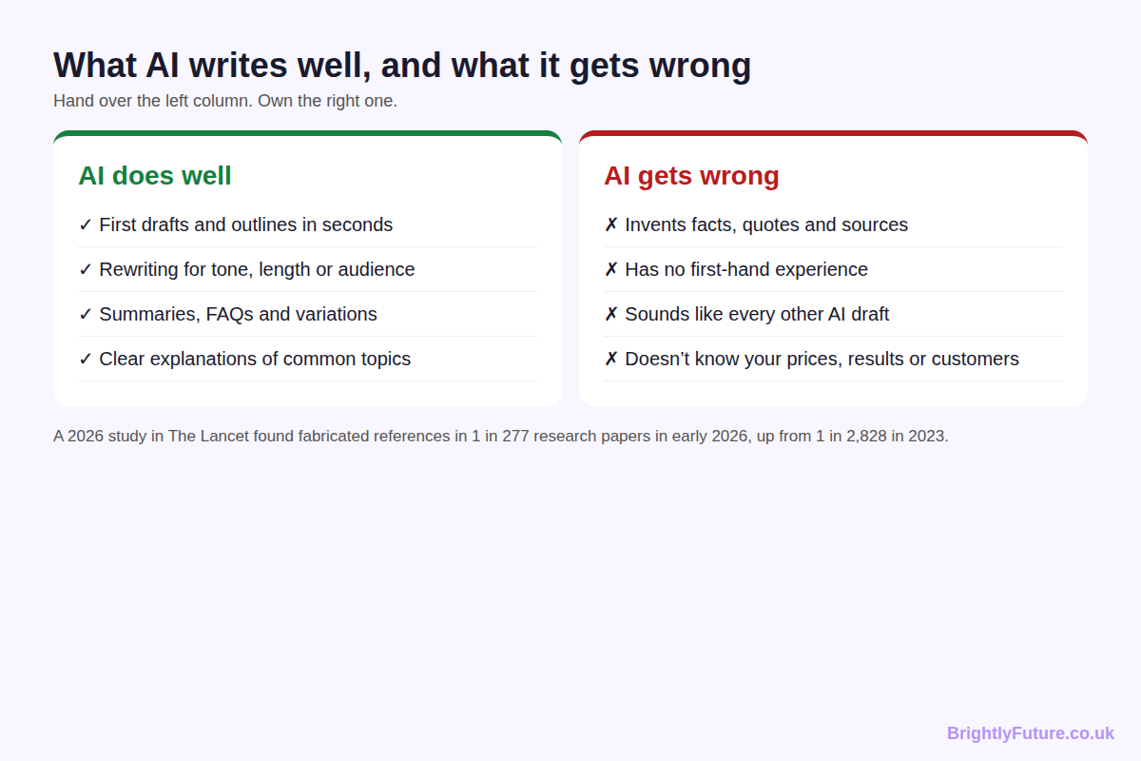
Content type | AI's role | What a person must add
Blog posts and guides | Outline, first draft, FAQ ideas | Angle, first-hand examples, fact-checks
Emails and newsletters | Subject lines, structure, variations | The offer and the voice
Social media posts | Captions, variations, repurposing | Photos, timing, personality
Product descriptions | Clear, consistent descriptions at scale | Accurate specs and prices
Ads and landing pages | Headline and copy variations to test | The claim, the proof, compliance
Health, legal, financial content | Research summaries for an expert | Everything a reader relies on

Tips for each format
Blog posts. Give the AI your outline and your facts, then draft one section at a time. Whole-article prompts produce the most generic results. The step-by-step blog guide covers this format in depth.
Emails. Ask for five subject lines and pick one yourself. Keep the body short, write the offer in your own words, and make sure the sign-off sounds like a person, because readers notice when a newsletter stops sounding like you.
Social posts. AI is at its most useful here as a repurposing tool. Paste in a finished article and ask for three captions for different platforms, then add your own photo and cut anything that sounds like an advert.
Product descriptions. Give the AI a fixed template and the real specifications for each product. It's excellent at producing consistent descriptions across a catalogue, and poor at knowing whether a size, material or price is correct, so check every figure.
Ads and landing pages. Use AI to generate headline and copy variations for testing, not to decide what you promise. Every claim on an ad or landing page needs to be one you can prove.
The same rule applies across all of them: the closer the content gets to a promise a reader will act on, the more a qualified person needs to write or approve it.
For a business, this becomes a question of which jobs to hand over and how much time to budget. AI content writing for small business covers that strategy, including costs, a Claude setup and a 90-day plan.

Is AI content as good as human writing?
Raw AI output is not as good as skilled human writing, but AI drafting plus human editing often matches it and is much faster. The difference is less "AI versus human" and more "reviewed versus unreviewed". Unedited AI and lazy human writing fail for the same reason: they add nothing new.
Where AI is stronger: speed, structure, consistency and covering the basics of a topic. Where people are stronger: original insight, first-hand experience, judgement about what matters, and knowing when a "fact" is wrong.
That's why the most useful question isn't whether to use AI, but where in the process a person adds value. I compare the two approaches in detail, including cost, quality and when to choose each, in AI blog writer vs human writer.

Which AI writing tools should you use?
Most writers need one general AI assistant for drafting and one editing or SEO tool for checking. You don't need a large stack. The tools fall into four groups, and the right pick depends on what you write and how much.
[Image: 04-ai-writing-tool-types.webp] Alt: The four kinds of AI writing tools: assistants, writing platforms, editing tools and SEO tools
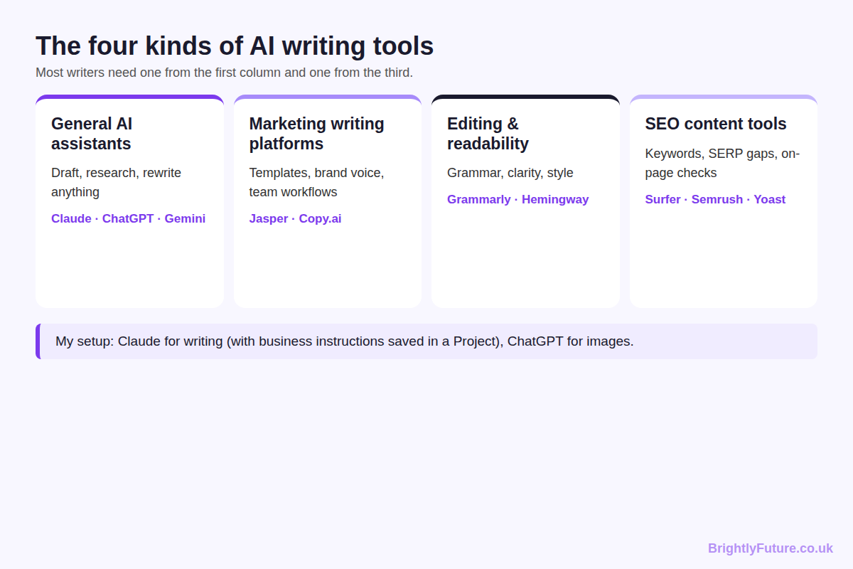
Tool type | What it does | Examples
General AI assistants | Draft, research, rewrite, summarise | Claude, ChatGPT, Gemini
Marketing writing platforms | Templates, brand voice, team workflows | Jasper, Copy.ai
Editing and readability tools | Grammar, clarity, sentence-level style | Grammarly, Hemingway Editor
SEO content tools | Keyword gaps, SERP analysis, on-page checks | Surfer, Semrush, Yoast SEO

My own setup is simple. Claude is my first choice for writing because it follows long, detailed instructions consistently, which is what keeps drafts on-brand. ChatGPT is what I use for images. WordPress is where everything gets published.
If you're choosing for the first time, the best AI blog writing tools compares ten free and paid options I've tested, with recommendations by budget and volume.

What does an AI content workflow look like?
A reliable AI content workflow has seven stages: brief, research, outline, draft, edit, optimise, and publish and measure. AI does most of the work in two of them, outlining and drafting. The stages that decide whether a page ranks are the ones a person leads.
[Image: 03-ai-writing-workflow.webp] Alt: The 7-stage AI content workflow from brief to measurement
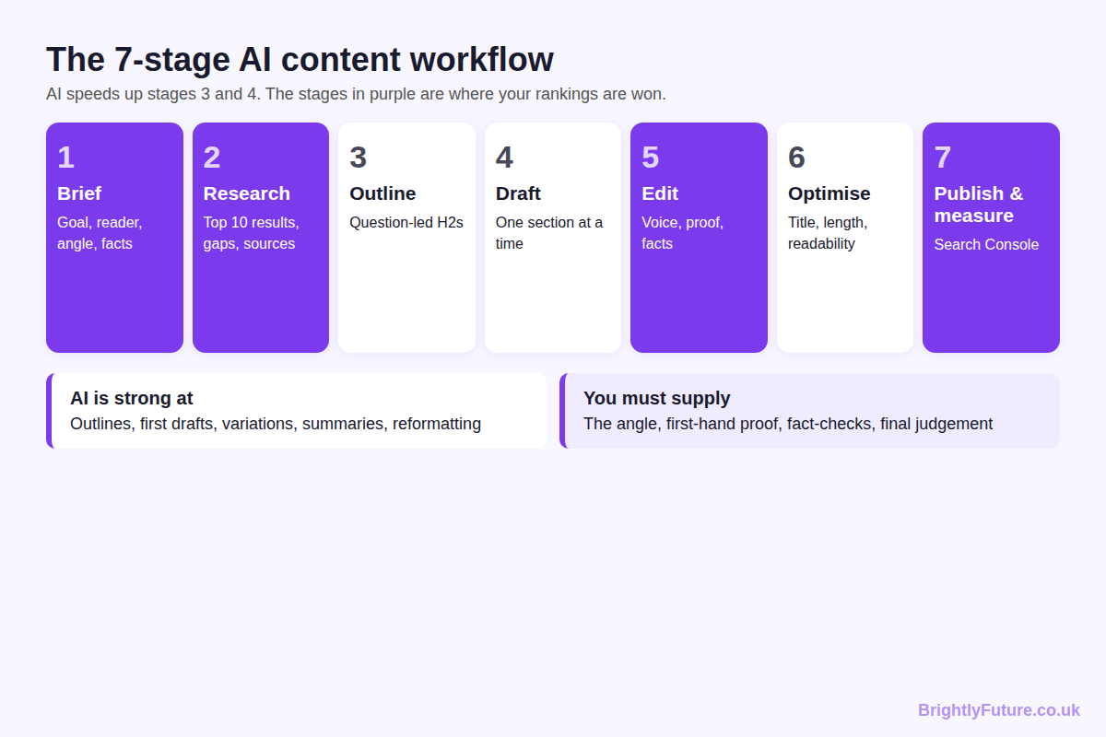
1. Brief. Decide the goal, the reader and the angle before opening any tool. A vague brief is the main cause of generic drafts.
2. Research. Read what already ranks and note what it misses. That gap is your reason to publish.
3. Outline. Turn the reader's questions into headings, each answered directly in its first sentence.
4. Draft. Let AI write section by section from your outline and facts, not the whole article from one prompt. The step-by-step guide to writing a blog post with AI walks through this stage with prompts.
5. Edit. Remove filler, add first-hand examples, vary sentence rhythm and check every claim. How to humanize AI content covers the editing techniques. If you're reworking existing text, know the difference between paraphrasing and rewriting, because only one of them produces something new.
6. Optimise. Write a title that earns the click (blog headlines that get clicks), check the text is easy to read (improve your readability score) and make sure the length fits the topic (how long a blog post should be).
7. Publish and measure. Watch impressions and clicks in Google Search Console, then update the posts that show promise.
One habit made the biggest difference for me: saving the brief in one place so the AI starts every draft already knowing the business. In Claude that's a Project with instructions and reference files. In other tools, a saved instruction document does the same job.

How do you measure whether AI content is working?
Measure AI content the same way as any content: by whether people find it, click it, read it and act on it. Add one extra measure for AI: how much time each piece actually saved once editing is counted.
A simple monthly scorecard covers most sites:
What to check | Where | What it tells you
Impressions | Google Search Console | Whether Google is showing the page at all
Clicks and click-through rate | Google Search Console | Whether the title and snippet earn the visit
Average position | Google Search Console | Whether updates are moving the page up
Engagement time | Google Analytics 4 | Whether visitors actually read it
Conversions | Google Analytics 4 or your CRM | Whether it brings enquiries or sales
Hours per published piece | Your own log | Whether AI is saving time after editing

Give new pages a few months before judging them. Then update the pages with impressions but few clicks (usually a title problem) and the pages with clicks but short engagement (usually a content problem). In my experience, improving a page that's already close is worth more than publishing another new one.

Is AI writing good for SEO?
Yes, AI writing can be good for SEO, as long as the finished page is helpful, accurate and adds something that competing pages don't. Google ranks content on quality and usefulness, not on whether AI helped write it.
The largest public test of this is Ahrefs' July 2025 study of 600,000 top-ranking pages, which found a 0.011 correlation between AI use and ranking position, in other words none. Most ranking pages mixed human and AI writing.
What makes AI content rank is the same as what makes any content rank:
- Match the search intent. Give people the format they came for, whether that's a list, a how-to or a comparison.
- Add information gain. Google's 2026 guidance on AI features warns against "commodity content" built on common knowledge, and asks for "unique expert or experienced takes". A test, a dataset or a real example does that. A reworded competitor article doesn't.
- Show experience and expertise. Named authors, first-hand detail and cited sources support the E-E-A-T signals Google's quality raters look for.
- Get the basics right. A clear title, a direct answer under each heading and readable paragraphs help both search results and AI answers pick up your page.
AI search follows the same rules. Google says there are no additional requirements to appear in AI Overviews or AI Mode beyond being indexed and eligible for a snippet. Clear, well-structured, original pages are what get quoted.

Can Google detect AI content, and is it against Google's policies?
AI content is not against Google's policies, and Google does not rank pages on whether AI wrote them. Google's February 2023 guidance says it rewards high-quality content however it's produced. What breaks its rules is using AI, or anything else, to publish large amounts of low-value content to manipulate rankings.
That rule is called scaled content abuse, and it's defined in Google's spam policies: generating many pages primarily to manipulate rankings rather than help users, whether by AI, people or both.
Whether Google can technically detect AI text is a separate and more complicated question. It involves watermarks, spam systems and the limits of AI detectors, and I tested detectors myself to find out how reliable they are. That's all covered in can Google detect AI content?

What are the risks of AI content writing?
The main risks are invented facts, generic content, accidental plagiarism, privacy mistakes and publishing more than you can review. Each is manageable with a clear process; none is a reason to avoid AI entirely.
- Invented facts and sources. AI states made-up details with confidence. The problem is visible even in academic publishing: a 2026 study in The Lancet found fabricated references in 1 in 277 research papers in early 2026, up from 1 in 2,828 in 2023. Open every source before you publish it.
- Sameness. If you and your competitors use the same tool with similar prompts, you get similar articles. Your examples, data and opinions are what separate them.
- Plagiarism by paraphrase. Asking AI to reword someone else's article doesn't make it yours, and Google's spam policies name synonym swapping as scraping.
- Privacy. Don't paste customer data or confidential documents into AI tools unless your use meets UK GDPR and your provider's terms allow it.
- Scale without review. Publishing faster than you can check is how sites end up with the low-value pages Google's spam updates target.

AI content writing glossary
Large language model (LLM): the type of AI behind Claude, ChatGPT and Gemini. It generates text by predicting the next word from patterns in its training data.
Prompt: the instruction you give an AI tool. A good prompt includes the goal, the reader, the format and the facts to use.
Project or custom instructions: saved instructions an AI tool applies to every chat, such as your tone, audience and banned words.
Hallucination: a confident but false statement produced by an AI, such as an invented statistic or source.
Context window: how much text an AI can consider at once, including your instructions, files and the conversation so far.
Humanizing: editing AI text so it reads naturally and carries real experience, not just swapping words.
Information gain: what a page adds beyond what already ranks, such as original data, tests or first-hand examples.
E-E-A-T: experience, expertise, authoritativeness and trustworthiness, the qualities Google's quality raters look for.
Scaled content abuse: Google's spam policy against publishing many low-value pages to manipulate rankings, however they're produced.
AEO and GEO: answer engine optimisation and generative engine optimisation, the practice of structuring content so AI answers and AI search features can quote it.
AI detector: a tool that estimates whether text was machine-written. Useful for spotting AI-style sentences, but unable to prove authorship.

Free tools for AI content writers
These free BrightlyFuture tools cover the checking stages of the workflow. All run in your browser, with no sign-up.
- AI Blog Generator – generate a first draft from a topic.
- AI Paraphraser – rewrite sentences and see how many phrases still match the original.
- AI Writing Checker – find sentences that read like unedited AI.
- Readability Checker – get Flesch, grade level and the sentences to fix.
- Headline Analyzer – check title length, keyword position and truncation.
- Word Counter – count words and characters as you edit.
If you'd rather have the writing done for you, our content marketing service uses the same workflow described in this guide.

Frequently Asked Questions

What's the difference between AI content writing and AI copywriting?
AI content writing usually means longer, informative pieces such as blog posts and guides, written to educate or rank. AI copywriting means short, persuasive text such as ads, product descriptions and landing pages, written to sell. The tools overlap; copywriting needs more testing and tighter control over every claim.

Can AI write a whole website?
It can draft the pages, but it can't supply what makes a website trustworthy: your real services, prices, team, results and contact details. Use AI to draft structure and copy, then replace every placeholder with verified facts and have a person review each page before launch.

What skills do you need to be good at AI content writing?
The most useful skills are the editorial ones: knowing your reader, writing a clear brief, spotting weak or false claims, and editing for voice. Prompting matters less than most people think. A writer who knows the subject and checks facts will get better results from any tool than an expert prompter who doesn't.

How do you keep AI content consistent across a team?
Agree one brief template, one list of tone rules and banned phrases, and one editor who approves everything before publishing. Store the instructions somewhere every writer uses, such as a shared Claude Project on Team plans or a shared document, so every draft starts from the same rules.

Final thoughts
AI content writing isn't a shortcut to rankings. It's a faster route to a first draft, and what you do after that draft decides whether it's worth reading. Keep a person in charge of the angle, the facts and the final edit, and AI becomes the most useful writing tool you've had.
Start with the part of the process you need most: the step-by-step blog guide if you're new, the editing guide if your drafts sound robotic, or the Google guide if you're worried about rankings.

