BLOG POST (Cluster 2, article 4) | Category: Social Media | URL: /instagram-bio-ideas-for-business/ | Title Tag: Instagram Bio Ideas for Business: 18 Examples You Can Adapt (2026) | Meta Description: 18 Instagram bio ideas for cafes, salons, shops, coaches, consultants and creators, plus a 4-line formula, link tips and the mistakes that cost followers. | Focus Keyword: instagram bio ideas for business | Secondary: instagram bio for business, instagram bio examples for small business, what to put in instagram bio for business, instagram bio character limit, instagram bio links | Schema: Article, HowTo, FAQ

Instagram Bio Ideas for Business: 18 Examples You Can Adapt (2026)
Quick Answer: A good Instagram bio for business says what you do and who it's for, gives one reason to trust you, adds the practical detail customers need (location, hours or delivery) and ends with one clear action. You have 150 characters, so every word should help a visitor decide to follow, tap or message.
[Image: 01-instagram-bio-featured.webp] Alt: Instagram bio ideas for business: 18 examples you can adapt in 2026
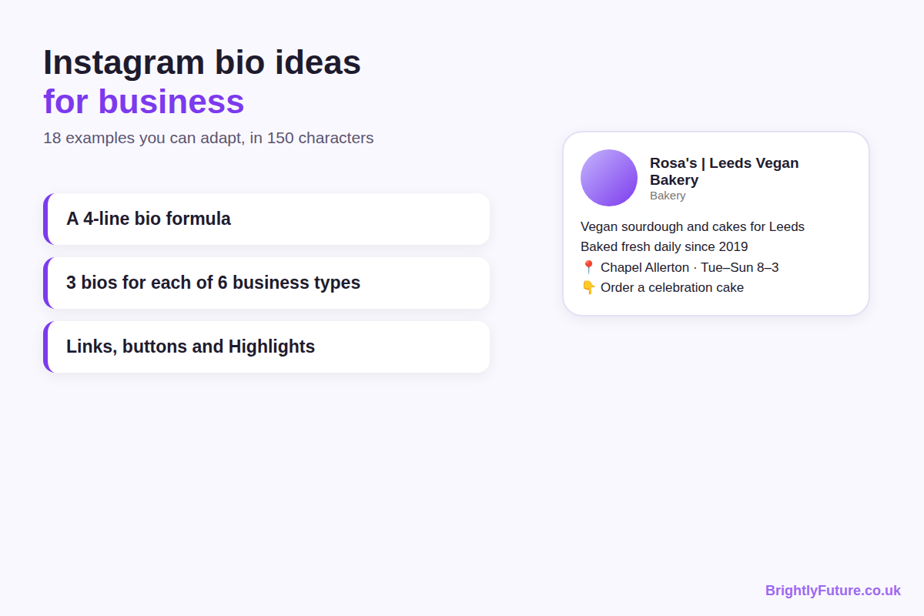
Most bio guides show you what Nike or a celebrity wrote. That doesn't help a café in Leeds or a bookkeeper in Bristol, because those brands don't need to explain what they do. A small business does.
This guide gives you 18 bios for six types of business, a four-line formula to write your own, and the profile settings that do the work 150 characters can't. It's part of our social media marketing guide.

What should a business put in its Instagram bio?
Put four things in your bio: what you do and for whom, one reason to trust you, the practical detail customers need, and one call to action. Each gets roughly one short line.
Line | Its job | Example (vegan bakery)
1. What + who | Tells visitors in seconds if you're for them | Vegan sourdough and cakes for Leeds
2. Proof | Gives a reason to choose you | Baked fresh daily since 2019
3. Practical info | Answers "can I buy from you?" | 📍 Chapel Allerton · Tue–Sun 8–3
4. Call to action | Says what to do next | 👇 Order a celebration cake

The bio sits under your name and above your posts, so it's often the first thing a new visitor reads. Your name field, links, category and buttons sit around it and carry the rest (covered below), so the bio text doesn't need to hold everything.

Instagram bio ideas for every type of business
Below are three bios for each of six business types, written for this guide as examples to adapt. Each "/" marks a new line. The character count includes spaces, emojis and line breaks, and every bio is well under Instagram's 150-character limit, leaving room for your own details (some emojis count as more than one character). Swap in your own product, place and proof.
[Image: 02-instagram-bio-formula.webp] Alt: The 4-line Instagram bio formula: what and who, proof, practical info, call to action
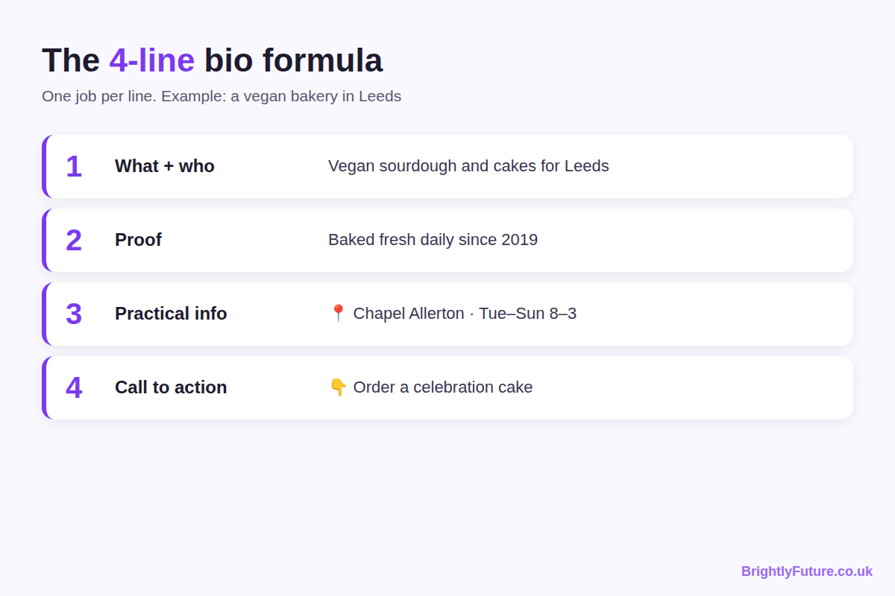

Cafes and restaurants
Local customers want to know where you are, when you're open and what to order.
Bio | Characters | Why it works
Brunch and specialty coffee in Ancoats / Dog-friendly, laptop-friendly / 📍 Open daily 8–4 / 👇 Book a table | 100 | Place, who it suits and opening hours in four lines
Neapolitan pizza, wood-fired in 90 seconds / Family-run since 2015 / 🚚 Delivery across Cardiff / 👇 Order online | 105 | A specific detail ("90 seconds") makes the claim believable
Plant-based café + bakery / Gluten-free options every day / 📍 Clifton, Bristol / New menu every season 👇 | 98 | Answers the dietary question before it's asked

Salons and beauty businesses
People choose a salon for a specific result, so lead with the service you're known for.
Bio | Characters | Why it works
Balayage and curly hair specialists / 📍 Bristol city centre / Free consultations / 👇 Book online | 90 | Names two specialisms people search for
Gel nails and nail art in Leeds / Appointment only, Tue–Sat / See prices in Highlights 💅 / 👇 Book your slot | 101 | Sends visitors to Highlights for prices instead of cramming them in
Lash lifts and brow lamination / Certified technician / 📍 Solihull home studio / DM to book or tap below | 98 | "Home studio" sets expectations for a solo business

Online shops
Online buyers want to know what you sell, why it's different and whether you ship to them.
Bio | Characters | Why it works
Handmade ceramic mugs and plates / Made in small batches in Cornwall / 🚚 UK + EU shipping / 👇 Shop new drops | 102 | Covers product, origin and delivery area
Refillable cleaning products / Plastic-free, made in the UK / Free delivery over £30 / 👇 Shop the starter kit | 103 | A threshold offer and a single starting product
Personalised gifts for new parents / Ships in 48 hours / 4.9★ from 2,000+ reviews / 👇 Find a gift | 91 | Proof only works if it's true: use your real rating

Fitness coaches and gyms
Fitness clients want a result they recognise, from someone who works with people like them.
Bio | Characters | Why it works
Strength coach for women over 40 / Online and in Birmingham / Free 3-day starter plan 👇 | 83 | Names the audience exactly and offers a low-risk first step
Small-group training in Hackney / Max 6 per class / Beginners welcome / 👇 Book a free trial session | 93 | "Max 6" answers the fear of being lost in a big class
Running coach / From couch to 10K in 12 weeks / Plans for busy parents / 👇 Join the next group | 88 | A clear timeframe for a clear goal

Consultants and B2B services
Business buyers look for the problem you solve and proof you've solved it for businesses like theirs.
Bio | Characters | Why it works
Bookkeeping for UK small businesses / Xero certified / Tax tips every Tuesday / 👇 Book a free call | 92 | Credential plus a reason to follow
Websites for therapists and coaches / 120+ sites launched / Plain-English advice, no jargon / 👇 See our work | 102 | Narrow niche makes the right buyer stop
HR support for teams of 5–50 / Contracts, policies, tricky conversations / 👇 Free 20-min HR check | 93 | Lists the jobs a small employer worries about

Bloggers and creators
Readers follow a creator for a topic and a promise, so say what they'll get from your posts.
Bio | Characters | Why it works
Easy vegan dinners in 30 minutes / New recipe every Sunday / 👇 Get the free meal plan | 81 | Topic, posting rhythm and a lead magnet
UK hiking routes for beginners / Maps, parking, cafés at the end / 👇 Latest routes on the blog | 90 | Specific details show the posts are useful
Money tips for freelancers / Ex-accountant, now self-employed / Weekly newsletter 👇 | 79 | The personal angle is the proof

If you'd rather start from a draft, our free Instagram Bio Generator suggests bios from a few details about your business. Edit what it gives you so it sounds like you.

How do you write your own Instagram bio?
Write your name field first, then the four lines, then check the result on your phone. It takes about 15 minutes.
[SCREENSHOT PLACEHOLDER: Instagram "Edit profile" screen showing the Name, Username, Bio and Links fields. Add manually.]

Step 1: Put a search keyword in your name field
Your name field is separate from your username, and both are searchable on Instagram. Use it for your business name plus the word people search for, such as "Rosa's | Leeds Vegan Bakery" or "Sam Patel | Bookkeeper". Your username can stay as your brand handle (@rosasbakes).

Step 2: Write the four lines
Draft each line from the formula above:
1. What + who. Use the words your customers use, not your industry's jargon.
2. Proof. A real detail: years trading, a certification, a number of clients, a rating. Never invent one.
3. Practical info. Location for local businesses, delivery area for shops, availability for services.
4. Call to action. One action that matches your first link.

Step 3: Match the call to action to your buttons and link
If your bio says "Book a table", your first link or action button should take people straight to booking. A bio that says "order online" and a link to your homepage makes visitors hunt for it.

Step 4: Check it on a phone
Save the bio and view your profile from another account or ask someone to look. Check that the lines break where you meant, that emojis don't replace important words and that the whole bio shows without tapping "more". Bios over a few lines can be cut off on some screens.

Before and after: fixing a weak bio
Most weak bios describe a feeling instead of the business. Here's an illustration: a typical salon bio, rewritten with the formula.
Before:
✨ Living the dream ✨ / Passion for beauty 💕 / Est. 2018 / DM for info
After:
Gel nails and nail art in Leeds / Appointment only, Tue–Sat / See prices in Highlights 💅 / 👇 Book your slot
[Image: 03-instagram-bio-before-after.webp] Alt: Before and after: rewriting a weak Instagram bio for a nail salon
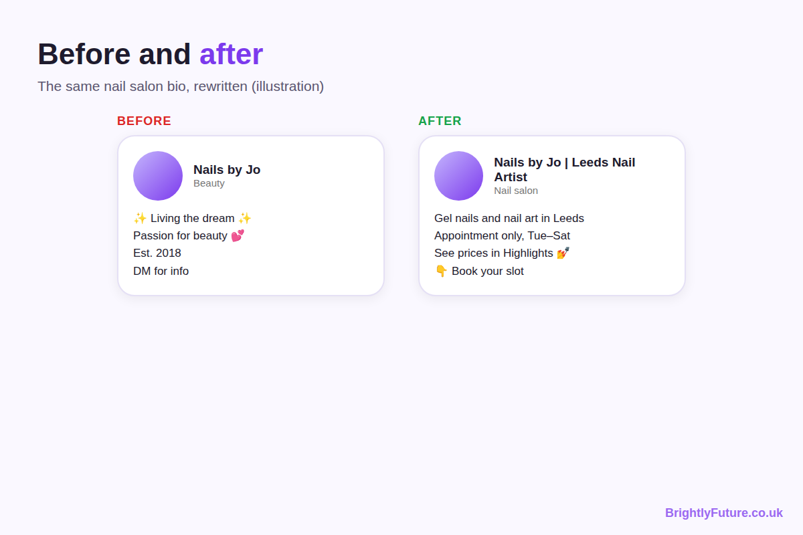
What changed:
- "Living the dream" became the service and the place. A visitor now knows in a second if this salon is for them.
- "DM for info" became a clear booking action. Fewer people message to ask a question they could answer themselves.
- Prices moved to Highlights. The bio stays short and the detail is one tap away.

How do you use the links in your Instagram bio?
You can add up to five links to your Instagram bio. Instagram launched the feature in April 2023, as Social Media Today reported, so you don't need a link-in-bio tool just to share more than one page.
[SCREENSHOT PLACEHOLDER: Instagram "Links" screen in Edit profile showing "Add external link" and a list of links. Add manually.]
Use them in order of importance:
- Link 1: the action in your bio. The booking page, shop or sign-up you ask people to use. It's the one most visitors see first.
- Links 2–3: what people ask for most. A menu, price list or best-selling product.
- Leave the rest empty if you don't need them. Five weak links are harder to choose from than two clear ones.
Add a short title to each link so people know where it goes. If you want to know which link gets clicks, add UTM tags to your website links so the visits show up in your website analytics.

What else on your profile works with your bio?
Your category, contact buttons, Highlights and pinned posts carry the information that won't fit in 150 characters. Set them up once and update them when something changes.
[SCREENSHOT PLACEHOLDER: a business profile showing the category label under the name and the Call / Email / Book buttons. Add manually.]
- Category. Professional accounts can show a label such as "Bakery" or "Accountant" under the name. Pick the closest match so visitors understand your business before reading the bio.
- Contact and action buttons. Add the ways customers actually contact you: call, email, directions or a booking button. Then you don't need your phone number in the bio text.
- Story Highlights. Use them for prices, FAQs, reviews and how to order. Name them clearly ("Prices", "Reviews") so people find them.
- Pinned posts. Pin up to three posts that answer the next question: your best-selling product, a client result or how to book.
- Branded hashtag. If customers post about you, add your branded hashtag to the bio so their photos are one tap away. Our guide to Instagram hashtag strategy for business explains when one is worth having.

What Instagram bio mistakes should businesses avoid?
The most common mistake is making visitors guess what you do. These are the others to check for:
- Writing a slogan instead of a description. "Dream big ✨" tells visitors nothing about what you sell.
- Asking people to DM for prices. Many won't bother. Put prices in a Highlight or on your site.
- Using several calls to action. "Follow, shop, book, DM, subscribe" leaves people unsure which to do.
- Replacing words with emojis. Screen readers read each emoji's description aloud, so a bio like "🍕 + 🍺 = ❤️" becomes confusing. The University of Kentucky's accessibility guidance recommends using emojis sparingly and not in place of words.
- Letting it go out of date. Old opening hours, finished offers or a broken link cost you customers. Check your bio each time something changes.

How do you know if your Instagram bio is working?
Compare your profile visits with the actions that follow them in Instagram Insights: link taps, button taps and new follows. If many people visit your profile but few tap or follow, the bio isn't convincing them.
To test a change:
1. Note your numbers for profile visits, link taps and follows over two weeks.
2. Change one line, such as the proof line or the call to action.
3. Compare the next two weeks. Keep the change if more visitors tap or follow.
Look at the proportion, not just the totals. A post that goes viral brings more visits but won't tell you if the bio got better.

Frequently Asked Questions

Should you add pronouns to a business profile?
It's optional. Pronouns suit a personal brand where you are the business, such as a coach or creator. For a business account with a team, they usually aren't needed. Instagram shows them next to your name, and you can choose who sees them.

How often should you change your Instagram bio?
Update it whenever something it mentions changes, such as hours, offers or your main link. Beyond that, leave it alone long enough to measure, about two weeks per change, so you can tell what worked.

Should you use your own name or your business name?
Use the name people search for. If customers come to you as a person, as with a hairdresser or coach, lead with your name and add the service. If they know the business, use the business name plus a keyword.

Can you use the same bio on TikTok and other platforms?
You can reuse the core message, but each platform has its own character limit and layout, so the wording usually needs trimming or expanding. Keep the same description of what you do so people recognise you across platforms.

Write your bio in four lines
Open your profile now and read your bio as a stranger would. If it doesn't say what you do, who it's for, why to trust you and what to do next, rewrite it with the four lines above, check it on your phone and measure for two weeks.

