BLOG POST (Cluster 2, article 6) | Category: Social Media | URL: /how-to-write-youtube-titles/ | Title Tag: How to Write YouTube Titles That Get More Views (2026) | Meta Description: How to write YouTube titles people click: a 5-step method, formulas by video type, data from 60 ranking titles and YouTube's own rules on testing and clickbait. | Focus Keyword: how to write youtube titles | Secondary: how to write clickable youtube titles, youtube title length, youtube title formulas, youtube shorts titles, youtube title a/b testing, youtube clickbait | Schema: Article, HowTo, FAQ

How to Write YouTube Titles That Get More Views (2026)
Quick Answer: Write YouTube titles that promise one clear result in viewers' own words, put the main keyword in the first 40 characters and match the thumbnail. YouTube allows 100 characters; top-ranking titles in our 60-title sample had a median of 55. Test up to three versions with Test & Compare.
[Image: 01-youtube-titles-featured.webp] Alt: How to write YouTube titles that get more views in 2026
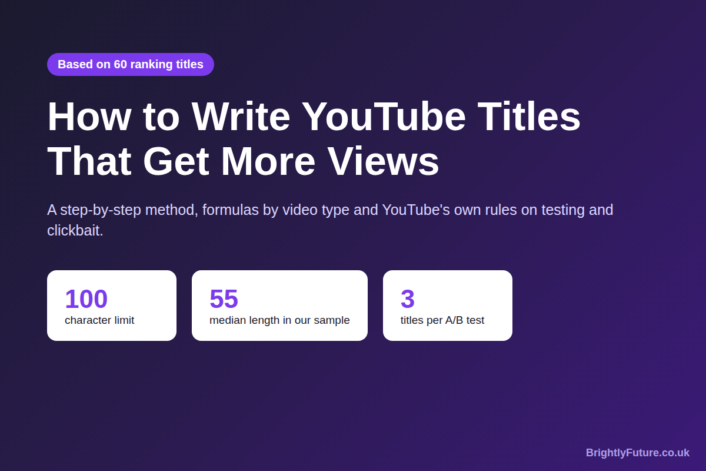
Your video is shown to people. They just don't click. In YouTube Analytics that looks like plenty of impressions and a low click-through rate, and the title is usually the cheapest thing to fix.
Most title advice is a list of "power words" and formulas with no evidence behind it. This guide uses three things instead: what YouTube's own help pages say, the 60 titles currently ranking for six everyday business searches, and YouTube's rules on testing and clickbait. It's about titles for YouTube videos and Shorts, and it's part of our social media marketing guide.

What makes a YouTube title get clicked?
A YouTube title gets clicked when it promises one clear result, in the words the viewer would use, and the thumbnail backs up the same promise. The viewer decides in a second whether this video answers their question or is worth their time, and the title is most of what they read.
The title also does a slightly different job depending on where the video is shown:
Where the viewer sees it | What they're doing | What the title needs
YouTube search | Looking for an answer | The words they typed, near the start, and a reason to pick yours
Home and Suggested videos | Browsing, not searching | A reason to stop: a result, a question, a surprise or a feeling (relief, worry, excitement)
Shorts feed | Swiping | Context for the clip; the video itself does most of the work

A tutorial that people search for needs a search title. A story or opinion video that mostly appears on the home page needs a browse title. Step 1 below shows how to tell which one your video is.

What do the top-ranking YouTube titles have in common?
Most of them say exactly what the video covers, early, and add one detail that tells the viewer it's for them. To check this rather than guess, we collected the top 10 videos YouTube returned for six searches a small business might target, on 17 October 2026 (UK, English): how to bake sourdough bread, how to do a tax return UK, home workout for beginners, how to start a small business, Excel pivot table tutorial and how to edit YouTube videos.
Across those 60 titles:
What we checked | Result
Contain the search's main word (sourdough, tax return, workout…) | 56 of 60
Have that word in the first 40 characters | 47 of 60
Add a second part with brackets, a colon, a dash or a pipe | 37 of 60
Name the audience or the ease ("beginner", "first", "easy", "step-by-step") | 34 of 60
Contain any number | 32 of 60
Include a year | 16 of 60
Use an emoji | 6 of 60
Length | Median 55 characters; 18 of 60 longer than 70

[Image: 02-youtube-titles-sample-data.webp] Alt: What 60 top-ranking YouTube titles have in common
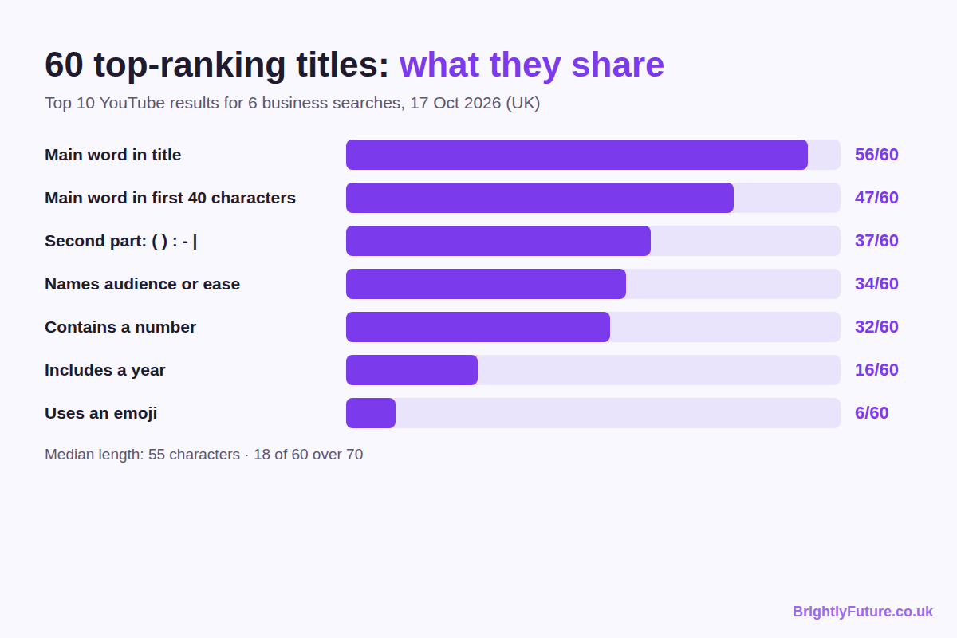
Two real examples show the pattern. "How to File Your FIRST UK Self Assessment Tax Return (Step-by-Step)" puts the topic first and uses the brackets to say who it's for. "Excel Pivot Table EXPLAINED in 10 Minutes (Productivity tips included!)" adds a time promise and a bonus.
This is one day of results in one country, and it shows what ranks, not why. Views, channel size and watch time all affect ranking too. It's still a better starting point than copying titles from a list.

How do you write a YouTube title, step by step?
Find out where your views come from, collect the words your viewers use, write several versions, then cut the best one down and check it next to the thumbnail. The steps below take one video from idea to final title.
[Image: 03-youtube-titles-5-steps.webp] Alt: Write a YouTube title in 5 steps
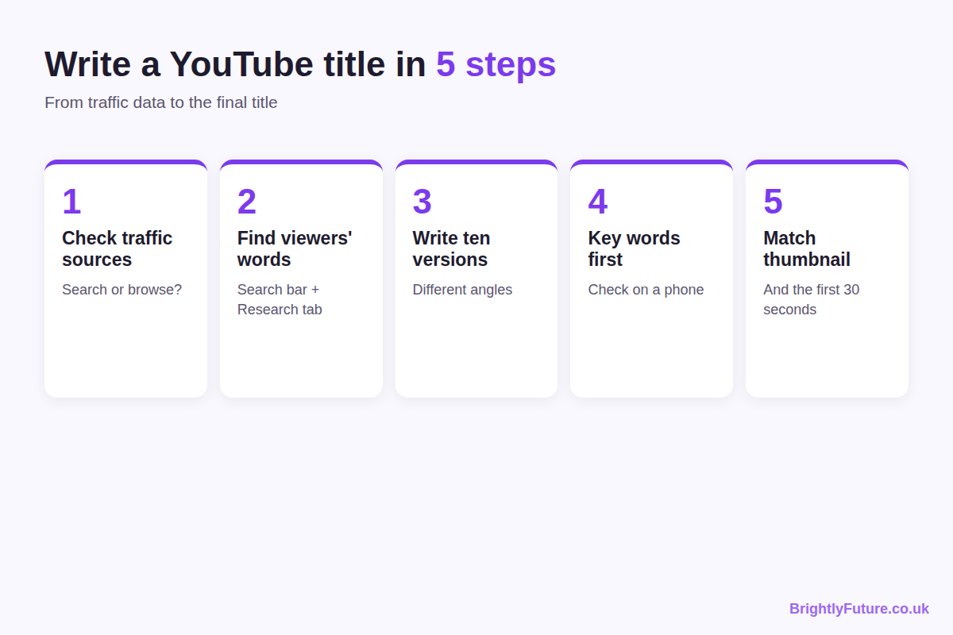

Step 1: Check where your views come from
Open YouTube Studio, go to Analytics, then the Reach tab, and look at Traffic source types. If most views on similar videos come from YouTube search, write a search title. If they come from Browse features or Suggested videos, write for curiosity and appeal.
[SCREENSHOT PLACEHOLDER: YouTube Studio > Analytics > Reach > "Traffic source types" card. Add manually.]
New channel with no data yet? Write a search title. Search is the one source you can target before YouTube knows your audience.

Step 2: Find the words your viewers search
YouTube's help page on descriptions recommends identifying one or two main words that describe your video and using them in both the title and the description. To find them:
- Type your topic into YouTube's search bar and note the suggestions. They come from what people actually search.
- Use the Research tab in YouTube Analytics, which shows what your viewers and wider YouTube audience search for.
- Look at the top results for your topic and note the words that keep appearing.
[SCREENSHOT PLACEHOLDER: YouTube Studio > Analytics > Research tab showing searches for a topic. Add manually.]
Use the viewer's words, not your industry's. A bookkeeper might call it "Self Assessment filing"; most viewers type "tax return".

Step 3: Write ten versions
Your first title is rarely your best. Write ten, each using a different angle from the formula table below: a how-to, a number, a mistake, a result. Then pick the two or three that make the clearest promise. An AI tool can draft extra variations quickly, but edit them into your viewers' words; our guide to making AI writing sound human shows what to change.

Step 4: Put the key words first and check it on a phone
Move the main keyword into the first 40 characters, cut words that add nothing ("video", "amazing", "very"), use the keyword once rather than repeating it, and read the title on a phone. Titles are cut off sooner on small screens, and the cut point varies with the device and where the video appears. If the visible part still makes sense, the title works.

Step 5: Match the thumbnail and the first 30 seconds
The title, the thumbnail and the opening of the video should make the same promise. Let the thumbnail show what the title doesn't say: the finished loaf, the before and after, the surprised face. Then start the video by confirming the viewer is in the right place.
Before and after (illustration):
Before | After | What changed
My Sourdough Journey Part 3 | Sourdough for Beginners: My First Loaf, Step by Step | The search term is first; the audience and format are named
Pivot Tables!!! | Excel Pivot Tables in 10 Minutes (Beginner Tutorial) | A time promise and a level replace the exclamation marks
Big News About Our Shop | We Moved Our Etsy Shop to Shopify: Costs After 6 Months | A specific result replaces a vague tease

What YouTube title formulas work for each type of video?
Use a formula that matches the type of video, then fill it with your own topic and a real detail. Formulas are starting points for your ten versions, not finished titles.
Video type | Formula | Business example (illustration)
How-to | How to [result] (for [audience]) | How to File a Self Assessment Tax Return (First-Timer Guide)
List | [Number] [things] that [result] | 7 Pricing Mistakes That Cost Small Shops Money
Mistake | Stop [common action] (Do This Instead) | Stop Posting Daily on Instagram (Do This Instead)
Review | [Product] Review: [honest verdict or condition] | Canva Pro Review After 1 Year of Daily Use
Comparison | [A] vs [B]: [deciding factor] | Shopify vs Etsy for Handmade Sellers: Fees Compared
Result or case study | I [did X] for [time]: [result] | I Posted Shorts Every Day for 30 Days: What Happened
Question | [Question your viewer asks]? | Is a Limited Company Worth It for Freelancers?

Use a number only if it's true, and use "I tried" only if you did. For more general headline patterns, our guide to writing blog headlines covers the formulas that work across formats.

How long should a YouTube title be?
A YouTube title can be up to 100 characters, as YouTube Help states, but aim to get the full promise into roughly the first 40–60. Our sample's median was 55 characters.
Longer titles do rank: 18 of our 60 were over 70 characters. They work when the extra words are the second part in brackets ("(Achievable, No Equipment)"), so nothing essential is lost if the end is cut. YouTube doesn't publish where titles are truncated, and it varies by screen. For limits on other platforms, see our social media character limits table.

How do you write titles for YouTube Shorts?
Write Shorts titles shorter and plainer than video titles: say what happens in the clip, with the topic word first. Viewers in the Shorts feed see the video before they read the title, but Shorts also appear in YouTube search, so a clear topic word still helps people find them later.
Two differences from long videos:
- You can't A/B test Shorts titles in YouTube Studio, according to YouTube's testing help page. Compare similar Shorts with different title styles instead.
- A Short can link to a longer video. If it does, use the same key words in both titles so viewers know they're connected.

What should your description add to the title?
The description should repeat the title's main words in its first one or two lines and add the detail the title can't fit. Those opening lines show before "more", and YouTube's help page says the description helps viewers and YouTube's systems understand what the video is about.
A simple opening that supports the title "Excel Pivot Tables in 10 Minutes (Beginner Tutorial)":
*"Learn to build an Excel pivot table from scratch in 10 minutes, using a sales spreadsheet you can download below. No formulas needed."*
Tags play a much smaller role than titles and descriptions; our guide to YouTube tags covers when they still matter.

Where is the line between a curious title and clickbait?
A curious title becomes clickbait when the video doesn't deliver what the title promises. Curiosity is fine; a broken promise isn't, and YouTube treats it as a policy problem.
- YouTube's spam and deceptive practices policy bans "malicious clickbait": misleading titles, thumbnails or descriptions that trick people into watching something that doesn't deliver. Its example is a title promising a full sports match on a video that shows only a clip. Violations can lead to removal, a warning or a strike.
- In December 2024 YouTube said it would step up enforcement against "egregious clickbait", starting in India, especially for breaking news. Its example: a title saying "the president resigned!" on a video that never covers a resignation.
Clickbait also fails on its own terms: viewers who click and leave early cut your watch time, which is the number YouTube's own title test uses to pick a winner.
Before publishing, ask three questions: does the video deliver exactly what the title promises? Would a viewer who watched to the end feel the title was fair? Is the promise in the first 30 seconds? If any answer is no, rewrite the title, not the video.

What does YouTube's own help say about titles?
YouTube's help pages give five rules for titles, scattered across different articles:
1. Titles can be up to 100 characters and can't include invalid characters (YouTube Help).
2. Use one or two main words that describe the video in both the title and description, found with the Research tab or Google Ads Keyword Planner (Tips for video descriptions).
3. Don't mislead. Titles that promise what the video doesn't deliver break the spam and deceptive practices policy.
4. Test up to three titles with Test & Compare (details below).
5. Translate titles for viewers in other languages; translated titles and descriptions can appear in search for speakers of those languages.
Everything else, from power words to emojis, is creator advice rather than YouTube guidance.

How do you test which YouTube title works?
Use Test & Compare in YouTube Studio to test up to three titles, or title and thumbnail combinations, on one video. YouTube picks the winner by watch time, not click-through rate, and shows the winning version to everyone when the test ends. Title testing reached all eligible creators in December 2025, as Search Engine Journal reported.
The rules, from YouTube's help page:
- Desktop only, in YouTube Studio, with advanced features turned on.
- Not available for Shorts, scheduled Lives or Premieres; Live archives can be tested.
- Tests finish within two weeks. Titles that are too similar take longer to produce a result, and a video with few impressions may not get a clear winner.
[SCREENSHOT PLACEHOLDER: YouTube Studio upload or details page showing "Test & compare" with three title options. Add manually.]
Test titles that differ in angle (a how-to against a result, for example), not in one word.

Should you change the title of an old video?
Yes, if it gets impressions but few clicks, or if its search term has changed. Leave it alone if it's still getting steady views from search, because a new title can lose the words people find it with.
Before you change it:
1. Check its traffic sources. If most views come from YouTube search, keep the main search words in the new title.
2. Note the date and the numbers: impressions, click-through rate and average view duration over the last 28 days.
3. Change only the title, not the thumbnail at the same time, so you know which change worked.
4. Compare the next 28 days. If clicks go up and viewers still watch, keep it. If not, change it back.
On eligible long videos, running a Test & Compare is safer than a straight swap.

Frequently Asked Questions

Should you put hashtags in a YouTube title?
Usually not. YouTube lets you add hashtags to titles, but hashtags in a title link to a page of other videos using that hashtag, which can send viewers away. Put them in the description instead, where up to three of them can still appear next to your title.

Should you use ALL CAPS in a YouTube title?
Capitalise one word for emphasis at most. In our sample, 17 of 60 titles had a word in capitals, such as "FIRST" or "BEGINNER". Whole titles in capitals are harder to read and look like shouting.

Do emojis help YouTube titles?
Rarely for search. Only 6 of the 60 top-ranking titles in our sample used one, mainly baking and small-business vlogs. If you use one, put it at the end where it won't push your keyword back.

Should you put the year in a YouTube title?
Only for topics that change each year, such as tax rules, software updates or "best tools" lists. In our sample, 16 of 60 titles included a year, mostly in tax, Excel, video editing and start-a-business videos. Update the year when you update the content, not just the title.

Does your YouTube title affect Google search too?
Yes. Google shows YouTube videos in its search results and video tabs using the video's YouTube title, so a title with the viewer's search words works on both. A vague title like "Part 3" gives Google nothing to match.

Write your next title in ten minutes
Check where your views come from, find the two words viewers search, write ten versions and keep the one with the clearest promise in its first 40 characters. Then run it through our free Headline Analyzer and test it against a second version in YouTube Studio.

