Create IgnoreExample.txt

Edit content of IgnoreExample.txt

Use git status and screenshot the outcome

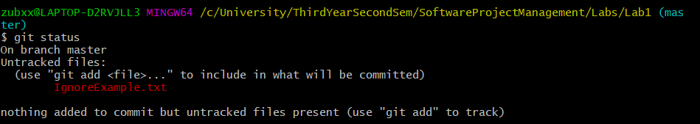

Add IgnoreExample.txt to .gitignore file

● Edit content of IgnoreExample.txt

● Use git status and screenshot the outcome

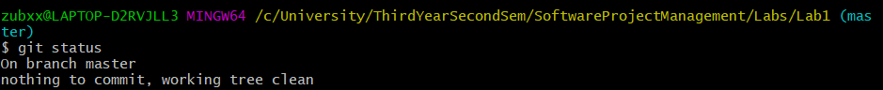

Use git add to update branch example, commit and use the

notepad command again

● Screenshot content

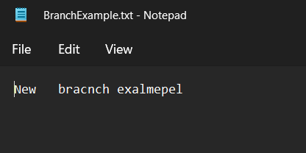

Switch back to the master branch

● Use the same notepad command

● Screenshot the outcome

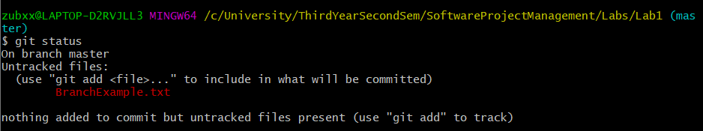

Remove RemoveExample.txt (create one first if not present)

● Commit

● Use git status and screenshot outcome

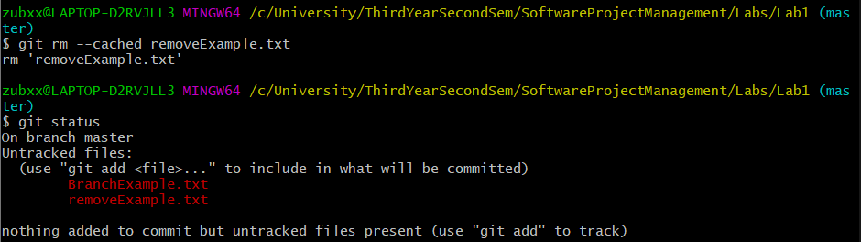

Use the clean command to remove the file completely

● Use git status and screenshot outcome

