
MCERTS Site Inspection Report {inspectionReportNo}

 | Report prepared by: | {reportPreparedBy}
 | Inspector: | {inspector}
 | Consent/Permit Holder: | {consentPermitHolder}
 | Site Name: | {siteName}
 | Site Contact: | {siteContact}
 | Site Address: | {siteAddress}
 | Site Ref or Postcode: | {siteRefPostcode}
 | Irish Grid ref for Site Entrance: | {irishGridRef}
 | Consent/Permit No: | {consentPermitNo}
 | Type of Flowmeter(s): | {flowmeterType}
 | Serial number(s) of Flowmeter(s):  NIW Asset ID: | Sensor: {flowmeterSensorSerial}  Transmitter: {flowmeterTransmitterSerial}  {niwAssetId}
 | Statement of Compliance: | {statementOfCompliance}
 | Uncertainty: | ± {uncertainty}
 | Inspection report No: | {inspectionReportNo}
 | Date of Inspection: | {dateOfInspection}
Siris Flow Inspections Ltd
Washington Business Park
Turbine Way
Sunderland
SR5 3NZ
Tel: 0191 513 1313
Site description
{siteDescription}

Location of flowmeter(s)
{flowmeterLocation}

Emission point(s) requiring flow measurement
{siteName}  Information provided by NIW. | WOC number: {wocNumber}  Dry weather flow: {dryW} m³/day  Maximum daily volume: {maxD} m³/day  Maximum FFT flow rate: {maxFFT}/s  Qmax of flowmeter: {qmaxF} l/s

Does the flow meter carry MCERTS product certification?
{field2}

Method of secondary verification
{field1}

Site maintenance arrangements
{field3}

Contents

1.0 References

2.0 Site review
2.1 Site process & basic schematic diagram
2.2 Integrity of flow monitoring

3.0 Site inspection of flow monitoring system(s)
3.1 Primary device
3.2 Secondary device
3.3 Flow measurement verification
3.4 Telemetry check
3.5 Flow measurement NIEA viewpoint

4.0 Maintenance & calibration
4.1 Routine maintenance
4.2 Routine verification / calibration

5.0 Survey measurement equipment

- Conclusions
6.1 Data and calculated uncertainty
6.2 Report signatories

Appendix A Survey & Compliance Data
Appendix B Stage discharge relationship and flow uncertainty curve
Appendix C Calculated daily weighted uncertainty

References 1.0

{#references}
● {.}
{/references}

Site review 2.0

Site process & schematic diagram 2.1

{siteProcessDescription}

Site process & schematic diagram 2.1

{%siteProcessImage1}
{siteProcessImage1Caption}
{%siteProcessImage2}
{siteProcessImage2Caption}

{%siteProcessImage3}
{siteProcessImage3Caption}
{%siteProcessImage4}
{siteProcessImage4Caption}

{%siteProcessImage5}
{siteProcessImage5Caption}

Integrity of flow monitoring 2.2

{aerialViewDescription}

{%aerialViewImage1}
{aerialViewImage1Caption}

{%aerialViewImage2}
{aerialViewImage2Caption}

{%aerialViewImage3}
{aerialViewImage3Caption}
{%aerialViewImage4}
{aerialViewImage4Caption}

{%aerialViewImage5}
{aerialViewImage5Caption}

Site inspection of flow monitoring system 3.0

Primary device (Flow meter sensor) 3.1

{primaryDeviceDescription}

{%primaryDeviceImage1}
{primaryDeviceImage1Caption}

{%primaryDeviceImage2}
{primaryDeviceImage2Caption}

{%primaryDeviceImage3}
{primaryDeviceImage3Caption}
{%primaryDeviceImage4}
{primaryDeviceImage4Caption}

{%primaryDeviceImage5}
{primaryDeviceImage5Caption}

FE Thin Plate V-Notch Weir Chamber

Secondary device (Flow meter transmitter) 3.2

{secondaryDeviceDescription}

{%secondaryDeviceImage1}
{secondaryDeviceImage1Caption}

{%secondaryDeviceImage2}
{secondaryDeviceImage2Caption}

{%secondaryDeviceImage3}
{secondaryDeviceImage3Caption}
{%secondaryDeviceImage4}
{secondaryDeviceImage4Caption}

{%secondaryDeviceImage5}
{secondaryDeviceImage5Caption}

Flow Meter Verification 3.3

The flow measurement structure includes for a fixed calibration-mounting bracket to assist routine flow validation. A removable calibration target plate was positioned in the path of the ultra-sonic sensor. The plate was measured at {verificationPlateMeasurement}mm above the zero datum. The flow instrument displayed an average of {verificationPlateMeasurement2}mm taken from the 20 separate head readings.

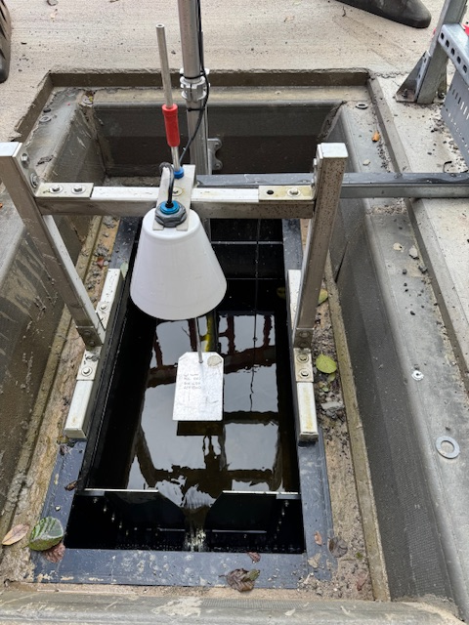

A {verificationInstrumentDisplay}mm head error and a {verificationInstrumentDisplay2}mm repeatability error have been applied to the uncertainty budget and are within accepted limits. An Additional curve point was checked. The flow measurement verification was successful.

Calibration Reference: Blue Collar 212mm (±1mm)

Flow measurement NIEA viewpoint 3.4

{nieaDescription}

{%nieaImage1}
{nieaImage1Caption}

{%nieaImage2}
{nieaImage2Caption}

{%nieaImage3}
{nieaImage3Caption}
{%nieaImage4}
{nieaImage4Caption}

{%nieaImage5}
{nieaImage5Caption}

Maintenance & calibration 4.0

Routine maintenance 4.1

{routineMaintenanceDescription}

{%routineMaintenanceImage1}
{routineMaintenanceImage1Caption}
{%routineMaintenanceImage2}
{routineMaintenanceImage2Caption}

{%routineMaintenanceImage3}
{routineMaintenanceImage3Caption}
{%routineMaintenanceImage4}
{routineMaintenanceImage4Caption}

{%routineMaintenanceImage5}
{routineMaintenanceImage5Caption}

Routine verification 4.2

{routineVerificationDescription} {nextFlowValidationDate}

{%routineVerificationImage1}
{routineVerificationImage1Caption}

{%routineVerificationImage2}
{routineVerificationImage2Caption}

{%routineVerificationImage3}
{routineVerificationImage3Caption}
{%routineVerificationImage4}
{routineVerificationImage4Caption}

{%routineVerificationImage5}
{routineVerificationImage5Caption}

Critical data stickers on flow meter.

Survey measurement equipment 5.0

{surveyEquipmentDescription}

{%surveyEquipmentImage1}
{surveyEquipmentImage1Caption}

{%surveyEquipmentImage2}
{surveyEquipmentImage2Caption}

{%surveyEquipmentImage3}
{surveyEquipmentImage3Caption}
{%surveyEquipmentImage4}
{surveyEquipmentImage4Caption}

{%surveyEquipmentImage5}
{surveyEquipmentImage5Caption}

Conclusions 6.0

Data and Calculated Uncertainty 6.1

Based upon flow data provided by NIW and using data for {conclusionUncertaintySheetF2} that being a typical dry weather day, the weighted uncertainty was calculated to be {conclusionUncertaintySheetF104} % of the total daily discharge.

Report Signatories 6.2

The data enclosed relates to circumstances and detail found on the date of the inspection being {conclusionUncertaintySheetF2Formatted}.

Signed,
{signatureName}
{signatureName}
{signatureCompany}

Appendix A
{appendixField1}

{%appendixAImage1}
{appendixAImage1Caption}

{%appendixAImage2}
{appendixAImage2Caption}

{%appendixAImage3}
{appendixAImage3Caption}
{%appendixAImage4}
{appendixAImage4Caption}

{%appendixAImage5}
{appendixAImage5Caption}

Appendix B

{appendixField2}

{%appendixBImage1}
{appendixBImage1Caption}

{%appendixBImage2}
{appendixBImage2Caption}

{%appendixBImage3}
{appendixBImage3Caption}
{%appendixBImage4}
{appendixBImage4Caption}

{%appendixBImage5}
{appendixBImage5Caption}

Appendix C

{appendixField3}

{%appendixCImage1}
{appendixCImage1Caption}

{%appendixCImage2}
{appendixCImage2Caption}

{%appendixCImage3}
{appendixCImage3Caption}
{%appendixCImage4}
{appendixCImage4Caption}

{%appendixCImage5}
{appendixCImage5Caption}

