

MCERTS Site Inspection Report 1459 25 Rev1 Manual

Report prepared by: | Siris Flow Inspections Ltd Fixed
Inspector: | Aaron McGilligan MI 16 025 Dropdown Menu
Consent/Permit Holder: | Glen Water Ltd Dropdown Menu
Site Name: | Ballyrickard WwTW Input Data D4
Site Contact: | Mr Paul Gardiner Dropdown Menu
Site Address: | Ballyrickard WwTW Manual or From DB  Newtownards Road / Comber Road  Strangford Lough  County Down
Site Ref or Postcode: | BT23 5LS (Nearest Postcode) Manual or From DB
Irish Grid ref for Site Entrance: | J 48572 70621 Manual or From DB
Consent/Permit No: | 2025/2006 Input Data D5
Type of Flowmeter(s): | Pulsar Ultra 5 Input Data I5 & I6
NIW Asset ID: | 0324638 Manual or from DB
Statement of Compliance: | The flow monitoring arrangements meet Fixed  the requirements of the Environment Agency’s “Minimum requirements for the self-monitoring of flow.
Uncertainty: | ±6.02 % Uncertainty Sheet F104
Inspection report No: | 1459 25 rev1 Manually Entered
Date of Inspection: | 22nd May 2025 Manually Entered

Site description
Ballyrickard is a medium sized works located off the main road between Newtownards and Comber midway between the two towns. The site operates an aeration type treatment process. With treated effluent being flows discharged into Strangford Lough.

The FFT rectangular flume flow measurement system forms the certified device for this site.

Location of Flowmeter(s)
There is an open channel rectangular flume flow measurement system located downstream of the inlet screens and immediately upstream from primary settlement. The flume channel is located on a raised concrete channel towards the right-hand side of the site, in relation to the main control building.

The associated flow meter displays (x2) are located immediately adjacent to the flow measurement channel.

Emission point(s) requiring flow measurement
Ballyrickard WwTW From Input Data D4  Information provided by NIW. | WOC number: 2025/2006 E5  Dry weather flow: 211 m³/day C10  Maximum daily volume: 211 m³/day C9  Maximum FFT flow rate: 2.44 l/s D6  Qmax of flowmeter: 10.00 l/s D8  All from Input Data

Does the flow meter carry MCERTS product certification?
Yes- The flow meter is MCert product approved. Permanent

Explanation of secondary verification could not be carried out
Secondary verification successfully undertaken. Permanent

Site maintenance arrangements
NIW operational personnel record maintenance activities in “Tough Books” this information is
Subsequently uploaded to NIW central database. At the time of the inspection the weir and channel were clean and free from significant fouling.

Maintenance appears satisfactory. Permanent

Contents

1.0 References

2.0 Site review
2.1 Site process & basic schematic diagram
2.2 Integrity of flow monitoring

3.0 Site inspection of flow monitoring system(s)
3.1 Primary device
3.2 Secondary device
3.3 Flow measurement verification
3.4 Flow measurement NIEA viewpoint

4.0 Maintenance
4.1 Routine maintenance
4.2 Routine verification

5.0 Survey measurement equipment

- Conclusions
6.1 Data and calculated uncertainty
6.2 Report signatories

Appendix A Survey data
Appendix B Survey & compliance data
Appendix C Stage discharge relationship and flow uncertainty curve
Appendix D Calculated daily weighted uncertainty

References 1.0

● Minimum Requirements for the Self-Monitoring of Effluent Flow
● BS ISO 4359 Liquid flow measurement in open channels (Flumes)
● Siris Software Rectangular flume

Site Review 2.0
Gravity Inlet
To River
Inlet Screen

Primary
Settlement
Biological
Treatment
Final
Settlement
To River
Pumping Station
Storm
Tanks
Final Effluent V-Notch & Ultra-sonic
flow measurement system
MCERTS certified
measurement point.

Storm Overflow

Site process & schematic diagram 2.1
Sludge

Flows enter the site from the local catchment and pass-through screening and grit removal. An inlet FFT flume, which includes a storm overspill weir, then quantifies flows. Flows then proceed through the works in a standard configuration of primary settlement, aeration treatment and final settlement, which further includes tertiary and UV treatment. Flows are then discharged from site through a parti-mag meter and tidal pumping station.

Storm water that overspills at the FFT storm overspill weir feeds the site storm tank with any overspill from the storm tank spilling to Strangford Lough. Stored storm water is returned to a point upstream of the FFT flume. Sludge drawn from primary settlement together with surplus sludge from aeration is stored in a sludge tank and tankered off site. Returned supernatant / top water is re-circulated to a point upstream of the aeration process.

The FFT rectangular flume & associated flow meter display are used to certify the works under the Environment Agency MCERTS scheme.

Site process & schematic diagram 2.1

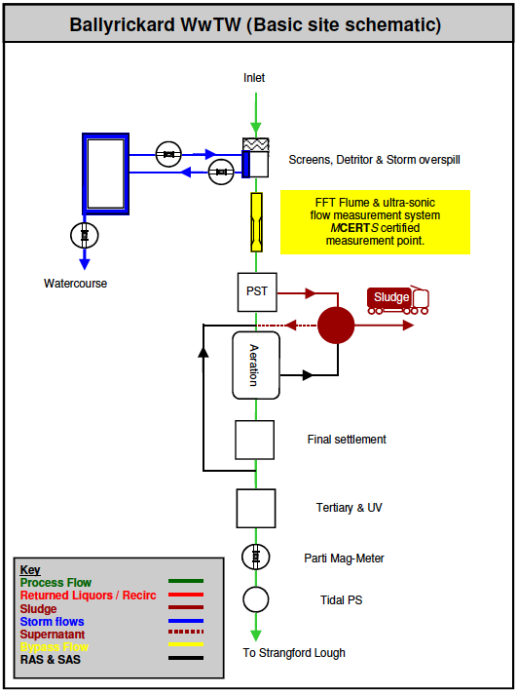

Schematic layout confirmed by client.

Integrity of flow monitoring 2.2

The FFT rectangular flume and associated flow meter are correctly located to ensure representative measurement of the total daily volume of effluent being treated and therefore discharged from the site.
There is no double counting or undercounting of flows at this location. There are no significant risks to the integrity of the flow measurement system.

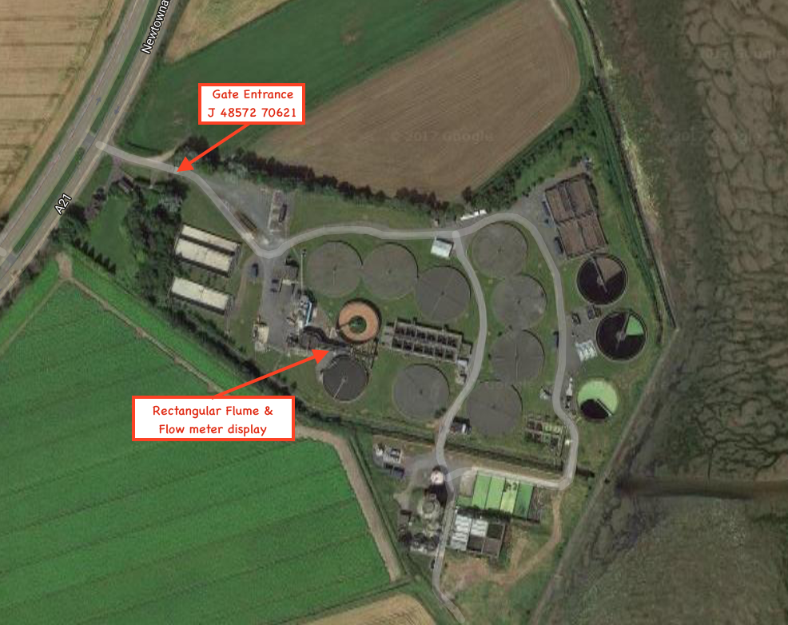
Site aerial view

Site inspection of flow monitoring system 3.0

Primary device 3.1

There is an inlet open channel rectangular flume installation used to monitor the volume of effluent going forward to treatment and thus representative of treated flow being discharged to the watercourse. The flume is manufactured from stainless steel and has a smooth concrete approach channel. The primary device is compliant with the key dimensional requirements of BS ISO 4359 and is in good condition. Flow is free discharging with no evidence of the flume ever having been drowned under operating conditions. Flow within the approach channel appears uniform and steady with an apparent even velocity distribution, no significant hydraulic disturbances were apparent.
There is a visible top scum mark located 460mm above zero¹, equating to approximately 360 L/sec.
Permanent Except for items highlighted. Input Data c69
¹Visible scum mark is difficult to accurately measure and is used only as a guide for flows at site

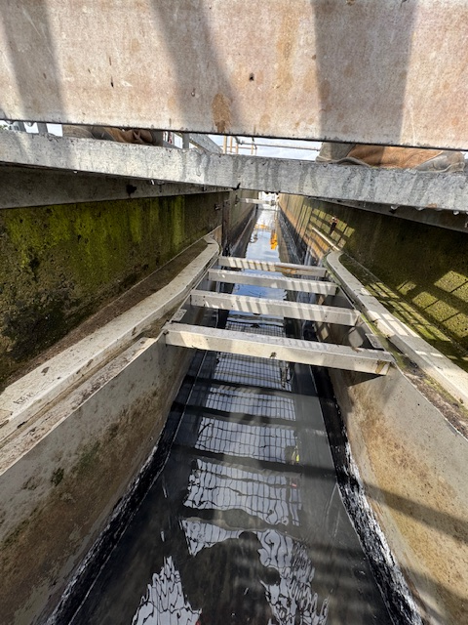
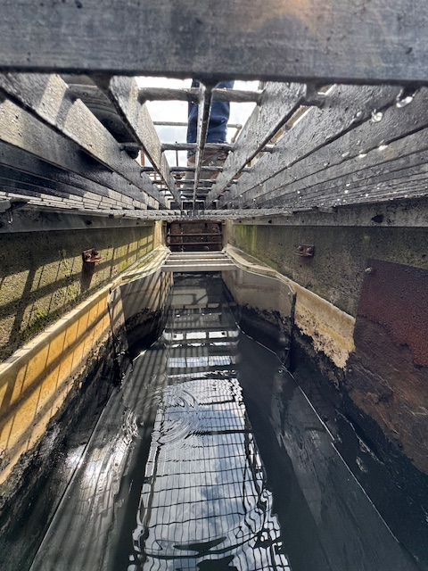

Flume and approach conditions

Secondary device 3.2

Located directly adjacent to the flume channel is the associated flow meter. There are 2 identical flow meters one is used as the TARIFF meter and is for recording flows for billing purposes to NI water. The second flow meter is the PROCESS flow meter and this is used by Veolia water. Both flow meters are Pulsar ultra5 units and are mounted in adjacent weatherproof kiosks.

The Flow meters are linked to a type DB6 ultra-sonic sensors with built in temperature compensation.
The sensors are correctly located within the upstream approach channel for the range of the instrument being 1600 & 2100mm upstream. The sensors are secured to cross channel bridge brackets and are shaded from direct sunlight being located under a dedicated sun shield.
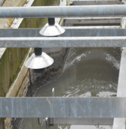
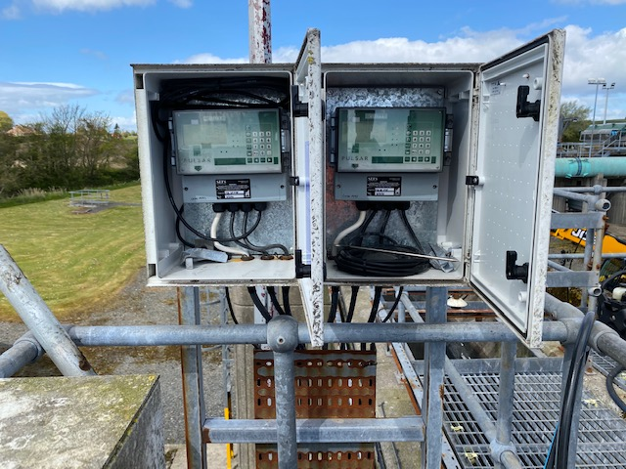

Flow transmitters & associated sensors
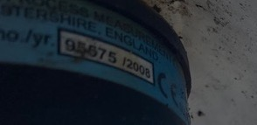
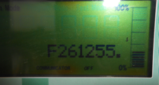

Flow transmitter and sensor serial numbers.

Both flow meters are programmed to calculate flow using an 11-point flow curve derived from BS ISO. Displayed flow rates from the flow meters compare favourably with the calculated values using Siris Software. An additional 1% has been included in the uncertainty budget to account for minor variations in results. The 4-20mA output was checked. An additional 2% has been included in the Uncertainty budget to account for data transmission via telemetry system.

Flow measurement verification 3.3

The flow measurement structure includes for a fixed calibration-mounting bracket to assist routine flow validation. A removable calibration target plate was positioned in the path of the ultra-sonic sensor. The plate was measured at 212mm above the zero datum. The flow instrument displayed an average of 212.55mm taken from the 20 separate head readings. Permanent Except for items highlighted. Input Data I 26 & I27

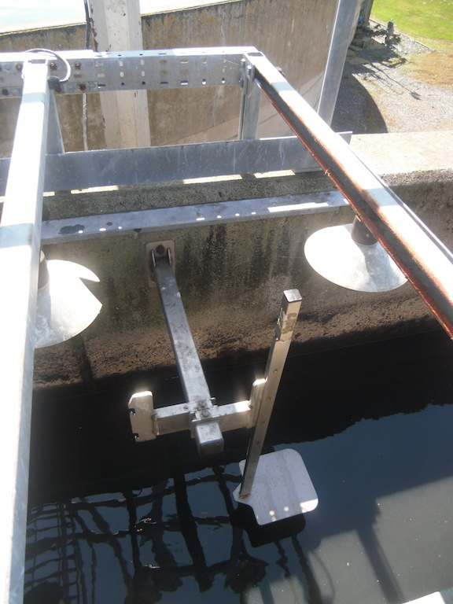

Reference plate used for flow verification

A 0.55mm head error and a 0.40mm repeatability error have been applied to the uncertainty budget and are within accepted limits. An Additional curve point was checked. The flow measurement verification was successful. Permanent Except for items highlighted. Data & Results D23 & D24.

Calibration Reference: Blue Collar 212mm (±1mm)

Flow measurement NIEA viewpoint 3.4

The flow meters display forms the NIEA viewpoint and there is no secondary flow display. The flow meter display provides instantaneous flow in (L/s) litres per second. The flow meter has a new MCERTS sticker.

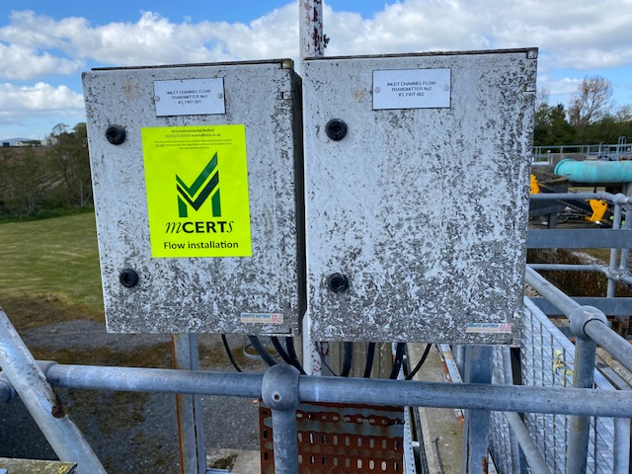
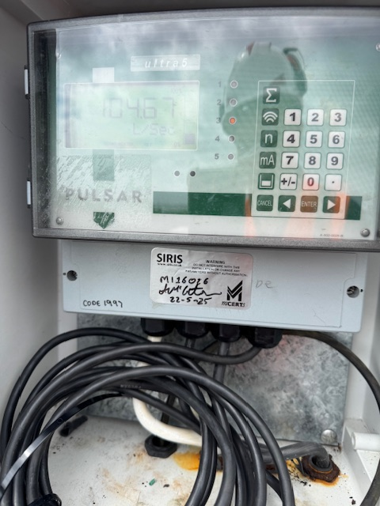

Kiosks containing flow transmitters (Left) Pulsar Ultra 5 flow transmitters, labelled with MCert stickers (middle & right)

Maintenance & calibration 4.0

Routine maintenance 4.1

NIW operational personnel record maintenance activities in “Tough Books” this information is subsequently uploaded to NIW central database. At the time of the inspection the flume and approach channel were clean and free from significant fouling. The sensor was clean and free from sedimentary deposits on the sensor face and cobwebs etc.
It is important that regular maintenance procedures should be undertaken and documented for subsequent QMS inspection. Maintenance appears satisfactory.

Routine verification 4.2

The flow sensor has a fixed calibration bracket for a removable calibration reference plate. It is understood NIW have a program of annual flow validation. NIW will need to undertake a routine flow validation on or before the 12th September 2026. Date of Inspection: + 1 year.

Labelling has been affixed to the flow installation, displaying critical data and calibration details.

Calibration Reference: Blue Collar 212mm (±1mm)

Survey measurement equipment 5.0

The following is a list of equipment taken to each inspection

Site survey vehicle SIRIS 4
Equipment | Serial No | Uncertainty
Engineers level | 335620 | ±2.0mm
1000mm Steel rule | Shinwa (Purple) | ±0.5mm
3m Talmeter tape | Purple label | ±0.5mm
5m Macallister tape | Purple label | ±0.5mm
ISOTech IDM (DVM) | 85003701 | ±0.008% 1 digit
Ridgid Micro LM-100 (Laser distance meter) | SZQA0470080416 | ±0.5mm
Gas Detector |  | n/a
PT878 | GAA1518003 | ±3.06%
Nivus OCM Pro | Van A (Purple Label) | ±5.5%
Nivus Wedge | Van A (Purple Label) | ±5.5%
Calibration plate | CRP 10.02 | ±2mm (Reference only)
Engineers Staff (Red/White) | Purple label | ±1mm (Reference only)
Steel Calipers | Purple label | ±1mm (Reference only)

Conclusions 6.0

Data and Calculated Uncertainty 6.1

Based upon flow data provided by NIW and using data for 26/09/2025 that being a typical dry weather day, the weighted uncertainty was calculated to be ± 3.03 % of the total daily discharge. Uncertainty Sheet F104 Uncertainty Sheet F2

Report Signatories 6.2

The data enclosed relates to circumstances and detail found on the date of the inspection being 12th September 2025. Date of inspection

Signed,
Aaron McGilligan
Aaron McGilligan
SIRIS Flow Inspections Ltd
27th September 2025

