
MCERTS Site Inspection Report {inspectionReportNo}

 | Report prepared by: | {reportPreparedBy}
 | Inspector: | {inspector}
 | Consent/Permit Holder: | {consentPermitHolder}
 | Site Name: | {siteName}
 | Site Contact: | {siteContact}
 | Site Address: | {siteAddress}
 | Site Ref or Postcode: | {siteRefPostcode}
 | Irish Grid ref for Site Entrance: | {irishGridRef}
 | Consent/Permit No: | {consentPermitNo}
 | Type of Flowmeter(s): | {flowmeterType}
 | NIW Asset ID: | {niwAssetId}
 | Statement of Compliance: | {statementOfCompliance}
 | Uncertainty: | ± {uncertainty}
 | Inspection report No: | {inspectionReportNo}
 | Date of Inspection: | {dateOfInspection}

Site description
{siteDescription}

Location of flowmeter(s)
{flowmeterLocation}

Emission point(s) requiring flow measurement
{siteName}  Information provided by NIW. | WOC number: {wocNumber}  Dry weather flow: {dryW} m³/day  Maximum daily volume: {maxD} m³/day  Maximum FFT flow rate: {maxFFT}/s  Qmax of flowmeter: {qmaxF} l/s

Does the flow meter carry MCERTS product certification?
{field2}

Method of secondary verification
{field1}

Site maintenance arrangements
{field3}

Contents

1.0 References

2.0 Site review
2.1 Site process & basic schematic diagram
2.2 Integrity of flow monitoring

3.0 Site inspection of flow monitoring system(s)
3.1 Primary device
3.2 Secondary device
3.3 Flow measurement verification
3.4 Flow measurement NIEA viewpoint

4.0 Maintenance & calibration
4.1 Routine maintenance
4.2 Routine verification

5.0 Survey measurement equipment

- Conclusions
6.1 Data and calculated uncertainty
6.2 Report signatories

Appendix A Survey data
Appendix B Stage discharge relationship and flow uncertainty curve
Appendix C Calculated daily weighted uncertainty

References 1.0

{#references}
● {.}
{/references}

Site review 2.0

Site process & schematic diagram 2.1

{siteProcessDescription}

Site process & schematic diagram 2.1

{%siteProcessImage1}
{siteProcessImage1Caption}
{%siteProcessImage2}
{siteProcessImage2Caption}

{%siteProcessImage3}
{siteProcessImage3Caption}
{%siteProcessImage4}
{siteProcessImage4Caption}

{%siteProcessImage5}
{siteProcessImage5Caption}

Integrity of flow monitoring 2.2

{aerialViewDescription}

{%aerialViewImage1}
{aerialViewImage1Caption}

{%aerialViewImage2}
{aerialViewImage2Caption}

{%aerialViewImage3}
{aerialViewImage3Caption}
{%aerialViewImage4}
{aerialViewImage4Caption}

{%aerialViewImage5}
{aerialViewImage5Caption}

Site inspection of flow monitoring system 3.0

Primary device 3.1

There is an inlet open channel rectangular flume installation used to monitor the volume of effluent going forward to treatment and thus representative of treated flow being discharged to the watercourse. The flume is manufactured from stainless steel and has a smooth concrete approach channel. The primary device is compliant with the key dimensional requirements of BS ISO 4359 and is in good condition. Flow is free discharging with no evidence of the flume ever having been drowned under operating conditions. Flow within the approach channel appears uniform and steady with an apparent even velocity distribution, no significant hydraulic disturbances were apparent. There is a visible top scum mark located {scummark} above zero1, equating to approximately {variableflow}
Visible scum mark is difficult to accurately measure and is used only as a guide for flows at site

{%primaryDeviceImage1}
{primaryDeviceImage1Caption}

{%primaryDeviceImage2}
{primaryDeviceImage2Caption}

{%primaryDeviceImage3}
{primaryDeviceImage3Caption}
{%primaryDeviceImage4}
{primaryDeviceImage4Caption}

{%primaryDeviceImage5}
{primaryDeviceImage5Caption}

Secondary device 3.2

{secondaryDeviceDescription}

{%secondaryDeviceImage1}
{secondaryDeviceImage1Caption}

{%secondaryDeviceImage2}
{secondaryDeviceImage2Caption}

{%secondaryDeviceImage3}
{secondaryDeviceImage3Caption}
{%secondaryDeviceImage4}
{secondaryDeviceImage4Caption}

{%secondaryDeviceImage5}
{secondaryDeviceImage5Caption}

Flow Meter Verification 3.3

The flow measurement structure includes for a fixed calibration-mounting bracket to assist routine flow validation. A removable calibration target plate was positioned in the path of the ultra-sonic sensor. The plate was measured at {verificationPlateMeasurement}mm above the zero datum. The flow instrument displayed an average of {verificationPlateMeasurement2}mm taken from the 20 separate head readings.

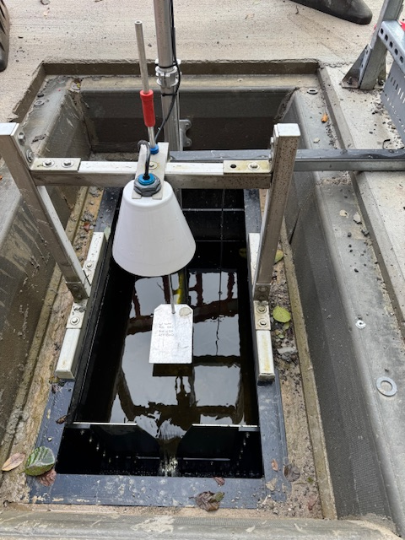

A {verificationInstrumentDisplay}mm head error and a {verificationInstrumentDisplay2}mm repeatability error have been applied to the uncertainty budget and are within accepted limits. An Additional curve point was checked. The flow measurement verification was successful.

Calibration Reference: Blue Collar 212mm (±1mm)

Flow measurement NIEA viewpoint 3.4

{nieaDescription}

{%nieaImage1}
{nieaImage1Caption}

{%nieaImage2}
{nieaImage2Caption}

{%nieaImage3}
{nieaImage3Caption}
{%nieaImage4}
{nieaImage4Caption}

{%nieaImage5}
{nieaImage5Caption}

Maintenance & calibration 4.0

Routine maintenance 4.1

{routineMaintenanceDescription}

{%routineMaintenanceImage1}
{routineMaintenanceImage1Caption}
{%routineMaintenanceImage2}
{routineMaintenanceImage2Caption}

{%routineMaintenanceImage3}
{routineMaintenanceImage3Caption}
{%routineMaintenanceImage4}
{routineMaintenanceImage4Caption}

{%routineMaintenanceImage5}
{routineMaintenanceImage5Caption}

Routine verification 4.2

{routineVerificationDescription} {nextFlowValidationDate}

{%routineVerificationImage1}
{routineVerificationImage1Caption}

{%routineVerificationImage2}
{routineVerificationImage2Caption}

{%routineVerificationImage3}
{routineVerificationImage3Caption}
{%routineVerificationImage4}
{routineVerificationImage4Caption}

{%routineVerificationImage5}
{routineVerificationImage5Caption}

Critical data stickers on flow meter.

Survey measurement equipment 5.0

{surveyEquipmentDescription}

{%surveyEquipmentImage1}
{surveyEquipmentImage1Caption}

{%surveyEquipmentImage2}
{surveyEquipmentImage2Caption}

{%surveyEquipmentImage3}
{surveyEquipmentImage3Caption}
{%surveyEquipmentImage4}
{surveyEquipmentImage4Caption}

{%surveyEquipmentImage5}
{surveyEquipmentImage5Caption}

Conclusions 6.0

Data and Calculated Uncertainty 6.1

Based upon flow data provided by NIW and using data for {conclusionUncertaintySheetF2} that being a typical dry weather day, the weighted uncertainty was calculated to be {conclusionUncertaintySheetF104} % of the total daily discharge.

Report Signatories 6.2

The data enclosed relates to circumstances and detail found on the date of the inspection being {conclusionUncertaintySheetF2Formatted}.

Signed,
{signatureName}
{signatureName}
{signatureCompany}

Appendix A
{appendixField1}

{%appendixAImage1}
{appendixAImage1Caption}

{%appendixAImage2}
{appendixAImage2Caption}

{%appendixAImage3}
{appendixAImage3Caption}
{%appendixAImage4}
{appendixAImage4Caption}

{%appendixAImage5}
{appendixAImage5Caption}

Appendix B

{appendixField2}

{%appendixBImage1}
{appendixBImage1Caption}

{%appendixBImage2}
{appendixBImage2Caption}

{%appendixBImage3}
{appendixBImage3Caption}
{%appendixBImage4}
{appendixBImage4Caption}

{%appendixBImage5}
{appendixBImage5Caption}

Appendix C

{appendixField3}

{%appendixCImage1}
{appendixCImage1Caption}

{%appendixCImage2}
{appendixCImage2Caption}

{%appendixCImage3}
{appendixCImage3Caption}
{%appendixCImage4}
{appendixCImage4Caption}

{%appendixCImage5}
{appendixCImage5Caption}

