
MCERTS Site Inspection Report undefined

 | Report prepared by: | Test
 | Inspector: | Test
 | Consent/Permit Holder: | Test
 | Site Name: | Test Site
 | Site Contact: | undefined
 | Site Address: | undefined
 | Site Ref or Postcode: | undefined
 | Irish Grid ref for Site Entrance: | undefined
 | Consent/Permit No: | 2025/123
 | Type of Flowmeter(s): | Electromagnetic
 | NIW Asset ID: | undefined
 | Statement of Compliance: | undefined
 | Uncertainty: | ± undefined
 | Inspection report No: | undefined
 | Date of Inspection: | undefined

Site description
undefined

Location of flowmeter(s)
undefined

Emission point(s) requiring flow measurement
Test Site  Information provided by NIW. | WOC number: undefined  Dry weather flow: undefined m³/day  Maximum daily volume: undefined m³/day  Maximum FFT flow rate: undefined/s  Qmax of flowmeter: undefined l/s

Does the flow meter carry MCERTS product certification?
undefined

Method of secondary verification
undefined

Site maintenance arrangements
undefined

Contents

1.0 References

2.0 Site review
2.1 Site process & basic schematic diagram
2.2 Integrity of flow monitoring

3.0 Site inspection of flow monitoring system(s)
3.1 Primary device
3.2 Secondary device
3.3 Flow measurement verification
3.4 Flow measurement NIEA viewpoint

4.0 Maintenance & calibration
4.1 Routine maintenance
4.2 Routine verification

5.0 Survey measurement equipment

- Conclusions
6.1 Data and calculated uncertainty
6.2 Report signatories

Appendix A Survey data
Appendix B Stage discharge relationship and flow uncertainty curve
Appendix C Calculated daily weighted uncertainty

References 1.0

Site review 2.0

Site process & schematic diagram 2.1

undefined

Site process & schematic diagram 2.1

undefined
undefined

undefined
undefined

undefined

Integrity of flow monitoring 2.2

undefined

undefined

undefined

undefined
undefined

undefined

Site inspection of flow monitoring system 3.0

Primary device 3.1

undefined

undefined

undefined

undefined
undefined

undefined

Secondary device 3.2

undefined

undefined

undefined

undefined
undefined

undefined

Flow Meter Verification 3.3

The flow measurement structure includes for a fixed calibration-mounting bracket to assist routine flow validation. A removable calibration target plate was positioned in the path of the ultra-sonic sensor. The plate was measured at undefinedmm above the zero datum. The flow instrument displayed an average of undefinedmm taken from the 20 separate head readings.

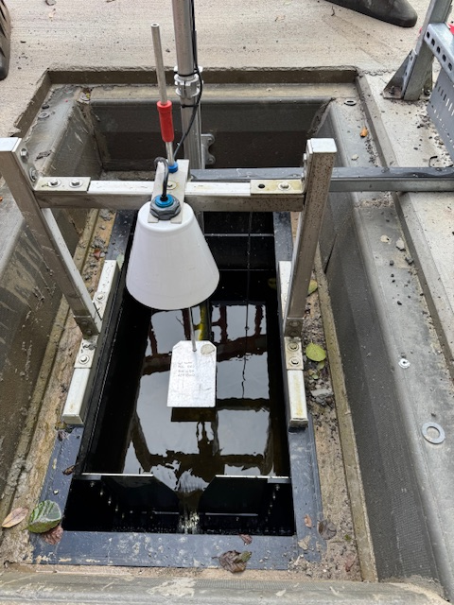

A undefinedmm head error and a undefinedmm repeatability error have been applied to the uncertainty budget and are within accepted limits. An Additional curve point was checked. The flow measurement verification was successful.

Calibration Reference: Blue Collar 212mm (±1mm)

Flow measurement NIEA viewpoint 3.4

undefined

undefined

undefined

undefined
undefined

undefined

Maintenance & calibration 4.0

Routine maintenance 4.1

undefined

undefined
undefined

undefined
undefined

undefined

Routine verification 4.2

undefined undefined

undefined

undefined

undefined
undefined

undefined

Critical data stickers on flow meter.

Survey measurement equipment 5.0

undefined

undefined

undefined

undefined

undefined

undefined

Conclusions 6.0

Data and Calculated Uncertainty 6.1

Based upon flow data provided by NIW and using data for undefined that being a typical dry weather day, the weighted uncertainty was calculated to be undefined % of the total daily discharge.

Report Signatories 6.2

The data enclosed relates to circumstances and detail found on the date of the inspection being undefined.

Signed,
undefined
undefined
undefined

Appendix A
undefined

undefined

undefined

undefined

undefined

undefined

Appendix B

undefined

undefined

undefined

undefined
undefined

undefined

Appendix C

undefined

undefined

undefined

undefined

undefined

undefined

