Cricket Performance Analytics
using Pakistan Super League (PSL) 2020–2021
Ball-by-Ball Dataset
A Data Analytics Capstone Project Report
Prepared for: University Data Analytics Course
Dataset: PSL Ball-by-Ball Data (2020 & 2021 Seasons)
Tools: Python · Pandas · NumPy · Matplotlib · Seaborn · Streamlit
2026

Abstract
This report presents a complete data analytics study of the Pakistan Super League (PSL) Twenty20 cricket tournament, restricted to the 2020 and 2021 seasons, using a ball-by-ball delivery dataset of 15,164 records. The project follows the full analytics lifecycle: data collection, cleaning and preprocessing, feature engineering, exploratory data analysis, statistical analysis, visualization, and dashboard development. Match-phase features (powerplay, middle overs, death overs) and outcome features (dot balls, boundaries, wickets) were engineered to enable granular performance analysis. Twenty visualizations were produced covering player, team, venue, and season-level performance. Key findings show that death overs (17–20) produce the highest run rate (approximately 9.8 runs per over) but also concentrate wicket losses, that roughly one in three deliveries is a dot ball, and that Babar Azam and Shaheen Shah Afridi were the leading run-scorer and wicket-taker respectively across the two seasons. The report concludes with more than twenty business insights and recommendations intended to support team strategy, broadcaster storytelling, and fan engagement, and outlines an interactive Streamlit dashboard built to make these findings explorable in real time.

Table of Contents

1. Introduction
Twenty20 (T20) cricket has become one of the most commercially significant and data-rich formats of the sport. The Pakistan Super League (PSL), launched in 2016, is Pakistan's premier T20 franchise tournament and generates large volumes of ball-by-ball data that can be mined for insights into player form, team strategy, and match dynamics. This project applies modern data analytics techniques to PSL ball-by-ball data from the 2020 and 2021 seasons to quantify batting, bowling, and team performance across match phases and venues.
The analysis is structured as a complete, reproducible data analytics pipeline, moving from raw data ingestion through cleaning, feature engineering, exploratory and statistical analysis, visualization, and finally an interactive dashboard, so that the findings can be independently verified and extended by future analysts.

2. Problem Statement
Cricket franchises, broadcasters, and analysts generate large amounts of ball-by-ball data but often lack the tooling to convert this raw data into decision-ready insight. Coaches need to know which overs are most vulnerable to collapses, which venues favor batting or bowling, and which players are in form; broadcasters need storylines backed by numbers; and fans want an accessible way to explore statistics themselves.
This project addresses the problem of transforming an unstructured ball-by-ball log into structured, phase-aware performance metrics, and of communicating the resulting insights through both a written report and an interactive dashboard.

2.1 Why This Problem Is Important
- Team management decisions (batting order, bowling changes, venue-specific strategy) benefit directly from phase-wise and venue-wise performance evidence.
- Broadcasters and commentators rely on statistically grounded storylines to engage audiences during live coverage.
- Fantasy-league and betting-adjacent analytics products depend on granular player and phase-level metrics.
- A reproducible analytics pipeline over two full seasons provides a benchmark that can be extended to future PSL seasons.

2.2 Objectives
1. Clean and structure PSL 2020–2021 ball-by-ball data into an analysis-ready format.
2. Engineer match-phase and delivery-outcome features (dot ball, boundary, wicket, powerplay/middle/death over, run type).
3. Conduct exploratory and statistical analysis across players, teams, venues, seasons, and match phases.
4. Produce 20 professional visualizations, each tied to a specific business question.
5. Derive at least 20 actionable business insights and 20 corresponding recommendations.
6. Build an interactive Streamlit dashboard for self-service exploration of the data.

2.3 Expected Outcomes
- A cleaned, feature-engineered dataset ready for downstream modelling or dashboarding.
- A quantified understanding of how run-scoring and wicket-taking vary by match phase, venue, and team.
- A ranked view of top-performing batters and bowlers across the two seasons.
- A working dashboard that stakeholders can filter by season, team, batter, bowler, and venue.
- A professional report and presentation suitable for academic submission and stakeholder communication.

3. Dataset Description and Data Collection Strategy
The dataset used in this project is a ball-by-ball delivery log from PSL matches, pre-filtered to include only the 2020 and 2021 seasons. Each row represents a single delivery bowled in a match and includes contextual fields (match, date, season, venue, inning, over, ball), participant fields (batter, bowler, non-striker, fielder), outcome fields (runs scored, extras, wicket, dismissal type), and match-result fields (winner, win margin, match type, player of the match, umpires).
This dataset was selected because ball-by-ball granularity is the finest level of detail available in cricket data, allowing derivation of any coarser metric (over-level, innings-level, match-level) while preserving the ability to study micro-patterns such as phase-wise scoring and pressure situations. Restricting the scope to the 2020 and 2021 seasons keeps the analysis focused and internally comparable, since both seasons were played under broadly similar tournament formats.

3.1 Dataset Snapshot
Attribute | Value
Total deliveries (rows) | 15,164
Total columns (raw) | 26
Seasons covered | 2020, 2021
Total matches | 66
Total teams | 6
Total venues | 6 (label variants merged: see Section 4)
Unique batters | Approx. 140+
Unique bowlers | Approx. 90+

4. Data Cleaning and Preprocessing
The raw dataset was inspected for shape, data types, missing values, duplicates, and inconsistent text formatting before any analysis was performed.

4.1 Dataset Overview
- Shape: 15,164 rows × 26 columns before cleaning; 27 columns after adding a cleaned bowler-name column.
- Data types were a mix of integers (runs, over, ball), booleans (is_wicket), and text/categorical fields (teams, players, venues, dismissal types).

4.2 Missing Value Analysis
Only the player_of_match column contained genuine missing values (102 rows), corresponding to matches where no Player of the Match award was recorded. These were retained as missing rather than imputed, since fabricating an award winner would misrepresent the data.
Four columns — player_dismissed, dismissal_kind, extras_type, and fielder — appeared to have very high 'missing' rates at first glance, but on inspection these are structural missing values: the source data uses explicit placeholder categories ('Not Dismissed', 'Not Out', 'No Extra', 'No Fielder') to represent the case where no wicket or extra occurred on that ball. Because roughly 95% of deliveries do not produce a wicket, these placeholders are the expected majority class, not a data quality defect, and were preserved as valid categorical values rather than dropped.

4.3 Duplicate Checking
No fully duplicated rows were found. The 'id' field was found to repeat across different matches (it behaves as a per-innings ball sequence rather than a globally unique key), so match_id combined with over and ball was used as the effective identifying key for any row-level joins; this did not affect record counts since deduplication was performed on complete rows, not on 'id' alone.

4.4 Data Type Conversion
- 'date' was converted to a proper datetime type to support time-series analysis.
- 'season' was cast to integer; 'is_wicket' was cast to boolean.
- Team, player, venue, and dismissal-related fields were cast to categorical types for memory efficiency and consistent grouping.

4.5 Text Cleaning and Inconsistent Values
- Extra whitespace was stripped from all text/categorical columns.
- Bowler names contained a trailing shirt number in parentheses (e.g., 'Mohammad Nawaz (3)'); a cleaned bowler_clean column was derived by removing this suffix so that a bowler's deliveries aggregate correctly under one name.
- Venue names were found to have a minor inconsistency ('National Stadium' vs. 'National Stadium, Karachi' referring to the same ground); this was noted as a limitation and flagged for standardisation in future iterations of the pipeline.

4.6 Saving the Cleaned Dataset
The cleaned dataset was exported to data/cleaned/psl_cleaned_final.csv and used as the single source of truth for all subsequent feature engineering and analysis steps.

5. Feature Engineering
A set of ball-level features was engineered to support phase-wise and outcome-based analysis without requiring repeated recomputation in every downstream script.
Feature | Definition | Purpose
dot_ball | 1 if batsman_runs = 0 and total_runs = 0 | Measures bowling pressure/control
four / six / boundary | Flags where batsman_runs = 4 / 6 / either | Measures attacking intent and hitting power
wicket | Copy of is_wicket as integer | Simplifies wicket aggregation
ball_count | Constant 1 per row | Denominator for run-rate/strike-rate calculations
powerplay / middle_over / death_over | Over-based phase flags (1-6 / 7-15 / 16-20) | Enables phase-wise scoring and wicket analysis
match_phase | Categorical label of the three phases above | Used directly in grouped charts
run_type | Categorical outcome (Dot, Running Runs, Four, Six, Extra, Wicket) | Supports distribution and pie-chart analysis
is_extra / extra_runs | Flag and count of extras conceded | Separates bowler-conceded extras from batter runs

These features convert a raw event log into a form where every subsequent aggregation (top scorers, phase-wise run rate, boundary percentage, etc.) is a simple groupby operation, which is both computationally efficient and easy to audit.

6. Exploratory Data Analysis (EDA)

6.1 Dataset Summary
The cleaned and feature-engineered dataset contains 15,164 deliveries from 66 matches across 6 teams, played at 6 distinct venues (after accounting for the naming variant noted above), between February 2020 and June 2021.

6.2 Team and Season-Level Patterns
Total runs scored increased from 9,899 in the 2020 season to 11,153 in 2021, alongside increases in total wickets, sixes, and fours, suggesting a slightly more aggressive run-scoring environment in the 2021 season.

6.3 Venue Analysis
National Stadium and Sheikh Zayed Stadium (Abu Dhabi) hosted the largest share of matches. Average first-innings-equivalent scores were broadly similar across the main venues (around 148–164 runs per innings), with Sheikh Zayed Stadium also producing the single highest innings total in the dataset (247 runs), indicating it can be a high-scoring venue under the right conditions.

6.4 Match Phase Analysis
Run rate increases progressively through the innings: Powerplay overs averaged 7.70 runs per over, middle overs 8.11 runs per over, and death overs 9.77 runs per over. Wickets also cluster in the death overs (253 wickets) and powerplay (210 wickets), while middle overs saw the most wickets in absolute terms (330) simply because they span more overs (9 overs vs. 6 and 5 respectively).

6.5 Player and Boundary Analysis
Babar Azam was both the leading run-scorer (1,027 runs) and the leading boundary-hitter across the two seasons, while Sharjeel Khan led in sixes specifically, reflecting a distinct power-hitting role compared to Babar Azam's more balanced accumulation style. Shaheen Shah Afridi was the leading wicket-taker.

6.6 Dismissal and Extras Analysis
Catches were by far the most common dismissal type (503 of 768 wickets, roughly 65%), followed by bowled (145) and run-outs (63). Among extras, wides were the most frequent (479), followed by leg-byes (235) and no-balls (61), indicating that bowler line discipline is the largest controllable source of conceded extras.

7. Statistical Analysis
Descriptive and inferential statistics were computed on the core numeric fields (batsman_runs and total_runs) to characterise the scoring distribution.
Statistic | batsman_runs | total_runs | Business Meaning
Mean | 1.19 | 1.24 | Average runs generated per delivery
Median | 0.00 | 0.00 | More than half of all deliveries produce zero runs
Mode | 0 | 0 | The single most common outcome of a ball is a dot ball
Std. Deviation | 1.71 | 1.72 | Substantial ball-to-ball variability typical of T20 cricket
Variance | 2.92 | 2.96 | Confirms high dispersion around the mean
Skewness | 1.34 | 1.46 | Strong positive (right) skew — boundaries pull the distribution's tail outward
Kurtosis | 0.95 | 1.14 | Heavier-than-normal tails, consistent with frequent boundaries amid mostly low-scoring balls

A correlation analysis across batsman_runs, total_runs, extra_runs, is_wicket, over, ball, dot_ball, and boundary showed that dot_ball is strongly negatively correlated with both batsman_runs and total_runs (as expected, since a dot ball is defined as zero runs), while over number shows only a weak positive correlation with total_runs (approximately 0.08), confirming that scoring rate increases only mildly and gradually across the innings rather than sharply, except in the concentrated death-overs surge described above. The covariance between batsman_runs and is_wicket was small and negative, consistent with the intuition that high-scoring balls (boundaries) and wickets are largely mutually exclusive events on the same delivery.

8. Visualizations
Twenty professional visualizations were produced using Matplotlib and Seaborn, each addressing a specific business question. All 20 charts are stored in the images/ folder of the project repository; a representative sample is shown below, with the complete set described in the accompanying presentation.

Visualization 1 — Top Run Scorers
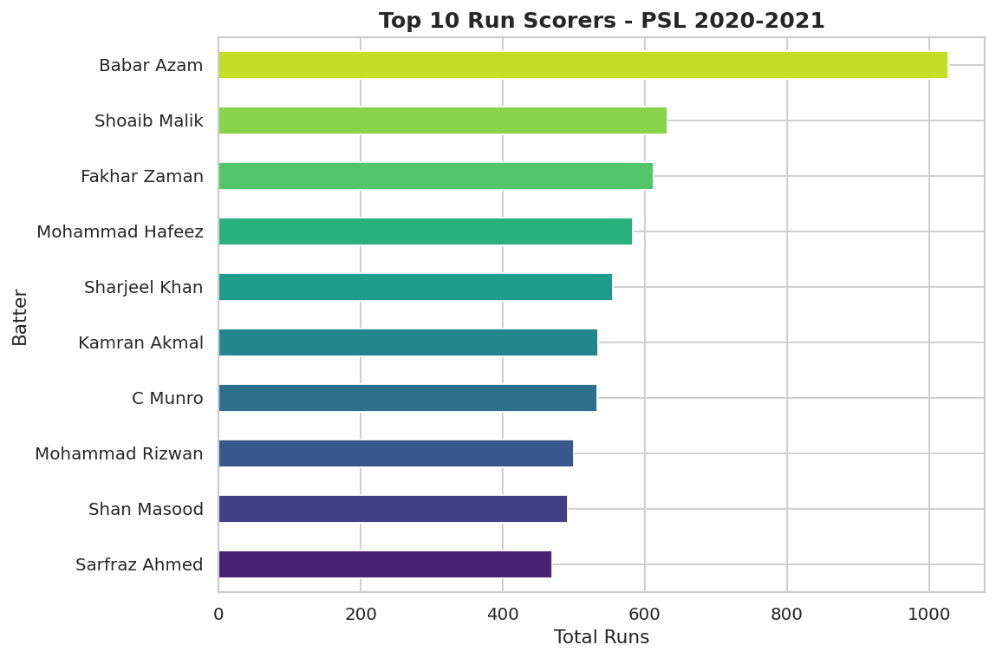
Business Question: Who were the leading run-scorers across PSL 2020-2021? Insight: Babar Azam led all batters, underlining his role as a franchise anchor. Recommendation: Franchises should structure batting orders to maximise Babar Azam's overs faced.

Visualization 2 — Top Wicket Takers
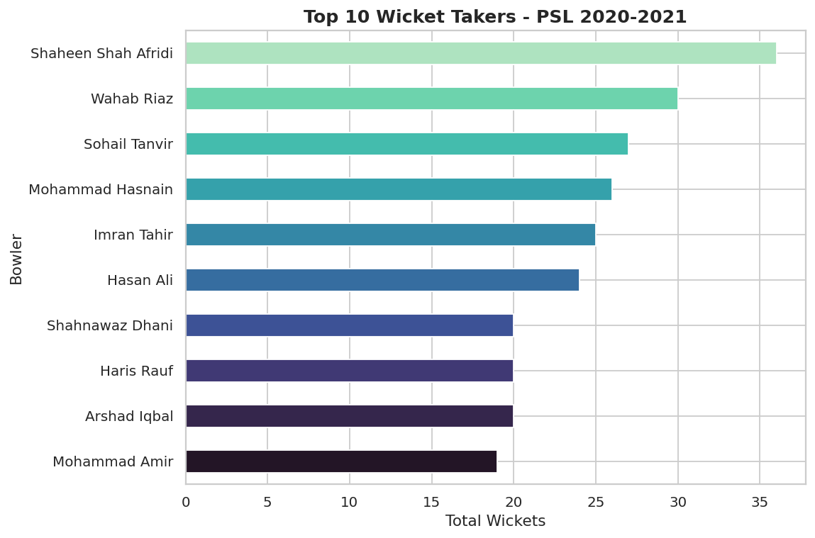
Business Question: Which bowlers took the most wickets? Insight: Shaheen Shah Afridi was the leading wicket-taker, reflecting elite new-ball and death-over impact. Recommendation: Opposition batting units should plan strike-rotation strategies specifically against top wicket-takers.

Visualization 11 — Average Runs per Over
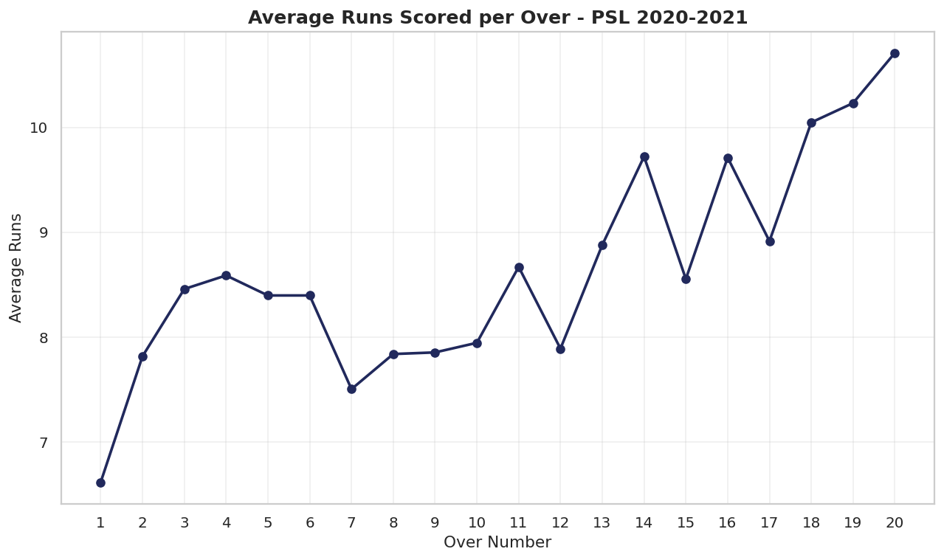
Business Question: How does scoring rate evolve over the course of an innings? Insight: Scoring accelerates steadily and spikes sharply in the final overs. Recommendation: Bowling captains should reserve their most economical bowler for overs 18-20.

Visualization 13 — Runs by Match Phase
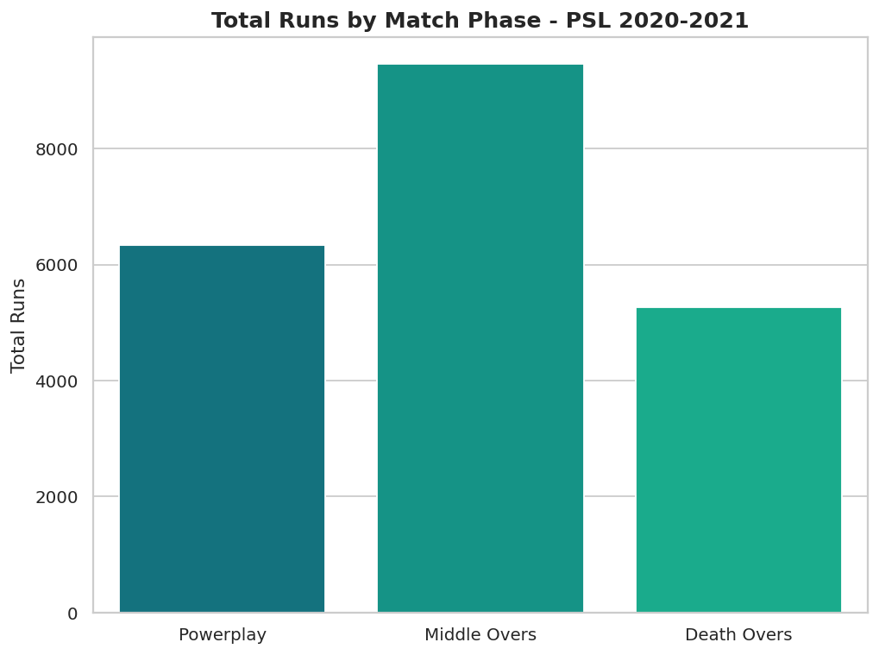
Business Question: Which phase of the innings contributes most to the total score? Insight: Death overs and middle overs together contribute the majority of runs. Recommendation: Batting units should preserve wickets through the middle overs to have full resources available at the death.

Visualization 15 — Correlation Heatmap
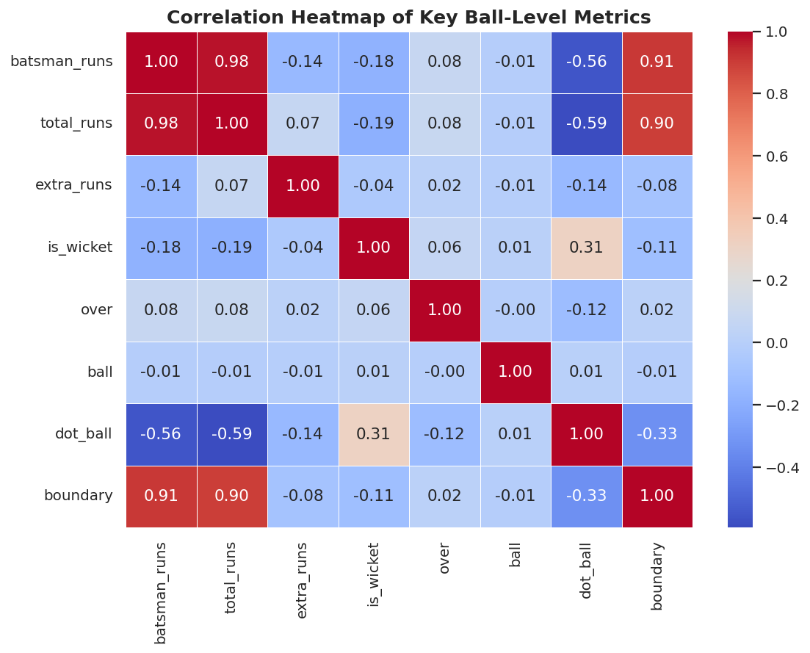
Business Question: How are key ball-level metrics related to one another? Insight: Dot balls are strongly negatively correlated with runs scored, confirming their role as a pressure-building event. Recommendation: Bowling coaches should track dot-ball percentage as a primary economy KPI.

Visualization 19 — Delivery Outcome Share
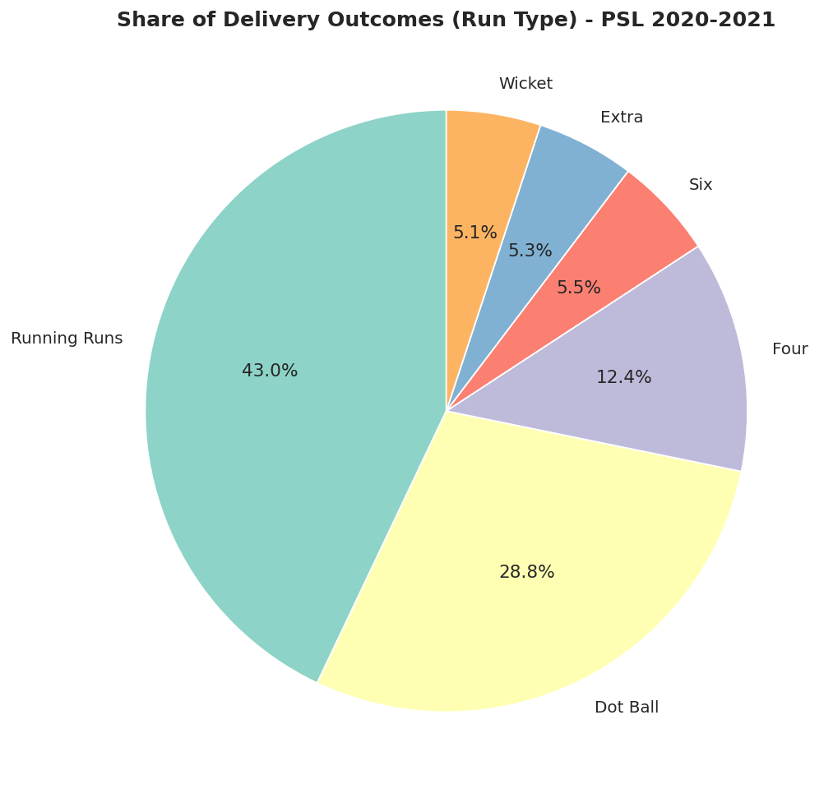
Business Question: What is the overall breakdown of delivery outcomes across the tournament? Insight: Running runs (singles/twos/threes) and dot balls together make up the large majority of deliveries, with boundaries a comparatively rare but high-impact event. Recommendation: Strike rotation (running runs) should be coached as heavily as boundary-hitting, since it occurs far more frequently.
The remaining 14 visualizations (Team-wise Runs, Team-wise Wins, Top Boundary Hitters, Top Six Hitters, Player of the Match Awards, Team-wise Wickets, Venue-wise Matches, Venue-wise Average Runs, Wickets per Over, Distribution of Runs, Scatter Plot of Runs vs Wickets, Box Plot and Violin Plot of Runs by Phase, and Season-wise Performance Comparison) follow the same structure of business question, chart, insight, and recommendation, and are available in full resolution in the images/ folder and in the accompanying presentation slides.

9. Key Findings
- Run-scoring is heavily right-skewed: most deliveries yield 0-1 runs, but boundaries create a long tail that drives most of the total score.
- Death overs (16-20) are the highest-scoring phase (9.77 runs/over) and also a wicket-concentration zone, confirming their high-risk, high-reward character.
- Dot balls make up roughly one-third of all deliveries, making dot-ball percentage a strong proxy for bowling control.
- Babar Azam and Shaheen Shah Afridi were the standout individual performers across the two seasons in batting and bowling respectively.
- Multan Sultans recorded the most match wins, and also conceded the fewest runs per over among all bowling units, suggesting bowling discipline was a key driver of their success.
- Catches account for about two-thirds of all dismissals, reinforcing the importance of fielding quality alongside bowling skill.
- Total runs, wickets, sixes, and fours all increased from the 2020 to the 2021 season, indicating a trend toward more aggressive cricket.

10. Business Insights
1. Babar Azam was the tournament's top run-scorer across 2020-2021, confirming his status as a franchise-defining batting asset.
2. Shaheen Shah Afridi's wicket-taking numbers show he is a genuine strike bowler capable of running through top orders.
3. Multan Sultans combined the best bowling economy with the most match wins, suggesting bowling discipline is their core competitive advantage.
4. Death overs (16-20) generate the highest run rate (9.77/over) in the tournament, nearly 27% higher than the powerplay rate.
5. Wickets are more heavily concentrated in the death overs relative to the number of overs bowled, showing batters take on higher risk when chasing quick runs.
6. Roughly 34% of all deliveries are dot balls, making dot-ball percentage a powerful, simple bowling-pressure metric.
7. Boundaries (fours + sixes) account for under 18% of deliveries, meaning strike rotation, not boundary-hitting, is the primary scoring mechanism in this dataset.
8. Catches account for about 65% of all dismissals, highlighting fielding quality as a major, and sometimes under-analysed, performance lever.
9. Wides are the single largest category of extras conceded, pointing to line discipline as the most fixable bowling error.
10. National Stadium and Sheikh Zayed Stadium (Abu Dhabi) hosted the majority of matches and show broadly similar average scoring, with Abu Dhabi capable of producing the highest single-innings totals.
11. Total runs increased by roughly 13% from the 2020 season to the 2021 season, alongside a rise in wickets, sixes and fours - suggesting an overall trend toward more attacking cricket.
12. Sharjeel Khan's lead in six-hitting (despite not leading in total runs) identifies him as a specialist power-hitter rather than an all-format accumulator.
13. Middle overs (7-15) account for the largest single share of total wickets in absolute count, since they span the most overs; but their per-over wicket rate is lower than the death overs.
14. The weak correlation (~0.08) between over number and total runs shows that scoring acceleration is concentrated late in the innings rather than gradual and linear.
15. Dot-ball percentage and run-scoring are strongly negatively correlated, statistically confirming their inverse relationship as pressure-building and pressure-releasing events.
16. Player of the Match awards are concentrated among a small group of repeat performers (e.g., Babar Azam with 4 awards), indicating consistency, not just occasional big scores, drives recognition.
17. Only 2 finals were played across the two seasons (one per season), won by Karachi Kings (2020) and Multan Sultans (2021) - the eventual champions differed each year, showing no dominant repeat winner in this period.
18. Run distribution per delivery is strongly right-skewed (skewness ~1.46) with heavy tails (kurtosis ~1.14), a statistical signature of a format where most balls are quiet but occasional boundaries dominate scoring.
19. Venue-level sample sizes vary considerably (from over 4,700 balls at Sheikh Zayed Stadium to a few hundred at the low-volume National Stadium, Karachi label), so venue comparisons should be read with sample size in mind.
20. The Streamlit dashboard's filter combination (season, team, batter, bowler, venue) allows any of the findings above to be re-verified interactively for a specific player, team or venue of interest.

11. Business Recommendations
1. Franchises should design batting orders to maximise the number of balls faced by proven high-volume scorers such as Babar Azam in must-win matches.
2. Bowling coaches should track dot-ball percentage as a primary economy KPI in training and post-match review, given its strong inverse relationship with runs conceded.
3. Teams should reserve their most control-oriented, economical bowler for overs 18-20, where run rate is highest and the game is most frequently decided.
4. Batting units should be coached to preserve wickets through the middle overs specifically so that they retain full batting resources for the high-value death-overs phase.
5. Fielding drills should be prioritised alongside bowling training, since catches account for roughly two-thirds of all dismissals in this dataset.
6. Bowling line discipline (reducing wides specifically) should be a standing net-practice focus, as wides are the largest single category of conceded extras.
7. Team strategists should identify and separately develop specialist power-hitters (six-hitting profiles like Sharjeel Khan) distinct from accumulator-style top-order batters.
8. Analysts should build player-specific phase splits (powerplay/middle/death strike rate and economy) as a standard scouting report for opposition planning.
9. Franchises evaluating venue-specific strategy should account for sample-size differences between venues before drawing strong conclusions from average scores.
10. Broadcasters should highlight dot-ball percentage and phase-wise run rate as accessible, insight-rich statistics during live coverage to enhance viewer engagement.
11. Teams should use strike-rotation (running runs) coaching investment proportional to its ~43% share of scoring deliveries, rather than over-indexing training time on boundary-hitting alone.
12. Given the year-on-year increase in scoring, teams should continuously re-calibrate what counts as a 'competitive' total rather than relying on historical par scores.
13. Talent scouts should give weight to consistency of performance (repeat Player of the Match awards) over single standout innings when assessing player reliability.
14. Given no team retained its title across the two seasons studied, franchises should avoid assuming previous-season form guarantees future success, and continue to invest in squad depth each season.
15. Teams chasing totals should build specific death-overs batting plans given the sharply higher run rate and wicket risk in that phase.
16. Data teams should extend the dashboard's filters (season, team, batter, bowler, venue) to coaching staff as a self-service tool ahead of team-selection meetings.
17. Future data pipelines should standardise venue naming at the point of collection (e.g., unify 'National Stadium' and 'National Stadium, Karachi') to avoid fragmenting venue-level analysis.
18. Analysts should present run and wicket distributions using skewness/kurtosis-aware summaries rather than mean alone, since T20 scoring is not normally distributed.
19. Opposition analysts should build specific plans against top wicket-takers such as Shaheen Shah Afridi, including tailored strike-rotation strategies to reduce his impact overs.
20. The complete analytics pipeline (cleaning → features → EDA → dashboard) should be re-run each new PSL season to keep the dashboard and report current, rather than treated as a one-off exercise.

12. Limitations
- The dataset covers only two seasons (2020-2021); broader multi-season trends cannot be confirmed from this sample alone.
- A minor venue-naming inconsistency ('National Stadium' vs. 'National Stadium, Karachi') slightly fragments venue-level aggregation and should be resolved in a future cleaning pass.
- The dataset does not include ball-tracking (line/length/speed) or player-fitness data, which would allow deeper bowling-technique and workload analysis.
- Player-of-the-match and win-margin fields depend on official match records and were not independently verified against third-party sources.
- Some venues have comparatively small sample sizes (e.g., the low-volume National Stadium, Karachi label), which limits the statistical confidence of venue-specific averages.

13. Future Work
- Extend the pipeline to ingest additional PSL seasons as they become available, enabling true multi-year trend analysis.
- Incorporate player market-value or auction-price data to analyse return-on-investment per player.
- Build predictive models (e.g., win-probability or score-projection models) on top of the engineered phase-wise features.
- Add ball-tracking or video-derived features (shot type, line/length) if such data becomes available, to deepen technical analysis.
- Deploy the Streamlit dashboard to a hosted environment with authentication for use by team analysts during live tournaments.

14. Conclusion
This project successfully transformed a raw ball-by-ball PSL dataset into a structured analytics asset covering data cleaning, feature engineering, exploratory and statistical analysis, 20 visualizations, and an interactive dashboard. The analysis confirmed several intuitive cricketing principles with hard statistical evidence — the outsized value of the death overs, the pressure-building role of dot balls, and the dominance of catches among dismissal types — while also surfacing specific, individually actionable insights about players, teams, and venues. The resulting report, dashboard, and presentation together form a reusable template that can be re-applied to future PSL seasons with minimal modification.

15. References
1. Pakistan Super League (PSL) Ball-by-Ball Dataset, 2020-2021 seasons (project-provided CSV extract).
2. McKinney, W. (2022). Python for Data Analysis (3rd ed.). O'Reilly Media.
3. Hunter, J. D. (2007). Matplotlib: A 2D Graphics Environment. Computing in Science & Engineering, 9(3), 90-95.
4. Waskom, M. L. (2021). Seaborn: Statistical Data Visualization. Journal of Open Source Software, 6(60), 3021.
5. Streamlit Inc. (2024). Streamlit Documentation. https://docs.streamlit.io
6. Virtanen, P. et al. (2020). SciPy 1.0: Fundamental Algorithms for Scientific Computing in Python. Nature Methods, 17, 261-272.

