Y = b – a * x

a = r1; x = r2; b = r6

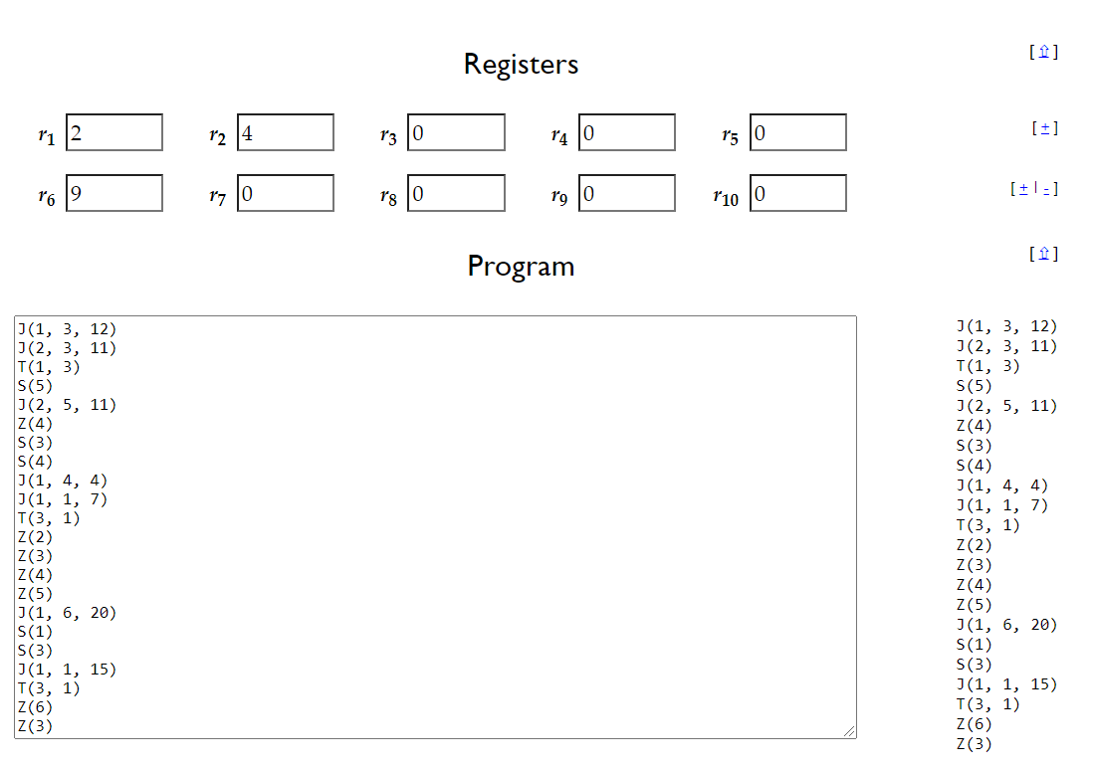

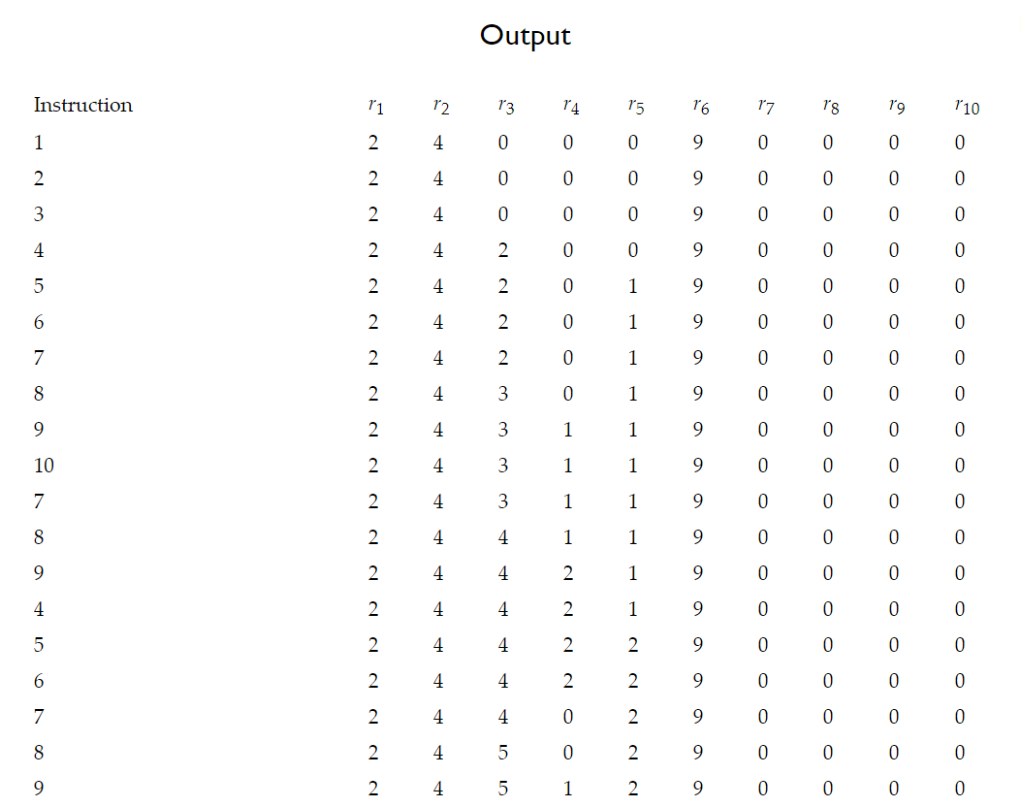

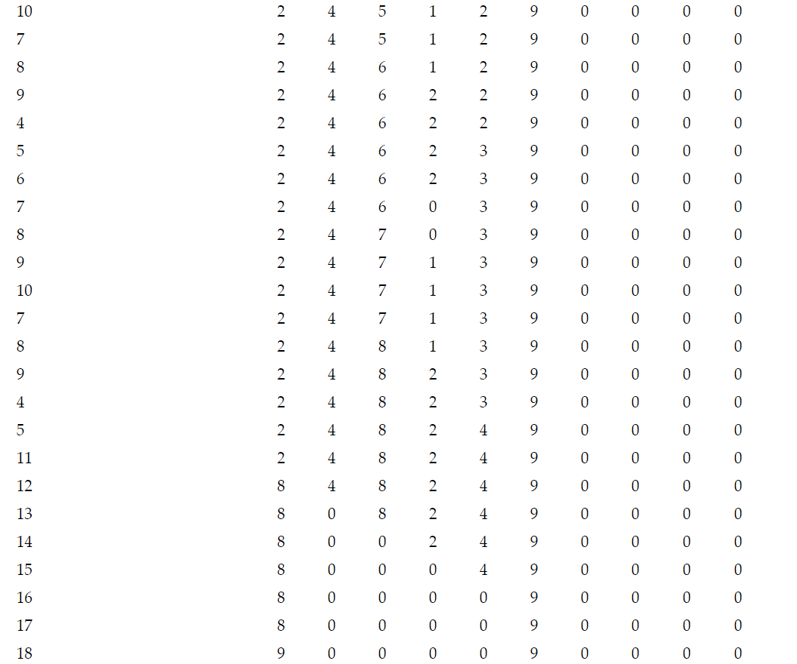

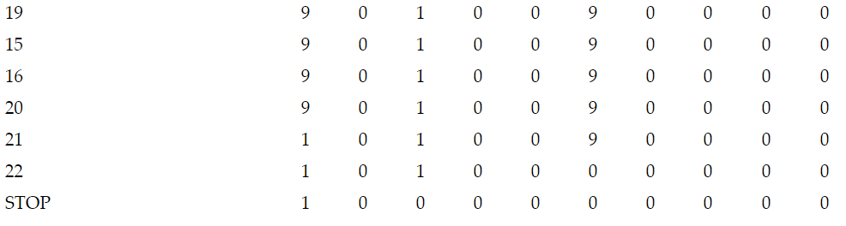

**Code:**

J(1, 3, 12)

J(2, 3, 11)

T(1, 3)

S(5)

J(2, 5, 11)

Z(4)

S(3)

S(4)

J(1, 4, 4)

J(1, 1, 7)

T(3, 1)

Z(2)

Z(3)

Z(4)

Z(5)

J(1, 6, 20)

S(1)

S(3)

J(1, 1, 15)

T(3, 1)

Z(6)

Z(3)