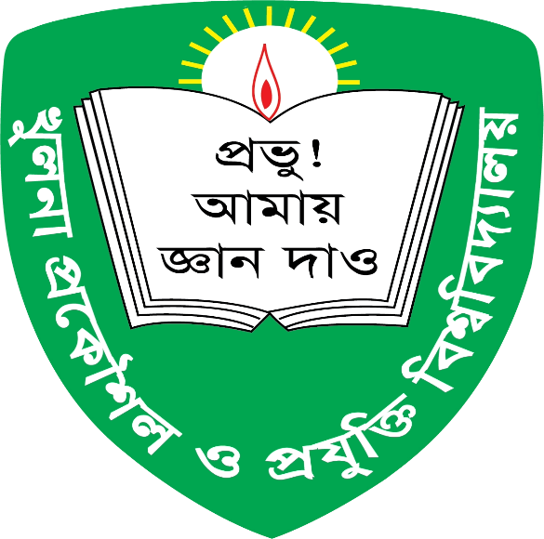

**KHULNA UNIVERSITY OF ENGINEERING & TECHNOLOGY, KHULNA**

**Project Title : Student Management System**

Course Code : CSE 1102

*Submitted by:*

* *2307073 – Khalid Bin Atik*
* *2307074 – MD. Abdullahil Kafi*
* *2307076 – MD. Habibur Rahman*

**Instructor:**

* **Md Nazirulhasan Shawon**
* **Md Tajmilur Rahman**

Submission Date : 29-01-2025

**Introduction** :

This project focuses on developing a **Student Management System** using the C programming language to efficiently handle student information at our university. It includes features for student sign-up, login, searching, updating, and deleting records, along with modules for **Class Representative elections**, **course registration**, **term-wise grade sheets**, and **GPA calculation**.

**Description :**

Students can-

* Sign-up
* Log in
* View information
* Edit information
* Delete account
* Register for a course
* View Result
* Log out

Teachers can-

* Sign-up
* Log in
* View information
* Edit information
* Calculate GPA
* Calculate CGPA
* Elect Class Representative
* Search student’s information and result
* Log out

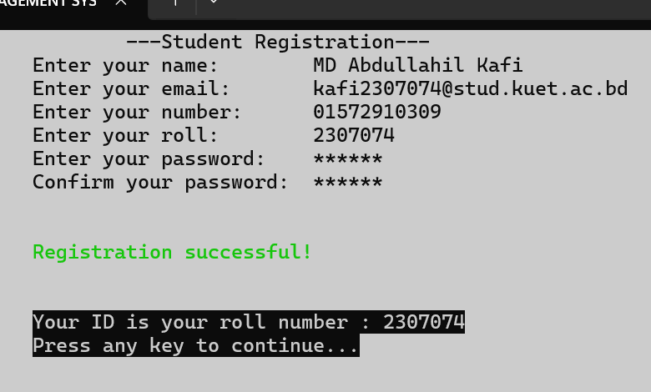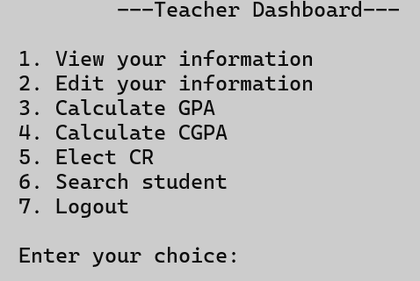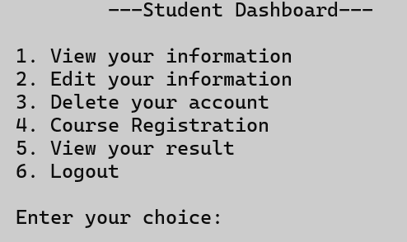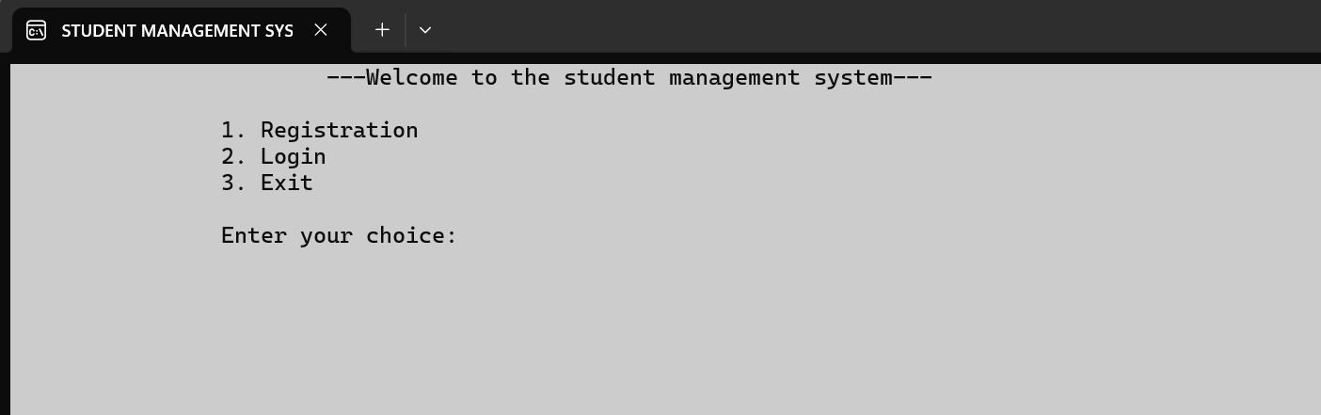**Sample Screenshots:**

**Diagram :**

**Aims & Objectives :**

The goal of this project is to create a simple and user-friendly system to help students and teachers manage important tasks easily. Students can register, update their information, check results, and register for courses, while teachers can calculate GPAs, manage class representatives, and access student details. It's all about making things easier for everyone.

**Software Requirements:**

1. Programming Language : C/C++
2. Integrated Development Environment(IDE) : Code Blocks/Visual Studio Code
3. Operating System : Windows

**Learnings :**

Throughout the development of the project, we worked with many important programming concepts, and here’s what we learned from them:

* If-else construct & loops
* Switch-case & type conversion
* Arrays
* Strings
* Structures
* Pointers
* User defined function
* File Handling
* User defined header file
* Header Guards
* Modularity

Conclusion :

This project taught us how to use important programming tools like files, pointers, and structures. We learned how to organize our code and solve problems better. It was a great learning experience that improved our coding skills and helped us understand how everything works together in a program.