TO'QUV DASTGOHLARI
RIVOSHLANISH LOYIHASI

═══════════════════════════════════════

14-iyun 2026-yil
Jami rasmlar: 15 ta

Loyiha nomi: | To'quv Dastgohlari - Rivoshlanish
Rasmlar soni: | 15 ta
Sana: | 14-iyun 2026-yil
Hujjat turi: | Professional arxiv nusxasi

RASM 1 • To'quv Dastgohlari Hujjati
Vaqt: 16:03:45 • O'lcham: 720×1224 px
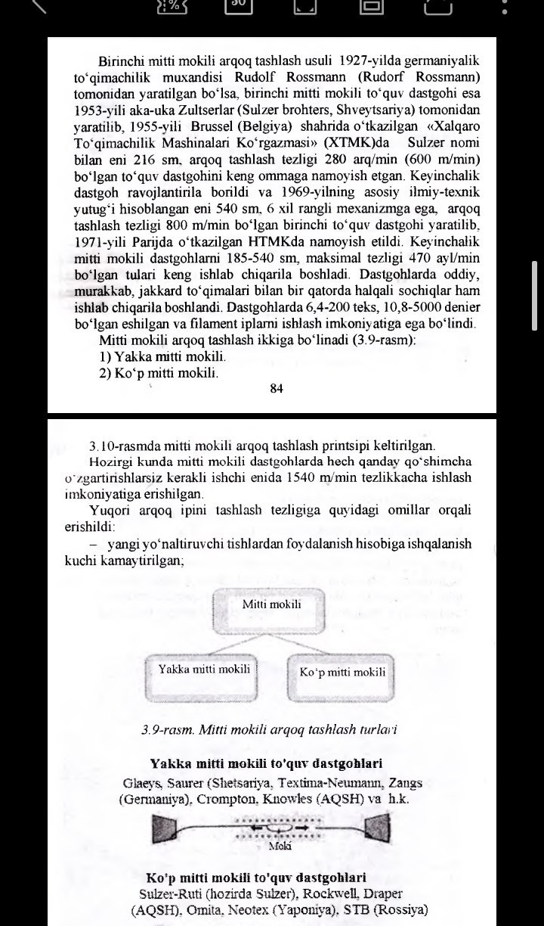

━━━━━━━━━━━━━━━━━━━━━━━━━━━━━━━━━━━━━━━━━━━━━━━━━━━━━━━━━━━━

RASM 2 • To'quv Dastgohlari Hujjati
Vaqt: 16:03:57 • O'lcham: 720×1172 px
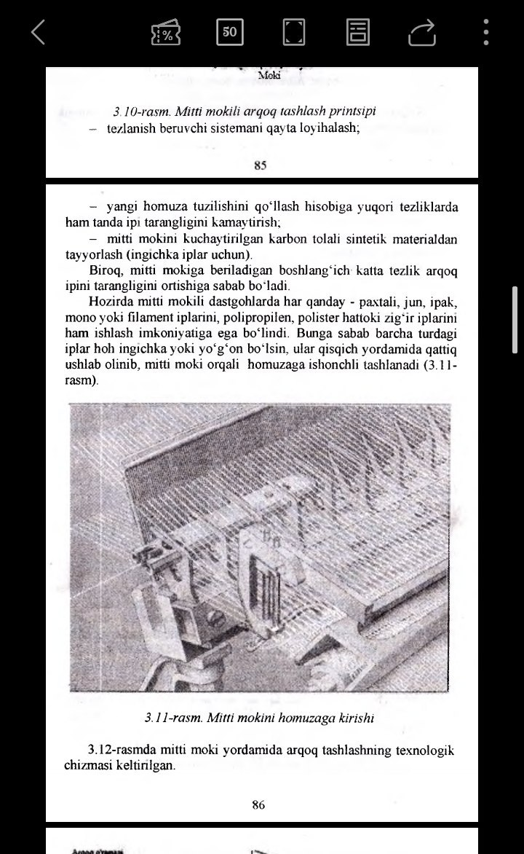

━━━━━━━━━━━━━━━━━━━━━━━━━━━━━━━━━━━━━━━━━━━━━━━━━━━━━━━━━━━━

RASM 3 • To'quv Dastgohlari Hujjati
Vaqt: 16:03:59 • O'lcham: 720×1060 px
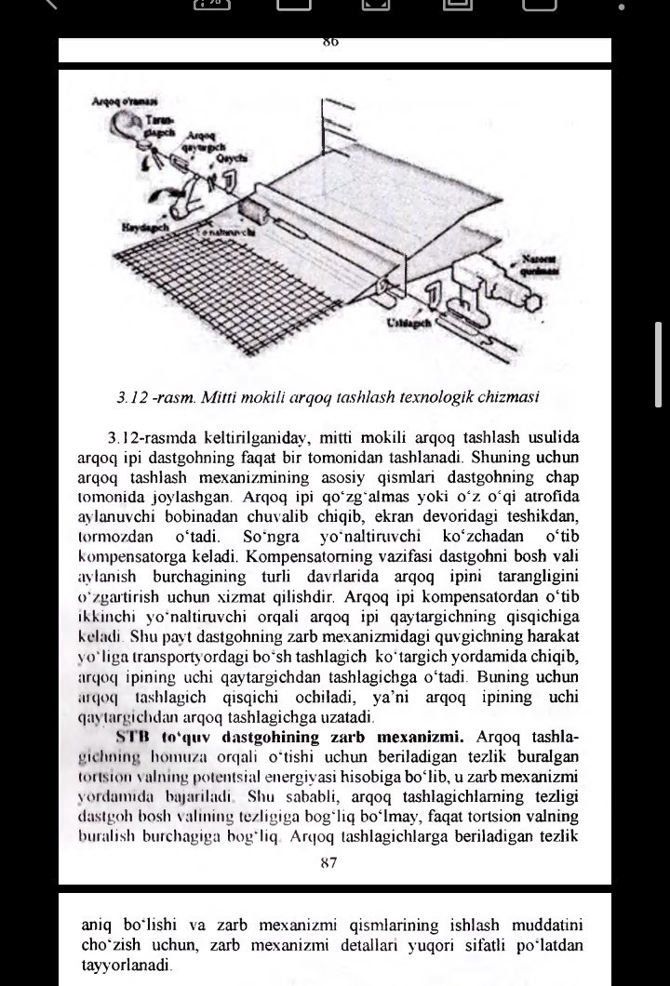

━━━━━━━━━━━━━━━━━━━━━━━━━━━━━━━━━━━━━━━━━━━━━━━━━━━━━━━━━━━━

RASM 4 • To'quv Dastgohlari Hujjati
Vaqt: 16:04:01 • O'lcham: 720×1225 px
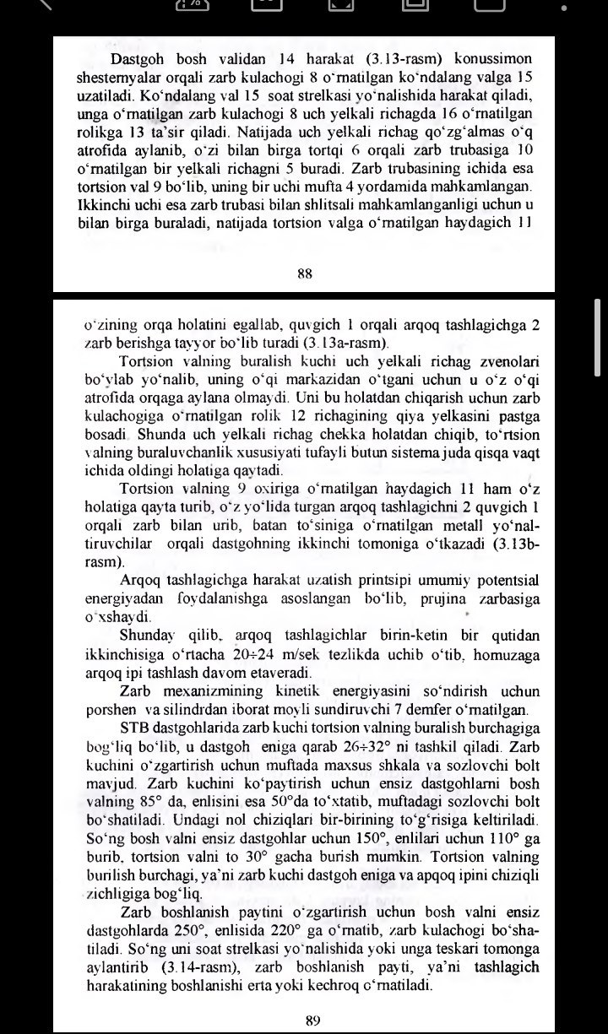

━━━━━━━━━━━━━━━━━━━━━━━━━━━━━━━━━━━━━━━━━━━━━━━━━━━━━━━━━━━━

RASM 5 • To'quv Dastgohlari Hujjati
Vaqt: 16:04:05 • O'lcham: 720×1203 px
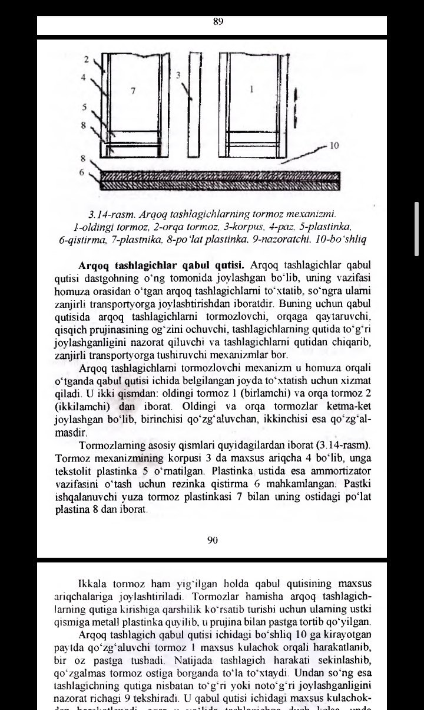

━━━━━━━━━━━━━━━━━━━━━━━━━━━━━━━━━━━━━━━━━━━━━━━━━━━━━━━━━━━━

RASM 6 • To'quv Dastgohlari Hujjati
Vaqt: 16:04:07 • O'lcham: 720×1217 px
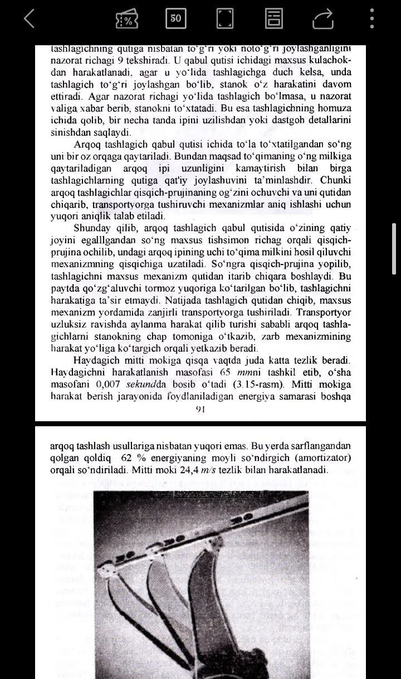

━━━━━━━━━━━━━━━━━━━━━━━━━━━━━━━━━━━━━━━━━━━━━━━━━━━━━━━━━━━━

RASM 7 • To'quv Dastgohlari Hujjati
Vaqt: 16:04:09 • O'lcham: 720×1102 px
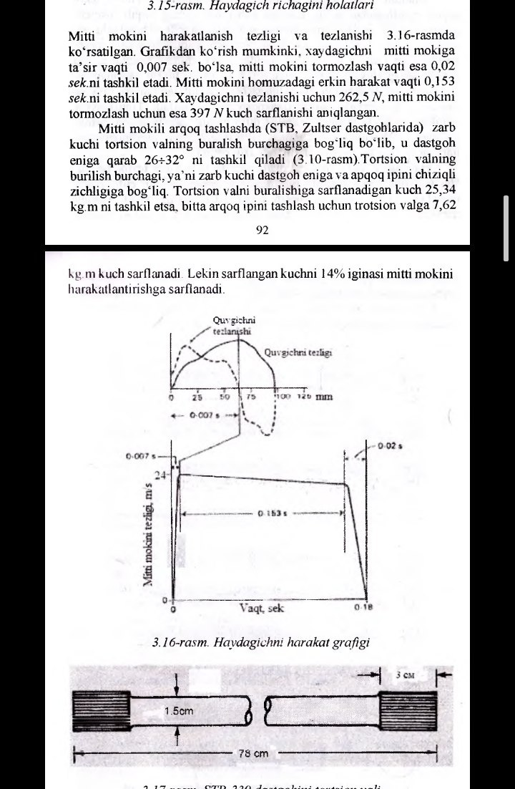

━━━━━━━━━━━━━━━━━━━━━━━━━━━━━━━━━━━━━━━━━━━━━━━━━━━━━━━━━━━━

RASM 8 • To'quv Dastgohlari Hujjati
Vaqt: 16:04:11 • O'lcham: 720×906 px
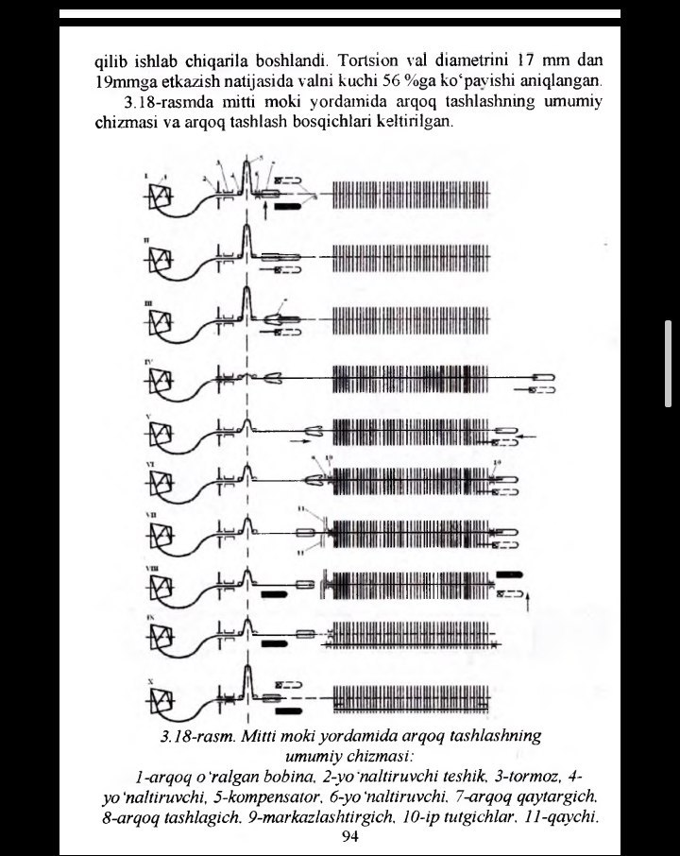

━━━━━━━━━━━━━━━━━━━━━━━━━━━━━━━━━━━━━━━━━━━━━━━━━━━━━━━━━━━━

RASM 9 • To'quv Dastgohlari Hujjati
Vaqt: 16:04:13 • O'lcham: 720×998 px
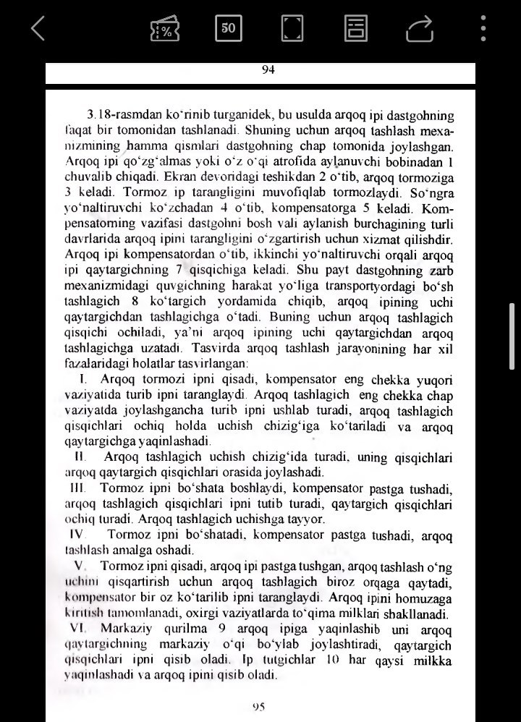

━━━━━━━━━━━━━━━━━━━━━━━━━━━━━━━━━━━━━━━━━━━━━━━━━━━━━━━━━━━━

RASM 10 • To'quv Dastgohlari Hujjati
Vaqt: 16:04:16 • O'lcham: 720×1120 px
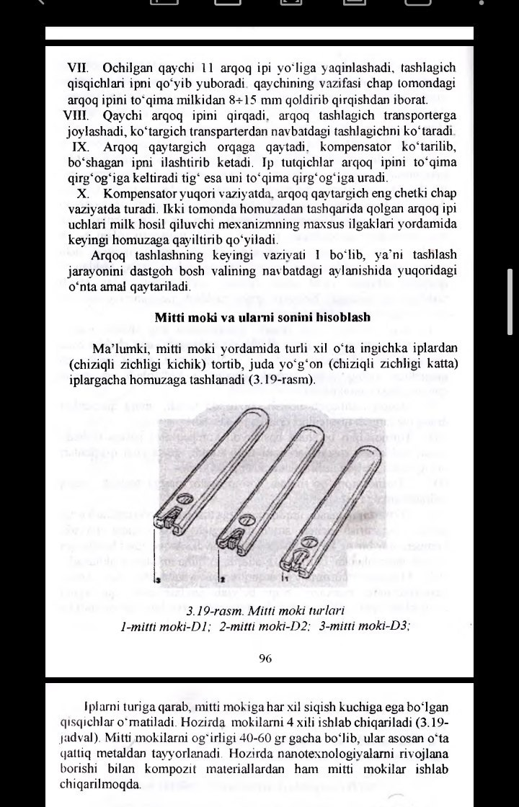

━━━━━━━━━━━━━━━━━━━━━━━━━━━━━━━━━━━━━━━━━━━━━━━━━━━━━━━━━━━━

RASM 11 • To'quv Dastgohlari Hujjati
Vaqt: 16:04:18 • O'lcham: 720×1149 px
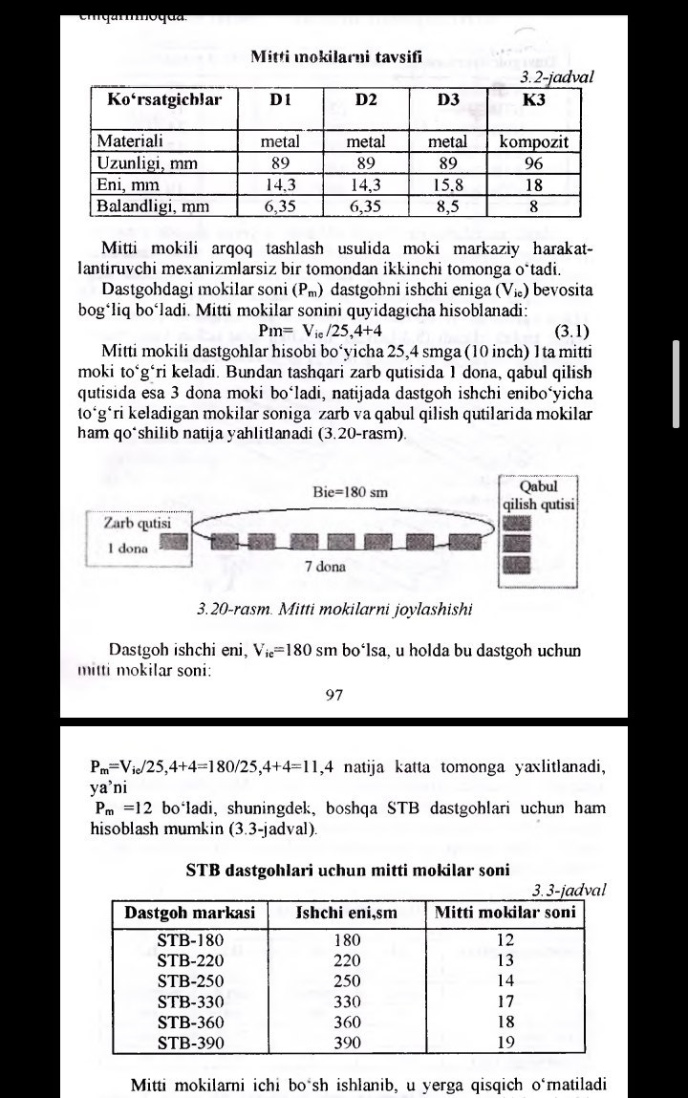

━━━━━━━━━━━━━━━━━━━━━━━━━━━━━━━━━━━━━━━━━━━━━━━━━━━━━━━━━━━━

RASM 12 • To'quv Dastgohlari Hujjati
Vaqt: 16:04:20 • O'lcham: 720×1173 px
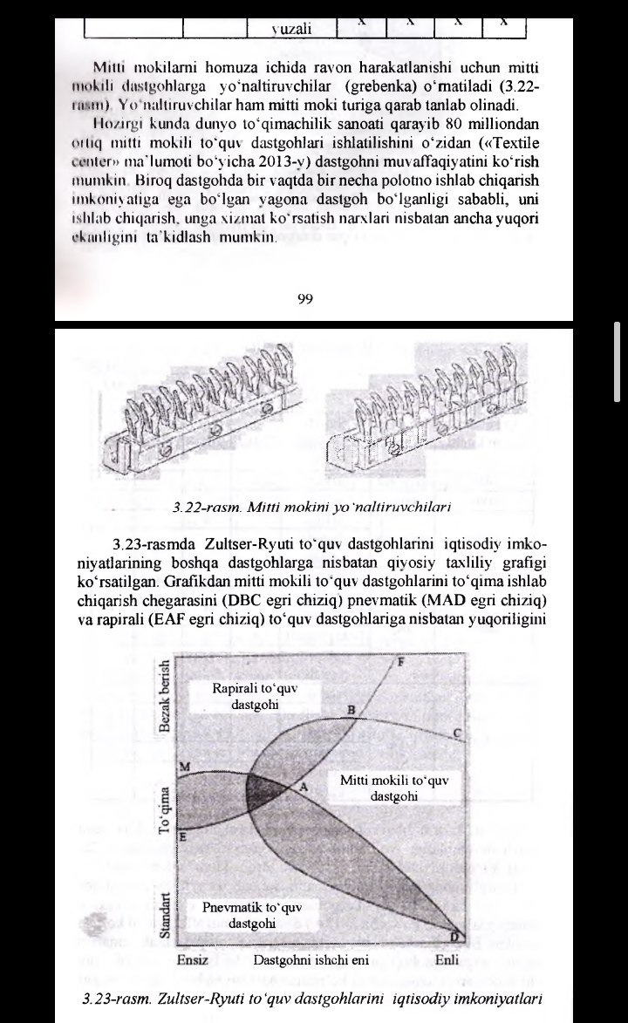

━━━━━━━━━━━━━━━━━━━━━━━━━━━━━━━━━━━━━━━━━━━━━━━━━━━━━━━━━━━━

RASM 13 • To'quv Dastgohlari Hujjati
Vaqt: 16:04:23 • O'lcham: 720×839 px
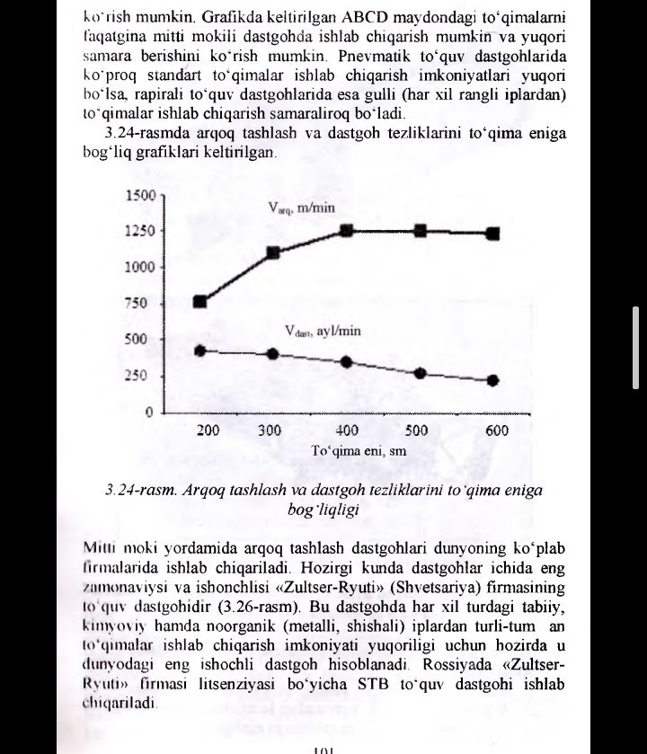

━━━━━━━━━━━━━━━━━━━━━━━━━━━━━━━━━━━━━━━━━━━━━━━━━━━━━━━━━━━━

RASM 14 • To'quv Dastgohlari Hujjati
Vaqt: 16:04:25 • O'lcham: 720×985 px
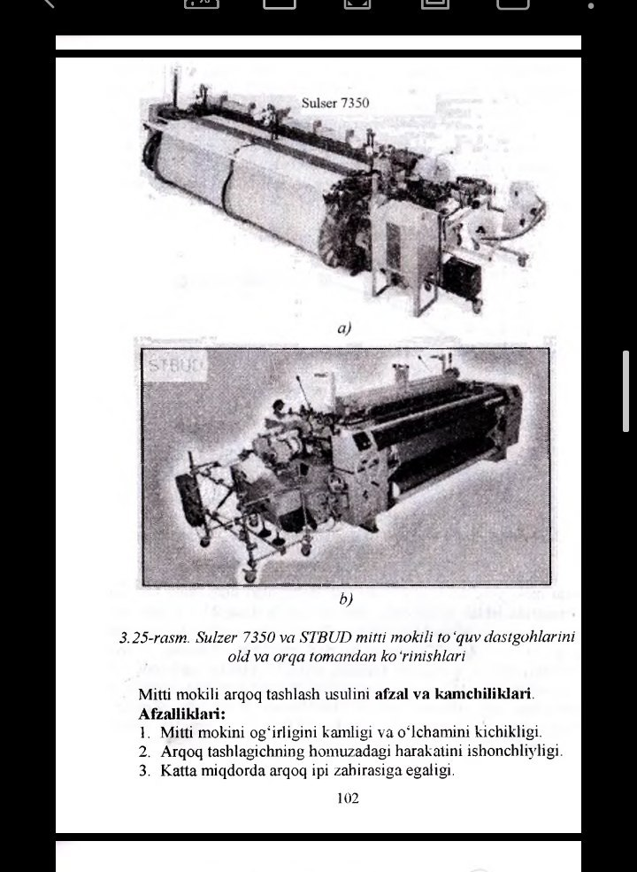

━━━━━━━━━━━━━━━━━━━━━━━━━━━━━━━━━━━━━━━━━━━━━━━━━━━━━━━━━━━━

RASM 15 • To'quv Dastgohlari Hujjati
Vaqt: 16:04:27 • O'lcham: 720×654 px
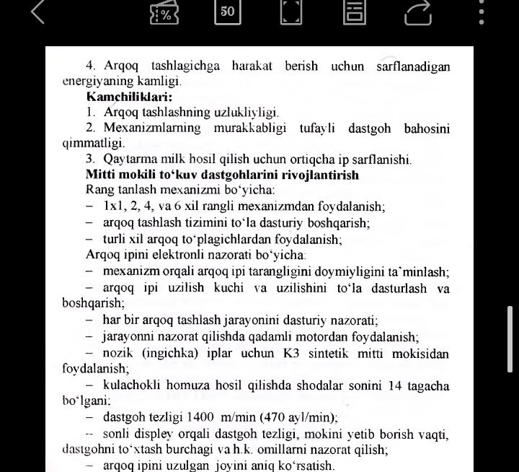

━━━━━━━━━━━━━━━━━━━━━━━━━━━━━━━━━━━━━━━━━━━━━━━━━━━━━━━━━━━━

HUJJAT TUGADI
═══════════════════════════════════════

To'quv Dastgohlari - Rivoshlanish Loyihasi
14-iyun 2026-yil | Barcha huquqlar himoyalangan

