[1]

Visual Analytics to Develop Dashboard of Performance and Activities for the control and monitoring of Construction Projects.

E. Avendano, C. Gutierrez, C. Zubieta, I. Muñoz, J. Hernandez y J. Guerra.

*Abstract*— AGZ is a multinational what work in the field of the construction and instalation of Industries projets. The PMO (Project Management Office) needs to present information about the progress of the projects and observe the deviations in what is planned and executed. We will use different views to observe the different metrics and indicators and their comparisons based on Framework for Visual Analytics of Tamara Munzner.

*Index Terms*—Visual Analytics, Project Management, Performance metrics, Dashboard.

# INTRODUCTION

T

HIS document is an implementation of vis (Visual Analytics) for Develop a Dashboard for the control of projects in AGZ construtors. AGZ is a multinational that works in the field of construction and installation of Industrial projects and the director of PMO has as one of its main tasks, present to the board of directors the progress of each of the projects compared to the baseline.

In order to guarantee and control each of its projects the PMO must generate weekly and monthly reports from different departments to constantly verify the progress of the project and the administration of Money and Activities in each area.

These reports should be unified from different sources and formats of data that each department handles to be presented in a single format that is directed to the management area. Based on these unified final reports, management adjusts and restructuring decisions in each project, if necessary. This final format should be clear, understandable and should highlight the characteristics most relevant to the project.

Currently, the process of **verification and unification of the sources is done by hand** through multiple tables of Excel, on the other hand, part of the information is processed by software called **Primavera** by **Oracle** that allows the administration and control of multiple projects, for this case, the benefit provided by the tool is not relevant, because the client **does not handle multiple projects at the same time**. Primavera also generates a kind of dashboard that is **very restrictive in terms of displaying the parameters of interest of the client**.

The client has been working on improving the process of generating the reports of:

- Activity and Performance.

- Costs.

For this purpose, it has been working with multiple departments and with management to determine the relevant data and the presentation of the data for each of the reports. Thanks to this work we achieved a dashboard of **activity and performance** debugged with only the parameters of interest to the company. For this Dashboard, the client needs to improve the way of presentation and navigation, as currently **must spend time in the generation of the dashboard whenever it requires generating the weekly and monthly report for each project**.

On the Cost Dashboard, the client is in the process of debugging and coordination between departments and management. **Now, they have a base of the board of costs that is not definitive**, reason they require a proposal to represent the costs that implies each project. In addition, he told us that with the current process it takes a lot of effort and time **to detect deviations of time and money in the execution of each one of the projects**.

For the development of the activity and performance dashboard we will use the Framework proposed by Professor Tamara Munzner, in which she proposes to approach the problem of creating visualizations from 3 aspects. **What**, **Why** and **How** [1].

What: Type of Data and Dataset.

Why: Refers to the tasks that users must perform.

How: It refers to which idioms are going to be used and what interactions they will have in order to solve the tasks and generate *Insights*.

# State of the art

In this section, we will discuss the different works and tools related to the development of dashboards for the monitoring of projects.

## Review of Primavera

This tool has the advantage that the source of the data is in it and for the management of the dashboards there are frames where you can add up to 12 windows and in each one of them can be added a visualization. Each window is named "Portlet" [1] [2].

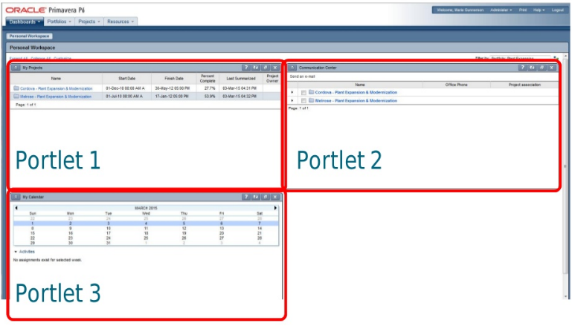

Fig 1. Dashboard Frame with 3 Portlet.

There are several Dashboards by default and you can create a new one based on an old one. You can also define user access to the dashboard. One of the main advantages of Portlets is that they can be collapsed and reordered in the Dashboard.

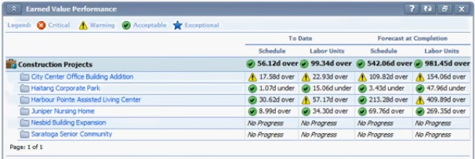

Fig. 2. Earned value Metrics in a Portlet.

In terms of earned value metrics, you can see that you can create a Portlet that has all the metrics added per project.

Another interesting visualization proposed by "Primavera" in his dashboard is the Gant diagram. “The Project Gantt Chart portlet is a great way to view the entire group of projects (those matching filter criteria for this dashboard) on a single Gantt-styled chart” [3].

## Gantt Charts by Kidasa.

This is a proposal of Kidasa Software for the creation of several types of graphs for the monitoring of projects, between the graphs that propose is the Gantt chart and the Dashboard of value gained.

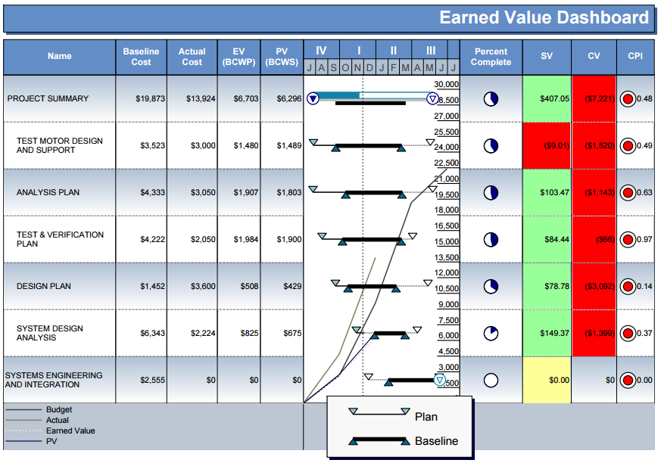

Fig. 3. Earned Value Dashboard by Kidasa using Milestone Professional.

“This is an example of a Dashboard Gantt chart. The Gantt chart portion of the dashboard is in the middle, while the columns display a wealth of other information which will be of interest to anyone monitoring the project. Information includes Earned Value performance metrics such as Schedule Variance, Cost Variance, Cost Performance Index, Planned Value (PV) and Earned Value (EV). Additionally, graphed on top of the Gantt chart area, are the Budget, Actual, Earned Value (EV) and Planned Value (PV) values” [5]

In this case, you can obtain graphs of Earned value for a single project.

# Proposal

To implement the proposal, we made the characterization analysis of What, Why and How.

## What:

The dataset is type **table** (All tables are in an Excel workbook that was obtained from the "Primavera" program). As for the attributes, most are of a sequential quantitative type. But there are also some with a *special semantics* (use a temporal semantics), which are used to identify a date (day, month and year).

## Why:

Several sections of interest were identified: Earned value, man hours and productivity:

### Earned Value Tasks:

T1. Identify what are the deviations in * the areas * that most influence the performance of the project.

T2. Compare **PV** *, * **EV** * and * **AC** * distribution for the areas of interest in the project.

T3. Identify in a specific week the values for * PV *, * EV * and * AC *.

### Hours Man Tasks:

T4. Present what are the hours consumed both directly and indirectly in the project by the people.

T5. Compare Scheduled Man Hours with Reals for each period.

### Productivity Tasks:

T6. Compare the planned distribution of the most relevant parameters in the project (Concrete, Steel, Structure, Welding) vs actual distribution.

T7. Present the distribution of the multiple parameters of expected vs. actual production.

*C. How:*

### Earned Value:

The marks used are the horizontal and vertical position lines, which have the color channel to identify the EV, PV and AC.

T1, T2 y T3: For these tasks a *Multi Line Chart* is used where the axis x represents the dates with intervals of weekly cut periods, in the axis and the number of hours of the Planned Value, Earned Value and Actual Cost, for these categories the channel hue is used to identify them among themselves.

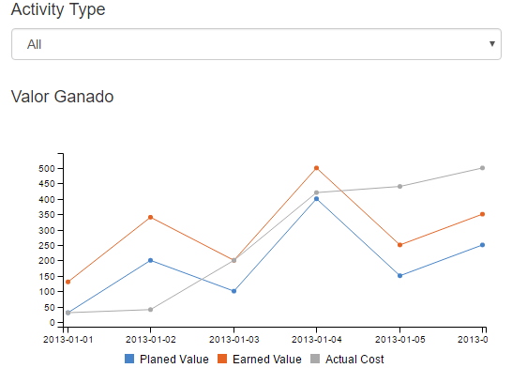

Fig. 4. Multi Line Chart for Earned Value.

The use of line char is justified because this idiom is very effective for the representation of large volumes of data that take place in a continuous interval of time, and this happens in this case, since we are interested in seeing the behavior of the PV, EV and AC in a period.

Main interactions:

--Zoom

--Filter: By Category and Date.

--Details on Demand: Tooltip for each category and

--Coordinate views: we use a chart for explain the top ten for the activities with high deviation, the data depend on the click of the mouse in the Earned Value chart.

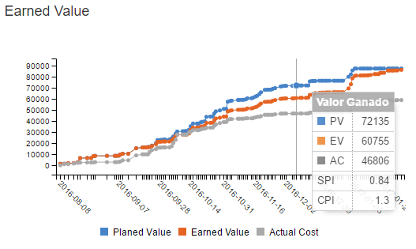

Fig. 5. Earned Value Chart with Tooltip.

Observing figure 5 shows the interaction of the mouse over with the graph, where the detail of the PV, EV, AC and date metrics is shown. In addition, the SCI (Schedule Performance Index) and CPI (Cost Performance Index) That identify the performance of one project.

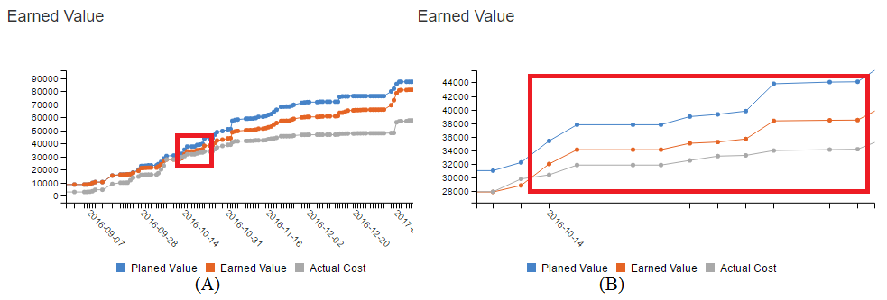

Fig. 6. Earned Value with Zoom.

Figure 6 shows the effect of the Zoom, in part (A) it is noticed that there are several glued points and it is not possible to see if there is a deviation, in part (B) it is noticed that when zooming You can see the detail that there is a change in the metric of EV and AC, this could not be seen in part (A).

# Results and Evaluation

The client's greatest pain was to be able to make the comparisons of the earned value curves, then we analyzed the visualizations with respect to that task.

The related works could not solve the task that the user had, since they could not make the comparisons of the different curves of Earned value, they could relate the value metrics gained, but they did it in a global way of the project or the idiom did not allow to identify Easily the dates where the major deviations were found.

The graph of earned value proposed allows to easily identify the dates in which the different deviations exist and when using the coordinated views can generate insights when reviewing the graph that shows which activities that caused the greater difference.

# Conclusion

The goal of this project was to create a visualization that would help to solve the tasks of the users and to use the proposal of the framework of the teacher Tamara was able to identify the main tasks and solve them through an idiom with their respective interactions.

With respect to the visualizations by the Primavera software, it can be said that is important that the tools conform to the business and not the business to the tools.

In another hand, to be able to generate better and greater “insigths” it is necessary to know the business.

The main part was to achieve a visualization, but the preprocessing of the data was what enabled the generation of Insights.

# References

|  |  |
| --- | --- |
| [1] | T. Munzner, Visualization Analysis & Design, Boca Ratón: Taylor & Francis Group, 2014. |
| [2] | p6academy, «slideshare.net,» 20 11 2016. [En línea]. Available: http://es.slideshare.net/p6academy/200620-demystifying-p6-eppm-dashboards. |
| [3] | I. C. Ascui, «slideshare.net,» 10 11 2016. [En línea]. Available: http://es.slideshare.net/iverclaros/primavera-p6-project-management. |
| [4] | Safari, «safaribooksonline.com,» Safari, [En línea]. Available: https://www.safaribooksonline.com/library/view/oracle-primavera-p6/9781849684682/ch15s03.html. [Último acceso: 10 11 2016]. |
| [5] | K. Software, «ganttchart.com,» [En línea]. Available: http://www.ganttchart.com/DashboardChart.html. [Último acceso: 25 11 2016]. |

1. E. Avendaño, C. Gutierrez y C. Zubieta son estudiandes de la maestría de ingeiería de sistemas y computacion en la Universidad de los Andes (email: ea.avendano | cd.gutierrez | ci.zubieta @uniandes.edu.co).

   I. Muñoz is engineer and the PMO Director at AGZ.

   J. Hernandez y J. Guerra are Professors and researchers of the University of Los Andes in the area of Visual Analytics (email: ja.guerrag | jhernand @uniandes.edu.co)