Workflow Automation Design Document
AI-Enabled Internal Request Triage System
No-Code AI Automation | Zubeen Khalid
Platform | Microsoft Power Automate - Anglia Ruskin University environment

Tools Used | Microsoft Forms, AI Builder (Sentiment Analysis), Outlook (V2), Excel (SharePoint)

Flow Name | Request Triage Flow

Status | Built, improved, and tested all test runs, which succeeded with confirmed email outputs

Flow Overview
The screenshot below shows the complete automated flow as built in Microsoft Power Automate.

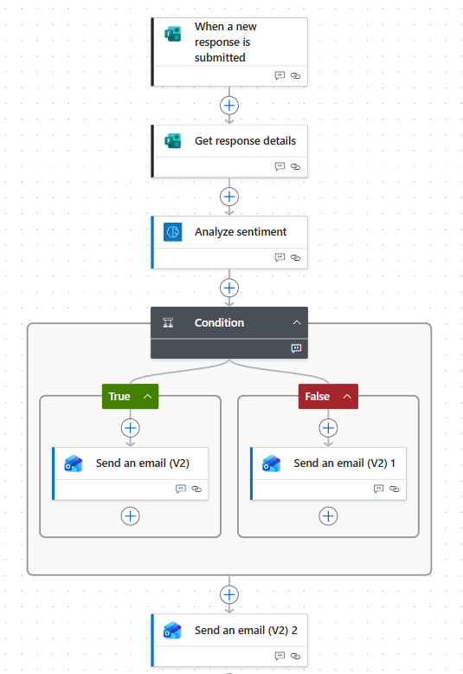

1. Description of the Business Process
Many organisations receive a high volume of internal requests each day. These requests vary widely, covering IT issues, HR concerns, training needs, and general administrative queries. Processing these manually is time-consuming, inconsistent, and prone to delays, particularly when messages are urgent or emotionally charged.
This automation creates a structured, intelligent triage system. When a staff member submits an internal request through a Microsoft Form, the flow automatically analyses the language used, determines whether the message carries a negative or frustrated tone, checks the selected urgency level, and routes the request accordingly, either flagging it as urgent or processing it as a routine submission.
The process is relevant to any organisation handling internal communications at scale, including universities, NHS trusts, local authorities, and private sector businesses.

2. Current Manual Workflow
Without automation, the current process works as follows:

Step | Action | Tool / Who | Time (est.)
1 | Staff member submits request by email or paper form | Staff member | 5 minutes
2 | Admin reads each message individually | Admin staff | 3-5 min per request
3 | Admin judges tone and urgency manually | Admin staff | 2-3 minutes
4 | Admin forwards to the correct department | Admin staff | 2 minutes
5 | Department acknowledges receipt | Department lead | 1-2 hours
6 | Request logged or tracked manually | Admin staff | 3 minutes

Common inefficiencies with this approach include:
- Urgent or emotionally distressed messages are not always identified quickly
- Requests are sometimes sent to the wrong department
- No consistent process for prioritising high-urgency submissions
- Admin time is spent on repetitive, low-value reading and forwarding tasks
- No reliable audit trail unless manually recorded
3. Proposed Automated Workflow
The automated workflow uses Microsoft Power Automate to eliminate the manual steps above. The flow was built, improved, and tested successfully in the Anglia Ruskin University Power Automate environment.

Step-by-step flow structure

Step | Action | Tool / Who | Time (est.)
1 | Staff member submits the Microsoft Form | Microsoft Forms (trigger) | Instant
2 | Flow retrieves all form response details | Power Automate | Instant
3 | AI analyses the description field for sentiment | AI Builder | Instant
4 | Condition checks: is sentiment Negative OR urgency High? | Power Automate | Instant
5a | TRUE: Sends URGENT email with full request details | Outlook (V2) | Instant
5b | FALSE: Sends standard email with full request details | Outlook (V2) | Instant
6 | Confirmation email sent to the submitter automatically | Outlook (V2) | Instant
7 | Response logged automatically in the Excel spreadsheet | Excel / SharePoint | Instant

Both routing emails include the following details pulled directly from the form: submitter name, department, request title, urgency level, full description, and the AI sentiment result. This means the recipient has everything they need without having to look anything up.
The confirmation email sent to the submitter acknowledges their request immediately, improving the experience for the submitter and reducing follow-up queries.

Evidence of successful test runs

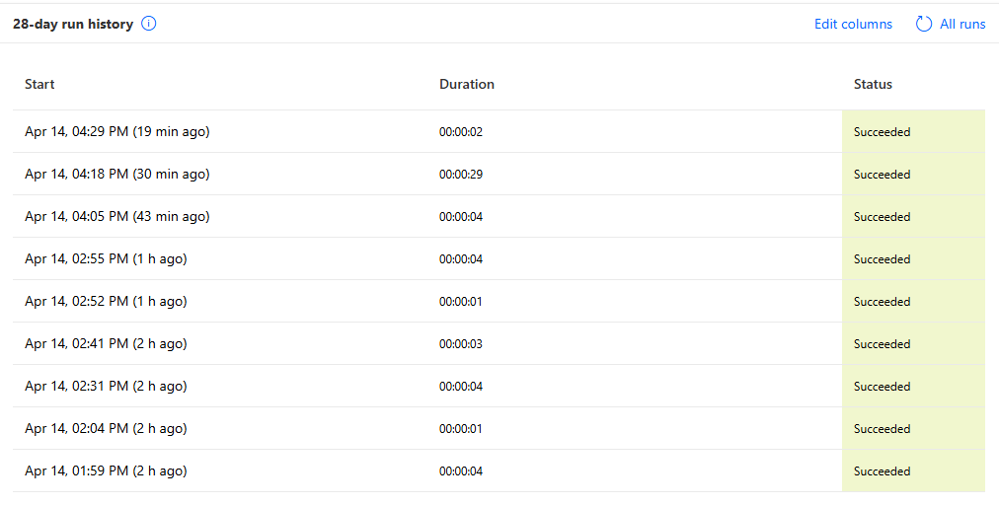
[ Run history showing succeeded status ]

4. AI Used in the Automation
The AI component uses the Microsoft AI Builder Sentiment Analysis model: a pre-trained machine learning model built into Power Automate. It applies natural language processing to the submitted text and returns a sentiment classification without requiring any custom coding or prompt writing.

What the AI receives
The AI Builder action receives the content of the 'Describe your request' field from the form submission. This is the free-text field where the requester describes their issue or need in their own words.

What the AI returns
The model returns an Overall Text Sentiment value of one of three possible outputs:
- Positive - the message has a constructive or satisfied tone
- Neutral - the message is factual with no strong emotional content
- Negative - the message contains frustration, dissatisfaction, or urgency

How the AI output is used
The Condition step checks whether the Overall Text Sentiment equals 'negative'. If it does, the urgent routing pathway activates. The AI is directly controlling the routing decision; it is not simply filtering keywords but analysing the meaning and tone of natural language text.
Example test: A submission reading 'I have been waiting three weeks, and nobody has helped me. This is completely unacceptable, and I am very frustrated' was correctly classified as Negative, triggering the URGENT email pathway.

5. Human Validation and Governance Controls

Dual trigger for urgent routing
A key governance improvement added to this flow is that urgent routing is triggered by two conditions, not just one. The Condition step fires the URGENT pathway if:
- The AI detects negative sentiment in the message, OR
- The submitter has manually selected High urgency on the form

This is an important safeguard. A politely worded but time-sensitive message might not be detected as negative by the AI, but if the submitter selects High urgency, it will still be escalated correctly. The automation catches cases that AI alone might miss.

Human review points
- Every email generated by the flow is sent to a staff inbox, and a human reads every routed message before any further action is taken
- The URGENT flag prompts the recipient to respond more quickly, but the human makes the final decision on what action to take
- No automated response is sent directly to the requester without human knowledge; the confirmation email is a standard acknowledgement only

What happens if the AI output is incorrect
If a message is misclassified, for example, a direct but non-urgent message is flagged as negative, the human recipient simply treats it as a routine request. No irreversible automated action has been taken. The AI influences the priority level of the email, but the human retains full control over the response.

Audit trail
Every form submission is automatically logged to an Excel spreadsheet stored in SharePoint. This creates a permanent record of every request received, which department it was routed to, and what sentiment the AI detected. This log can be reviewed at any time to identify patterns, misrouted items, or areas for improvement.

Data handling
All form submissions remain within the Microsoft 365 environment. No data is sent to third-party services. The AI Builder model runs within Microsoft's secure cloud infrastructure, compliant with GDPR requirements applicable to UK organisations.

6. Evidence of Flow in Action

URGENT email - negative sentiment detected
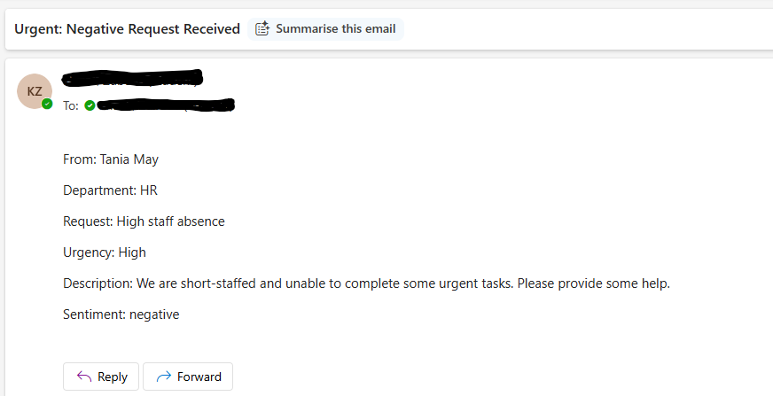

[URGENT email received in inbox ]

Standard email - neutral or positive submission
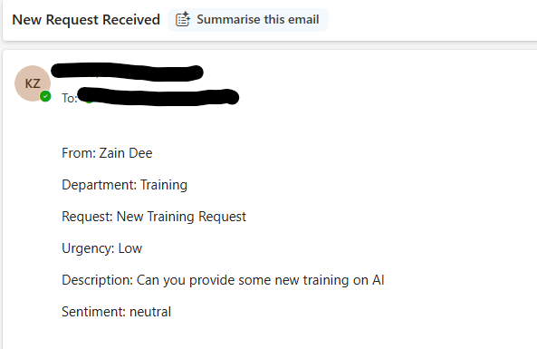
[Standard routing email received in inbox ]

Excel audit log
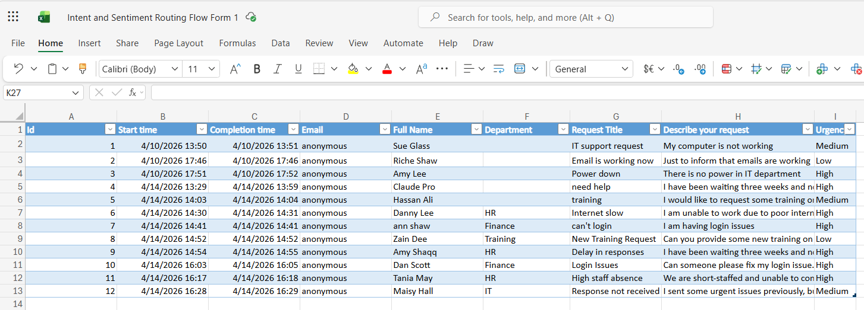

[ Excel spreadsheet showing logged form responses ]

7. Expected Productivity Benefits
The following estimates are based on a realistic assumption of 20 internal requests received per working day.

Step | Action | Tool / Who | Time (est.)
 | Reading and manually assessing each request | Before: 3–5 min each | After: 0 min
 | Judging urgency and tone | Before: 2–3 min each | After: 0 min (AI)
 | Forwarding to the correct pathway | Before: 2 min each | After: 0 min
 | Sending acknowledgement to the submitter | Before: 2 min each | After: 0 min
 | Total admin time per day (20 requests) | Before: ~2.5 hours | After: ~15 minutes

Key benefits include:
- Estimated 90% reduction in manual triage time for routine requests
- Immediate identification of urgent or distressed submissions, reducing average response time from hours to minutes
- Automatic acknowledgement means submitters are never left wondering if their request was received
- Consistent routing every time, no risk of a message being missed or misfiled
- Staff freed to focus on resolving requests rather than processing them
- The system scales without additional resources. 200 submissions per day requires no more effort than 20

8. Risks and Limitations

Identified risks and mitigations
- Misclassification:
The AI may occasionally classify a direct message as negative when it is not urgent.
Mitigation: Human review of all URGENT emails before action is taken. The dual trigger (sentiment OR urgency) also reduces over-reliance on AI alone.
- False negatives:
A politely worded message may conceal genuine urgency.
Mitigation: The form includes a mandatory urgency field so submitters can self-identify priority independently of the AI.

- Over-reliance on automation:
Staff may assume the AI has correctly identified all urgent cases.
Mitigation: Regular review of the Excel audit log and periodic spot-checks of routed emails.

- Sensitive content:
HR or safeguarding-related submissions may be routed to a general inbox.
Mitigation: A future improvement would add a dedicated question asking whether the request is confidential, with a separate routing pathway.

- AI model accuracy:
The AI Builder model is pre-trained and cannot be customised for organisation-specific language. Unusual phrasing may reduce accuracy.
Mitigation: Monitor misrouted submissions over time and refine form questions to guide more structured responses.

Overall risk assessment
The risks associated with this automation are low because no irreversible automated action is taken. Every output is an email to a human inbox. The AI informs and prioritises, it does not act independently. The addition of a dual trigger condition, a confirmation email, and an Excel audit log means this flow includes multiple layers of oversight suitable for a real workplace deployment.

Professional Summary
This flow demonstrates how AI-enabled automation can improve the efficiency and responsiveness of internal request handling whilst maintaining appropriate human oversight. By combining Microsoft Forms, AI Builder sentiment analysis, dual-condition routing logic, automated email notifications, and Excel-based audit logging, all within Microsoft Power Automate, the workflow removes repetitive manual processing, identifies urgent cases immediately, acknowledges every submission automatically, and maintains a full audit trail. The design is practical, scalable, and deployable within existing Microsoft 365 infrastructure at no additional cost to the organisation.

