

KARNATAK UNVIRSITY DHARWAD

ANJUMAN INSTITUTE OF INFORMATION SCIENCE AND MANAGEMENT,DHARWAD

BACHELOR OF COMPUTER APPLICATIONS

VI SEMISTER

-:PROJECT REPORT ON:-

“BOOK YOUR LAPTOP”

UNDER THE GUIDENCE OF

PROF: A.M KITTUR

SUBMITED BY

MOHAMMAD ZUBER SAGAR

20U10218

**ACKNOWLEDGEMENT**

The satisfaction that accompanies the successful completion of any task would be incomplete without the mention of people whose ceaseless cooperation made it possible, whose constant guidance and encouragement crown all efforts with success. I am grateful to my project guide "A.M Kittur" for the guidance, inspiration and constructive suggestions that helps me in the preparation of this project. I also thank mine colleagues who have helped me in successful completion of the project.

We express our heartfelt gratitude to Principal Prof. ABDUL MATEEN BIDIWALE for his constant guidance, inspiration and suggestion through the project.

**Table of contents**

1. Introduction
2. Advantages of the proposed system
3. Admin module
4. Abstract
5. Objectives
6. Er diagram
7. Software requirement
8. Hardware requirement
9. Application

10.Advantages & Disadvantages

**Introduction**

Welcome to our online laptop sale project! In today's fast-paced digital world, having a reliable and efficient laptop is essential for both personal and professional endeavours. Our project aims to provide you with a convenient and seamless online platform to explore and purchase the latest laptops from top brands.

With our extensive collection of laptops, Whether you're a student, a professional, a gamer, or someone who simply enjoys the convenience of portable computing, we have the perfect laptop to suit your requirements.

**Advantages Of the Proposed System :**

Convenience: The online platform allows users to browse and purchase laptops from the comfort of their own homes or anywhere with an internet connection. This eliminates the need to visit physical stores, saving time and effort.

Extensive Selection: Our system offers a wide range of laptops from top brands, providing users with a diverse selection to choose from.

Detailed Product Information: The system provides detailed product descriptions, specifications, and customer reviews for each laptop.

User-Friendly Interface : The platform is designed with a user-friendly interface, making it easy for users to navigate, search for specific laptops, and complete their purchases with minimal effort.

**Abstract**

The Laptop Booking Project is to provide an online platform for Customers to book Laptops.

**Methodology**: This Platform will be developed using modern Web technologies ,such as HTML, CSS & JavaScript for the front end and a popular server-side language, such as PHP for the backend

**Features**: the platform will have several features to make the booking process as seamless as possible for customers. these features include a user-friendly interface for browsing an available notification system to Confirm Booking .

In this project ,we use PHP and MySQL database. It has two modules

* user
* admin

**User** : user can view the Website and Checkout the Information About

laptop

**Admin Module**

Admin is super user of the website who can manage everything on the website. Admin can log in through the login page

**Dashboard** : In this Section ,admin can see all detail in brief like the Laptop Configrations

**Company info** : in this section,admin can mange car company information (add/update)

+-

**Objectives**

* It is very much faster than manual system
* Easy and fastest record finding technique
* It is very much flexible to work
* Man power required is very less
* Data can be stored for longer record

**Use case diagram user**



**Admin**

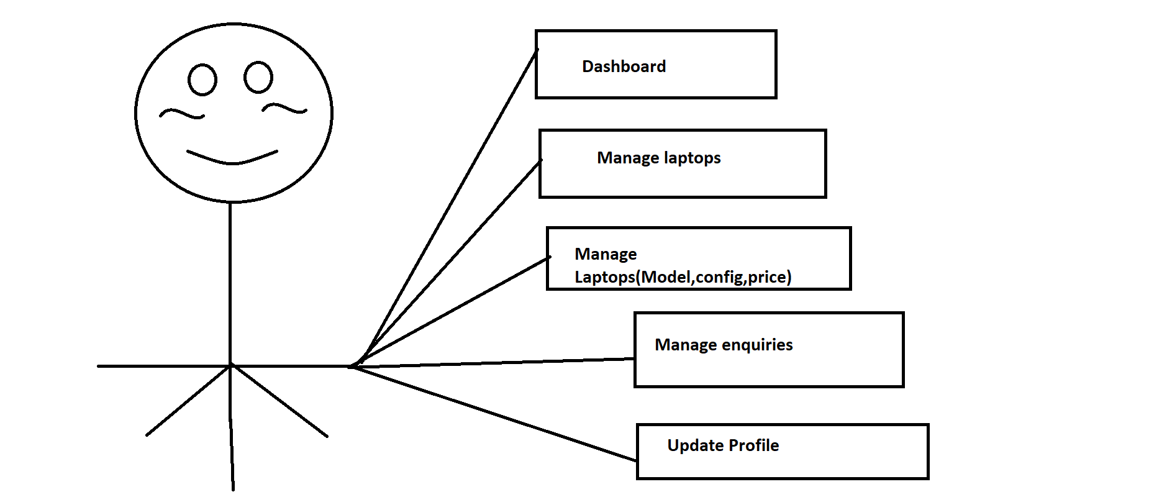

**Software Requrement** : Xamp -win32 -1.8.2-3-VC9

**Hard ware requirement** : intel processor 2.0Ghz or Above

2 GB RAM or More 160 GB or more

**Application** : Run Project Xamp-win32-1.8.2-3-vc9

**Advantages** :

* User Can Find Various Vehicles information along with images at a Single place
* This System is Effective and Saves time , efforts and Cost of Users
* Sellers Can Also Easily find buyer for Their Vehicle easily by posting ads
* Easy registration

**Disadvantages :**

* No human interaction
* If poor quality photographs are uploaded ,system proves inefficient