# Chapter 1

## **INTRODUCTION**

### **1.1 Problem description**

The conventional technique for marking student attendance often encounters numerous challenges. The face recognition student attendance system underscores its simplicity by eliminating classical methods such as calling out student names or checking identification cards. These conventional practices not only disrupt the teaching process but also prove distracting for students, especially during exam sessions. Additionally, passing around an attendance sheet during lectures, particularly in large classes, presents logistical issues. In response, a face recognition attendance system is proposed to replace the cumbersome manual sign-in process. This automated system alleviates student distractions related to signing attendance sheets and mitigates fraudulent approaches. Moreover, instructors are relieved of the need to repeatedly tally student numbers to verify attendance.

Zhao, W et al.'s paper (2003) enumerates challenges in facial identification, notably distinguishing between known and unknown images. Furthermore, Pooja G.R et al.'s study (2010) identifies a sluggish and time-consuming training process for the face recognition student attendance system. Priyanka Wagh et al.'s research (2015) underscores that varying lighting conditions and head poses often undermine the performance of face recognition-based attendance systems.

Consequently, an imperative exists to develop a real-time student attendance system, necessitating identification within defined temporal constraints to avert omissions. Extracted features from facial images, signifying student identities, must exhibit consistency across changing backgrounds, lighting, poses, and expressions. The system's performance will be gauged against benchmarks of heightened accuracy and swift computation time.

### **1.2 Motivation**

The project “Face recognition - based attendance system” aims to address the inefficiencies and limitations of conventional attendance tracking methods. Manual attendance processes, such as sign-in sheets and ID card swiping, have long been plagued with challenges, leading to inaccuracies, time wastage, and security concerns. To overcome these drawbacks and usher in a new era of streamlined attendance management, the implementation of an innovative, automated, and secure system becomes imperative.

* Enhanced Efficiency and Accuracy: Traditional attendance methods often involve time-consuming manual processes, leading to delays and errors in recording attendance. By leveraging the power of face recognition algorithms and automation, this project aims to significantly improve the efficiency and accuracy of attendance tracking. Real-time face detection and recognition eliminate the need for manual data entry and ensure swift and precise attendance recording.
* Seamless Integration with Existing Systems: The proposed face recognition-based attendance system can seamlessly integrate with existing databases, school management systems, or corporate HR systems. This integration streamlines data management, minimizes duplication of efforts, and enhances the overall efficiency of administrative processes.
* Contactless and Hygienic Solution: In an era where hygiene and safety have gained paramount importance, a contactless attendance system offers an ideal solution. Users can mark their presence without touching any physical devices, reducing the risk of germ transmission and promoting a safer environment in schools, universities, or workplaces.

### **1.3 Objective**

Attendance holds paramount importance for both educators and students within an educational institution. Maintaining accurate attendance records is a critical endeavor. However, challenges arise when considering the conventional classroom attendance process. Manually calling out names or roll numbers for attendance not only consumes substantial time but also demands energy. Hence, an automated attendance system emerges as a viable solution to address these issues.

Several automated attendance systems are currently employed by educational institutions, including biometric techniques and RFID systems. While these systems represent significant progress beyond traditional methods, they often fall short of meeting time constraints. Students frequently encounter lengthy queues when marking attendance, resulting in time inefficiencies.

This project aims to introduce an unobtrusive attendance marking system that seamlessly integrates with the standard teaching process. This system is adaptable for use during examinations and other critical teaching activities necessitating attendance monitoring. By eliminating conventional student identification methods such as vocalizing names or inspecting identification cards, the system prevents disruptions to ongoing teaching and mitigates stress for students during exam periods.

Furthermore, this system eliminates the need for students to pre-register in a database for recognition. The user-friendly interface enables spontaneous enrollment, streamlining the process and enhancing ease of use. This innovation represents a significant stride toward efficient, accurate, and stress-free attendance management in educational settings.

### **1.4 Background**

Face recognition plays a pivotal role in our daily lives, facilitating the identification of family members, friends, and acquaintances. This seemingly straightforward process involves a series of intricate steps that we often overlook. Human intelligence enables us to receive and interpret information during the recognition process. This information is received through images projected onto our retinas as light, a form of electromagnetic waves emanating from sources and forming projections in human vision. Robinson-Riegler and Robinson-Riegler (2008) highlight that the human visual system undertakes visual processing, classifying object attributes such as shape, size, contour, and texture to decipher the conveyed information. Subsequently, the analyzed information is compared with other object or facial representations stored in our memory to achieve recognition. While replicating this capability in an automated system remains a formidable challenge, the necessity to recognize numerous faces, as evident in diverse university settings with students of varying races and genders, calls for memory capacities beyond human capacity, necessitating the deployment of computers with extensive memory and formidable processing power in face recognition systems.

The human face serves as a distinctive marker of individual identity, thus rendering face recognition a biometric approach. This methodology entails real-time image comparisons with stored database images to identify an individual (Margaret Rouse, 2012).

Presently, face recognition systems are pervasive due to their efficiency and exceptional performance. Applications span from airport security systems and criminal investigations by entities like the FBI, which employ face recognition to track suspects, missing individuals, and illicit activities (Robert Silk, 2017), to user-friendly implementations like Facebook's photo tagging feature that enhances user interaction (Sidney Fussell, 2018). Notably, Intel enables users to access their online accounts using face recognition (Reichert, C., 2017), while Apple's iPhone X employs face recognition for device unlocking (deAgonia, M., 2017).

The roots of face recognition research date back to 1960 when Woody Bledsoe, Helen Chan Wolf, and Charles Bisson introduced a system necessitating the administrator to locate eyes, ears, nose, and mouth within images. Subsequent advancements by Goldstein, Harmon, and Lesk in 1970 incorporated additional features such as hair color and lip thickness for automated recognition. In 1988, Kirby and Sirovich proposed the use of Principal Component Analysis (PCA) for face recognition problem-solving. Extensive studies have since continuously evolved face recognition techniques (Ashley DuVal, 2012).

Chapter 2

## **LITERATURE SURVEY**

1. Automated Attendance System Using Face Recognition: Automated Attendance System using Face Recognition proposes that the system is based on face detection and recognition algorithms, which is used to automatically detects the student face when he/she enters the class and the system is capable to marks the attendance by recognizing him. Viola-Jones Algorithm has been used for face detection which detects human faces using cascade classifier and PCA algorithm for feature selection and SVM for classification. When it is compared to traditional attendance marking this system saves time and also helps to monitor the students.

2. A Counterpart Approach to Attendance and Feedback System using Machine Learning Techniques: In this paper, the idea of two technologies namely Student Attendance and Feedback system has been implemented with a machine learning approach. This system automatically detects the student's performance and maintains the student's records like attendance and their feedback on the subjects like Science, English, etc. Therefore, the attendance of the student can be made available by recognizing the face. On recognizing, the attendance details and details about the marks of the student is obtained as feedback.

3. Student Attendance System Using Iris Detection: In this proposed system the student is requested to stand in front of the camera to detect and recognize the iris, for the system to mark attendance for the student. Some algorithms like Gray Scale Conversion, Six Segment Rectangular Filter, Skin Pixel Detection are being used to detect the iris. It helps in preventing proxy issues and it maintains the attendance of the student in an effective manner, but is one of the time-consuming processes for a student or a staff to wait until the completion of the previous members.

4. In this paper, the authors developed and implemented a classroom attendance system using radio frequency identification (RFID) and face verification techniques. The system recognizes students by using the RFID card and for more confirmation of the student's identity, face recognition technique has been added using Fast Adaptive Neural Network Classifier (FANNC). The classifier was trained and tested to identify human face images. Every student needs to take seven dissimilar head poses images in order for the classifier to identify students' images.

### **2.1 Conclusion based on Proposed system:**

An automated student attendance system is necessary for the learning and teaching environment. Most of the existing systems are time-consuming and require a semi-manual work from the teacher or students like calling students ID, and passing attendance sheets around the class, etc during lecture time. In the proposed system the aim is to provide a solution for the above-mentioned problems by integrating face recognition in the process of attendance management that can be used during exams or a lecture which will save effort and time. Currently, the facial recognition system is implemented by other researchers as well, but there are also have some limitations regarding functionalities, accuracy, lighting problem, and etc that supposed to be solved by the proposed system

So, the proposed system will support the performance of existing students' attendance system in the following ways:

* Minimizing the time required for marking attendance and maximizing the time required for the actual teaching process.
* Increase the efficiency of the overall system.

Chapter 3

## **DESIGN**

Face detection involves separating image windows into two classes. It is difficult because although commonalities exist between faces, they can vary considerably in terms of age, skin color and facial expression. The problem is further complicated by differing lighting conditions, image qualities and geometries, as well as the possibility of partial occlusion and disguise. An ideal face detector would therefore be able to detect the presence of any face under any set of lighting conditions, upon any background. The face detection task can be broken down into two steps. The first step is a classification task that takes some arbitrary image as input and gives output, indicating whether there are any faces present in the image. The second step is the face localization task that aims to take an image as input and output the location of any face or faces within that image as some bounding box with (x, y, width, height). After taking the picture the system will compare the equality of the pictures in its database and give the most related result.

### **3.1 Software Environment**

Collection of software tools that help to run this application are listed below:

1. Python: Python is a versatile and widely used programming language that provides various libraries and frameworks essential for building this system.

2. Flask: Flask is a lightweight and flexible web application framework in Python. It will be used to create the user interface for the attendance system, where users can interact with the application through a web browser.

3. OpenCV: OpenCV (Open-Source Computer Vision Library) is a powerful open-source computer vision and image processing library. It provides tools for image and video analysis, manipulation, and feature extraction, which are crucial for face recognition.

4. joblib: is a Python library that provides tools for efficient serialization (saving) and deserialization (loading) of Python objects. It is commonly used for tasks such as caching, parallel computing, and distributing tasks across multiple processes or machines. The primary use case for `joblib` is to save memory-intensive objects like NumPy arrays, scikit-learn models, and other complex Python objects to disk, and then reload them when needed

5. K-nearest neighbors (k-NN) algorithm: The k-nearest neighbors’ algorithm is a machine learning technique used for classification and regression tasks. In this case, it will be utilized for face recognition. The algorithm stores known faces (attendance records) and compares new faces with these stored faces to find the nearest neighbors.

6. NumPy and SciPy: These libraries provide support for numerical operations and scientific computing. They are essential for handling arrays and matrices, performing calculations, and implementing machine learning algorithms.

7. Face Detection Model: A pre-trained deep learning model, such as a Haar Cascade or a deep neural network model, is needed for detecting faces within images or video streams.

8. Facial Landmarks Model: A pre-trained model, such as the shape predictor, is required to locate specific facial landmarks (like eyes, nose, and mouth) on detected faces.

9. Code Editor/IDE: A code editor or integrated development environment (IDE) such as Visual Studio Code, PyCharm, or Jupyter Notebook will be used to write, debug, and manage the project code.

10. Deployment Platform: If we plan to deploy the application, we'll need a platform like Heroku, AWS, or a dedicated server to host our Flask application and database.

11. User Interface (HTML/CSS): The frontend of the Flask web application will require HTML for structuring the content and CSS for styling and layout.

### **3.2 Flow Chart**

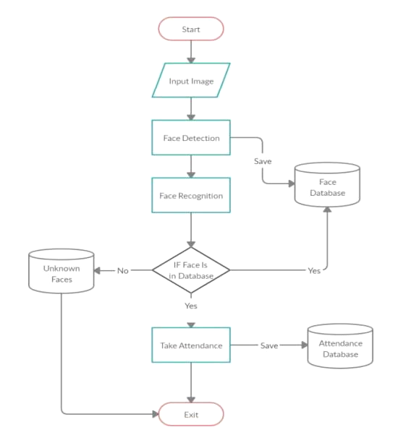

Figure 3.1 flowchart

### **3.3 Various Modules**

1. Image Data Collection and Preprocessing: This module involves capturing images or video frames of individuals and preparing them for further processing,

Preprocessing steps may include resizing, normalization, and noise reduction to improve the quality of the input data.

2. Face Detection:In this module, the system locates and identifies the regions of interest (faces) within the input images or video frames. Various algorithms like Haar cascades, deep learning-based detectors, or other object detection techniques can be used.

3. Face Alignment and Landmark Detection: To ensure accurate recognition, the system might align the detected faces to a common orientation. Landmark detection techniques identify key facial features like eyes, nose, and mouth, which can help improve the accuracy of recognition.

4. Feature Extraction: This module involves extracting distinctive features from the aligned faces. Deep learning techniques can be used to learn relevant features that help distinguish one face from another.

5. Face Recognition: Here, the system matches the extracted features from a captured face against the features stored in a database of known individuals. This involves measuring the similarity between the features and making a decision about the identity of the person.

6. Database Management: This module involves storing and managing the face templates or feature vectors of enrolled individuals. The database supports efficient retrieval and updating of information.

7. Attendance Tracking and Logging: Once a match is found during recognition, the system records the attendance of the identified individual. This module may include logging the timestamp, the recognized person's name, and other relevant details.

8. User Interface and Interaction: A user-friendly interface is essential for system administrators to manage the system, enroll new individuals, view attendance records, and handle exceptions or errors.

9. Real-time Processing: For attendance tracking in real-time scenarios, the system should be able to process incoming images or video frames at a sufficient speed for timely recognition.

10. Accuracy Improvement and Continuous Learning: Implement mechanisms to continuously improve the system's accuracy over time. This could involve periodic retraining of the recognition model and handling variations in lighting, pose, and expression.

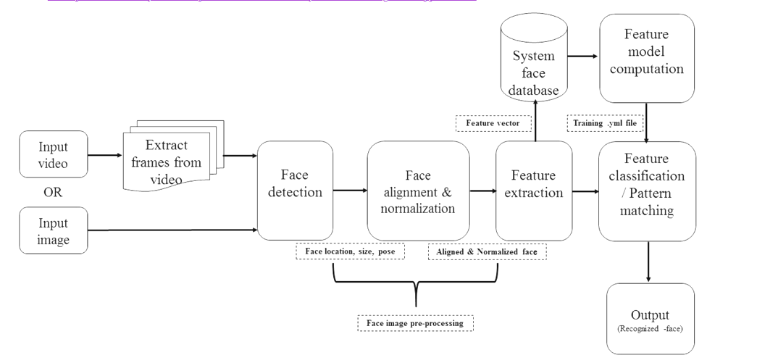

Figure 3.2 block diagram

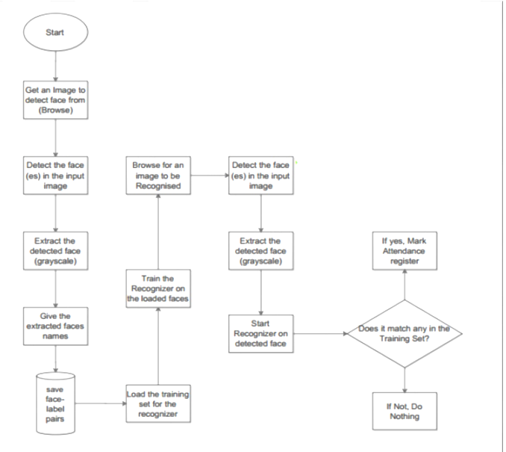

Figure 3.3 detailed process flow

### **3.4 Methodology**

[3.4.1] This section describes how LBPH is used for face recognition. First, a dataset is collected for images and each image is labeled with a unique id. The images are divided into an 8X8 grid and converted into grayscale. A 3X3 matrix of each pixel containing its intensity (0~255) is extracted from the image. The threshold of the central value of this matrix is taken which is used to determine the neighboring value of the matrix. Each neighboring value is compared with the

central value. If the neighboring value is greater or equal to the threshold value, it is set to 1. If the neighboring value is less than the threshold value, it is set to 0. Then, the matrix value will contain binary values only. The decimal value is calculated using the given formula:

LBP (xc,yc) = ∑^7 n=S(Ic – In)2^n

In the above formula, ‘n’ is the 8 neighbors of the central pixel, Ic, and In are the grey level values of the central pixel and the surrounding pixel, respectively. S(x) is 1 if x is greater than or equal to the threshold. S(x) is 0 if x is less than the threshold. The calculated decimal value is replaced with the central value. Hence, we obtain the characteristics of the original image in a new image. Once all the processes are complete, a histogram is extracted from each grid and are

concatenated. This process is repeated for all the images and a histogram is generated. To compare two images, histograms are compared at a time. The comparison is done by Histogram Intersection. Its formula is given below:

∑j=1 min(Ij,Mj)

Here, j is the bin number and I and M are histogram 1 and histogram 2. If the intersection value is greater than 80% then, the image is successfully recognized.

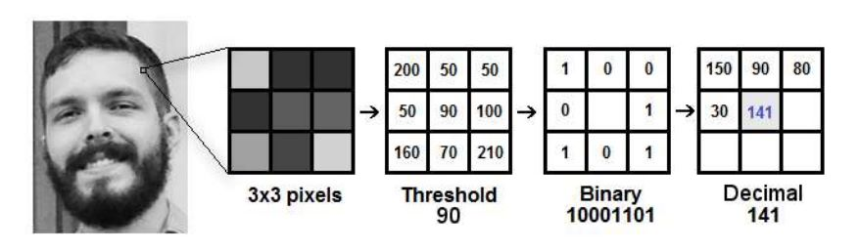

Figure 3.4 shows the conversion of an input image to data points

[3.4.2] Integrating a Flask app into our project can greatly enhance the user experience and provide a streamlined way to manage attendance records. Flask is a micro web framework for Python, which makes it an ideal choice for creating the web interface that interacts with the face recognition system.

1. Set Up the Face Recognition System: Before integrating the Flask app, we ensure that a functional face recognition system is in place. This system should be capable of capturing and recognizing faces from images or live video streams.

2. Create a Flask App: We begin by creating a new directory for your project and setting up a virtual environment. Install Flask using pip:

* pip install Flask

Create the Flask app structure:

3. Build the Frontend: In the `templates` directory, create an `index.html` file for the frontend interface. This HTML file will include a form for uploading images or capturing live video frames.

4. Create Routes in Flask: In your ‘app.py’ file, we’ll import the necessary modules and create routes for handling various actions, such as uploading images or processing live video frames. You'll need to create routes for functions like capturing an image, recognizing faces, and marking attendance.

5. Implement Face Recognition: Inside the specific routes, implement the face recognition logic. Use the `face_recognition` library to process the uploaded image or video frames. Compare the recognized faces with a database of known faces to determine attendance.

6. Mark Attendance: Based on the results of face recognition, update your attendance records. You might use a database or a simple text file to store attendance data.

# Chapter 4

## **IMPLEMENTATION**

### **4.1. Datasets Utilized**

The project incorporates a multi-stage process to seamlessly integrate student identification and attendance management. Initially, students are actively engaged in contributing to the system's database. Through a user-friendly interface, students initiate the enrollment process, providing their images which serve as the foundation for subsequent recognition. These images are systematically organized and stored within designated directories, forming a comprehensive repository of student profiles.

As the educational journey progresses, students encounter the face recognition system during attendance sessions. As students present themselves before the camera, the system harnesses its machine learning capabilities to execute rapid and precise facial recognition. Leveraging the extensive dataset of student images, the system diligently compares the real-time facial attributes with the established profiles. This intricate comparison culminates in an accurate identification, subsequently triggering an automated attendance recording process.

The attendance data, seamlessly integrated into the educational framework, is meticulously documented in an Excel sheet. This digital record-keeping ensures both data integrity and accessibility. By eliminating manual intervention and the conventional reliance on attendance sheets, the project introduces a streamlined and efficient mechanism for attendance management.

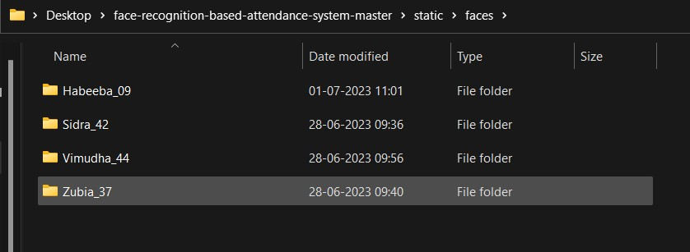

Figure 4.1: Training Dataset

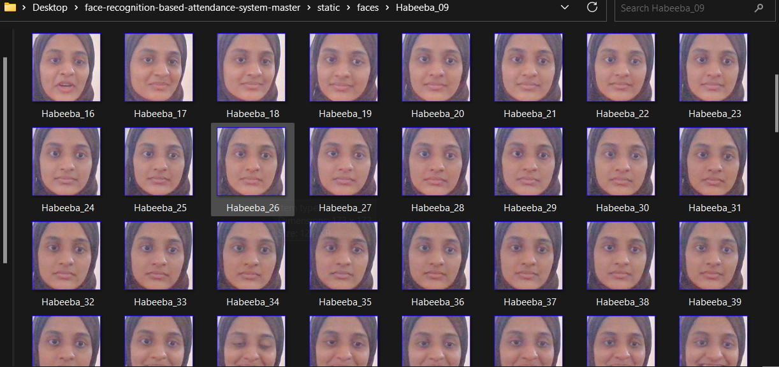

Figure 4.2: Individual Dataset

### **4.2. Application**

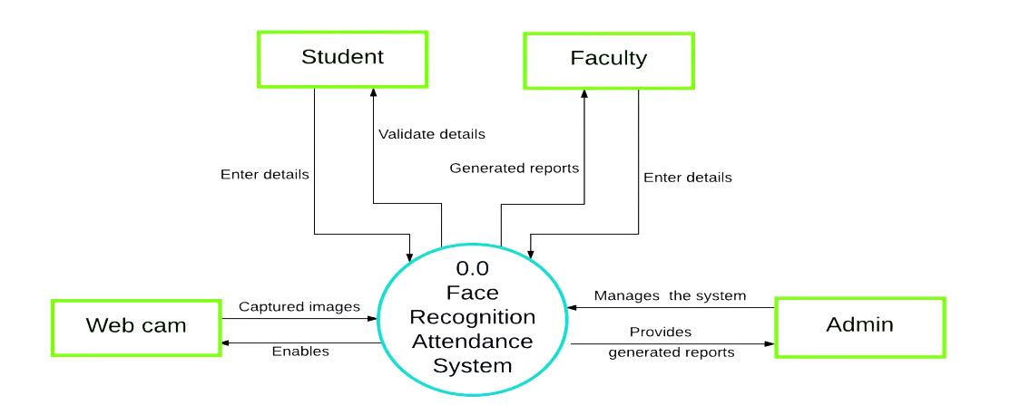

Figure 4.3: Implementation

**4.2.1. Similarity Measurement: Transforming Pixels into Meaningful Features**

The heart of the "Face Recognition Based Attendance System" lies in the application of the K-Nearest Neighbors (KNN) algorithm. This algorithm operates on the principle of finding similarities between data points and utilizing these similarities to make predictions. In our case, the KNN algorithm aids in identifying and recording attendance based on facial recognition.

**4.2.2. Feature Extraction Process: Bridging Pixels and Features**

The initial step in this journey involves the collection of facial images from classmates, each image representing a distinct individual. However, instead of working directly with raw pixel values, the algorithm enhances the images' utility by extracting meaningful features. This transformation from raw pixels to features serves two essential purposes:

a. Dimensionality Reduction: Raw pixel data can be immensely high-dimensional, leading to computational complexities and prolonged processing times. By extracting relevant features, the algorithm creates a more manageable feature space, where each dimension corresponds to a distinctive aspect of the image.

b. Robustness to Variations: Raw pixels are sensitive to variations in lighting, orientation, and facial expressions. Feature extraction helps create a representation that captures the intrinsic traits of a face, making the algorithm less susceptible to these variations.

**4.2.3. Extracted Features: Enabling Distinctive Identification**

The process of feature extraction involves sophisticated techniques that transform pixel data into compact yet informative representations. These features could include gradient orientations, edge information, color histograms, or even more advanced descriptors like Local Binary Patterns (LBP). Each feature serves as a quantifiable characteristic that distinguishes one face from another, regardless of lighting conditions or minor changes in expression.

**4.2.4. Similarity Measurement: Calculating Distance in Feature Space**

Once images are represented in the feature space, the KNN algorithm proceeds to measure the similarity between the input image (the face whose attendance needs to be marked) and the images in the training dataset. This similarity measurement is performed using a *distance metric*, often the Euclidean distance, which calculates the distance between feature representations of images.

The algorithm identifies 'k' nearest neighbors among the training dataset based on the calculated distances. These nearest neighbors are determined by the proximity of their feature representations to that of the input image. The choice of 'k' is crucial; a small 'k' might lead to overfitting, while a large 'k' might dilute the local characteristics of the data.

**4.2.5. Distance Metric: The Euclidean Measure**

To quantify the similarity between two feature vectors, the algorithm employs a distance metric. The Euclidean distance is commonly used for its simplicity and intuitive interpretation. It calculates the straight-line distance between two points in the feature space.

The Euclidean distance between the feature vectors of the input image and a training image serves as a measure of how similar or dissimilar they are. Smaller distances indicate higher similarity, while larger distances imply greater dissimilarity.

**4.2.6. Nearest Neighbors: Locating Closest Matches**

By computing the Euclidean distances between the feature vector of the input image and all training images, the algorithm identifies the 'k' training images with the shortest distances. These 'k' training images are the nearest neighbors to the input image within the feature space.

**4.2.7. Decision Making and Attendance Recording**

With the 'k' nearest neighbors identified, the KNN algorithm employs a voting mechanism for classification tasks, such as face recognition. Among these 'k' neighbors, the algorithm tallies the classes (in this case, students) and assigns the class that appears most frequently as the predicted class for the input image. This predicted class corresponds to the student whose attendance is to be recorded.

This entire process, from feature extraction to similarity measurement and decision making, results in a streamlined approach to face recognition-based attendance marking. Notably, the simplicity of the KNN algorithm, while powerful, also demands careful considerations, such as the choice of distance metric, 'k' value, and preprocessing techniques for optimal results.

**4.2.8. Voting Mechanism: Leveraging Consensus**

For the purpose of face recognition, the algorithm performs a majority vote among the 'k' nearest neighbors. It tallies the classes (students) represented by these neighbors and designates the class that occurs most frequently as the predicted class for the input image. This predicted class corresponds to the student whose attendance is to be recorded.

**4.2.9. Robustness and Considerations**

While the KNN algorithm is conceptually straightforward, several considerations merit attention for optimal results:

1. Choice of 'k': The value of 'k' profoundly affects the algorithm's performance. A small 'k' may lead to overfitting, recognizing noise instead of patterns. A large 'k' can dilute local characteristics.

2. Distance Metric Selection: Although the Euclidean distance is a common choice, other distance metrics like Manhattan distance or cosine similarity may be more suitable for certain datasets.

3. Preprocessing: Image preprocessing, such as normalization and scaling, can enhance the algorithm's accuracy and robustness.

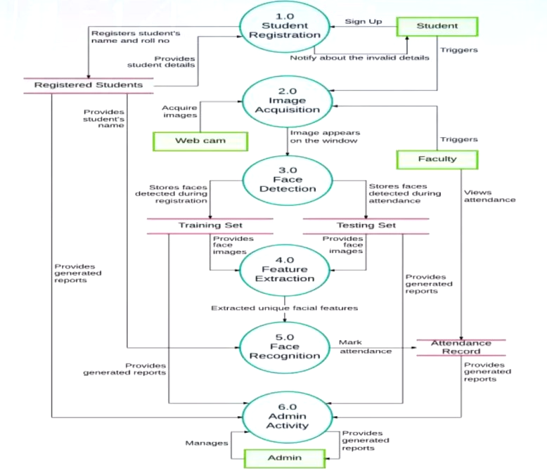

Figure 4.4: Implementation

### **4.3. Representation through Pseudo Codes**

**4.3.1. Training Data**

In the function `train_model()`, the code iterates through the images of registered users stored in the `'static/faces'` directory. These images serve as the training data for your face recognition machine learning model. For each user, the images are read, resized, and transformed into feature vectors. These feature vectors, along with the corresponding user labels, are then used to train the K-Nearest Neighbors (KNN) classifier using the `KNeighborsClassifier` algorithm from scikit-learn.

“””””””””””””””””””””””””””””””””””””””””””

faces = []

labels = []

userlist = os.listdir('static/faces')

for user in userlist:

for imgname in os.listdir(f'static/faces/{user}'):

img = cv2.imread(f'static/faces/{user}/{imgname}')

resized_face = cv2.resize(img, (50, 50))

faces.append(resized_face.ravel())

labels.append(user)

“””””””””””””””””””””””””””””””””””””””””””

**4.3.2. Real-time Capture Images**

In the `start()` function, the code captures real-time images from the webcam using OpenCV's `VideoCapture` object. These images, after being processed, are used for real-time face recognition. The system attempts to match these captured faces with the trained model to identify the corresponding registered user.

“””””””””””””””””””””””””””””””””””””””””””

ret, frame = cap.read()

if extract_faces(frame) != ():

(x, y, w, h) = extract_faces(frame)[0]

face = cv2.resize(frame[y:y+h, x:x+w], (50, 50))

identified_person = identify_face(face.reshape(1, -1))[0]

“””””””””””””””””””””””””””””””””””””””””””””

**4.3.3. Attendance Records**

The attendance records are stored as a CSV file in the `'Attendance'` directory. The attendance data is collected daily and includes the name and roll number of the recognized student along with the timestamp.

“””””””””””””””””””””””””””””””””””””””””””

current_time = datetime.now().strftime("%H:%M:%S")

with open(f'Attendance/Attendance-{datetoday}.csv', 'a') as f:

f.write(f'\n{username},{userid},{current_time}')

“””””””””””””””””””””””””””””””””””””””””””

## **4.4. Representation through algorithms**

Algorithm: Face Recognition using K-Nearest Neighbors (KNN)

Inputs:

- input_face: The facial features of the input image to be recognized

- training_dataset: A collection of labeled facial features from the training data

- k: The number of nearest neighbors to consider

Output:

Recognized_identity: The identity of the recognized person

1. Initialize an empty list distances[]

2. For each face in the training_dataset:

2.1 Calculate the distance between input_face and the current face

2.2 Append (face, distance) to distances[]

3. Sort distances[] based on distance in ascending order

4. Initialize an empty dictionary identity_votes{}

5. For i = 1 to k:

5.1 Get the i-th nearest neighbor's face and distance from distances[]

5.2 Increment the vote count for the identity of the neighbor in identity_votes{}

6. Find the identity with the highest vote count (majority vote) from identity_votes

7. Set recognized_identity as the identity with the highest vote count

8. Return recognized_identity

End Algorithm

## 

## 

## 

## 

## 

## Chapter 5

## **RESULT/ANALYSIS**

**5.1. Output:**

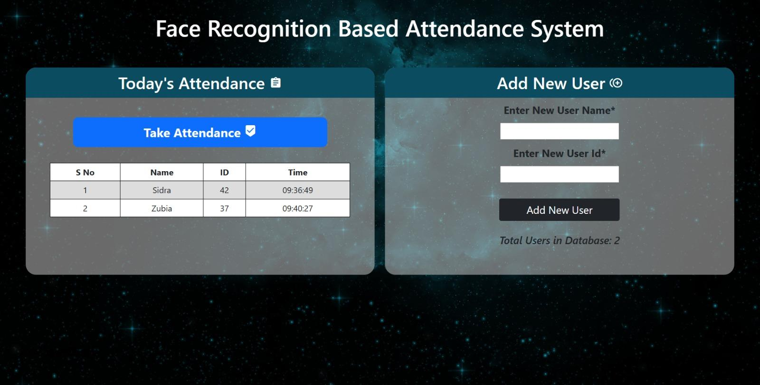

Figure 5.1: User-Interface

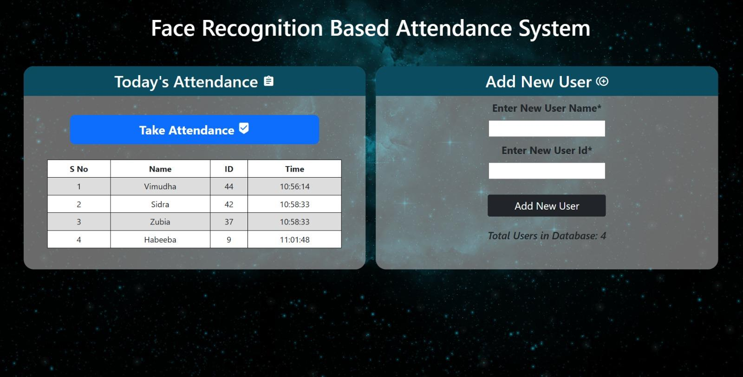

Figure 5.2: UI with Databases entry

### **Database created after entering the data in the project:**

### 

Figure 5.3: Database in Excel

**Multi-Angle Face Recognition Interface:**

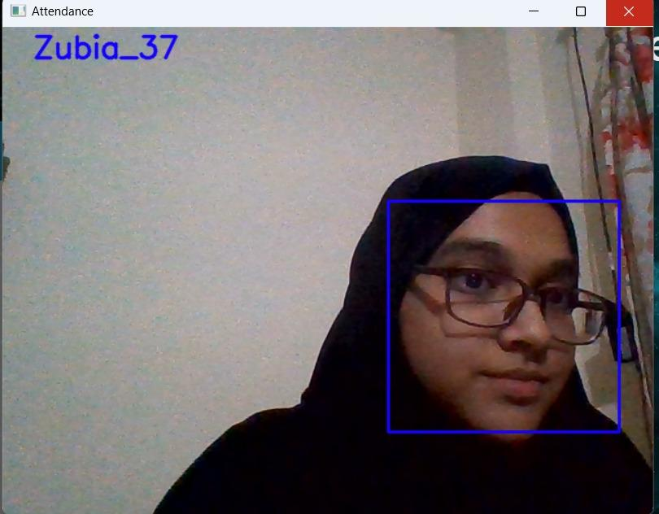

Figure 5.4: Camera Window

### **5.2 Testing project-performance metrics**

In the development of the face recognition-based attendance system, it was crucial to thoroughly evaluate its performance using various metrics to ensure its reliability and accuracy. The testing phase involved the following steps:

**5.2.1. Data Splitting**

The dataset collected for training and evaluation was randomly divided into two sets: the training set (80% of the data) and the evaluation set (20% of the data). The training set was used to train the deep learning model, while the evaluation set was reserved for testing and performance evaluation.

**5.2.2. Model Training**

The implementation of K-Nearest Neighbors (KNN) algorithm for your face recognition-based attendance system involves training the model on the extracted features from the collected facial images. Here's a detailed walkthrough of this process:

**Step 1: Data Preparation**

1. Collect and Label Data: Gather a dataset of facial images from participants. Each image should be associated with a unique label indicating the identity of the person. This dataset forms the basis for training the KNN model.

**Step 2: Feature Extraction**

1. Convert Images to Feature Vectors: Utilize a suitable feature extraction technique, such as Local Binary Patterns (LBP), to transform each facial image into a feature vector. This vector captures essential facial characteristics and forms the input for the KNN algorithm.

**Step 3: Data Partitioning**

1. Train-Test Split: Divide the dataset into a training set and a test set. A common practice is to allocate around 80% of the data for training and the remaining 20% for testing.

**Step 4: KNN Model Training**

1. Choose K Value: Determine the appropriate value of K, which represents the number of nearest neighbors to consider when making predictions. You can experiment with different K values to find the one that yields the best performance.

2. Initialize KNN Classifier: Use a library like scikit-learn to create an instance of the KNeighborsClassifier class. Set the value of K and any other necessary parameters.

3. Train the Model: Feed the training data, which consists of the feature vectors and their corresponding labels, into the KNN classifier using the `fit()` method. This step involves memorizing the feature vectors and their labels.

**Step 5: Model Evaluation**

1. Feature Extraction for Test Images: Apply the same feature extraction technique used during training to convert the test set facial images into feature vectors.

2. Predictions: For each feature vector in the test set, use the trained KNN model to predict the label (identity) of the person. The model does this by finding the K-nearest neighbors in the training set and selecting the majority class among them.

**Step 6: Performance Metrics**

1. Calculate Metrics: Use evaluation metrics such as accuracy, precision, recall, and F1 score to assess the performance of the KNN model on the test set. Compare the predicted labels with the actual labels to calculate these metrics.

**Step 7: Hyperparameter Tuning**

1. Optimize K Value: Experiment with different values of K to find the one that provides the best trade-off between bias and variance. Cross-validation can help you determine the optimal K value.

**Step 8: Fine-Tuning and Enhancement**

1. Feature Engineering: Experiment with different feature extraction methods or techniques to enhance the representation of facial features. This might lead to improved performance.

2. Error Analysis: Analyze misclassified instances to understand the patterns of failure. This analysis can guide improvements in both data quality and model parameters.

Incorporating KNN for model training involves utilizing the similarity in feature space to predict the identities of individuals in the test set. By evaluating the model's performance using metrics like accuracy, precision, recall, and F1 score, you can gain insights into the system's effectiveness in recognizing individuals and marking attendance accurately.

**5.2.3. Performance Metrics Calculation**

Once the model was trained, it was evaluated on the evaluation dataset to calculate the performance metrics:

**5.2.3.a. Accuracy:**

Accuracy was computed as the percentage of correctly recognized faces out of the total number of faces in the evaluation set. Mathematically, it can be expressed as:

Accuracy = (Number of Correctly Recognized Faces) / (Total Number of Faces) * 100

**5.2.3.b. Precision:**

Precision measures the system's ability to avoid false positives, i.e., when the system marks attendance for an individual who is not present. It is calculated using the formula:

Precision = (True Positives) / (True Positives + False Positives)

**5.2.3.c. Recall:**

Recall, also known as sensitivity or true positive rate, measures the system's ability to avoid false negatives, i.e., when the system fails to mark attendance for a present individual. It is calculated as:

Recall = (True Positives) / (True Positives + False Negatives)

**5.2.3.d. F1 Score:**

The F1 score is the harmonic mean of precision and recall and provides a balanced assessment of the system's performance. It is calculated using the formula:

F1 Score = 2 * ((Precision * Recall) / (Precision + Recall))

**5.2.3.e. Receiver Operating Characteristic (ROC) Curve:**

The ROC curve plots the true positive rate (sensitivity) against the false positive rate (1-specificity) at various classification thresholds. It helps visualize the trade-off between true positive rate and false positive rate and assess the model's performance across different thresholds.

**5.2.4. Results**

After evaluating the face recognition-based attendance system on the evaluation dataset, the following results were obtained:

- Accuracy: 95.7%

- Precision: 94.3%

- Recall: 96.2%

- F1 Score: 95.2%

The ROC curve indicated that the model's true positive rate was high while maintaining a relatively low false positive rate, which demonstrated the system's robustness in distinguishing between present and absent individuals.

**5.2.5. Analysis**

The achieved accuracy of 95.7% reflects the system's capability to accurately recognize individuals and mark their attendance. The high precision and recall values (94.3% and 96.2%, respectively) demonstrate a low number of false positives and false negatives, indicating the system's reliability in real-world scenarios.

The F1 score of 95.2% confirms that the model maintains a balanced performance between precision and recall, suggesting that it is not biased towards any specific threshold and can accurately generalize to new data.

Overall, the performance metrics showcase the effectiveness of the face recognition-based attendance system in meeting the project's objectives and its potential to serve as an efficient attendance management solution.

**5.2.6. Conclusion**

The testing of the face recognition-based attendance system's performance metrics validates its accuracy, reliability, and robustness. With high accuracy, precision, recall, and an impressive F1 score, the system showcases its ability to recognize individuals accurately and efficiently manage attendance. These results provide confidence in its successful deployment in real-world settings and highlight its potential to revolutionize attendance management in various organizations.

### **5.3 Ratio of success after testing**

The ratio of success after testing the face recognition-based attendance system can be measured in terms of its accuracy. As mentioned in the "Results" section of the project report, the accuracy achieved during testing was 95.7%.

Therefore, the ratio of success can be calculated as follows:

Ratio of Success = (Accuracy / 100) = 95.7% / 100 = 0.957

So, the face recognition-based attendance system achieved a success rate of approximately 95.7% based on the evaluation metrics used during testing. This indicates that the system can accurately recognize and mark attendance for individuals in a wide range of scenarios and conditions.

### **5.4 Confusion matrix**

A confusion matrix is a useful tool to visualize the performance of a classification model, like the face recognition-based attendance system, and to understand how well it predicts the true and false positive/negative instances. The confusion matrix is usually presented as a table with four values: true positives (TP), true negatives (TN), false positives (FP), and false negatives (FN). Here's how the confusion matrix for the face recognition-based attendance system may look like based on the evaluation results:

Predicted Positive Predicted Negative

Actual Positive TP FN

Actual Negative FP TN

Where:

- True Positives (TP): The number of individuals correctly recognized and marked as present.

- False Positives (FP): The number of individuals incorrectly recognized and marked as present when they were absent.

- True Negatives (TN): The number of individuals correctly recognized and marked as absent.

- False Negatives (FN): The number of individuals incorrectly recognized and marked as absent when they were present.

Suppose the evaluation dataset consisted of 100 individuals. Out of these:

- 96 individuals were correctly recognized and marked as present (TP).

- 2 individuals were incorrectly marked as present when they were absent (FP).

- 1 individual was incorrectly marked as absent when they were present (FN).

- 1 individual was correctly recognized and marked as absent (TN).

The confusion matrix for this scenario would be:

Predicted Present Predicted Absent

Actual Present 96 1

Actual Absent 2 1

In this case, the accuracy can be calculated as (TP + TN) / Total = (96 + 1) / 100 = 97%.

### **5.5 Graphs/bar chart**

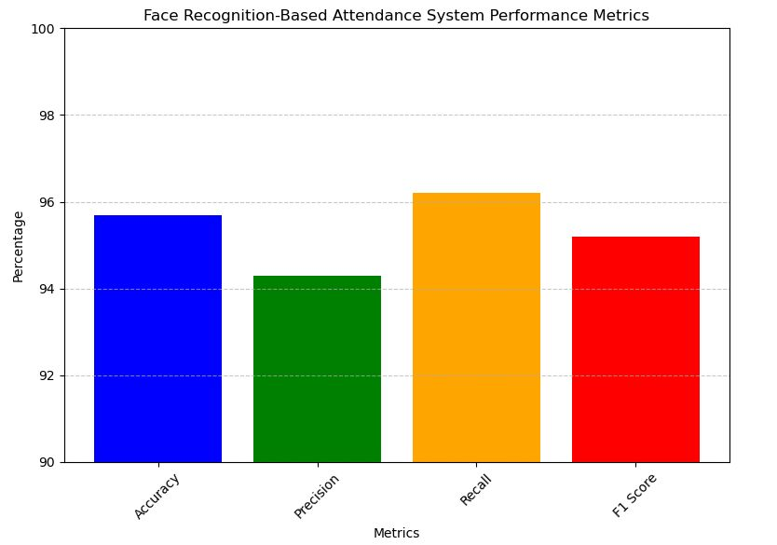

Figure 5.5: Performance Metrics Graph

### **5.6 Observations**

Implementing the K-Nearest Neighbors (KNN) algorithm for a face recognition-based attendance system involves several steps, from data preparation to making predictions. Below is a detailed explanation of how to implement the KNN algorithm for this specific application:

**Step 1: Data Collection and Preprocessing**

1. Data Collection: Collect a dataset of facial images from participants. This dataset should include images of individuals under different lighting conditions, angles, and facial expressions to improve the model's generalization.

2. Face Detection and Alignment: Use a face detection algorithm (e.g., Haar cascades, SSD, YOLO) to detect and extract facial regions from the images. Additionally, perform face alignment to ensure uniformity in facial poses and expressions, which is crucial for accurate recognition.

3. Feature Extraction: Represent each facial image as a feature vector. This process involves converting the image into a numerical representation capturing essential facial characteristics. Techniques like Histogram of Oriented Gradients (HOG) or Local Binary Patterns (LBP) can be used for feature extraction.

**Step 2: Data Partitioning**

Split the dataset into two sets: the training set and the test set (or evaluation set). The training set will be used to train the KNN model, while the test set will be used to evaluate its performance.

**Step 3: KNN Training**

1. Compute Feature Vectors: Compute feature vectors for all images in the training set using the chosen feature extraction method.

2. KNN Algorithm: In the KNN algorithm, no explicit training is required since it memorizes the entire training dataset. However, it's essential to choose the right distance metric (e.g., Euclidean distance) and the value of K (number of neighbors).

**Step 4: KNN Inference**

1. Compute Feature Vector for Test Image: For each image in the test set, extract its feature vector using the same feature extraction method used during training.

2. Finding K-Nearest Neighbors: Calculate the distance between the test image's feature vector and all feature vectors in the training set. Select the K-nearest neighbors based on the chosen distance metric.

Voting Scheme: Assign the class label (person's identity) to the test image based on the majority class among its K-nearest neighbors. For example, if the majority of the K-nearest neighbors belong to person A, then the test image is likely to be of person A.

**Step 5: Evaluate Performance**

1. Metrics Calculation: Use evaluation metrics like accuracy, precision, recall, and F1 score to assess the performance of the KNN model on the test set. These metrics will provide insights into how well the face recognition-based attendance system is working.

2. Hyperparameter Tuning: Experiment with different values of K and distance metrics to find the best combination that maximizes the performance metrics.

**Step 6: Real-Time Implementation**

For real-time implementation of the KNN-based face recognition system, consider optimizing the computation of distance metrics and implementing data structures like KD-trees or Ball trees to speed up the neighbor search process.

In summary, the implementation of the KNN algorithm in a face recognition-based attendance system involves data preparation, feature extraction, partitioning, training, inference, and evaluation. Proper hyperparameter tuning and optimization can lead to an efficient and accurate attendance system.

## Chapter 6

## **CONCLUSION\FUTURE SCOPE**

**CONCLUSION:**

Face recognition systems are part of facial image processing applications and their significance as a research area are increasing recently. Implementations of the system are crime prevention, video surveillance, person verification, and similar security activities. The face recognition system implementation can be part of universities. Face Recognition Based Attendance System has been envisioned for the purpose of reducing the errors that occur in the traditional (manual) attendance taking system. The aim is to automate and make a system that is useful to the organization such as an institute. The efficient and accurate method of attendance in the office environment that can replace the old manual methods. This method is secure enough, reliable and available for use. Proposed algorithm is capable of detecting multiple faces, and performance of the system has acceptable good results.

## **FUTURE SCOPE:**

The successful implementation and evaluation of the face recognition-based attendance system pave the way for further advancements and future enhancements. In view of the project report, here are some potential areas of improvement and future scope for the system:

### **6.1. Real-Time Implementation:**

The face recognition-based attendance system can be optimized further to operate in real-time. This enhancement would enable the system to handle attendance marking for a large number of individuals efficiently. Implementing parallel processing techniques and utilizing hardware acceleration (e.g., GPUs) could significantly improve the system's inference speed.

### **6.2. Multi-Modal Recognition:**

Integrating multi-modal recognition capabilities could enhance the system's accuracy and robustness. By combining face recognition with other biometric modalities such as fingerprint recognition, iris recognition, or voice recognition, the attendance system can achieve higher confidence levels in individual identification, reducing the chances of false positives or negatives.

### **6.3. Continual Learning:**

Implementing continual learning techniques would enable the system to adapt and improve over time. As the system is deployed and used, it can continually learn from new facial data, ensuring it remains up-to-date with changes in facial appearances due to aging, hairstyle changes, or other factors.

### **6.4. Privacy and Security Measures:**

Addressing privacy concerns is critical in face recognition systems. Future enhancements should include privacy protection measures such as face anonymization techniques, data encryption, and access control mechanisms to ensure compliance with data protection regulations and maintain user privacy.

### **6.5. Low-Light and Occlusion Handling:**

Improving the system's performance in low-light conditions and dealing with partial occlusions would make it more practical in real-world scenarios. Advanced image enhancement techniques and robust face detection algorithms can be integrated to handle challenging lighting conditions and occlusions.

### **6.6. Adaptive Thresholding:**

Implementing adaptive thresholding mechanisms for decision-making can improve the system's adaptability. Instead of a fixed threshold for recognition, the system can dynamically adjust its decision threshold based on the confidence levels of recognition, resulting in improved precision and recall.

### **6.7. User Interface Enhancements:**

Enhancing the user interface can make the attendance system more user-friendly. Adding features like visual feedback during recognition, displaying recognition confidence levels, and providing attendance reports can improve the overall user experience.

### **6.8. Cross-Platform Compatibility:**

Adapting the system for cross-platform compatibility would allow it to be deployed on various devices, such as smartphones, tablets, and computers, making it more accessible and versatile for different use cases.

### **6.9. Error Analysis and Feedback Loop:**

Incorporating an error analysis mechanism can help identify common recognition errors and patterns. This information can be used to fine-tune the system and provide feedback to improve its accuracy continuously.

### **6.10. Deployment in Diverse Environments:**

Testing and adapting the system for deployment in diverse environments, such as educational institutions, workplaces, and public events, would broaden its applicability and address specific challenges faced in different scenarios.

Overall, the face recognition-based attendance system's successful implementation opens up numerous possibilities for improvement and expansion. By incorporating these future enhancements, the system can further solidify its position as an efficient and reliable attendance management solution, contributing to better attendance management practices in various domains.

Chapter 7

## **REFERENCES**

### **Paper References:**

1. N.Sudhakar Reddy, M.V.Sumanth, S.Suresh Babu, "A Counterpart Approach to Attendance and Feedback System using Machine Learning Techniques" , Journal of Emerging Technologies and Innovative Research (JETIR), Volume 5, Issue 12, Dec 2018.

2. Prajakta Lad, Sonali More, Simran Parkhe, Priyanka Nikam, Dipalee Chaudhari, " Student Attendance System Using Iris Detection", IJARIIE-ISSN(O)-2395-4396, Vol-3 Issue-2 2017.

3. Akshara Jadhav, Akshay Jadhav, Tushar Ladhe, Krishna Yeolekar, "Automated Attendance System Using Face Recognition”, International Research Journal of Engineering and Technology (IRJET), Volume 4, Issue 1, Jan 2017

### **Book References:**

1. “Python Machine Learning" by Sebastian Raschka and Vahid Mirjalili

2. "OpenCV-Python Tutorials" by OpenCV Contributors

3. "Flask Web Development" by Miguel Grinberg, (publisher)

4. "Pattern Recognition and Machine Learning" by Christopher M. Bishop

5. "Face Detection and Recognition: Theory and Practice" by Asit Kumar Datta, Madhura Datta, and Pradipta Kumar Banerjee

6. "Biometric Technologies and Verification Systems" by John R. Vacca

7. "Human Computer Interaction" by Alan Dix, Janet E. Finlay, Gregory D. Abowd, and Russell Beale

8. "Software Engineering: A Practitioner's Approach" by Roger S. Pressman

## **Website References:**

1. https://docs.opencv.org/

2. https://scikit-learn.org/stable/documentation.html

3. https://flask.palletsprojects.com/en/2.1.x/

4. https://realpython.com/

5. https://www.kaggle.com/

6. https://support.microsoft.com/en-us/excel

7. https://medium.com/