Literature Review

David Kelly B00060572



The effect of fantasy sport

participation through social media

27/11/2014

**Contents**

**1.0 Abstract** ………………………………………………… 3

**2.0 Introduction** ………………………………………………… 4

2.1 General Topic .…………………………………………. 4

2.2 Existing Trends ...………………………………………. 4

2.3 Reason for Literature Review .…………………………. 4

**3.0 Literature Review** ..………………………………………… 5

3.1 Identification and Loyalty ..……………………………. 5

3.2 Consumption. .…………………………………………. 5

3.3 Attitudes and Behavior ...………………………………. 6

3.4 Research Paper Conclusion ……………………………. 6

3.5 Facebook ………………………………………………. 7

3.6 Twitter …………………………………………………. 8

3.7 YouTube ...……………………………………………... 8

3.8 Research Paper Conclusion ……………………………. 9

**4.0 Research Paper Connection** ……….…………………… 9

**5.0 Gaps in Research Papers** ……….…………………… 10

**6.0 Literature Review Conclusion** ……….…………………… 10

**7.0 References** ………………………...….…………………… 11

**1.0 Abstract**

The purpose of this literature review is to analyze data gathered from two research papers. The research papers titled, “The effects of fantasy football participation on NFL (National Football League) consumption: A qualitative analysis” and “Using Social Media to Build Community” are two I have chosen that connect to a current project I am working on that will implement a fantasy hurling game with social media capabilities.

The first paper reviewed is “The effects of fantasy football participation on NFL (National Football League) consumption: A qualitative analysis”, this paper exams a fantasy football gamers interaction with the NFL and how that interaction is altered by the participation in the fantasy game. A fantasy gamers experiences is altered from that of a normal spectator. A fantasy gamer consumes more information, changes their allegiance with their favorite team and interacts with their game differently depending on how their fantasy team is performing.

The second paper reviewed is, “Using Social Media to Build Community”, this paper explores what is necessary to create a successful online social community. Three large insurance firms in America are examined and their social media outlets researched to discover what makes a functioning social media community.

The social media accounts that are examined are Facebook, Twitter and YouTube. The findings show that companies that promote comments, feedback, engagement in applications and videos have larger more involved communities.

Finally the data gathered from the research papers are critiqued and parallels are drawn to show the connection of both studies.**2.0 Introduction**

2.1 General Topic

Sport spectatorship is one of the largest forms of leisure behavior in the world [1]. Large numbers of sports fans attend sporting events frequently and follow their sport ubiquitously through various mediums, TV, radio, newspapers, and magazines. With advancements in Internet technologies, fans are redirecting their consumption of sport to online platforms. Sports fans can now consume news and content via applications and social media on mobile devices. Fans can connect with each other through tweets, texts, blogs and Facebook.

Fantasy sport participation is not a new phenomenon; the history of fantasy sport is a topic of debate. In America the formation of a fantasy baseball league in the 1960’s by a man called Bill Gamson is considered to be the first documented account of a fantasy league [2].

Today the exponential growth of fantasy sports participation is fuelled by the increased televised broadcasting of sport, accessibility of sport and statistics on the Internet and the advent of social media as a communication outlet for fans worldwide, because of this, fantasy sport platforms are now formally aligned with many official major sporting leagues globally.

Fantasy sport provides engaged fans a unique and personal opportunity to be involved while also building the interest and knowledge of new participants with lower prior involvement. Further, fantasy sport provides additional social interaction between players. It can serve as an education tool about the sport, teams and players and can also serve to increase the commitment and interaction of consumers with a sport.

2.2 Existing Trends

In North America and Canada the fantasy sports industry has a body that monitors and provides information on all fantasy sports websites known as the Fantasy Sports Trade Association (FSTA) [3]. The FSTA released figures on the number of participants in 2011, more than 35.9 million users are involved in some type of fantasy sport. The FSTA then surveyed the group to find out how many users participate using mobile devices. The survey found that 30% (12,000,000) of users are engaging through mobile devices. Further, of the 12,000,000 users that play through mobile devices 14% (1,680,000) use social media to discuss their fantasy games.

|  |  |  |  |
| --- | --- | --- | --- |
|  | Members | Mobile Users | Social Media Users |
| BPL | > 3,000,000 | 900,000 | 125,000 |
| FSTA | >35,900,000 | 12,000,000 | 1,680,000 |

The Barclays Premier League (BPL) claims to have the biggest football fantasy game in the world [4]. The Fantasy Premier League game has over 3,000,000 participants. If we apply the same calculations from FSTA to the Fantasy Premier League game we can get an estimate value of over 125,000 users that discuss their fantasy football game via social media.

2.3 Reason for Literature Review

This literature review is being conducted to ensure a thorough understanding of the connection between social media communities and fantasy gaming. I am currently working on a project that is combining a fantasy-hurling platform that enables social media capabilities.

Upon completion of this literature review I hope to identify potential areas of difficulty that may be unforeseen with out specific research in to the topic of social media and fantasy gaming.

**3.0 Literature Review**

Joris Drayer, Stephen L. Shapiro, Brendan Dwyer, Alan L. Morse, Joel White. (2010).

“The effects of fantasy football participation on NFL (National Football League) consumption: A qualitative analysis”. *Sport Management Review, 13*, 129-141. [5]

Drayer, Shapiro, Dwyer, Morse and White proposed three areas of interaction that may be affected for fantasy football users and non-fantasy football users.

1. Identification and loyalty
2. Consumption
3. Attitudes and behavior

3.1 Identification and loyalty

To conduct a test on the fantasy gaming NFL fans, the authors must first define a norm. A fan that does not participate in fantasy football and the attributes of one such fan. A normal fan is considered to have allegiance to one team. The normal fan supports the team and the players that play for their team and no one else.

The authors expected gamers to have no loyalty or identification to a certain team, but rather have identification to a player. This was not the case, gamers still identified themselves with a team but their affiliation to other players via the fantasy game was just an extension.

Those interviewed stated that their loyalty to a fantasy player ended with the season.

Only 2 people of the 13 interviewed said that they carried affinity for a player in to the next season and rooted for them if their favorite team wasn’t playing.

3.2 Consumption

To conduct this test the authors once again had to define a norm. A normal fan is one that only consumes information about their favorite team.

The authors expected gamers to consume NFL information in a different manor. Having affiliation with many players in many different teams leads to greater consumption of information.

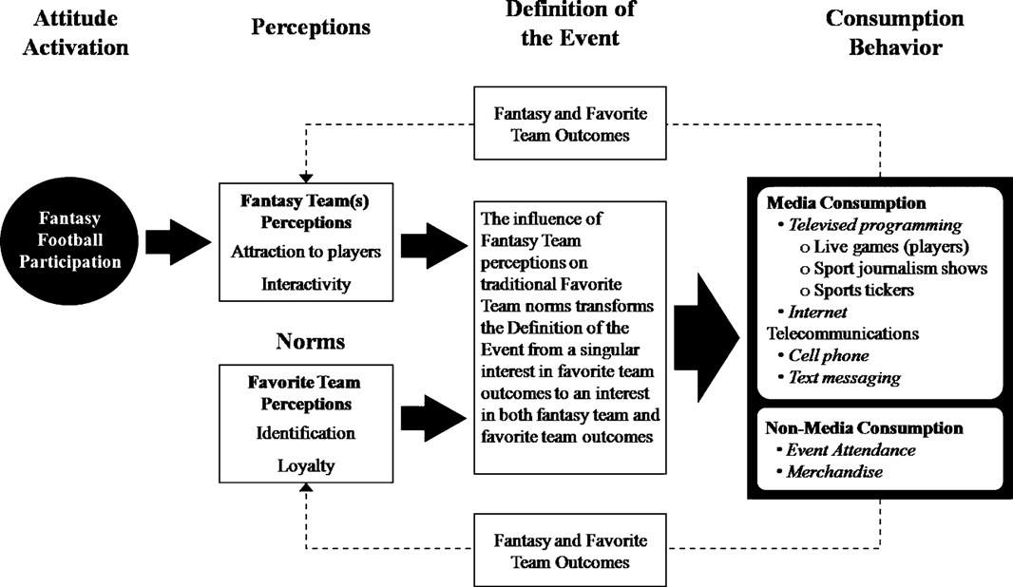

Fantasy gamers have an increased media consumption of the NFL, spending time on the Internet and watching ESPN to gain information on starting rosters, injured players and to check which teams are playing in game weeks. Of those surveyed participants admitted to checking their mobile device and going on to the Internet every 10 minutes while a game is on. Some gamers paid for subscription sites to get informed advice on their fantasy teams. Fantasy football participants found themselves watching more matches on game weeks because they had numerous players playing in different games. When asked if they would watch as many games if not playing the fantasy football game, the answer was no.

No change was noted in the form of consumerism. Only one person said they would buy the jersey of a player because she began to like him in her fantasy team.

3.3 Attitudes and behavior

The control norm for this test was that of a fan, who regardless of their favorite teams result would support them.

The results found in the survey suggested that a fantasy football player would have allegiance for a team but if that team lost, the fantasy football player would adjust their attitude towards a real team to suit their fantasy game. When the 13 fantasy gamers were asked about their behavior towards an opposing player, 2 gamers admitted to supporting opposing players of their favorite team.

Those interviewed stated that if their fantasy football team began to lose and become uncompetitive they would lose interest and stop updating their team towards the end of the season.

3.4 Research Paper Conclusion

The research results show that fantasy gaming participation really does have an effect on how fans, consume, interact, behave and identify themselves with teams. A non-fantasy gamer does not consume as much information over a broad scale but rather focuses solely on their favorite team. With fantasy gamers this is not the case. Fantasy gamers spend more time online, on blogs, sports news websites, social media, TV, magazines trying to get information on their fantasy team. Fantasy gamers tend to be more fickle in their allegiance to a team and player, favoring and supporting teams and players that can generate points for them in their fantasy league.

Kurt Komaromi, Scott Erickson (2011).

“Using Social Media to Build Community”, *Competition Forum,* *October 27-29*, 325-333. [6]

Komaromi and Erickson follow a template laid out by Culnan, McHugh and Zubillaga that assesses the effectiveness of an organizations social media strategy. Effective implementation of a social media strategy is one that attracts an audience enabling them to engage and interact with both the organization and each other.

Although the study is not conducted on a sports category, the essential requirements for a successful social media community apply in all communities. The study instead researches 18 insurance firms over a two-month period in 2011. The authors then present specific results for three firms that display a range of social media outlets to support a community.

The three insurance companies presented are, Progressive, Liberty Mutual and State Farm. The study begins by analyzing the companies website homepages. The homepages all display a range of tools that allow customers to interact by getting quotes, mobile apps, price comparisons and calculations for various insurance plans. What is important on all these homepages is the prominence of social media resources. All three websites have social media icons to connect via Twitter, Facebook and YouTube. Liberty Mutual is the only site that has a LinkedIn page that allows customer access. State Farm has an additional social media outlet through Flickr.

Metrics for each homepage visit can be seen in the graph below. Progressive has the highest unique visit rate at over 4 million visits per month. State Farm is second with 2.5 million and Liberty Mutual is third with 1 million unique visits.

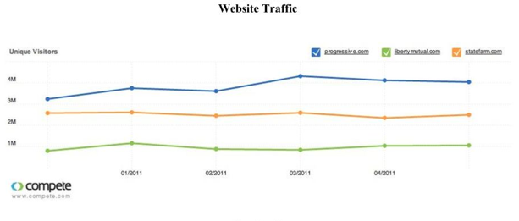

3.5 Facebook

Facebook is the first social media outlet covered in the findings. All three insurance companies are present on Facebook.

Progressive have a Facebook page that primarily provides information about the company, offers and customer feedback. Progressive also have a current marketing campaign that attracts the most followers of the three companies Facebook accounts. “Flo” is the name of that marketing campaign and has a Facebook account that is updated daily and has interactive videos and games to engage customers. At the time of research, Progressive has a following of over 2.5 million on their Facebook accounts.

The Liberty Mutual Facebook page is similar to Progressive, They have an about section to provide information about the company. Further Liberty Mutual has videos, comments, polls and games on their page to engage customers. Their Facebook wall has daily posts from employees and brokers that can be interacted with by visitors via likes and comments.

State Farm’s Facebook page offers a diverse content including offers, promotions, sponsorships for social causes, games to rate drivers and apps that can be played with friends. The site also has a driving game application to complete a safe driving discount offer. Their wall has many comments both by State Farm and visitors.

|  |  |  |  |
| --- | --- | --- | --- |
|  | Progressive | Liberty Mutual | State Farm |
| Facebook | ~2,500,000 followers | ~10,000 followers | ~90,000 followers |

Although Progressive have an advantage with a larger hold on the market, the evidence is clear that an updated and well-maintained Facebook page that interacts with visitors gathers more followers. State Farm has a large number of followers because they engage their visitors with apps, polls, videos and respond to comments daily.

3.6 Twitter

Twitter is the second social media outlet researched in the report. All three insurance companies have an active twitter presence.

Progressive utilize twitter to connect with customers with posts daily and responding to complaints, questions and criticism. Progressives Twitter account post basic answers to very common customer questions in a timely basis.

The Liberty Mutual Twitter account is active once or twice a day. Their Twitter account is used to promote news and answer questions from customers. Liberty Mutual also use their Twitter account to promote sponsorship activities and encouraging followers to attend social events.

State Farm populates their Twitter feed with posts daily, ranging from comments, questions, complaints, and re-tweets from other third party sources. The emphasis is on responding to customer queries. State Farm is more concerned with customer comments and feedback than Liberty Mutual and Progressive. State Farm shares a lot of content from their other social media sites through twitter, connecting their Facebook, YouTube and Flickr accounts.

|  |  |  |  |
| --- | --- | --- | --- |
|  | Progressive | Liberty Mutual | State Farm |
| Twitter | ~7000 followers | ~2500 followers | ~30,000 followers |

3.7 YouTube

YouTube is the third and final social media outlet researched in this paper. All three insurance companies again utilize YouTube as a connection tool to their customers.

Progressive don’t only use their YouTube account as a video player but also implement a quote app link and link to their other social media outlets. The site has adverts, promotions and visitor uploads. Progressive had 97 videos uploaded to their account at the time of research and the comments section on their YouTube channel is very active with over 400 comments.

Liberty Mutual has 31 videos uploaded to their YouTube account, providing both advertising and more in-depth information. Liberty Mutual does not update or maintain their YouTube account frequently with only a hand full of comments on their account page.

State Farm has the most amount of content on their YouTube account, with over 180 videos at the time of research. State Farms videos range from adverts, promotion offers, to custom content. Fail Fridays is a popular video series that compares customer reasons for claiming insurance. State Farm also provides instructional videos to prevent accidents. Comments are extensive across all their videos and a find-an-agent app is available.

|  |  |  |  |
| --- | --- | --- | --- |
|  | Progressive | Liberty Mutual | State Farm |
| YouTube | ~2,000,000 followers | ~250,000 followers | ~3,000,000 followers |

3.8 Research Paper Conclusion

Social media connections to customers are of huge importance to building a community around a product. The statistical analysis of three insurance firms provides evidence of such a statement. State Farm update their social media accounts more frequently than the other two firms as a result the community surrounding State Farm is larger and engages more with the company. State Farm makes it important to respond and interact with followers daily and update followers with relevant information regarding their industry and company.

**4.0 Research Paper Connection**

Although the topics in both research papers are very different, the ubiquitous nature of social media is the connection. Taking advantage of social media to connect fantasy sport gamers and allow them to share their information is easier said than done. In order to understand the best methods of engaging fantasy sport fans and encourage them to use social media as a platform to create and interact with a community is the problem.

The first paper reviewed states that fantasy sports gamers clearly consume information at a higher level than that of a normal spectator. Fantasy sports gamers gather more information regarding a their sport through magazines, TV, radio, blogs and online. A part of making the transition to social media is by creating a community where user content is updated and fans can interact with one another, sharing information, tactics, statistics and analysis.

The second paper reviewed contains data and an analysis of social media communities that already exist. This data gives an insight in to how a social media community works.

State Farm take advantage of their social media presence more than the other two firms. The number of followers proves that maintaining a regular social media presence attracts followers. Having a Facebook page and Twitter account is essential to connecting with an online community. All three firms in the research paper use these social media outlets regularly to post comments and just as importantly to receive questions, input and criticism.

**5.0 Gaps in Research Papers**

After doing research external of this literary review I would like to draw attention to some gaps that I feel exist in both research papers. Although the connection between the two papers is very real and an outlet for fantasy sport gamer discussion can be managed in a social media platform, questions must be asked about the data analyzed.

The research paper by, Joris Drayer, Stephen L. Shapiro, Brendan Dwyer, Alan L. Morse, Joel White. **“The effects of fantasy football participation on NFL (National Football League) consumption: A qualitative analysis”** is a research paper about fantasy football in America and not sports globally, including hurling. Questions about a fantasy sports player consumption of information must be asked in order to get a complete view of the fantasy sport industry.

* Do all fantasy sports players consume more information about their sport than that of a normal fan?
* Do fantasy sports games accommodate gamer interaction?

The survey documented in the research paper reports on only 13 test users. The information could be incorrect or corrupted by such a small number of test users.

Kurt Komaromi, Scott Erickson. **“Using Social Media to Build Community”** researched the social communities surrounding three large insurance firms in America. The data gathered in this research paper is informative and formidable but questions still exist in the form below.

* Can the social community of an insurance firm be relevant to that of a fantasy sport community?
* How do insurance customers differ from fantasy sports gamers?
* Have all forms of social media been researched?

**6.0 Literature Review Conclusion**

It appears that fantasy sports gamers may consume information and data of their sport on a different level to that of a normal fan. Fantasy sports fans follow a greater number of players and teams connected to their fantasy game. A platform to cater for an online community of gamers could exist to allow gamers to share information with fellow gamers. Fantasy gamers spend more time on mobile devices during games and between game weeks researching real life player and team data.

Fantasy players can still identify themselves normally with one team but can also extend their identification to a number of other teams during the season. Gamers however have a tendency to lose interest in their fantasy games if their fantasy team is performing poorly or their real life favorite team is performing well.

Social media communities flourish when content is updated regularly and interaction between community members is high. Building a social community takes many platforms through YouTube, Facebook and Twitter. Connecting social media outlets together such as linking videos on Twitter to videos on YouTube engages the community to interact within itself.

Having platforms high in content produced by community such as comments and questions creates a larger following. Users tend not to follow social media outlets that rarely post content. The insurance company with the smallest amount of content on social media platforms had the fewest number of followers. The insurance company that had the largest amount of content, videos, posts, tweets and applications had the largest number of followers. The connection between a maintained up to date social media presence directly relates to the number of followers in the community.

**7.0 References**

* [1] Ann Pegoraro. (2013). Sport Fandom in the Digital World. In: Paul M. Pederson *Routledge Handbook of Sport Cummunication*. USA: Routledge. p248-257.
* [2] Brody J. Ruihley, Robin L. Hardin. (2013). Focus On Fantasy (an overview of fantasy sport consumption). In: Paul M. Pederson *Routledge Handbook of Sport Cummunication*. USA: Routledge. p269-277.
* [3] Industry Demographics - Fantasy Sports Trade Association. 2014. *Industry Demographics - Fantasy Sports Trade Association*. [ONLINE] Available at: <http://www.fsta.org/?page=Demographics>. [Accessed 21 November 2014].
* [4] Fantasy Premier League - The official fantasy football game of the Barclays Premier League. 2014. *Fantasy Premier League - The official fantasy football game of the Barclays Premier League*. [ONLINE] Available at: <http://fantasy.premierleague.com/>. [Accessed 21 November 2014].
* [5] Joris Drayer, Stephen L. Shapiro, Brendan Dwyer, Alan L. Morse, Joel White. (2010). “The effects of fantasy football participation on NFL (National Football League) consumption: A qualitative analysis”. *Sport Management Review, 13*, 129-141.
* [6] Kurt Komaromi, Scott Erickson (2011). “Using Social Media to Build Community”, *Competition Forum,* *October 27-29*, 325-333.