**Appendix C: Code Listing: Hurling Web API**

**HurlingModel.Context.cs**



**IEntitiy.cs**



**Entity.cs**







**IRepository.cs**



**FantasyHurlingRepository**





**Repository Models**



Figure 1 Repository Models Classes

**League.cs**



**Position.cs**



**Team.cs**



**Player.cs**



**User.cs**



**Message.cs**



**Model DTOs**

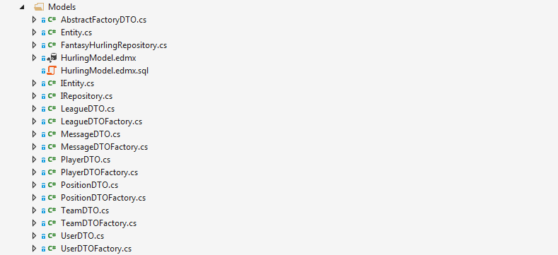

Figure 2Models Classes

**AbstractFactoryDTO.cs**



**TeamDTO.cs**



**TeamDTOFactory.cs**



**LeagueDTO.cs**



**LeagueDTOFactory.cs**



**MessageDTO.cs**



**MessageDTOFactory.cs**



**UserDTO.cs**



**UserDTOFactory.cs**



**PlayerDTO.cs**



**PlayerDTOFactory.cs**



**PositionDTO.cs**



**PositionDTOFactory.cs**



**Controllers**

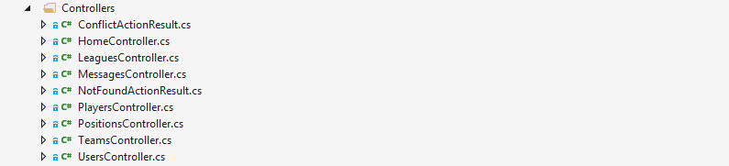

**ConflictActionResult.cs**



**HomeController.cs**



**LeagueController.cs**









**MessagesController.cs**







**NotFoundActionResult.cs**



**PlayersController.cs**









**PositionsController.cs**











**TeamsController.cs**

















**UsersController.cs**









