**Project 2**

**Analyzing the Floyd - Warshall algorithm**

CSE 5211: Analysis of Algorithms

Dr. William Shoaff

**Zubin Kadva**

Table of Contents

1. Problem Description 1

2. Known algorithms 1

3. The shortest path problem 1

4. A historical perspective 2

5. Algorithm description 2

5.1. A recursive solution 3

5.2. Matrix representation 5

6. Implementation 6

7. Generating random data 7

8. Analysis 9

9. Graphs 10

9.1. Execution Time 10

9.2. Memory consumption 12

9.3. Average performance 13

10. References and tools 14

# 1. Problem Description

The main purpose of this project is to analyse the Floyd-Warshall algorithm used to find the shortest path in a weighted graph with positive or negative edges, but no negative cycles. A shortest path problem is the problem of finding the path between two nodes in a graph such that the sum of the weights of its edges is minimized.

# 2. Known algorithms

The most important algorithms for solving this problem are:

* Dijkstra's algorithm
* Bellman – Ford algorithm
* A* search algorithm
* Floyd – Warshall algorithm
* Johnson's algorithm
* Viterbi algorithm

# 3. The shortest path problem

Two vertices are adjacent when they are both incident to a common edge. A path in an undirected graph is a sequence of vertices

$P=\left(v_{1},v_{2},{…,v}_{n}\right)∈V ×V×… ×V$

such that $v_{i}$ is adjacent to $v_{i+1}$ for $1≤i<n$. Such a path $P$ is called a path of length $n-1$ from $v_{1}$ to ${ v}_{n}$.

Let $e_{i,j}$ be the edge incident to both $v_{i}$ and $v_{j}$. Given a real-valued weight function $:E→R$, and an undirected (simple) graph $G$, the shortest path from $v$ to $v'$ is the path $P=\left(v_{1},v_{2},{…,v}_{n}\right)$ (where $v_{1}=v$ and $v_{n}=v'$ that over all possible $n$ minimizes the sum

$\sum_{i=1}^{n-1}{f(e_{i, i+1})}$.

When each edge in the graph has unit weight or $f:E→\{1\}$, this is equivalent to finding the path with fewest edges. [1]

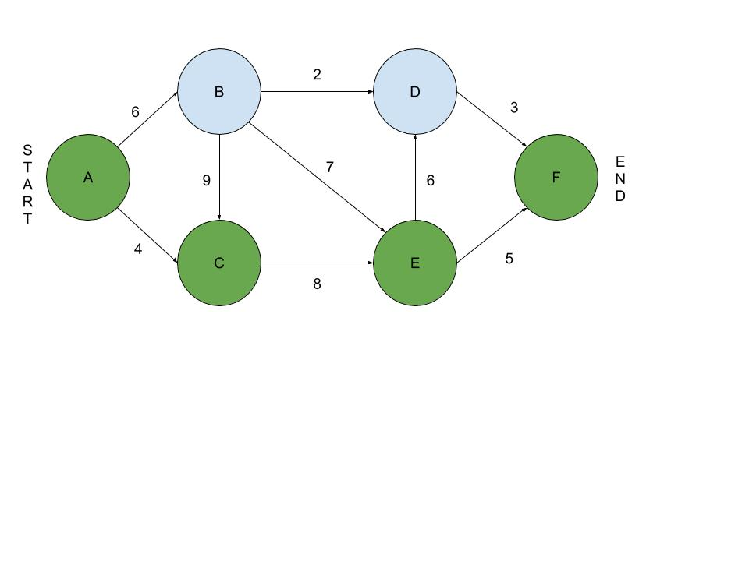

*Figure: Example of shortest path in a graph*

In the above figure, the shortest path is given by $P=(A, C, E, F)$ with a total cost of $4 + 8 + 5 = 17$

# 4. A historical perspective

The Floyd-Warshall algorithm is an example of a dynamic programming problem. It was first published by **Robert Floyd** in 1962. However, the working of this algorithm is similar to the algorithms previously published by Bernard Roy in 1959 and **Stephen Warshall** in 1962 for finding the transitive closure of a graph. The current formulation of the algorithm as three nested for loops was first described by Peter Ingerman in 1962. Hence, the algorithm is also known as the **Floyds algorithm**, the **Roy-Warshall algorithm** or the **Roy-Floyd algorithm.**

# 5. Algorithm description

The Floyd-Warshall algorithm considers the intermediate vertices of a shortest path, where an *intermediate vertex* of a simple path $P=\left(v_{1},v_{2},{…,v}_{n}\right)$ is any vertex of $P$ other than ${ v}_{1} or v_{n}$ that is, any vertex in the set $P=\left(v_{2},v_{3},{…,v}_{n-1}\right)$

The algorithm relies on the observation that the vertices of $G$ are $V=(1, 2, …, n)$, consider a subset $V=(1, 2, …, k)$ of vertices for some $k$. For any pair of vertices $i, j ϵ V$, consider all paths from $i$ to $j$ whose intermediate vertices are all drawn from $V=(1, 2, …, k)$, and let $p$ be a minimum-weight path from among them.

The algorithm exploits a relationship between path $p$ and shortest paths from $i$ to $j$ with all intermediate vertices in the set $V=(1, 2, .., k-1)$. The relationship depends on whether or not k is an intermediate vertex of path $p$.

This gives rise to the following cases:

1. *If $k$ is not an intermediate vertex of path $p$*, then all intermediate vertices of path $p$ are in the set $V=\left(1, 2, …, k-1\right)$. Thus, a shortest path from vertex $i$ to vertex $j$ with all intermediate vertices in the set $V=\left(1, 2, …, k-1\right)$ is also a shortest path from $i$ to $j$ with all intermediate vertices in the set $V=\left(1, 2, …, k-1\right)$.
2. *If $k$ is an intermediate vertex of path $p$*, then we decompose $p$ into $i, k and j$. $p_{1}$ is a shortest path from $i$ to $k$ with all intermediate vertices in the set $V=(1, 2, …, k-1)$. Similarly, $p_{2}$ is a shortest path from vertex $k$ to vertex $j$ with all intermediate vertices in the set $V=(1, 2, …, k-1)$.

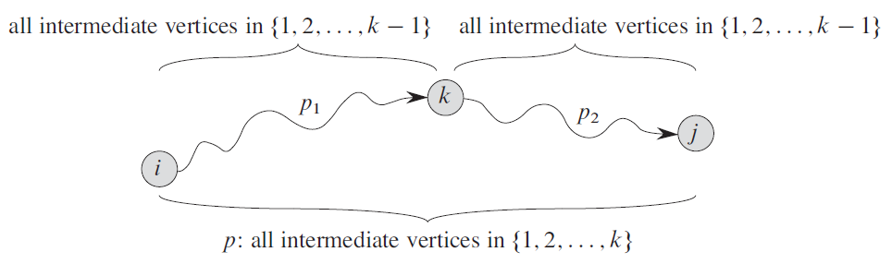

*Figure: Path $p$ is a shortest path from vertex $i$ to vertex $j$, and $k$ is the highest-numbered intermediate vertex of $p$ [2]*

## 5.1. A recursive solution

Let $d_{ij}^{(k)}$ be the weight of a shortest path from vertex $i$ to vertex $j$ for which all *intermediate vertices* are in the set $V=(1, 2, …, k)$. When $k=0$, a path from vertex $i$ to vertex $j$ with no intermediate vertex numbered higher than $0$ has no intermediate vertices at all. Such a path has at most one edge, and hence ${ d}_{ij}^{(0)}=w_{ij}$. [2]

This can be represented as:

$$d_{ij}^{(k)}=\left\{\begin{aligned}w_{ij}, if k=0 \\ min⁡(d_{ij}^{\left(k-1\right)}, d_{ik}^{\left(k-1\right)}, d_{kj}^{\left(k-1\right)}), & ifk≥1\end{aligned}\right.$$

$$FLOYD-WARSHALL(W)$$

$$n = W.rows$$

$$D^{(0)}=W$$

$$for k=1 to n$$

$$let D^{(k)}=\left(d_{ij}^{\left(k\right)}\right)be a new n × n matrix$$

$$for i=1 to n$$

$$for j=1 to n$$

$$d_{ij}^{\left(k\right)}=\min\left(d_{ij}^{\left(k-1\right)}, d_{ik}^{\left(k-1\right)}, d_{kj}^{\left(k-1\right)}\right)$$

$$return D^{(n)}$$

*Figure: The Floyd-Warshall algorithmic steps*

**function** Floyd-Warshall(V)

dist[v][v] = ∞

**for each** vertex *v*

dist[*v*][*v*] := 0

**for each** edge (*u*,*v*)

dist[*u*][*v*] := w(*u*,*v*)

**for** *k* = 1 **to** V

**for** *i* = 1 **to** V

**for** *j* = 1 **to** V

**if** dist[*i*][*j*] > dist[*i*][*k*] + dist[*k*][*j*]

dist[*i*][*j*] := dist[*i*][*k*] + dist[*k*][*j*]

**end if**

*Figure: The Floyd-Warshall algorithm pseudocode*

## 5.2. Matrix representation

Given the following graph:

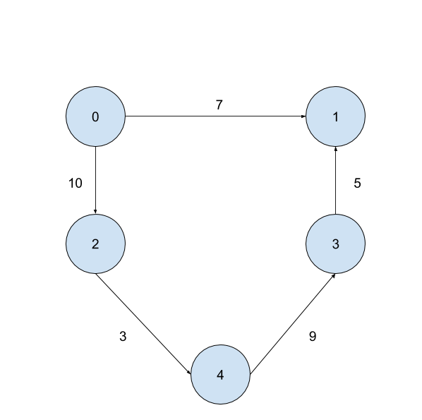

*Figure: Example directed graph*

Suppose the above graph is denoted by $G$. Then, the corresponding matrix is given as:

$$\begin{matrix} & 0 & 1 & 2 & 3 & 4 \end{matrix}$$

$$\begin{matrix}0 \\ 1 \\ 2 \\ 3 \\ 4\end{matrix} \left|\begin{matrix}0 & 7 & 10 & ∞ & ∞ \\ ∞ & 0 & ∞ & ∞ & ∞ \\ ∞ & ∞ & 0 & ∞ & 3 \\ ∞ & 5 & ∞ & 0 & ∞ \\ ∞ & ∞ & ∞ & 9 & 0\end{matrix}\right|$$

Programmatically, this can be represented as:

g[][] = { {0 , 7 , 10 , INF, INF},

{INF, 0 , INF, INF, INF},

{INF, INF, 0 , INF, 3 },

{INF, 5 , INF, 0 , INF},

{INF, INF, INF, 9 , 0 } }

# 6. Implementation

/* Author: Zubin Kadva

* Class: Analysis of Algorithms, Spring 2017

* Project: Floyd-Warshall algorithm

*/

public class FloydWarshall {

final static int INF = 999;

static void shortestPath(int graph[][]) {

int v = graph.length;

int dist[][] = new int[v][v];

**// Matrix initialization is done here**

for (int i = 0; i < v; i++) {

System.arraycopy(graph[i], 0, dist[i], 0, v);

}

for (int k = 0; k < v; k++) {

**// Start from a vertex as source**

for (int i = 0; i < v; i++) {

**// End at a vertex at the destination staring from the source**

for (int j = 0; j < v; j++) {

**// If vertex k is on the shortest path from i to j, then update the value of dist[i][j]**

if (dist[i][k] + dist[k][j] < dist[i][j]) {

dist[i][j] = dist[i][k] + dist[k][j];

}

}

}

}

**// Print the shortest distance matrix**

print(dist);

}

static void print(int dist[][]) {

int v = dist.length;

for (int i = 0; i < v; i++) {

for (int j = 0; j < v; j++) {

if (dist[i][j] == INF) {

System.out.print("INF\t");

} else {

System.out.print(dist[i][j] + "\t");

}

}

}

}

}

# 7. Generating random data

/* Author: Zubin Kadva

* Class: Analysis of Algorithms, Spring 2017

* Project: Floyd-Warshall algorithm

*/

static int[][] generate() {

final int DIAGONAL = 9999;

int V = 225;

int[][] graph = new int[V][V];

**// Initalize diagonals first**

for (int i = 0; i < V; i++) {

graph[i][i] = DIAGONAL;

}

**// Pick a random distance from 1 to 10**

for (int i = 0; i < V; i++) {

for (int j = 0; j < V; j++) {

if (i == j) {

continue;

}

graph[i][j] = new Random().nextInt(10);

}

}

**// Make sure there are INF distances also**

for (int i = 0; i < V; i++) {

int a = new Random().nextInt(V);

int b = new Random().nextInt(V);

if (graph[a][b] != DIAGONAL) {

graph[a][b] = INF;

}

}

**// Reset diagonals to 0**

for (int i = 0; i < V; i++) {

for (int j = 0; j < V; j++) {

if (graph[i][j] == DIAGONAL) {

graph[i][j] = 0;

}

}

}

return graph;

}

shortestPath(generate());

# 8. Analysis

Time Complexity

The print subroutine is expressed as:

$$T\left(n\right)= \sum_{i=0}^{v-1}{\sum_{j=0}^{v-1}{\left(1\right)}}$$

$$∴ T\left(n\right)= \sum_{i=0}^{v-1}{v}$$

$$∴ T\left(n\right)=v*v$$

$$∴ T\left(n\right)=v^{2}$$

$$∴ T\left(n\right)=O(v^{2})$$

Thus, complexity is $O (v^{2})$**.**

The shortestPath routine is expressed as:

$$T\left(n\right)=\sum_{i=0}^{v-1}{\left(1\right)+ }\sum_{k=0}^{v-1}{\sum_{i=0}^{v-1}{\sum_{j=0}^{v-1}{\left(1\right)}}}$$

$$∴ T\left(n\right)=v+\sum_{k=0}^{v-1}{\sum_{i=0}^{v-1}{v}}$$

$$∴ T\left(n\right)=v+\sum_{k=0}^{v-1}{v* v}$$

$$∴ T\left(n\right)=v+v*v*v$$

$$∴ T\left(n\right)=v+v^{3}$$

$$∴ T\left(n\right)=O(v^{3})$$

Thus, the worst case complexity is $O (v^{3})$**.**

The best, average case complexity of the algorithm is also $v^{3}$ and follows a similar proof. Hence, it follows that the **best case complexity** is $Ω (v^{3})$ and the **average case complexity** is $θ (v^{3})$**.**

Space complexity

We store the distances in a 2-D array with $v$ rows and $v$ columns. Therefore, the space complexity is given by

$$v*v=v^{2}$$

Thus, the complexity is $O (v^{2})$**.**

In summary,

|  |  |  |
| --- | --- | --- |
| Performance | Best | $$Ω (v^{3})$$ |
| **Average** | $$θ (v^{3})$$ |
| **Worst** | $$O (v^{3})$$ |
| Space | | $$O (v^{2})$$ |

# 9. Graphs

## 9.1. Execution Time

|  |  |
| --- | --- |
| V | Time (in ms) |
| 5 | 1.13 |
| 10 | 5.48 |
| 15 | 7.86 |
| 20 | 10.8 |
| 25 | 18.5 |
| 30 | 21.3 |
| 35 | 27.5 |
| 40 | 30.7 |
| 45 | 36.8 |
| 50 | 43.1 |
| 55 | 48 |
| 60 | 49.7 |
| 65 | 54.1 |
| 70 | 60.6 |
| 75 | 73.6 |
| 80 | 87.6 |
| 85 | 101.5 |
| 90 | 115 |
| 95 | 129 |
| 100 | 147 |

*Table: Floyd-Warshall execution time from v = 5 to 100*

*Graph: Scatter plot of the above data with a cubic trend line*

## 9.2. Memory consumption

|  |  |
| --- | --- |
| V | Memory (in MB) |
| 5 | 7.24 |
| 25 | 7.58 |
| 45 | 7.92 |
| 65 | 8.25 |
| 85 | 8.92 |
| 105 | 9.93 |
| 125 | 10.93 |
| 145 | 12.28 |
| 165 | 13.62 |
| 185 | 15.3 |

*Table: Floyd-Warshall execution time from v = 5 to 185*

*Graph: Scatter plot of the above data with a quadratic trend line*

## 9.3. Average performance

|  |  |
| --- | --- |
| V | Average |
| 10 | 6.36 |
| 20 | 9.02 |
| 30 | 14.44 |
| 40 | 19.14 |
| 50 | 25.51 |
| 60 | 28.81 |
| 70 | 34.425 |
| 80 | 47.925 |
| 90 | 61.96 |
| 100 | 77.96 |

*Table: Average performance for Floyd-Warshall*

*Graph: Scatter plot of the above data*

# 10. References and tools

[1] Shortest path from <https://en.wikipedia.org/wiki/Shortest_path_problem>

[2] Thomas H. Cormen, Charles E. Leiserson, Ronald L. Rivest, Clifford Stein, “*Introduction to Algorithms”*, MIT Press, 2009

[3] Algorithm pseudocode from [https://en.wikipedia.org/wiki/Floyd%E2%80% 93Warshall_ algorithm](https://en.wikipedia.org/wiki/Floyd%E2%80%25%2093Warshall_%20algorithm)

The NetBeans profiler for profiling the performance of the algorithm.

Microsoft Excel for plotting graphs of the gathered data.

Google Drawings for diagrammatic representation of data.