HOW FINANCIAL LITERACY
AFFECTS TEENAGERS’
SPENDING HABITS

Submitted by:
Zubiya Khanum

Independent Research Project
(Completed Independently)

Date:
21 May, 2026

ABSTRACT:

Financial literacy has become an important life skill in today’s digital and consumer-driven world, especially among teenagers who are beginning to develop independent spending habits and financial responsibilities. This study examines the relationship between financial literacy and teenagers’ spending behaviour, focusing on factors such as budgeting habits, saving practices, online shopping behaviour, and the influence of social media and digital trends on financial decisions.
The research was conducted using a quantitative survey-based method through Google Forms, and responses were collected from 50 participants, primarily teenagers between the ages of 13 and 19. The collected data was analysed using percentages, charts, and graphical representations to identify common financial behaviours and spending patterns among teenagers.
The findings of the study revealed that while many teenagers possess basic financial awareness, external influences such as social media, peer pressure, online shopping platforms, and digital trends significantly affect their spending decisions. The study also highlighted that financial literacy can contribute to better money management habits, including saving, budgeting, and responsible spending. In addition, the majority of participants believed that financial education should be introduced in schools.
Overall, the study emphasises the importance of financial literacy in shaping responsible financial behaviour among teenagers and highlights the need for greater financial education and awareness among young individuals.

INTRODUCTION:

Financial literacy is the ability to manage money wisely, invest effectively, and plan for a comfortable future. It includes the fundamentals of earning, spending, saving, borrowing, and investing. In today’s modern world, financial literacy has become an essential life skill, especially for teenagers who are beginning to develop independent spending habits and financial responsibilities.
Teenagers today are highly influenced by social media, online shopping, advertisements, and digital trends, which can strongly affect their spending behaviour. Many young people make purchases based on trends, peer influence, or impulsive decisions without fully understanding financial planning or money management. At the same time, many teenagers receive little formal financial education, making it difficult for them to develop responsible financial habits at an early age.
Several studies conducted in different parts of the world highlight the growing importance of financial literacy among young people. A study conducted in Aurangabad, India, found that youth spending habits have changed significantly due to westernization, online shopping, and increased brand consciousness among teenagers and young adults. Research conducted in the United States revealed that many teenagers lack understanding of key financial concepts and often learn about money informally through observation, television, and family discussions rather than formal education. Similarly, OECD studies conducted in Greece and South-East Europe showed that many young people have low levels of financial literacy, limited saving habits, and poor budgeting practices. These studies also emphasized the need for stronger financial education programs for students and young individuals.
Financial literacy plays an important role in helping teenagers make better financial decisions, track spending, save money, and distinguish between needs and wants. Developing these habits early can contribute to long-term financial stability and responsible money management in adulthood. The purpose of this study is to examine how financial literacy affects teenagers’ spending habits. This research aims to understand teenagers’ financial behaviours, including budgeting habits, saving patterns, online shopping behaviour, and the factors that influence their spending decisions. This study also aims to highlight the importance of financial education and raise awareness about responsible financial practices among teenagers.
METHODOLOGY:
A quantitative survey method was used for this study to investigate teenagers’ spending habits and their connection to financial literacy. Data was gathered through an online questionnaire created using Google Forms, which was circulated digitally among participants through peer groups, family contacts, and different social media platforms.
The questionnaire consisted of questions related to saving habits, budgeting practices, online shopping behaviour, and factors that influence financial decisions among teenagers. The responses obtained from the survey were organized and interpreted using charts, percentages, and graphical representations to identify common trends and patterns in teenage financial behaviour.

SAMPLE:
The survey sample primarily consisted of teenagers between the ages of 13 and 19, with a total of 42 responses collected from this age group. The remaining responses were received from young adults aged between 20 and 23, while a small number of participants from other age groups were also included in the study.

SAMPLING METHOD:
The study employed a voluntary response sampling approach, in which participation in the survey was open to anyone who came across or received the Google Forms link and decided to take part. The survey was disseminated through peers, family contacts, and multiple social media platforms, enabling the research to collect responses from teenagers exhibiting diverse financial habits, spending behaviours, and varying levels of financial awareness. This method allowed efficient and accessible data collection for the study.

DATA COLLECTION:
The questionnaire included both open-ended answers and multiple-choice questions. It covered broad aspects:
- Demographics (age, level of education)
- Spending behaviour (shopping habits, impulsive spending, online shopping patterns, and factors influencing spending decisions)
- Saving habits (frequency of saving, budgeting practices, and money management habits)
- Financial awareness (understanding of financial literacy, financial education, and awareness regarding responsible spending)
- Influence of digital factors (social media, advertisements, peer influence, and online trends affecting spending behaviour)

DATA ANALYSIS:
The responses collected from the survey were analysed using percentages, charts, and graphical representations provided by Google Forms. The data was studied to identify common trends and patterns related to teenagers’ spending habits, saving behaviour, budgeting practices, and financial awareness.
The analysis also helped compare different responses to understand how factors such as age, financial awareness, social media influence, and online shopping habits may affect teenagers’ spending decisions and money management behaviour.
LIMITATIONS:
This study was conducted using a limited sample size of 50 responses, which may not fully represent the financial behaviour of all teenagers. The responses were collected mainly through peers, family contacts, and social media platforms, which may have affected the diversity of participants. In addition, the study was based on self-reported responses, which may not always be completely accurate.
RESULTS:

- Demographics of the respondents:

- Age:
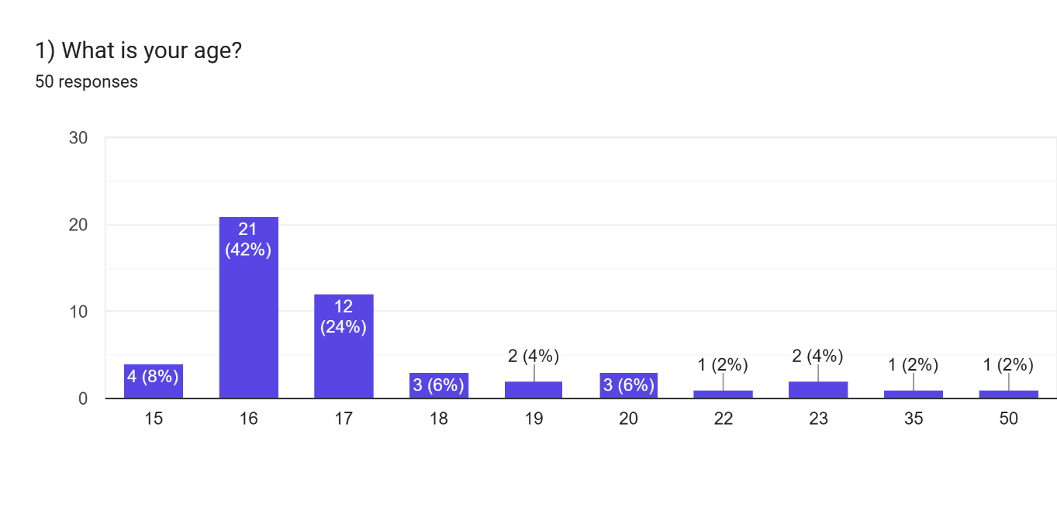
Fig. 1: age distribution

- Level of Study: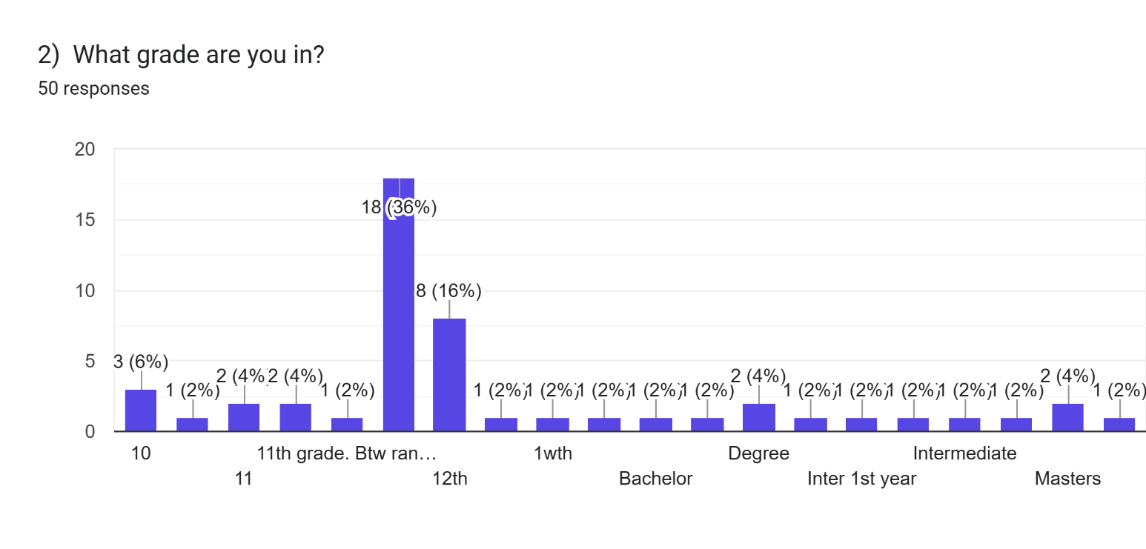
Fig. 2: Level of Study
- Spending behaviour:

- Percentage of participants who shop online
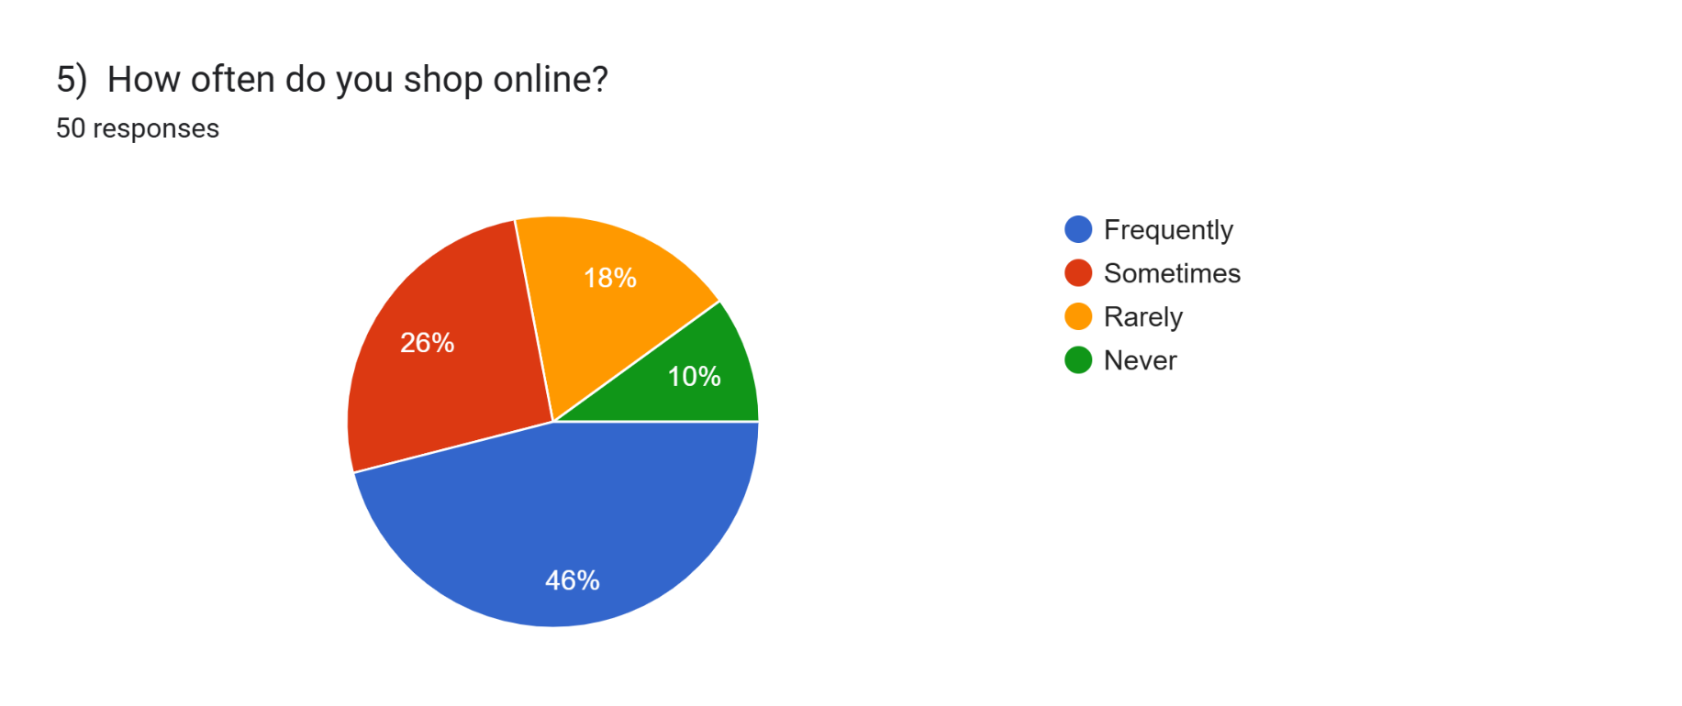Fig. 3: Frequency of online shopping

- Percentage of participants who track their spending
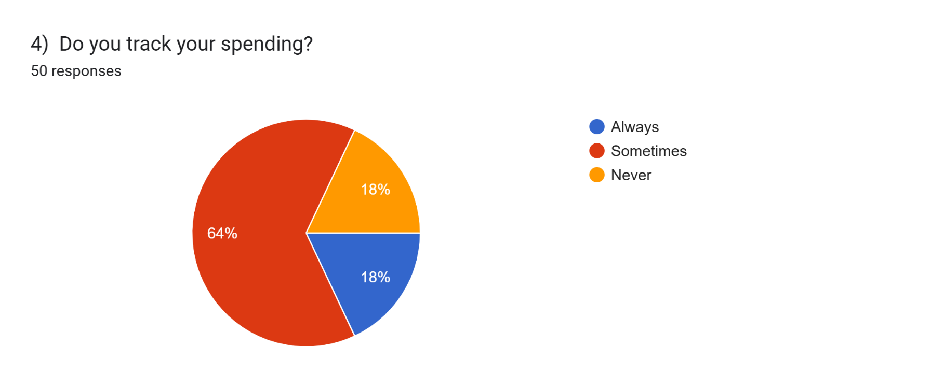
Fig. 4: Tracking the amount of spending
- Saving habits:

- Percentage of participants who save money regularly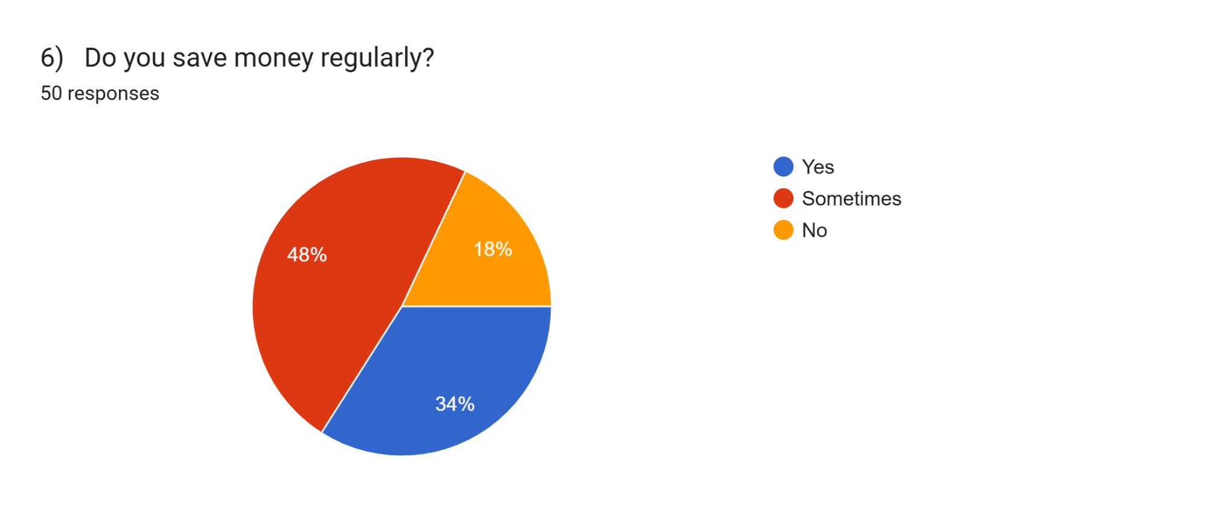
Fig. 5: saving money

- Financial Awareness:
- Percentage of participants who actually know what budgeting means
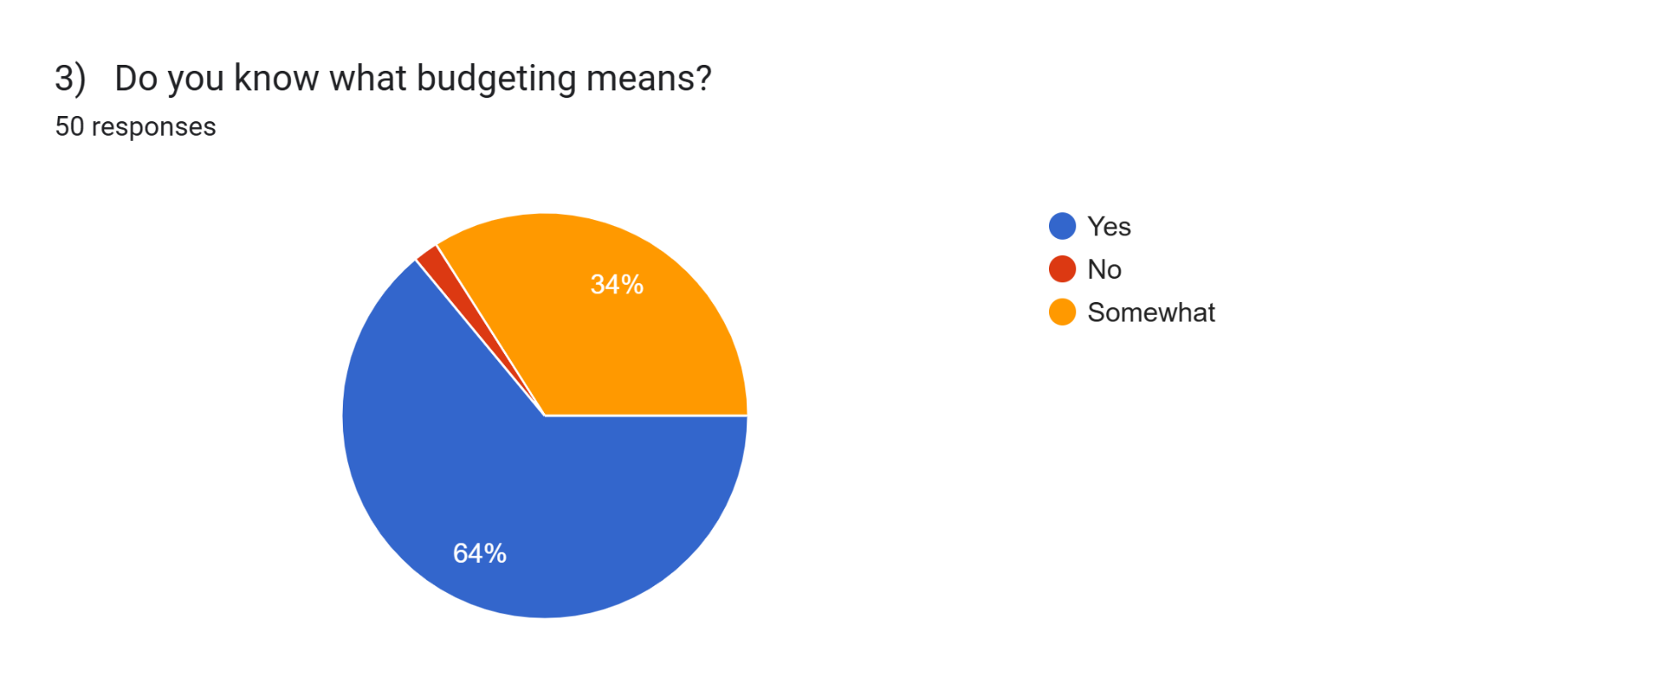Fig. 6: Budgeting
- Percentage of participants who think financial literacy should be taught
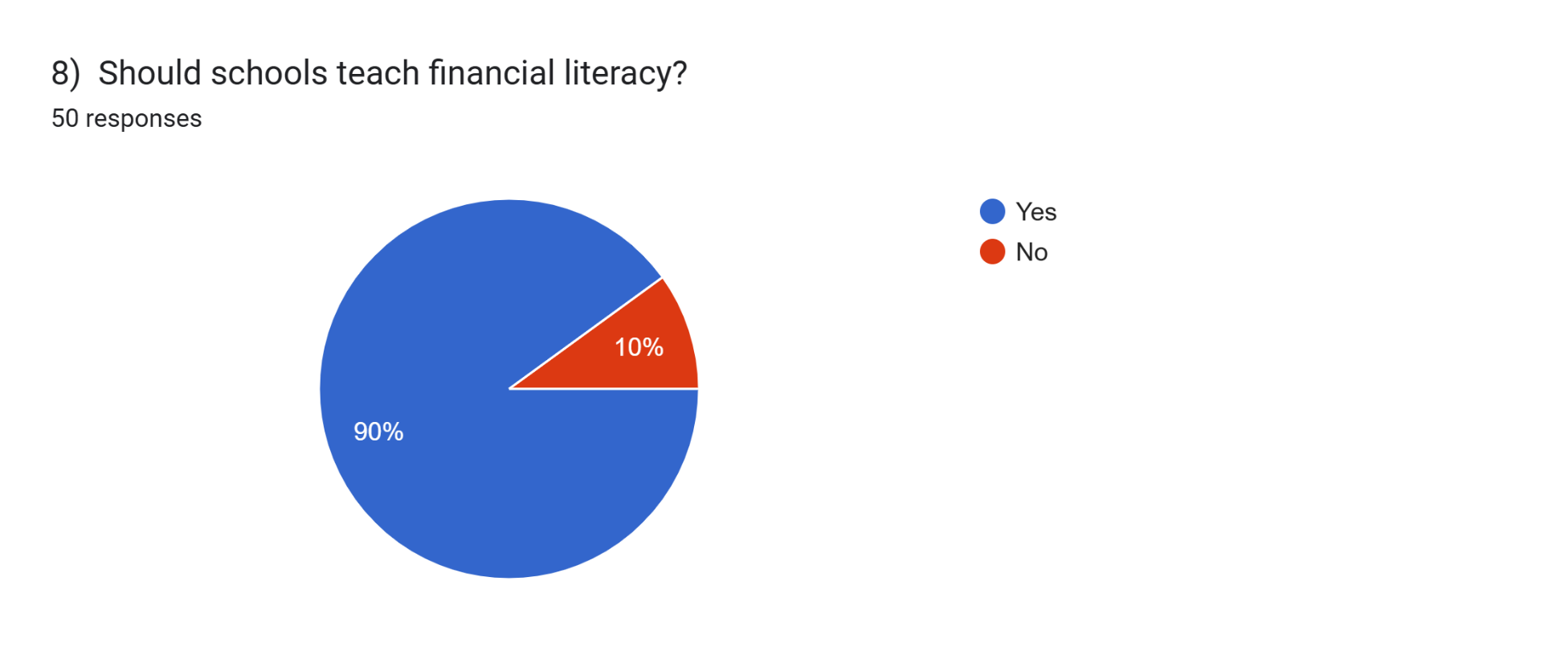
Fig. 7: Financial literacy
- Influence of Digital Factors:
- Percentage of different factors influencing spending
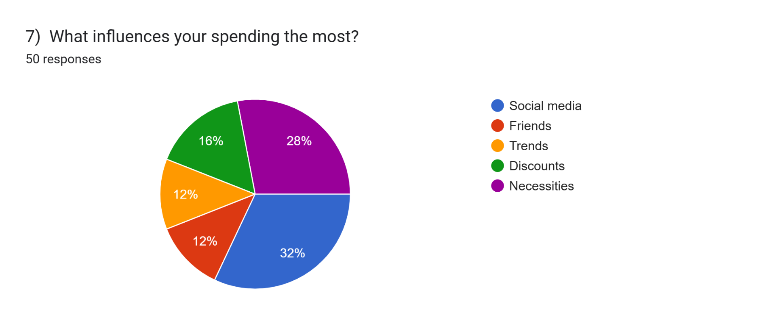
Fig. 8: Factors influencing spending

DISCUSSION:
The findings of this study indicate a strong relationship between financial literacy and teenagers’ spending behaviour. The survey responses revealed that many teenagers are familiar with basic financial concepts such as budgeting, saving money, and responsible spending. However, the results also indicate that financial knowledge alone does not always guarantee responsible financial behaviour, as several external factors continue to influence teenagers’ spending decisions. One of the major findings of the study was the strong influence of social media, online shopping platforms, advertisements, trends, and peer pressure on teenage spending habits. Many participants reported that digital trends and online shopping affect their purchasing decisions, often encouraging impulsive spending. The increasing accessibility of online shopping and digital payment methods has made spending easier and more frequent among teenagers. These findings support previous studies conducted in Aurangabad and other regions, which highlighted the growing influence of consumer culture, westernization, and digital media on youth spending behaviour.
The study also showed differences in saving and budgeting habits among participants. While some teenagers regularly save money and track their expenses, others admitted to inconsistent budgeting and impulsive purchases. This suggests that although teenagers may possess some financial awareness, many still struggle to apply financial knowledge in practical situations. Financial literacy therefore appears to play an important role in encouraging responsible money management, but habits and external influences also significantly affect financial behaviour.
Another important finding of the study was that the majority of participants believed financial literacy should be taught in schools. This reflects the growing recognition of financial education as an important life skill for young people. Introducing financial education at an early stage may help teenagers develop healthier spending habits, improve saving behaviour, and make more informed financial decisions in the future.
Overall, the findings suggest that financial literacy has a clear connection with teenagers’ spending habits and financial behaviour. The study highlights the importance of improving financial education and increasing awareness about responsible money management among teenagers in today’s increasingly digital and consumer-driven society.

CONCLUSION:
The findings of this study show that financial literacy plays an important role in shaping how teenagers spend money and manage their finances. The survey responses revealed that many teenagers understand basic financial ideas such as budgeting and saving, yet their spending decisions are still strongly influenced by social media, online shopping, trends, and peer pressure.
The study also found that while some teenagers regularly save money and keep track of their expenses, others struggle with impulsive buying and find it hard to stick to a consistent budget. Online shopping and digital lifestyle trends turned out to be strong reasons why teenagers spend money, showing how much technology and social media affect the way young people make money choices today.
In addition, the research highlights the importance of teaching financial skills at an early age. Most participants felt that financial literacy should be included in school lessons, pointing to the growing need for better money awareness among teenagers. Building financial knowledge and responsible habits during adolescence can help young people make smarter money choices and support long-term financial stability in adulthood.
Overall, this study shows that financial literacy is closely connected to teenagers’ spending patterns and underlines the need to promote financial education and more mindful money habits among young people, so they can develop healthier relationships with money as they grow up.

REFERENCES:

- Zimmerman, J., Forlizzi, J., Finkenaur, J., & Amick, S. Teens, Parents, and Financial Literacy. Google Scholar, published on 4 June 2016.
- Birari, A., & Patil, U. Spending & Saving Habits of Youth in the City of Aurangabad. Google Scholar, published in May 2014.
- OECD. Financial Literacy in Greece: Evidence on Adults and Young People. OECD Publishing, published on 23 January 2024.
- OECD. Youth Financial Education in South East Europe. OECD Publishing, published in 2021.
- McClain, C., Anderson, M., Sidoti, O., & Bishop, W. How Teens Use and View AI. Pew Research Center, published on 24 February 2026.
- Pew Research Center. Stories from Experts about the Impact of Digital Life. Published on 7 March 2018.
- Fernando, J. Financial Literacy: What It Is, and Why It Is So Important to Teach Teens. Investopedia, published on 24 February 2026.
- Smith, L. The Basics of Financial Responsibility. Investopedia, published on 11 April 2025.
- Daugherty, G. How To Save for Financial Goals: Emergencies, College, Retirement. Investopedia, published on 28 March 2026.

