1. What is nested list?
   * A nested list is a list that appears as an element in another list.
   * For example:
     + Nested = [‘abc’, 123, ‘xyz’, [5.43, ‘mymy’]]
     + Print(nested[3]) >>> [5.43, ‘mymy’]
2. Can a list store both integers and strings in it?
   * Yes, a list can store both integers and strings in it
   * For example:
     + Int_and_str = [‘abc’, 23, 0.43, ‘xyz’]

|  |  |
| --- | --- |
| *6iporAnbT.jpg* | ***Serious exercises*** |
|  |  |

1. Implement superuser login

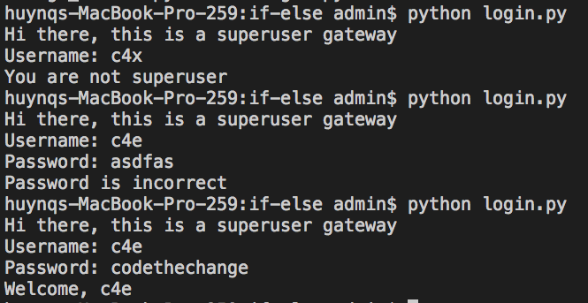

1. Repeat exercise 1 so that users can try login without running the file again (python login.py) when it fails
2. Finish CRUD exercise in class, simulate a clothes shop

Welcome to our shop, what do you want (C, R, U, D)? R

Our items: T-Shirt, Sweater

Welcome to our shop, what do you want (C, R, U, D)? C

Enter new item: Jeans

Our items: T-Shirt, Sweater, Jeans

Welcome to our shop, what do you want (C, R, U, D)? U

Update position? 2

New item? Skirt

Our items:  T-Shirt, Skirt, Jeans

Welcome to our shop, what do you want (C, R, U, D)? D

Delete position? 3

Our items:  T-Shirt, Skirt

Handle the exceptions (upper, lower case, index out of range) yourself