**浙江大学城市学院实验报告**

课程名称 计算机综合实践（一）

实验项目名称 Day04

学生姓名 王灵霜 专业班级 计算机1801 学号 31801061

实验成绩 指导老师（签名 ） 日期 20190809

**一、实验目的：**

1、掌握红外检测工作原理

2、掌握红外巡线工作原理

**二、实验内容：**

本次实验注意事项：

1）注意调整连体跳线帽的位置。

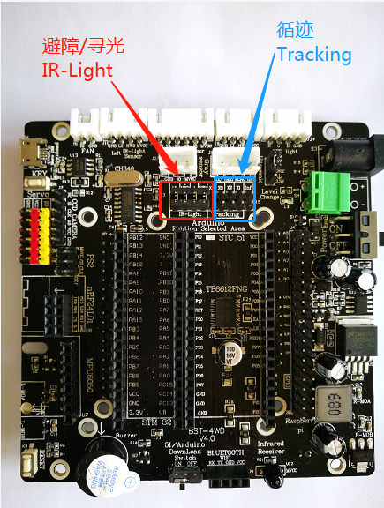

1）红外避障实验

环境要求：在室内，红外光线不强的地方。被跟随的物体宽度略大于11cm，高度大于6cm。

调试：调节旋钮，使得红外管距离障碍物小于10cm时，L1灯亮起，否则，L1灯灭。

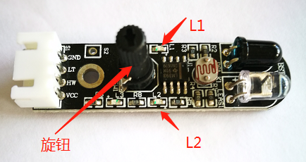

3）红外跟随实验（寻光模式）：

环境要求：在室内，光线不要过强的地方。手电筒的灯光相比室内光线较为明显。

调试：调试调节旋钮，使得正常室内光照下L2灯亮，当手电筒的灯光照射到光敏电阻上时，L2灯灭。

4） 红外巡线实验：

环境要求：在室内，光线不要过强的地方。白色底面上黑线轨道宽度需大于16mm。

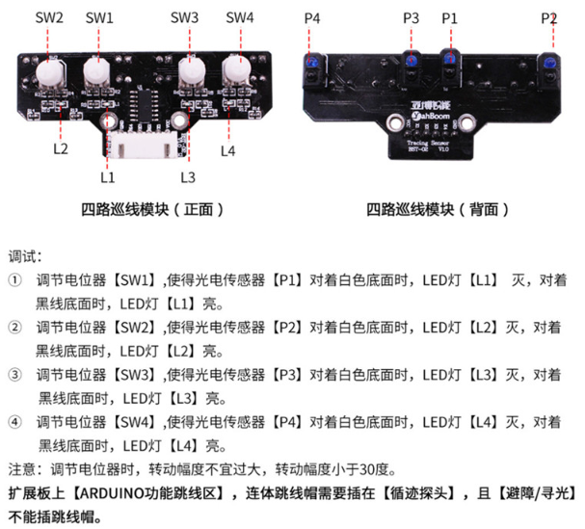

12）红外避障实验

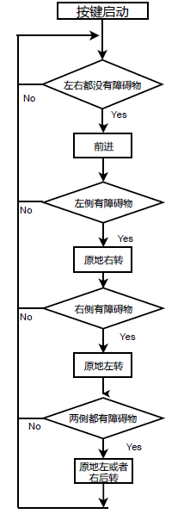

图 红外避障流程图

13）红外跟随实验

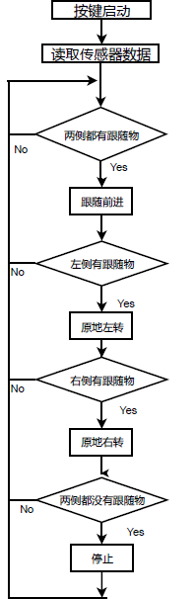

图 红外跟随流程图

14）红外巡线实验

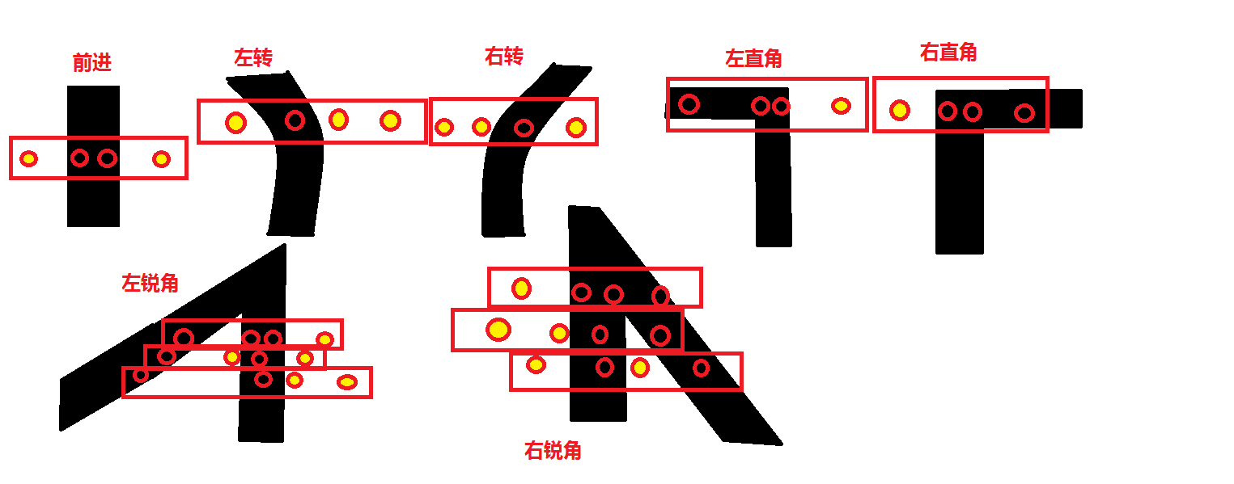

图 地面黑线情况处理

**三、实验步骤：**

1）自行完成以上实验内容

2）贴代码

3）运行效果拍照 或者 录像

12）红外避障实验

int pin1 = 8;

int pin2 = 7;

int pwm1 = 6;

int pin3 = 2;

int pin4 = 4;

int pwm2 = 5;

int key =A0;

int Sensorl_1 = A3;//红外

int Sensorr_1 = A1;

void setup() {

// put your setup code here, to run once:

pinMode(pin1,OUTPUT);

pinMode(pin2,OUTPUT);

pinMode(pwm1,OUTPUT);

pinMode(pin3,OUTPUT);

pinMode(pin4,OUTPUT);

pinMode(pwm2,OUTPUT);

pinMode(key,INPUT);

pinMode(A1,INPUT);

pinMode(A2,INPUT);

pinMode(A3,INPUT);

pinMode(A4,INPUT);

pinMode(Sensorl_1,INPUT);

pinMode(Sensorr_1,INPUT);

digitalWrite(key, HIGH);

Serial.begin(9600);

}

void key_scan()

{

while (digitalRead(key)); //当按键没有被按下一直循环

while (!digitalRead(key)) //当按键被按下时

{

delay(10); //延时10ms

if (digitalRead(key) == LOW)//第二次判断按键是否被按下

{

delay(100);

while (!digitalRead(key)); //判断按键是否被松开

}

}

}

void stop(){

digitalWrite(pin1,LOW);

digitalWrite(pin2,LOW);

digitalWrite(pin3,LOW);

digitalWrite(pin4,LOW);

analogWrite(pwm1,0);

analogWrite(pwm2,0);

//delay(time*100);

}

void go_ahead(int speed=50){

digitalWrite(pin1,HIGH);

digitalWrite(pin2,LOW);

digitalWrite(pin3,HIGH);

digitalWrite(pin4,LOW);

analogWrite(pwm1,speed);

analogWrite(pwm2,speed);

//delay(time*100);

}

void back(int speed=50){

digitalWrite(pin1,LOW);

digitalWrite(pin2,HIGH);

digitalWrite(pin3,LOW);

digitalWrite(pin4,HIGH);

analogWrite(pwm1,speed);

analogWrite(pwm2,speed);

//delay(time*100);

}

void turnl(int speed=50){

digitalWrite(pin1,LOW);

digitalWrite(pin2,LOW);

digitalWrite(pin3,HIGH);

digitalWrite(pin4,LOW);

analogWrite(pwm1,speed);

//analogWrite(pwm2,0);

//delay(time*100);

}

void turnr(int speed=50){

digitalWrite(pin1,HIGH);

digitalWrite(pin2,LOW);

digitalWrite(pin3,LOW);

digitalWrite(pin4,LOW);

//analogWrite(pwm1,0);

analogWrite(pwm2,speed);

//delay(time*100);

}

void ydturnl(int speed=50){

digitalWrite(pin1,LOW);

digitalWrite(pin2,HIGH);

digitalWrite(pin3,HIGH);

digitalWrite(pin4,LOW);

analogWrite(pwm1,speed);

analogWrite(pwm2,speed);

//delay(time*100);

}

void ydturnr(int speed=50){

digitalWrite(pin1,HIGH);

digitalWrite(pin2,LOW);

digitalWrite(pin3,LOW);

digitalWrite(pin4,HIGH);

analogWrite(pwm1,speed);

analogWrite(pwm2,speed);

//delay(time*100);

}

void bizhang(){

int SM_1 = digitalRead(A3);

int SM_2 = digitalRead(A1);

if (SM_1 == LOW && SM_2==LOW ){

delay(1);

ydturnr();

}

else {

if (SM_1==HIGH &&SM_2==HIGH)

{

delay(1);

go_ahead();

}

else if ( (SM_1 == HIGH) && SM_2 == LOW)

{

delay(1);

ydturnl();

}

else if ((SM_1 == LOW) && SM_2 == HIGH)

{

delay(1);

ydturnr();

}

else

{

stop();

}}}

void loop() {

// put your main code here, to run repeatedly:

key_scan();

while(1){

bizhang();

}

}

13）红外跟随实验

int Left_f = 8;

int Left_s = 7;

int Right_f = 2;

int Right_s = 4;

int Left_go = 6;

int Right_go = 5;

int key=A0;

void go_straight() {

digitalWrite(Left_f, HIGH);

digitalWrite(Left_s, LOW);

digitalWrite(Right_f, HIGH);

digitalWrite(Right_s, LOW);

analogWrite(Left_go, 50);

analogWrite(Right_go, 50);

}

void Stop() {

digitalWrite(Left_f, LOW);

digitalWrite(Left_s, LOW);

digitalWrite(Right_f, LOW);

digitalWrite(Right_s, LOW);

analogWrite(Left_go, 0);

analogWrite(Right_go, 0);

}

void turn_left() {

digitalWrite(Left_f, LOW);

digitalWrite(Left_s, HIGH);

digitalWrite(Right_f, HIGH);

digitalWrite(Right_s, LOW);

analogWrite(Left_go, 0);

analogWrite(Right_go, 50);

}

void turn_right() {

digitalWrite(Left_f, HIGH);

digitalWrite(Left_s, LOW);

digitalWrite(Right_f, LOW);

digitalWrite(Right_s, HIGH);

analogWrite(Left_go, 50);

analogWrite(Right_go, 0);

}

void back() {

digitalWrite(Left_f, LOW);

digitalWrite(Left_s, HIGH);

digitalWrite(Right_f, LOW);

digitalWrite(Right_s, HIGH);

analogWrite(Left_go, 50);

analogWrite(Right_go, 50);

}

void turn_left_stop() {

digitalWrite(Left_f, LOW);

digitalWrite(Left_s, HIGH);

digitalWrite(Right_f, HIGH);

digitalWrite(Right_s, LOW);

analogWrite(Left_go, 50);

analogWrite(Right_go, 50);

}

void turn_right_stop() {

digitalWrite(Left_f, HIGH);

digitalWrite(Left_s, LOW);

digitalWrite(Right_f, LOW);

digitalWrite(Right_s, HIGH);

analogWrite(Left_go, 50);

analogWrite(Right_go, 50);

}

void key_scan() {

while (digitalRead(A0));

while (!digitalRead(A0)) {

delay(10);

if (digitalRead(A0) == 0) {

delay(100);

while (!digitalRead(A0));

}

}

}

void setup() {

// put your setup code here, to run once:

pinMode(Left_f, OUTPUT);

pinMode(Left_s, OUTPUT);

pinMode(Right_f, OUTPUT);

pinMode(Right_s, OUTPUT);

pinMode(Left_go, OUTPUT);

pinMode(Right_go, OUTPUT);

pinMode(A0, INPUT);

pinMode(A2, INPUT);

pinMode(A1, INPUT);

pinMode(A3, INPUT);

pinMode(A4, INPUT);

digitalWrite(key, HIGH);

}

void xunguang(){

int SM_1 = digitalRead(A4);

int SM_2 = digitalRead(A2);

if (SM_1 == HIGH && SM_2==HIGH ){

delay(1);

go_straight();

}

else if(SM_1 ==LOW && SM_2==LOW){

delay(1);

Stop();

}

else if(SM_1 ==HIGH && SM_2==LOW){

delay(1);

turn_left_stop();

}

else{

delay(1);

turn_right_stop();

}

}

void loop() {

// put your main code here, to run repeatedly:

key_scan();

while(1){

xunguang();

}

}

14）红外巡线实验

int Left_f = 8;

int Left_s = 7;

int Right_f = 2;

int Right_s = 4;

int Left_go = 6;

int Right_go = 5;

void go_straight() {

digitalWrite(Left_f, HIGH);

digitalWrite(Left_s, LOW);

digitalWrite(Right_f, HIGH);

digitalWrite(Right_s, LOW);

analogWrite(Left_go, 70);

analogWrite(Right_go, 70);

}

void Stop() {

digitalWrite(Left_f, LOW);

digitalWrite(Left_s, LOW);

digitalWrite(Right_f, LOW);

digitalWrite(Right_s, LOW);

analogWrite(Left_go, 0);

analogWrite(Right_go, 0);

}

void turn_left() {

digitalWrite(Left_f, LOW);

digitalWrite(Left_s, HIGH);

digitalWrite(Right_f, HIGH);

digitalWrite(Right_s, LOW);

analogWrite(Left_go, 7);

analogWrite(Right_go, 50);

}

void turn_right() {

digitalWrite(Left_f, HIGH);

digitalWrite(Left_s, LOW);

digitalWrite(Right_f, LOW);

digitalWrite(Right_s, HIGH);

analogWrite(Left_go, 50);

analogWrite(Right_go, 7);

}

void back() {

digitalWrite(Left_f, LOW);

digitalWrite(Left_s, HIGH);

digitalWrite(Right_f, LOW);

digitalWrite(Right_s, HIGH);

analogWrite(Left_go, 50);

analogWrite(Right_go, 50);

}

void turn_left_stop() {

digitalWrite(Left_f, LOW);

digitalWrite(Left_s, HIGH);

digitalWrite(Right_f, HIGH);

digitalWrite(Right_s, LOW);

analogWrite(Left_go, 100);

analogWrite(Right_go, 100);

}

void turn_right_stop() {

digitalWrite(Left_f, HIGH);

digitalWrite(Left_s, LOW);

digitalWrite(Right_f, LOW);

digitalWrite(Right_s, HIGH);

analogWrite(Left_go, 100);

analogWrite(Right_go, 100);

}

void key_scan() {

while (digitalRead(A0));

while (!digitalRead(A0)) {

delay(10);

if (digitalRead(A0) == 0) {

delay(100);

while (!digitalRead(A0));

}

}

}

void setup() {

// put your setup code here, to run once:

pinMode(Left_f, OUTPUT);

pinMode(Left_s, OUTPUT);

pinMode(Right_f, OUTPUT);

pinMode(Right_s, OUTPUT);

pinMode(Left_go, OUTPUT);

pinMode(Right_go, OUTPUT);

pinMode(A0, INPUT);

pinMode(A2, INPUT);

pinMode(A1, INPUT);

pinMode(A3, INPUT);

pinMode(A4, INPUT);

digitalWrite(A0, HIGH);

}

void xunji(){

if (digitalRead(A2) && !digitalRead(A1) && !digitalRead(A3) && digitalRead(A4) ) {

go_straight();

}

else if (digitalRead(A2) && !digitalRead(A1) && digitalRead(A3) && digitalRead(A4)) {

turn_left();

}

else if (digitalRead(A2) && digitalRead(A1) && !digitalRead(A3) && digitalRead(A4)) {

turn_right();

}

else if (digitalRead(A2) && digitalRead(A1) && digitalRead(A3) && !digitalRead(A4)) {

turn_right();

delay(30);

}

else if (!digitalRead(A2) && digitalRead(A1) && digitalRead(A3) && digitalRead(A4)) {

turn_left();

delay(30);

}

else if (!digitalRead(A2) && !digitalRead(A1) && digitalRead(A3) && digitalRead(A4)) {

delay(40);

turn_left_stop();

}

else if (!digitalRead(A2) && digitalRead(A1) && !digitalRead(A3) && digitalRead(A4)) {

delay(40);

turn_left_stop();

}

else if (digitalRead(A2) && !digitalRead(A1) && digitalRead(A3) && !digitalRead(A4)) {

delay(40);

turn_right_stop();

}

else if (digitalRead(A2) && digitalRead(A1) && !digitalRead(A3) && !digitalRead(A4)) {

delay(40);

turn_right_stop();

}

else if (!digitalRead(A2) && !digitalRead(A1) && !digitalRead(A3) && digitalRead(A4)) {

delay(40);

turn_left_stop();

}

else if (digitalRead(A2) && !digitalRead(A1) && !digitalRead(A3) && !digitalRead(A4)) {

delay(40);

turn_right_stop();

}

else if (!digitalRead(A2) && !digitalRead(A1) && !digitalRead(A3) && !digitalRead(A4)) {

delay(40);

go_straight();

}

}

void loop() {

// put your main code here, to run repeatedly:

key_scan();

while (1) {

xunji();

}

}

**四、每日收获：**

记录今日学习感想。

今天学习了红外避障，红外跟随，以及红外巡线，红外跟随功能实现的较好，其他两项在编程过程中遇到很多问题，不过有同学的帮助，较好地完成了。