Robotics Engineering STUDY PROGRAM
POLITEKNIK NEGERI BATAM

Smartbin
PROGRESS REPORT

RE-070-TEAM 1 SC

05/11/2025

Project Name | Smartbin
Team Members | - Naufal Hafidzali Arrudzabari (4222501077)  - Emiliana Quratu’ain (4222501063)  - Azizah Sopiani (4222501081)  - Ramses Anjuari Silalahi (4222501079)  - Albert Brilian Putra Nugroho (4222501074)  - Rizki Andika (4222501082)
Project Manager | Dodi Radot Lumban Toruan, ST.,MT.
Start Date | 2025-September | Completion Date | 2025-November
Section 1: SYSTEM REQUIERMENT AND CONCEPT
SYSTEM REQUIREMENTS REVIEW (SRR)

In this project, there is a SmartBin, which is a smart trash bin that can automatically open and close its lid when it detects an object or a human hand in front of it.
The SmartBin uses an HC-SR04 ultrasonic sensor to detect distance, an ESP8266 microcontroller to process sensor data and connect it to the internet, and the Blynk application to monitor the trash bin’s status via a smartphone.
The components used are as follows:
No | Name | Amount
1. | Acrylic board | 1
2. | Perforated PCB | 1
3. | Hot Glue Sticks | 4
4. | 3.7V batteries | 4
5. | ESP8266 NodeMCU | 1
6. | 2-slot battery holder | 2
7. | Ultrasonic sensor HC-SR04 | 2
8. | Servo SG90 | 1

Smartbin Project Specifications
1. Dimensions: Width x Length = 150 mm x 300 mm
2. Power Source: Operates using a 12V battery
3. Sensors and Actuators:
* Ultrasonic sensor HC-SR04 to detect trash presence
* Ultrasonic sensor HC-SR04 to open the trash can lid automatically at a certain distance
* Servo SG90 to open and close the lid automatically
4. Controller: ESP8266 NodeMCU for controlling the servo and sensor
5. Monitoring: Real-time monitoring and control via Blynk IoT application
Operational Guidelines
1. The Smartbin must function properly before use
2. Trash detection should trigger automatic lid opening and closing
3. Users can monitor bin status (for example fill level) through the Blynk dashboard
4. The Smartbin should operate efficiently and safely with minimal manual intervention

CONCEPT DESIGN REVIEW (CDR)
During the Concept Design Review (CDR) phase, we conducted a comprehensive evaluation of the failures encountered in our previous Smartbin prototype. This evaluation served as the foundation for improvements and the development of a more efficient and reliable design. We also gathered various design ideas that were feasible to implement, taking into account efficiency, stability, and ease of integration between components.

As an initial step, we created a rough concept of the Smartbin using Onshape software. This design was inspired by our previous PBL project, which was simple and utilized only one servo for the lid mechanism.

Generating Feasible Solutions
We collected a variety of ideas for the Smartbin, including component placement and other design aspects, to identify the most practical and efficient solutions for implementation.

Concept of Review(CDR)

- Mechanical Concept

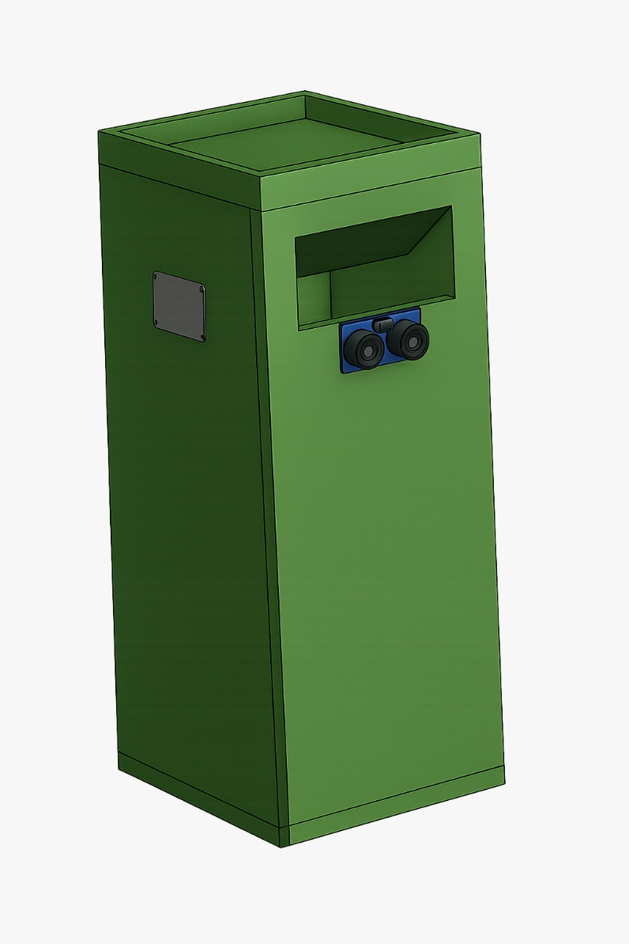

Picture 1.1 First Concept

Menentukan Dimensi dan Bobot
Menentukan Dimensi dan Bobot keseluruhan robot.
PRELIMINARY DESIGN REVIEW (PDR)
During the Preliminary Design Review (PDR) phase, the design we created was still in its early stage and not final, so it remains highly likely to undergo changes in the future. These changes will be adjusted according to field conditions and the availability of components that we acquire (subject to change). At this stage, we also began selecting the main components to be used. In addition, we started designing the basic algorithm for the Smartbin and creating an initial overview of the electrical system.
Creating Sketches
Membuat sketsa kasar atau model CAD Robot.

Preliminary Design Review (PDR)

Memilih komponen
Motor, Roda, Microcontroller, Sensor IR, Baterai, dll.

Gambar 2.1 Penempatan Komponen

- Electrical Concept

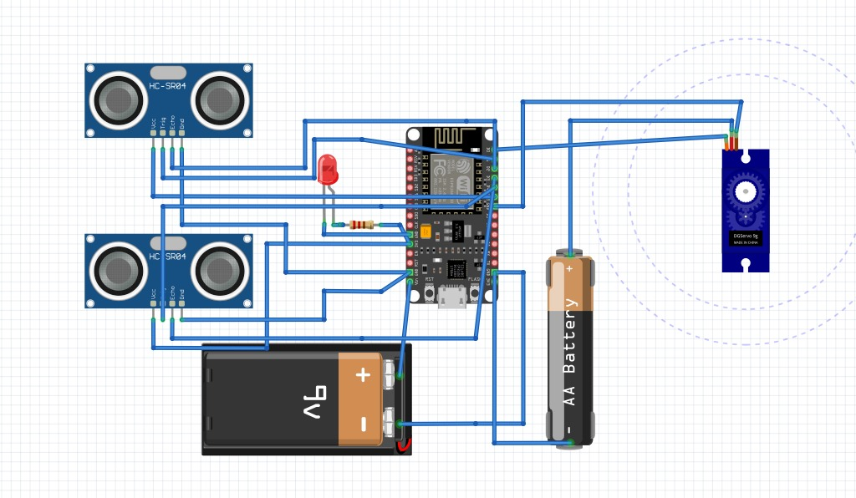

Picture 2.2 Electrical Rough Work

