红军长征重要战役：

#### 网页内容：

1. 血战湘江

The Xiangjiang Campaign

土地革命战争时期，中央红军长征途中，在广西北部湘江地区突破国民党军第4道封锁线的战役。

湘江战役是关系中央红军生死存亡的一战。

1934年11月27日至12月1日，中央红军在湘江上游广西境内的[兴安县](https://baike.baidu.com/item/%E5%85%B4%E5%AE%89%E5%8E%BF/7183236?fromModule=lemma_inlink" \t "https://baike.baidu.com/item/%E6%B9%98%E6%B1%9F%E6%88%98%E5%BD%B9/_blank)、[全州县](https://baike.baidu.com/item/%E5%85%A8%E5%B7%9E%E5%8E%BF/7183327?fromModule=lemma_inlink" \t "https://baike.baidu.com/item/%E6%B9%98%E6%B1%9F%E6%88%98%E5%BD%B9/_blank)、[灌阳县](https://baike.baidu.com/item/%E7%81%8C%E9%98%B3%E5%8E%BF/7183177?fromModule=lemma_inlink" \t "https://baike.baidu.com/item/%E6%B9%98%E6%B1%9F%E6%88%98%E5%BD%B9/_blank)，与国民党军苦战五昼夜，最终从全州、兴安之间强渡湘江，突破了国民党军的第四道封锁线，粉碎了蒋介石围歼中央红军于湘江以东的[企图](https://baike.baidu.com/item/%E4%BC%81%E5%9B%BE/70373?fromModule=lemma_inlink" \t "https://baike.baidu.com/item/%E6%B9%98%E6%B1%9F%E6%88%98%E5%BD%B9/_blank)。但是，中央红军也为此付出了极为惨重的代价。部队指战员和中央机关人员由长征出发时的8万多人锐减至3万余人。

湘江战役是中央红军突围以来最壮烈、最关键的一仗，我军与优势之敌苦战，终于撕开了敌重兵设防的封锁线，粉碎了蒋介石围歼红军于湘江以东的企图。 红军虽然突破了第四道封锁线，但付出了巨大的代价。5军团和在长征前夕成立的少共国际师损失过半，8军团损失更为惨重，34师被敌人重重包围，全体指战员浴血奋战，直到弹尽粮绝，绝大部分同志壮烈牺牲。渡过湘江后，中央红军和军委两纵队，已由出发时的8.6万人锐减到3万人。引起了广大干部和战士对王明军事路线的怀疑和不满到达了极点，纷纷要求改换领导。

湘江惨胜直接导致在遵义召开中共中央政治局扩大会议（史称“[遵义会议](https://baike.baidu.com/item/%E9%81%B5%E4%B9%89%E4%BC%9A%E8%AE%AE/64086?fromModule=lemma_inlink" \t "https://baike.baidu.com/item/%E6%B9%98%E6%B1%9F%E6%88%98%E5%BD%B9/_blank)”）。它是红军受到国民党军围追堵截身处绝境时召开的，确立了以毛泽东为核心的新的党中央的正确领导和毛泽东在红军及党中央的领导地位。

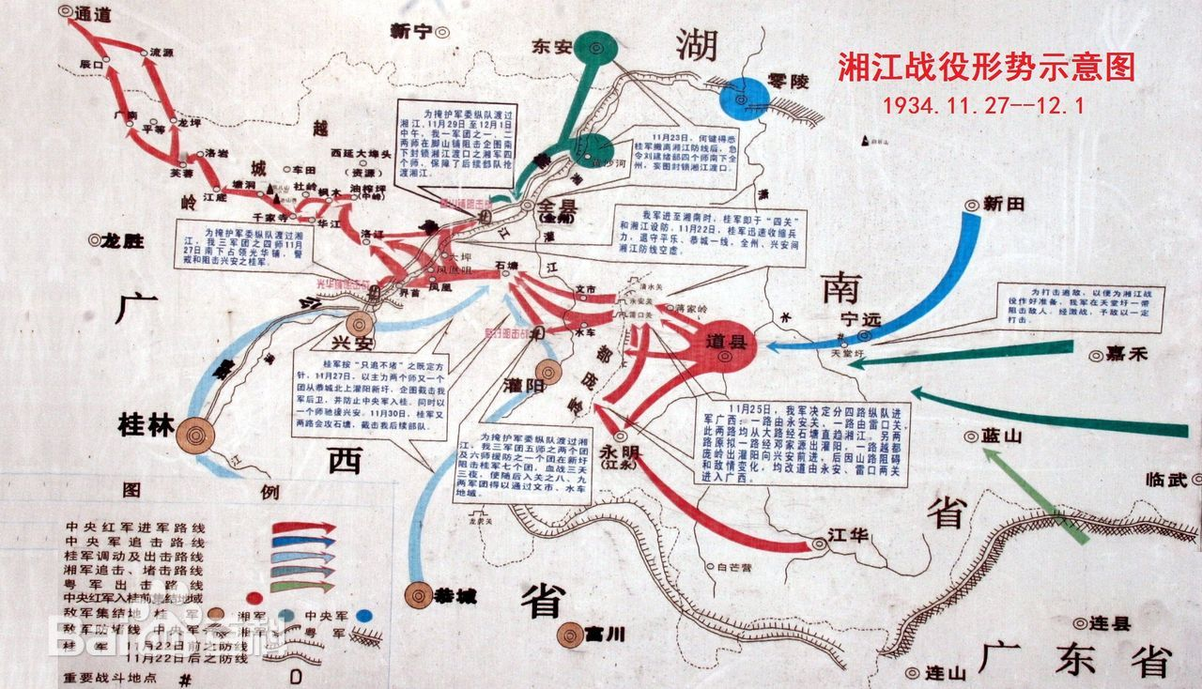During the period of the Land Revolution, the Central Red Army was engaged in a critical battle to break through the fourth line of blockade established by the Kuomintang army in the Xiangjiang region of northern Guangxi during their Long March.

The Xiangjiang Campaign was a battle that determined the life and death of the Central Red Army. From November 27 to December 1, 1934, the Central Red Army fought fiercely for five days and nights against the Kuomintang forces in the mountainous areas of Xing'an, Quanzhou, and Guanyang in Guangxi. Ultimately, they succeeded in crossing the Xiangjiang River between Quanzhou and Xing'an, thereby breaking through the fourth line of blockade. This victory thwarted Chiang Kai-shek's attempt to encircle and annihilate the Central Red Army east of the Xiangjiang River. However, this success came at an enormous cost. The number of troops and personnel in the Central Committee plummeted from over 80,000 at the start of the Long March to just over 30,000.

The Xiangjiang Campaign was the most heroic and crucial battle since the Central Red Army began its breakout. Our forces engaged in fierce combat against a numerically superior enemy, ultimately tearing through the heavily fortified blockade line and dismantling Chiang Kai-shek’s plan to encircle the Red Army east of the Xiangjiang. Although the Red Army managed to breach the fourth line of blockade, the price paid was staggering. The 5th Corps and the newly formed International Brigade suffered over fifty percent losses, while the 8th Corps faced even greater devastation. The 34th Division was heavily surrounded, and its officers and soldiers fought valiantly until they ran out of ammunition and supplies, resulting in the heroic sacrifice of the majority of their comrades. After crossing the Xiangjiang River, the Central Red Army and the two divisions of the Military Commission had dwindled from 86,000 at the start to just 30,000. This led to widespread doubt and dissatisfaction among many cadres and soldiers regarding Wang Ming's military strategy, with increasing calls for a change in leadership.

The bittersweet victory at the Xiangjiang directly resulted in the convening of an expanded meeting of the Central Political Bureau in Zunyi (historically known as the “Zunyi Conference”). This meeting was held when the Red Army was besieged and in dire straits, establishing the correct leadership of the new Central Committee centered around Mao Zedong and affirming Mao's leadership within both the Red Army and the Central Committee.

1. 四渡赤水

The Four Crossings of the Chishui River Campaig

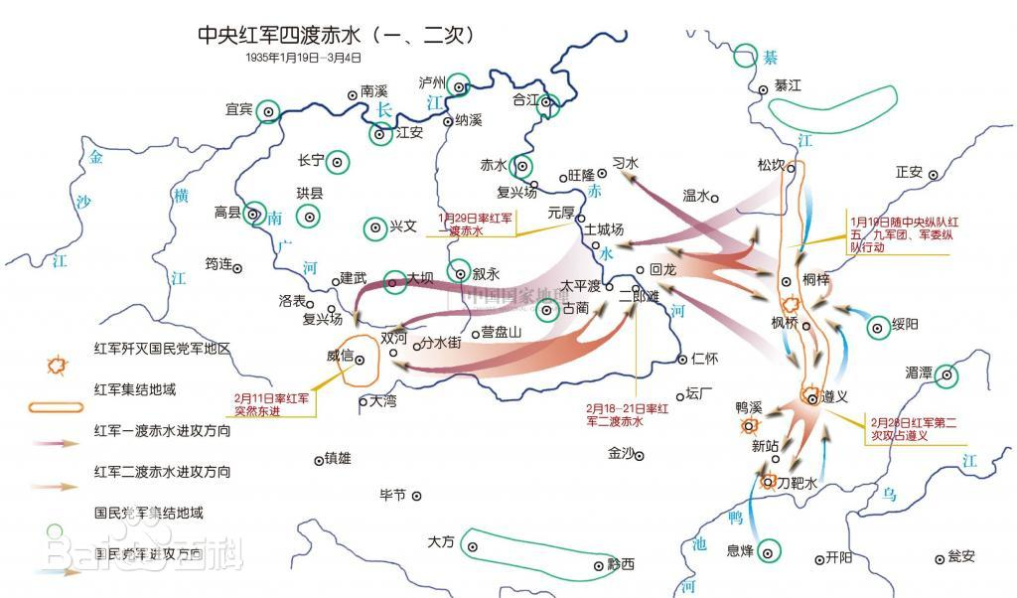During the period of the Land Revolution, the Central Red Army engaged in a series of mobile warfare battles against the Kuomintang forces in the basin of the Chishui River, located at the intersection of Guizhou, Sichuan, and Yunnan provinces during their Long March.

The Four Crossings of the Chishui River Campaign was a decisive mobile battle that took place after the Zunyi Conference, amid the perilous circumstances of the Central Red Army being pursued and besieged by hundreds of thousands of Kuomintang troops. Under the leadership of Mao Zedong, Zhou Enlai, and Zhu De, the Red Army adopted a highly mobile strategy, maneuvering freely across the vast areas of the Sichuan-Guizhou-Yunnan border. They actively sought opportunities for engagement, effectively mobilizing and destroying enemy forces, and ultimately thwarted Chiang Kai-shek’s ambitious plan to encircle the Red Army in this region. This campaign resulted in a strategically significant victory during their retreat.

Over the course of three months, Mao Zedong directed the Central Red Army in six crossings of three rivers, skillfully navigating between the encircled positions of the Kuomintang forces. By constantly seizing opportunities for battle, they managed to inflict substantial losses on the enemy, firmly establishing the initiative on the battlefield. This campaign stands as a brilliant example in the history of the Long March, showcasing how a smaller force can triumph over a larger one, turning a passive situation into an active one.

土地革命战争时期，中央红军长征中，在贵州、四川、云南3省交界的[赤水河](https://baike.baidu.com/item/%E8%B5%A4%E6%B0%B4%E6%B2%B3/13018359?fromModule=lemma_inlink" \t "https://baike.baidu.com/item/%E5%9B%9B%E6%B8%A1%E8%B5%A4%E6%B0%B4/_blank)流域同[国民党](https://baike.baidu.com/item/%E5%9B%BD%E6%B0%91%E5%85%9A/226551?fromModule=lemma_inlink" \t "https://baike.baidu.com/item/%E5%9B%9B%E6%B8%A1%E8%B5%A4%E6%B0%B4/_blank)军进行的运动战战役。

四渡[赤水](https://baike.baidu.com/item/%E8%B5%A4%E6%B0%B4/0?fromModule=lemma_inlink" \t "https://baike.baidu.com/item/%E5%9B%9B%E6%B8%A1%E8%B5%A4%E6%B0%B4/_blank)战役是[遵义会议](https://baike.baidu.com/item/%E9%81%B5%E4%B9%89%E4%BC%9A%E8%AE%AE/64086?fromModule=lemma_inlink" \t "https://baike.baidu.com/item/%E5%9B%9B%E6%B8%A1%E8%B5%A4%E6%B0%B4/_blank)之后，中央红军在[长征](https://baike.baidu.com/item/%E9%95%BF%E5%BE%81/22312?fromModule=lemma_inlink" \t "https://baike.baidu.com/item/%E5%9B%9B%E6%B8%A1%E8%B5%A4%E6%B0%B4/_blank)途中，处于国民党几十万重兵围追堵截的艰险条件下，进行的一次决定性[运动战](https://baike.baidu.com/item/%E8%BF%90%E5%8A%A8%E6%88%98/1075451?fromModule=lemma_inlink" \t "https://baike.baidu.com/item/%E5%9B%9B%E6%B8%A1%E8%B5%A4%E6%B0%B4/_blank)战役。在[毛泽东](https://baike.baidu.com/item/%E6%AF%9B%E6%B3%BD%E4%B8%9C/0?fromModule=lemma_inlink" \t "https://baike.baidu.com/item/%E5%9B%9B%E6%B8%A1%E8%B5%A4%E6%B0%B4/_blank)、周恩来、朱德等指挥下，中央红军采取高度机动的运动战方针，纵横驰骋于川黔滇边境广大地区，积极寻找战机，有效地调动和歼灭敌人，彻底粉碎了[蒋介石](https://baike.baidu.com/item/%E8%92%8B%E4%BB%8B%E7%9F%B3/184548?fromModule=lemma_inlink" \t "https://baike.baidu.com/item/%E5%9B%9B%E6%B8%A1%E8%B5%A4%E6%B0%B4/_blank)企图围歼红军于川黔滇边境的狂妄计划，红军取得了战略转移中具有决定意义的胜利。

毛泽东指挥[中央红军](https://baike.baidu.com/item/%E4%B8%AD%E5%A4%AE%E7%BA%A2%E5%86%9B/0?fromModule=lemma_inlink" \t "https://baike.baidu.com/item/%E5%9B%9B%E6%B8%A1%E8%B5%A4%E6%B0%B4/_blank)三个月的时间六次穿越三条河流，转战川贵滇三省，巧妙地穿插于国民党军重兵集团围剿之间，不断创造战机，在运动中大量歼灭敌人，牢牢地掌握战场的主动权，取得了红军长征史上以少胜多，变被动为主动的光辉战例。

1. 飞夺泸定桥

The Battle of Luding Bridge

飞夺泸定桥战役是红军长征中的一次重要战役，发生在1935年5月。这场战役的背景是红军为了摆脱敌军的围追堵截，必须迅速渡过大渡河，而泸定桥则是通往敌人后方的重要交通要道。

当时，红军面临着严峻的形势，敌军的封锁使得渡河变得极其困难。泸定桥横跨在大渡河上，桥身狭窄且结构老旧，常年风雨侵蚀，极为脆弱。然而，这座桥的战略意义不容忽视。红军决定采取果敢行动，力争在敌人未能及时反应过来之前夺取这座桥。

1935年5月29日，红军指挥官邓小平下令发起强渡。为了确保成功，红军士兵利用夜色掩护，分成几个小组，悄然接近泸定桥。战斗在清晨时分展开，红军战士们利用机动灵活的战术，迅速攀爬到桥上，展开激烈的战斗。敌军虽企图守卫，但由于红军的突然袭击和勇猛精神，迅速被击退。

战役中，红军战士表现出了非凡的勇气与毅力。尽管面临着枪林弹雨，他们不顾个人安危，奋勇向前，最终成功夺取了泸定桥。这一胜利不仅为红军的后续行动创造了条件，还极大鼓舞了士气，增强了士兵们对长征成功的信心。

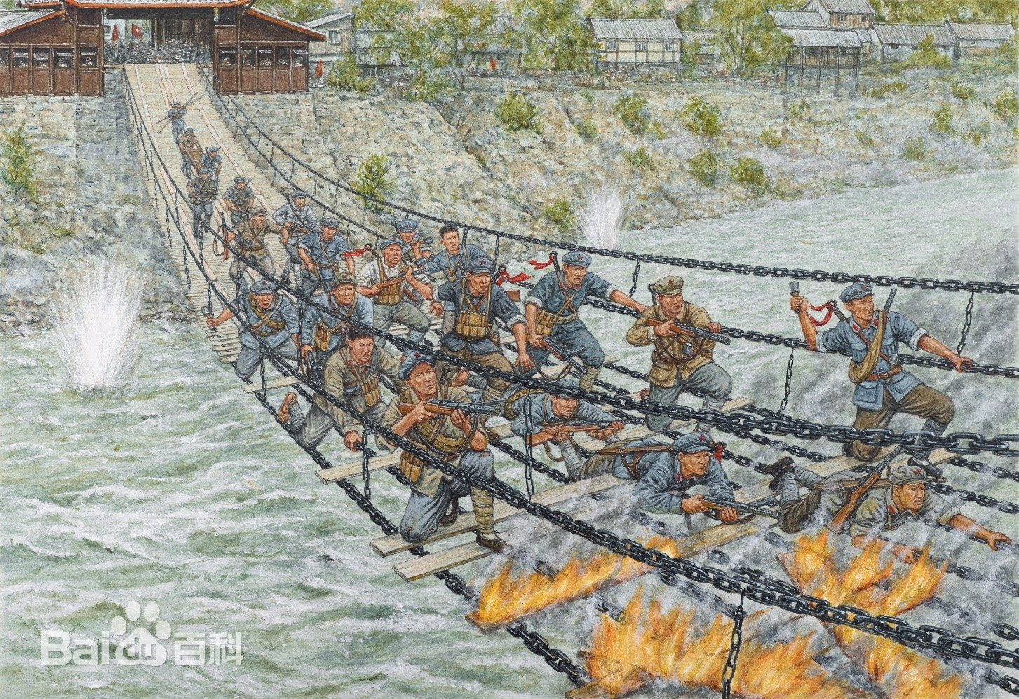The Battle of Luding Bridge was a crucial engagement during the Long March of the Red Army, taking place in May 1935. The context of this battle involved the Red Army's urgent need to cross the Dadu River to escape relentless enemy pursuit, with Luding Bridge serving as a vital route to the enemy's rear.

At that time, the Red Army faced severe challenges; the enemy's blockade made crossing the river extremely difficult. The bridge, narrow and dilapidated from years of weathering, was precariously weak. However, its strategic importance could not be overlooked. The Red Army decided to take bold action, aiming to seize the bridge before the enemy could respond.

On May 29, 1935, Commander Deng Xiaoping ordered the assault. To ensure success, Red Army soldiers moved under the cover of night, dividing into small groups to approach the bridge stealthily. The battle broke out at dawn, with Red Army fighters using agile tactics to quickly ascend the bridge and engage in fierce combat. Despite the enemy's attempts to defend it, they were swiftly repelled by the Red Army's surprise attack and indomitable spirit.

Throughout the battle, the Red Army soldiers demonstrated extraordinary courage and tenacity. Facing a hail of bullets, they pressed forward fearlessly, ultimately capturing Luding Bridge. This victory not only created favorable conditions for the Red Army's subsequent maneuvers but also significantly boosted morale, reinforcing the soldiers' confidence in the success of the Long March.

1. 甘孜会师

The Ganzi Meeting of the Red Army

1936年3月30日，根据红军总司令朱德、总政治委员张国焘的电报，在长征途中的红二、六军团北渡金沙江，越过大雪山，历尽艰辛，7月2日在甘孜与红四方面军会师。中共中央得知后，指令红二、六军团合编为红二方面军（红三十二军编入），贺龙任总指挥、任弼时任政治委员。此时，张国焘虽已取消另立的“中央”，但没有改变与中央对抗的立场。他企图拉拢刚刚会师的红二方面军支持他的错误活动和主张，遭到红二方面军领导人的坚决抵制。在朱德、刘伯承、任弼时、贺龙、关向应等力争下，红二、四方面军决定共同北上，同中央和红一方面军会合。

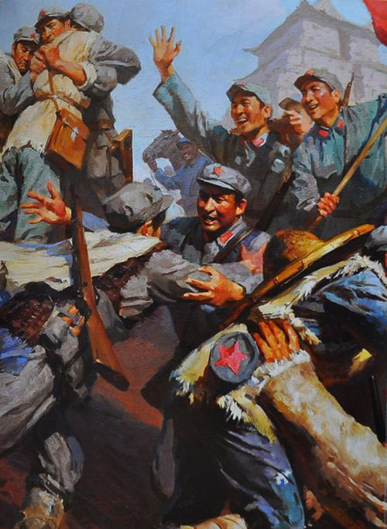On March 30, 1936, under the orders of Red Army Commander Zhu De and Political Commissar Zhang Guotao, the Second and Sixth Armies crossed the Jinsha River during their Long March. They endured harsh conditions as they traversed the towering Snow Mountains, and on July 2, they finally met up with the Fourth Front Army in Ganzi.

Upon receiving this news, the Central Committee directed the Second and Sixth Armies to merge into the Second Front Army, incorporating the 32nd Army as well. He Long was appointed as the overall commander, with Ren Bishi serving as the political commissar. At this time, although Zhang Guotao had disbanded his rival "central" authority, he still maintained a confrontational stance against the Central Committee. He attempted to enlist the newly united Second Front Army to support his misguided activities and proposals, but his efforts were met with strong resistance from the army’s leaders.

With the determined efforts of Zhu De, Liu Bocheng, Ren Bishi, He Long, and Guan Xiangying, the Second and Fourth Front Armies resolved to advance north together and reunite with the Central Committee and the First Front Army.

#### 预计数字化和可视化呈现：

时间轴：呈现战役前后的重要事件和战略决策

E.g.,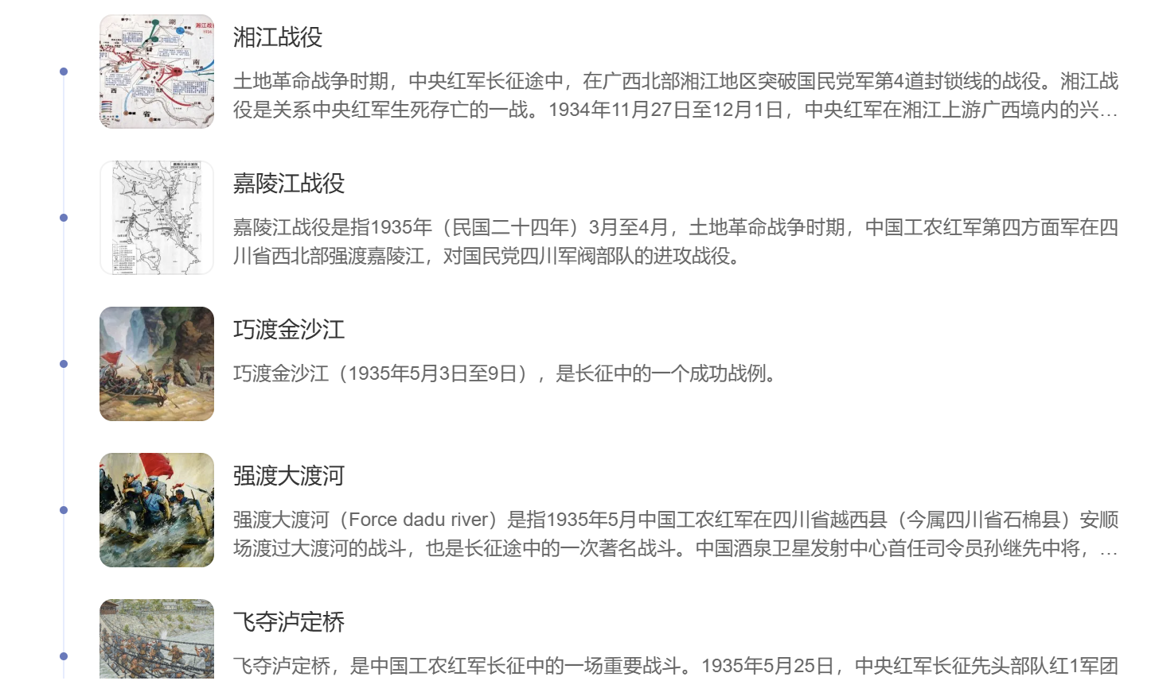

地图动态演示：展示八大战役的地点和路线分布地图，标出红军的位置变化（待定）

数据统计：战斗中的伤亡人数和损失情况（还需要数据库数据支撑）

#### **参考文献**

[四渡赤水：军事指挥艺术的生动体现--党史频道-人民网](https://baike.baidu.com/reference/11590/533aYdO6cr3_z3kATKCNzP2iMCzFZ9ml6LGHVudzzqIP0XOpTI_rXZs66Zkv-_h3GA6Fs5dvLtUb2eb7FUlF7_4Pceo3QKpxlXP_UDTfyr_k-984n9Ra-84eBA" \t "https://baike.baidu.com/item/%E5%9B%9B%E6%B8%A1%E8%B5%A4%E6%B0%B4/_blank)．党史

[渭图党建 | 党史故事：湘江战役](https://baike.baidu.com/reference/2624623/533aYdO6cr3_z3kATKGCxKj3MinAYNz6v7WGVeZzzqIPmGapB4P1FJ836c828Ll2BUXIv5Utc4kqqeqjQEY4pJISD5lER8tG7D6BMj7P3-O_q9QzmNVDpo5CX6sekail_kn-xGDU1ObdtzzrwmDM7tbjKyfDRtROi9BfUpyFC_g0JweBlhrrPl_qHqbEzf2uizyUANm3rDTdPYHCf5fbj6eYzTMUK-Wa68F9DqssHRKI6OG2IhYtGf0mSypJJZAGRbM_xM6S2LqvGaCcnPHq0lo9Gk7_yfsgF-yaC1qVFpLnFMU" \t "https://baike.baidu.com/item/%E6%B9%98%E6%B1%9F%E6%88%98%E5%BD%B9/_blank)．渭南市图书馆

[党史故事我们讲｜马荣：《橘子洲头》](https://baike.baidu.com/reference/2624623/533aYdO6cr3_z3kATPXeyvv1ZC-WNNiovuaBWudzzqIPmGapB4OrToA38NYv--UpFwWEsplrat8UnumlZUpG7PYXdusy" \t "https://baike.baidu.com/item/%E6%B9%98%E6%B1%9F%E6%88%98%E5%BD%B9/_blank)．中国煤地

[「每日一习话·中国共产党人精神谱系」遵义会议是生死攸关转折点](https://baike.baidu.com/reference/2624623/533aYdO6cr3_z3kATP3ZmqrwZC3DMtn5tuLXVLJzzqIPmGapB4zkU4I74d8-8bllFQLPpdZhb9tahbejXkZE6fYSd-wwR7wimXT5UjfLwL3i6Z5n2NwH49MXDe8B0a6zuwSv" \t "https://baike.baidu.com/item/%E6%B9%98%E6%B1%9F%E6%88%98%E5%BD%B9/_blank)．央广网

中国中共党史学会编．中国共产党历史系列辞典．中共党史出版社、党建读物出版社．2019