Python

Date: May 30, 2020

Assignment 2 –

q.1. Print all the datatype using python script.

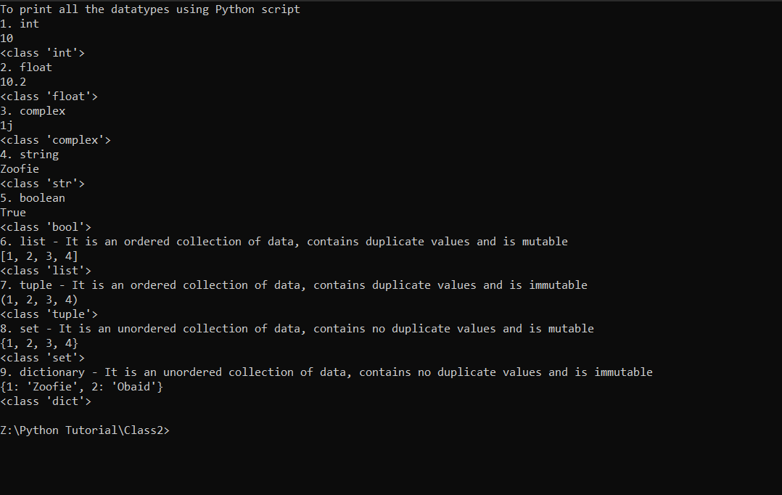

q.2.Create a calculator

