Studying a connected collection
A practical fixture for checking the shape and portability of Orion notes.
#research #export

Finding the useful passage
A personal library becomes more useful when retrieval is precise and the original evidence remains accessible. This fixture checks ordinary prose, formatting and links in a document that can be edited outside Orion.
The same document includes headings, task checkboxes, ordered lists, quotations, code, a table and a managed image. Free image positions become readable figures in the flow of the document.

A short reading checklist
Read the source and compare the claim
Keep a short explanation beside the evidence
Return to the second note
- Gather the relevant material.
- Compare the proposed explanation with the evidence.
- Keep the uncertainty visible.
A quotation should remain readable and clearly separated from surrounding prose.
It can continue into a second paragraph without becoming an image.

A small comparison
Feature | Preserved content | Result
Headings | Real Word heading styles | Yes
Tasks | Editable checkbox controls | Yes
Evidence | Public source titles and links | Yes
Images | Embedded local raster bytes | Yes

A portable example
The inline expression answer + 1 remains visually distinct.
const evidence = notes.filter(note => note.hasSource);
const answer = evidence.length;
console.log(answer);
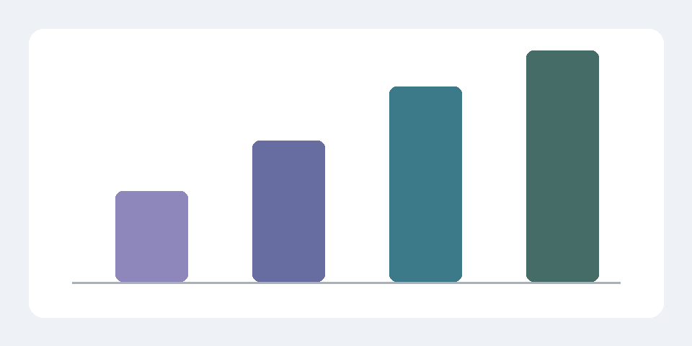
Figure 1 A synthetic chart used to check image size and caption flow
The figure and this paragraph should appear in normal reading order, with the caption close to the image. A grounded statement carries its numbered ^{[1]}.

References
- A public reference — pdf source · source text not included

Checking the exported document

Editing and navigation
This note starts on a fresh page. Its link to the first note should stay inside the document. A public link remains a conventional hyperlink.
- A bullet can contain a longer explanation.
  - Nested entries retain their own indentation.
  - Reordering a list remains a Word editing operation.

Characters and literal text
Text such as café, naïve, α, β, & and should survive package escaping. Superseded text retains its strikethrough.

