Experiment No.

Web-Based Online Examination System
(SRS Report) JAMIA MILLIA ISLAMIA
Department of Computer Engineering

Members:
Mohammad Zuhaib - 24BCS050 Mohammad Adnan Raza - 24BCS052

Table of Contents
- Introduction ........................................................................................... 3
  - Purpose .......................................................................................... 3
  - Product Scope ................................................................................... 3
  - Technologies to be Used ....................................................................... 3
  - Definitions, Acronyms and Abbreviations ..................................................... 4
- Overall Description ................................................................................... 4
  - Product Perspective ............................................................................. 4
  - User Classes and Characteristics ............................................................... 4
  - Operating Environment ......................................................................... 5
  - Software Interfaces ............................................................................. 5
  - Hardware Requirements ........................................................................ 5
  - Functionalities .................................................................................. 5
  - General Constraints ............................................................................. 6
- System Features ....................................................................................... 6
  - Functional Requirements ....................................................................... 6
  - Technical Issues ................................................................................ 7
  - Non-Functional Requirements ................................................................. 7
- Design .................................................................................................. 8
  - Use Case Diagram .............................................................................. 8
  - Class Diagram .................................................................................. 8
  - Data Flow Diagrams (DFD 0 and DFD 1) ..................................................... 9
- Database Design ....................................................................................... 10
  - Entity-Relationship Diagram (ERD) ........................................................... 10
- Future Scope ........................................................................................... 11
- Conclusion ............................................................................................. 12
- References ............................................................................................. 12

Introduction

Purpose
The purpose of this document is to outline the system requirements for a web-based online examination system. The platform, built for institutions, examiners and candidates, provides secure exam creation, timed delivery, automatic evaluation and result generation for both objective and subjective assessments. A key feature is a built-in proctoring layer meant to discourage malpractice when an exam is taken remotely, outside a supervised hall. This document details the system's functionalities, interfaces, constraints and features, and is meant to guide both the development team and the other stakeholders through the build.

Product Scope
This online examination system is designed to work as a digital alternative to the traditional pen-and-paper test, though nothing stops an institution from running it alongside conventional exams. It will be reachable through a standard web browser, and will let candidates register for an available exam, attempt it inside a fixed time window, and check their result once it is published. Examiners can build up a question bank over time, assemble exams from that bank, schedule when an exam opens, and manually grade the subjective portions that cannot be scored automatically. A proctoring layer — webcam checks, tab-switch detection, and an activity log reviewable by the examiner — is included to help preserve the integrity of an exam that isn't physically supervised.

Technologies to be Used

Technology | Description
Front-end | HTML, CSS, JavaScript and a modern framework such as React.js or Vue.js to build a responsive, timer-driven exam interface.
Back-end | A server-side framework such as Node.js (with Express), Python (Django/Flask), or PHP to handle exam logic, timing, auto-grading, and APIs.
Database | A relational DBMS such as PostgreSQL or MySQL to store user accounts, question banks, exam attempts, and results.
Proctoring Module | Webcam capture, tab/window-switch detection, and browser lockdown, used to flag suspicious activity during a live exam.
Question Bank Engine | A tagging and retrieval system that lets examiners organise questions by subject, topic and difficulty before assembling an exam.
User Notifications | Email and SMS gateways to send admit cards, exam reminders, and result announcements.
Logging & Auditing | The system records logins, exam attempts, and grading actions, mainly for monitoring, debugging and resolving result disputes.
Compliance & Maintenance | Adherence to data-protection standards (e.g. GDPR); regular patching, updates and backups.

Definitions, Acronyms and Abbreviations

Term | Meaning
SRS | Software Requirements Specification — a document describing all functions, features, and constraints of the proposed system.
UI | User Interface — the part of the application with which the user interacts (dashboards, menus, forms).
API | Application Programming Interface — functions and protocols that let software components communicate.
DBMS | Database Management System — software for storing and managing structured data (e.g. MySQL, PostgreSQL).
MCQ | Multiple Choice Question — a question with a fixed set of options, one or more of which is correct.
CBT | Computer-Based Test — an exam that is delivered and, largely, evaluated through a computer system rather than on paper.
Proctoring | The process of monitoring a candidate during an exam, manually or through automated means, to detect malpractice.
Question Bank | A repository of exam questions, organised by topic and difficulty, from which an exam is assembled.
Negative Marking | Deduction of marks for an incorrect answer, used in some objective exams to discourage random guessing.
Admit Card | A credential issued to a candidate confirming eligibility for an exam and carrying the exam login details.
Administrator (Admin) | A system manager handling platform operations such as user management, security, and maintenance.
Candidate | A registered user who attempts one or more exams on the platform.
Notification | An alert sent by email, SMS, or in-app message about an upcoming exam, a result, or an account event.

Overall Description

Product Perspective
The Online Examination System is a standalone web application. It is meant to be a complete solution for conducting an exam from start to finish — question bank management, scheduling, timed delivery, proctoring and result generation — rather than a collection of separate tools stitched together. It gives candidates, examiners and administrators a single, consistent place to work from.

User Classes and Characteristics
Candidates: The primary users. They register for exams, attempt them within the allotted time, and view their results and scorecards once published. Since an exam is time-bound, they are especially sensitive to the interface being fast and reliable under load.
Examiners: They build question banks, assemble and schedule exams, monitor candidates during proctored exams, and grade the subjective questions that a machine cannot score on its own. They need a workflow that doesn't slow them down when reviewing many answer scripts.

Administrators: They manage user accounts and platform-wide settings, and are responsible for system security, uptime, and maintenance.

Operating Environment
The platform is web-based, accessible from all major browsers (Chrome, Firefox, Safari, Edge) on desktop and mobile devices, though a proctored exam is expected to be attempted from a desktop or laptop with a working webcam. It will be hosted on a cloud server (e.g. AWS, GCP, Azure) to keep the system available and to absorb the traffic spikes that happen right when a scheduled exam opens.

Software Interfaces
    - Database Management System: the system connects to PostgreSQL for all data storage.
    - Front-end Framework: the UI is built with React, talking to the back-end through a RESTful API.
    - Proctoring Interface: a browser-based webcam/audio capture (via WebRTC) feeds the proctoring module during a live exam.

Hardware Requirements
    - Server: a virtual server with at least 8 CPU cores, 32 GB RAM, and 1 TB SSD storage, sized up for concurrent webcam streams during peak exam slots.
    - Client Devices: any standard computer with a modern browser; a working webcam and microphone are required for proctored exams.

Functionalities

User Management
    - Registration, login, and secure authentication for candidates and examiners.
    - Profile management, including updating personal details and viewing past exam attempts.

Exam Management
    - Examiners can build question banks, assemble exams, and schedule when each exam opens and closes; candidates can view the schedule and register for an exam ahead of time.
    - Exam Window & Auto-Submission: once an exam's duration runs out, the system auto-submits whatever the candidate has answered and locks further changes. A candidate who logs in after the window's grace period has lapsed cannot start that attempt; the system records this and notifies the candidate, and the examiner can, at their discretion, grant a fresh attempt.

Content Delivery
    - Delivery of exam sections and questions (MCQ, descriptive, and other types), with optional randomised ordering and a visible countdown timer.
    - A locked, auto-submitted exam still lets the candidate view — but not edit — the questions and their own submitted answers.

Evaluation & Grading
    - Objective sections (MCQ, true/false) are graded automatically the moment an exam is submitted.
    - Subjective answers are queued for an examiner to grade manually; a result is only finalised once every section has been marked.

Proctoring & Security

    - Webcam monitoring and tab/window-switch detection during a proctored exam, with suspicious events logged for later review.
    - Examiners get a review dashboard listing flagged candidates and the events that triggered the flag.

Result & Report Generation
    - Candidates can view their score, section-wise breakdown, and a downloadable scorecard once a result is published.
    - Examiners get batch-level performance reports and question-wise difficulty analysis across all candidates.

General Constraints
    - Security: the system must protect candidate data and exam content using secure authentication and encryption, and must prevent question papers from leaking before an exam opens.
    - Scalability: the platform must handle a large number of candidates logging in within the same short window, which is when load peaks hardest.
    - Accessibility: the UI should follow web accessibility standards (WCAG) so candidates with disabilities are not disadvantaged.
    - Exam Integrity: the platform must resist tampering — from question leakage to impersonation — and must keep an audit trail an institution can rely on if a result is disputed.

System Features

Functional Requirements

User Authentication and Authorization
    - The system shall allow new users to register as either a candidate or an examiner.
    - Users shall be able to log in securely with a username and password.
    - Different user roles (Candidate, Examiner, Admin) shall have different levels of access and privileges.

Exam and Question Bank Management
    - Examiners shall be able to add questions to a question bank, tagged by subject, topic and difficulty.
    - Examiners shall be able to assemble an exam from the question bank, organise it into sections, and set its duration and schedule.
    - Candidates shall be able to browse available exams and register for ones they are eligible for.

Exam Delivery and Proctoring
    - Candidates shall be able to attempt an exam within the platform, with a visible countdown timer.
    - For proctored exams, the system shall capture webcam frames and detect tab/window switches, logging any flagged event.
    - The system shall auto-submit an exam once its time window has elapsed.

Evaluation and Grading
    - Objective questions shall be automatically graded and scored on submission.
    - Subjective answers shall be routed to the concerned examiner for manual grading.
    - A result shall move to "published" status only once every section of an exam has been graded.

Result and Report Generation

    - Candidates shall be able to view their score, a section-wise breakdown, and download a scorecard.
    - Examiners shall have a dashboard summarising batch performance and flagging candidates whose proctoring log needs review.

Technical Issues
    - Database: PostgreSQL will be used as the database.
    - Operating System: the development and deployment environment will be a Linux-based server.

Non-Functional Requirements

Security
    - User passwords must be securely hashed and salted.
    - All data transmission between client and server must be encrypted using HTTPS.
    - Question papers must remain inaccessible to candidates before an exam's scheduled start time.

Performance
    - Webcam-based proctoring must run without noticeably slowing down the exam interface itself.
    - Timer countdowns and auto-submission must stay accurate to within a couple of seconds, even under load.
    - Page load times should not exceed 3 seconds under normal load.

Reliability
    - The system should have high uptime, aiming for 99.9% availability, especially during scheduled exam windows.
    - In-progress exam attempts must be saved incrementally, so a dropped connection does not cost a candidate their answers.
    - A regular backup strategy for all user, question bank, and result data must be in place.

Usability
    - The interface must be intuitive enough that a first-time candidate does not need instructions beyond what's shown on screen.
    - The system should give clear, immediate feedback — a saved answer, a submitted section, a low-time warning.

Scalability
    - The architecture should support horizontal scaling to absorb the login and traffic spike that happens right as a large exam opens.

Design

Use Case Diagram
The use case diagram shows the interactions between the three actors — Candidate, Examiner, and Administrator — and the actions each can perform within the Online Examination System.

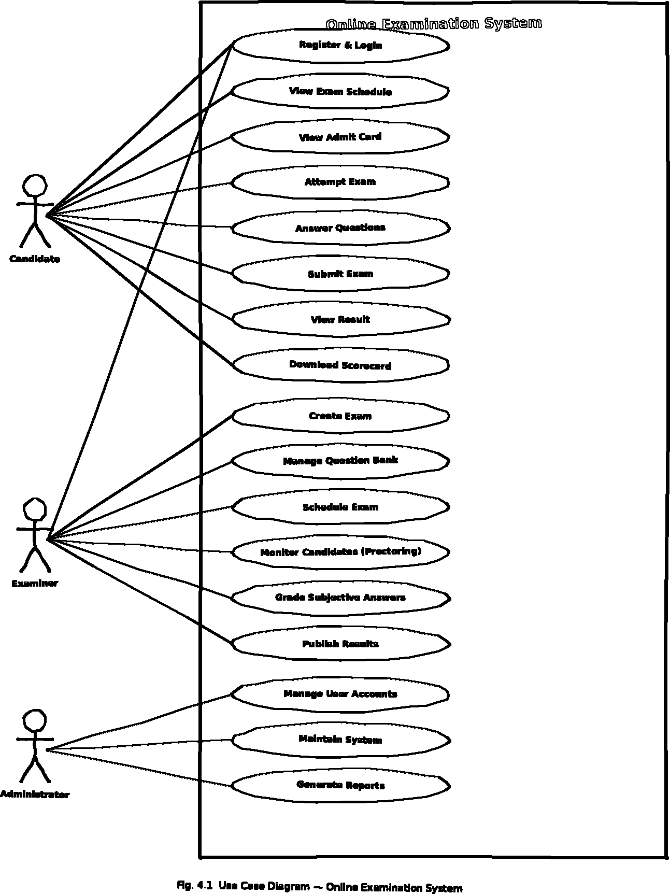

Class Diagram
This diagram models the core components of the system — User, Exam, Section, Question, Response, Result, and ProctoringLog — showing each class's attributes and methods together with the relationships and multiplicities between them.

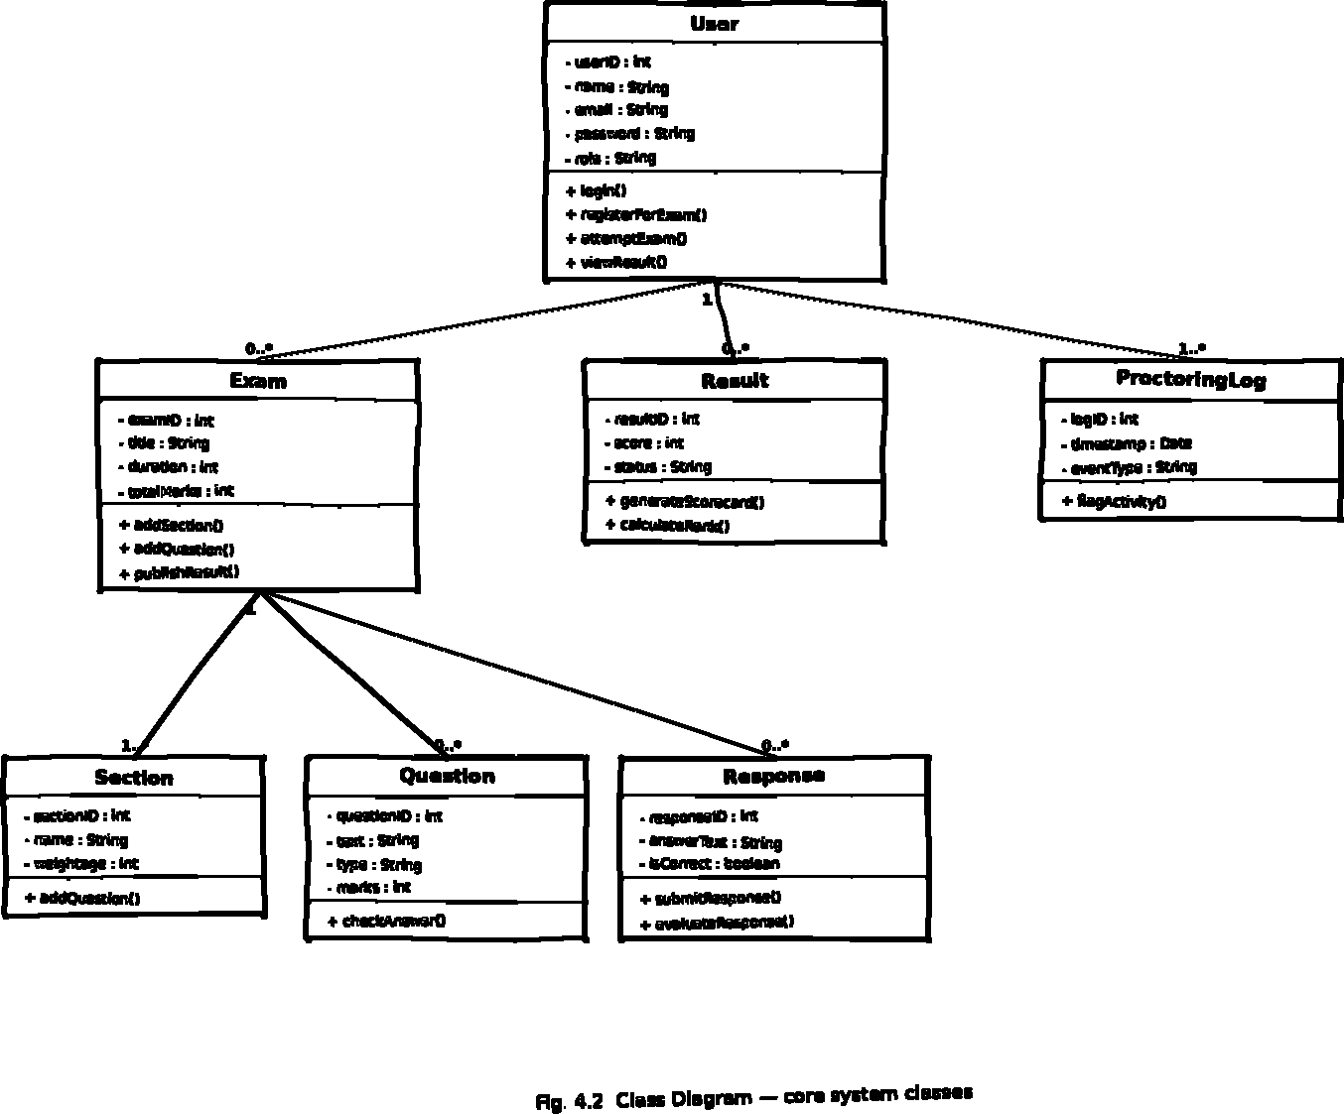
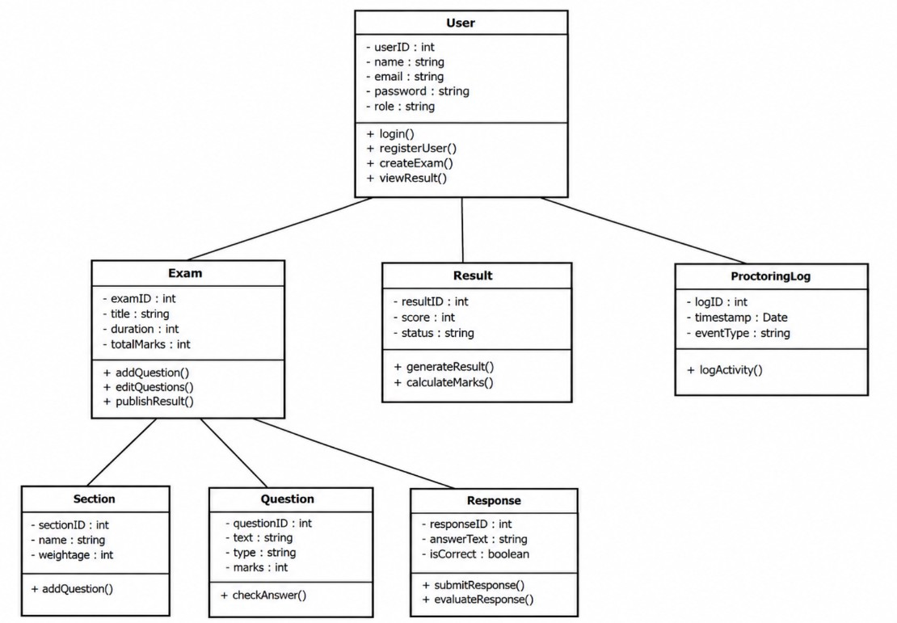
Data Flow Diagrams (DFD 0 and DFD 1)
The DFD 0 (context level) shows the whole system as a single process with the external entities Candidates and Examiners. The DFD 1 breaks the system down into its main sub-processes — User Management, Exam Management, Exam Delivery & Proctoring, and Evaluation & Result Generation — showing the data flow between them and the data stores.

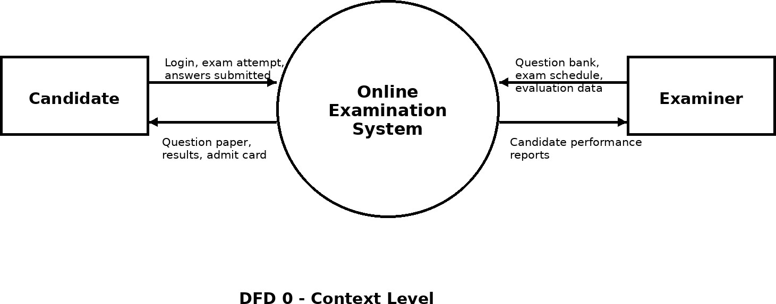
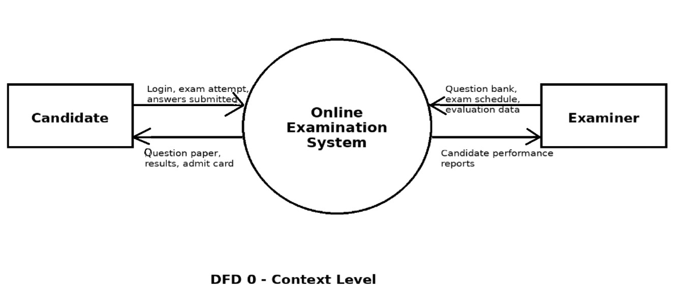
DFD 0 — Context Level

DFD 1 — Level 1

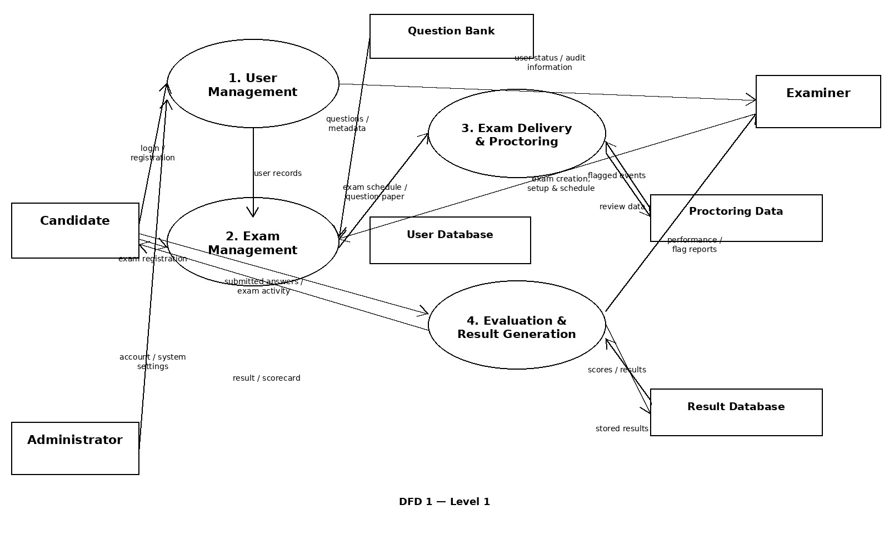

Database Design

Entity-Relationship Diagram (ERD)
The ER diagram shows the database structure — entities such as User, Exam, ExamComponent, Result, and Notification — along with their attributes and the relationships between them. Primary keys are underlined, and specialisation is expressed through ISA hierarchies: a User is a Candidate, Examiner, or Admin, and an ExamComponent is a Section, an MCQ Question, or a Descriptive Question. For example, a Candidate has a one-to-many relationship with Result, since a candidate can attempt more than one exam over time.

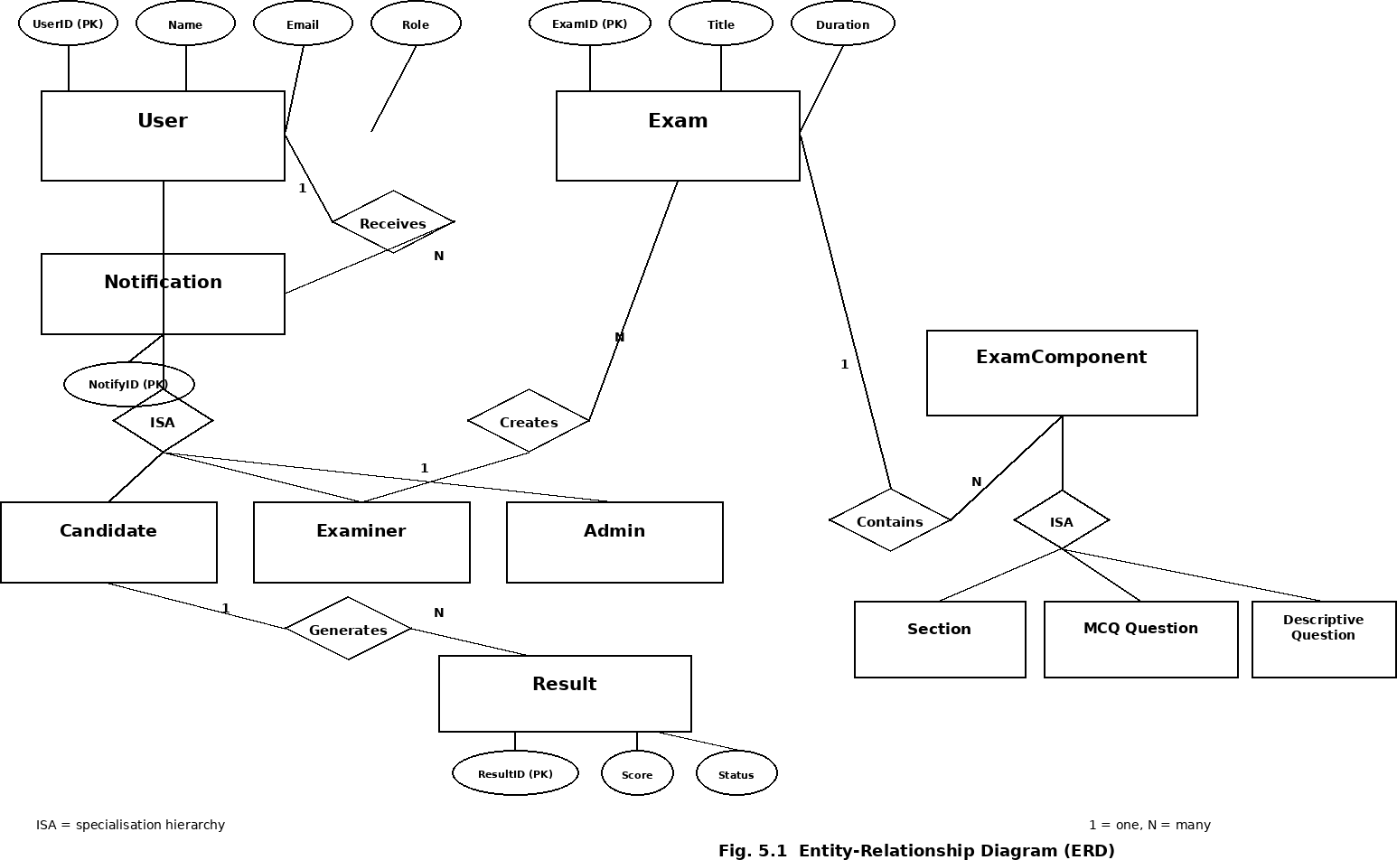

Future Scope
The future scope of the Web-Based Online Examination System includes:

Adaptive Testing
Beyond a fixed question paper, the platform could move toward computerised adaptive testing, where the difficulty of the next question adjusts in real time based on how a candidate is performing, giving a more precise read on their ability in less time.

AI-Assisted Proctoring
Proctoring can be strengthened with face-recognition checks at login, gaze and audio anomaly detection during the exam, and automated flagging that narrows down what an examiner actually needs to review by hand, rather than watching every recording.

Broader Question Types and Integrations
Future versions could support coding questions with automated test-case execution, drag-and-drop or diagram-based questions, and integration with external plagiarism-checking tools for descriptive answers.

Data Analytics and Insights
Item-response-theory-based calibration could tell examiners which questions are too easy, too hard, or ambiguous, while cohort-level analytics could highlight topics an entire batch is struggling with.

Offline and Mobile-First Access

A native mobile or offline-capable client would let candidates in low-connectivity exam centres download an exam ahead of time and sync answers once back online, with safeguards to prevent tampering with the downloaded question set.

Accessibility Enhancements
Future iterations can add screen-reader compatibility, extended-time accommodations configured per candidate, and adjustable font size and colour contrast for candidates with visual or motor impairments.

Certification and Career Integration
The platform could issue verifiable digital certificates (optionally backed by blockchain) for candidates who clear a certification exam, and could integrate with recruitment or HR platforms that use skill-assessment tests as part of hiring.

Conclusion
The Software Requirements Specification (SRS) for the Web-Based Online Examination System is a critical document that lays out the functional and non-functional requirements of the system. It is meant to guide the design, development, and testing phases, and to make sure the finished product actually meets the needs of candidates, examiners, and administrators.
A large part of this SRS is built around exam integrity — the proctoring layer, the strict exam-window and auto-submission behaviour, and the audit logging all exist to make a remotely conducted exam something an institution can trust. Just as important is the evaluation pipeline: automatic grading for objective questions, paired with a manageable review queue for subjective ones, so a result can be produced without an examiner drowning in answer scripts.
The document also lays out a scalable architecture, since exam traffic doesn't arrive evenly — it spikes hard right at the scheduled start time. The non-functional requirements around security, performance, and reliability are written with that spike specifically in mind, alongside the more usual expectations of accessibility and usability.
In conclusion, this SRS sets the foundation for building an examination platform that is secure, fair, and dependable under load, while leaving room to grow into adaptive testing, richer analytics, and broader accessibility as the platform matures.

References
- Academic Journals: research articles on computer-based testing, educational measurement, and secure remote proctoring provide background on best practices and emerging concerns in the field.
- Books: A Philosophy of Software Design, John Ousterhout.
- Online Databases: ACM Digital Library, IEEE Xplore, and Google Scholar, for academic papers on computer-based assessment, online proctoring, and web application security.
- Websites: foundational and practical resources for web development and software engineering — geeksforgeeks.org, slideshare.net, and en.wikipedia.org/wiki/Computer-based_testing.

