Question No. 1 Construct a code to generate a square wave of 100 Hz frequency pon Pin PORTB.5. Use timer 0, Normal Mode with prescalar = 1024. Assume XTAL = 8MHz. 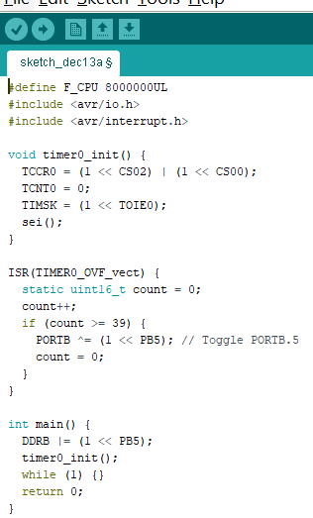

2: Question No. 2 [CLO2: 1 Mark] Construct a code that toggle pin PORTB.3 every 10ms, while at the same time read the switches which is connected from PORTC and send it to LED’s which is connected on PORTD. Assume XTAL = 4MHz.

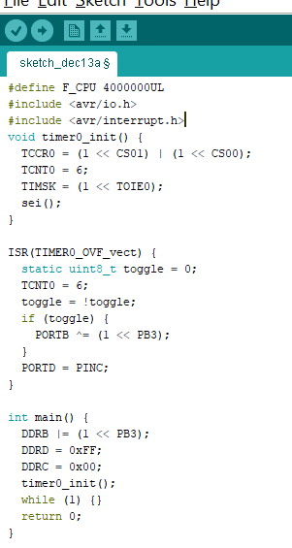

Question No. 3 A sensor is connected at the entrance of class at T0, construct a code to count using Timer 0 and convert the count into BCD and display in 7 segment connected on PORTD (SEG2 (PD7:PD4) , SEG1(PD3:PD0)).

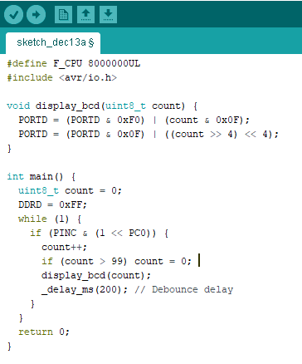

Question No. 4 Construct a code to send message “Bahria University” to the serial port. Use 8 bits data, 1 stop bit. Assume XTAL = 8 MHz.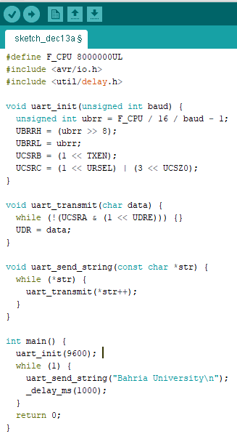

Question No. 5 Construct a code that switch is connected in INT0 which is normally high when it goes low it toggle the LED which is connected at PORTC.0. Use external interrupt in falling edge mode

